Issue 8: Forest Products and Carbon Sequestration

Overview

The history of forest product utilization in Hawaii is diverse and unique. Hawaii’s forests have changed dramatically from the time the first Polynesians migrated to these islands in 400 AD to the present. The native Hawaiians inadvertently introduced the Polynesian Rat (*Rattus exulans*) which caused the near-extinction of the entire genus of our native palm *loulu*, *(Pritchardia spp.)* by feeding on the seeds produced by the palm. Pritchardia were once the dominant overstory tree species in the dry forests of Hawaii and formed a unique dry forest ecosystem dominated by a palm species. *Pritchardia,* which also dominated the forests of Rapa Nui (Easter Island), suffered the same fate. The Rapa Nui Polynesians did not develop a sustainable land stewardship system, and their society collapsed as a result. However, the Hawaiian civilization adapted to these rapid changes, and succeeded in developing the *ahupuaa* system in harmony with the natural resource base and unique geography of the high islands.

When the first Europeans encountered Hawaii, they noted that the dry lowlands had been mostly converted to grasslands which were periodically burned by the Hawaiians to stimulate the growth of *pili* (*Heteropogon contortus*) which was the primary thatching material used by the Hawaiians. *Loulu*, no longer the dominant dry forest species, had been replaced by the endemic *wiliwili* (*Erythrina sanwdicensis*).

For the most part, native Hawaiians did not use wood-producing species from the forested uplands in significant quantities, with the exception of the endemic tree koa (Acacia koa). Koa is a dominant species in our Wet and Mesic forests. A mature koa tree can reach 120 ft tall, and is capable of producing a straight trunk with no defects that the native Hawaiians found ideal for producing ocean voyaging canoes. In addition to its superior woodworking qualities, a mature koa can produce beautiful wood with a “curl” that rivals any fine craft wood in the world. Today, a koa rocking chair currently retails for $3,000 to $5,000 depending on the curl and skill of the craftsman. Thus, koa is highly prized for its ecological, cultural and economic value. Most of Hawaii’s koa has already been harvested from private lands, and koa theft from the forest reserves has increased in the last several decades due to the high demand for the valuable heartwood.

The first commercial product extracted from Hawaii were the many endemic species of *iliahi*, or sandalwood (*Santalum spp*.). Sandalwood is prized for its fragrant wood and was a valuable commodity for the international trade that immediately took hold in Hawaii after 1778. But *iliahi* is a slow-growing species found generally in dry forests. Sandalwood harvesting boomed for 40 years, until the supply of fragrant old trees was exhausted and the genus was driven to the brink of extinction in Hawaii.

Hawaii’s other native tree species for the most part do not possess good woodworking qualities, and although several timber mills have successfully operated since the early 1800’s a sustainable export market has not yet been developed because less expensive wood-based building materials have been available from overseas sources such as the Pacific Northwest and Southeast Asia.

Large scale timber trials of introduced commercial species have been undertaken by the Hawaii Board of Forestry and Agriculture, the Hawaii Sugar Cane Grower’s Association and the U.S. Forest Service since the 1900’s. Despite the fact that several Hawaiian grown non-native commercial species have some of the highest growth rates in the world, we have yet to develop a viable and sustainable commercial timber industry. This will hopefully change in the next few years with the establishment of a medium-sized veneer plant and cogeneration facility to be built on the Hamakua Coast of the island of Hawaii, scheduled for initial operations in 2011.

Hawaii’s Forest Products

Increasing timber production and developing markets to support those products is highly desirable in Hawaii, but timber is not the only product derived from these forests. For the purposes of this assessment, forest products are defined as a suite of products including but not limited to the following categories and their corresponding examples:

Timber and Commercial Products (see Map 8.6 Managed Tree Plantations)

* Timber, wood chips, craft wood and other solid wood products – non-native planted commercial forests, new native forest plantations (koa most likely) for sustainable timber production, salvage operations
* Biomass and/or biofuel production – plantations, invasive species control efforts, commercial forestry byproducts, biomass fuel management, salvage operations
* Salvage and non-timber forest products – forest product recovery following natural disasters, pest or disease outbreaks or natural mortality

In addition to products, forests provide services including but not limited to:

Ecosystem Services

* Watershed protection and production of water – water capture, percolation, recharge and supply. (See Issue 1: Water Quality & Quantity for additional information.)
* Carbon sequestration – native or non-native plantations, reforestation or restoration projects for both non-commercial and commercial utilization. (See Present Conditions & Trends section of this Issue for more detail.)
* Native ecosystem protection – preservation of Hawaii’s unique flora and fauna. (See Issue 6: Conservation of Native Biodiversity for additional information.)

Social, Cultural and Non-Traditional Forest Products

* Benefits to human health – open space, air quality, exercise opportunities
* Cultural – sacred site protection, resource gathering & medicinal plants, access for cultural practices, spiritual inspiration
* Recreational opportunities – hunting, hiking, camping

Present Conditions & Trends

The commercial timber industry in Hawaii is in a nascent stage of development. A thriving forest products industry has many components that need to be operational in order for it to function at its capacity. Once fully operational such an industry will likely include lumber, veneer, wood biomass and biofuels, export wood chips, and more. Hawaii has a number of wood product companies, operators, and primary log processors who use small portable mills. However, there is currently no primary log or biomass processing equipment or facility operating on a large scale in Hawaii.

Although Hawaii does not yet have a large-scale timber industry, the craftwood industry is thriving. Local artisans produce an astonishing number of objects crafted from native wood species, notably koa (Acacia koa), but also out of the wide variety of introduced wood species. The Hawaii Forest Industry Association (HFIA) has been instrumental in helping this industry to grow and gain exposure locally and abroad. The HFIA has been sponsoring The Hawaii Woodshow every year since 1993. Only Hawaiian-grown wood works of art are displayed in Hawaii's Woodshow. The show is designed to strengthen appreciation for the artists' work and encourage sustainable forestry through the planting of native and non-native trees (See Figure 8.1 Poster for the 2002 Hawaii Wood Show).

An increased focus on reducing the reliance on fossil fuels and improving energy self-sufficiency has bolstered interest in development of wood biomass for fuel or electrical generation facilities in Hawaii. Also of interest are products such as biodiesel, biofuels, and carbon credits. Through implementation of appropriate policies and actions, such as Hawaii’s Greenhouse Gas Emissions and Climate Change task forces, it is hoped that the forest products industry can become operational at a meaningful scale. If accomplished, this could strengthen economic opportunities for other entities to become involved in sustainable forest products, ecosystem services, and increased self sustainability for Hawaii. Clearly there is the potential for a ‘win, win’ situation in using the native Acacia koa for restoration of wildlife habitat, conversion of marginal pasturelands and degraded croplands to native species, timber production, and carbon sequestration. Koa may not be as fast growing a tree as some other non-natives, but the overall positive impacts of using this species for the above goals, clearly outweigh that of a rather short sided view/quick gain approach that focuses on non-natives. Certainly, there are non-natives that could work to achieve a suite of ecosystem benefits as well.

A veneer plant and cogeneration facility

There are plans for a medium-sized veneer plant and cogeneration facility on the Hamakua Coast on Hawaii Island, scheduled for initial operations in 2011. This facility will be supported by locally-grown hardwoods (see maps below). Tradewinds Forest Products ([www.tradewindsforestproducts.com](http://www.tradewindsforestproducts.com/)) has proposed a two part plan: Phase One - construction of a $62 million veneer manufacturing plant at Ookala on the Hamakua Coast. Phase Two entails building a small cogeneration biomass power plant that will burn mill residuals and provide steam for running the dryers to finish the veneer products. Tradewinds Forest Products has a power purchase agreement with Hawaii Electric Company, as well as a Clear Air Permit issued by the State of Hawaii Department of Health - both of which are important steps in achieving these plans. Should Tradewinds complete these plans, the operation could have a significant impact on Hawaii’s ability to produce, market, and export high value timber, which could also positively impact related operations throughout the state.

Figure 8.1 Poster advertising the 2002 Hawaii Wood Show. Image courtesy of Hawaii Forest Industry Association. Photo credit Hal Lum, photographer.

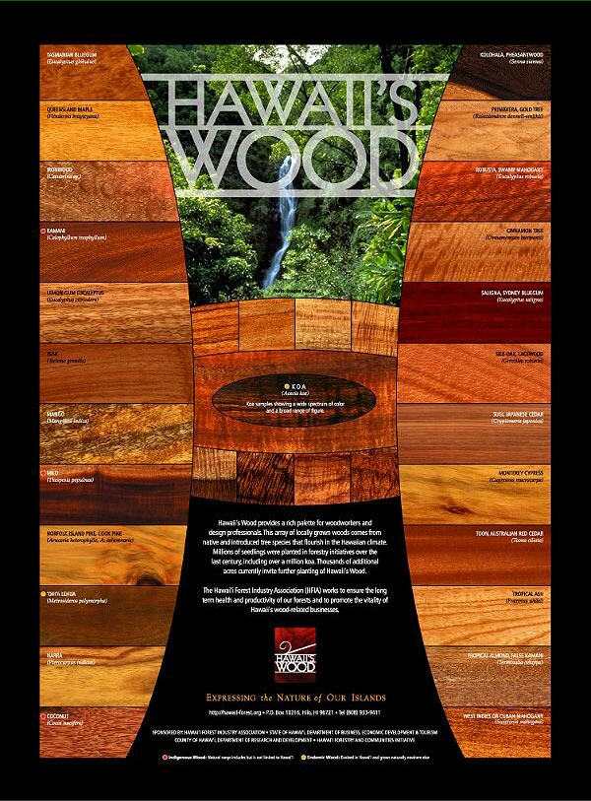

Carbon Sequestration

The active management and sustainable use of carbon can help reduce the harmful effects of carbon dioxide in our atmosphere, but there is much to learn about how to go about accomplishing this. A number of studies suggest that carbon storage and sequestration play very important roles in climate change by removing harmful carbon dioxide (CO2) from the atmosphere via photosynthesis in plant matter.11, 12, 13, 14, 20 The development of carbon markets is also occurring globally to incentivize ‘smart’ growth and ‘green’ living. Mathew Smith of the Society of American Foresters says “Carbon markets are more of a riddle to be solved than an easily defined path to a new payday for forestry.”18 Such a philosophy may be applicable to a small state with a young forest products industry such as Hawaii; however there is interest among private landowners, federally owned lands, and state agencies that hold & manage land to investigate the Voluntary Carbon Market. It is hoped that the use of this market could be an ideal option because it would highlight what is being phrased “charismatic carbon” that is to say carbon that has more values than fast sequestration of CO2 from the atmosphere.

We seek to better understand what role countries, states and private landowners can play in positively affecting climate change. We also need to be more diligent at managing our carbon resources and the many services they provide. An important factor to consider is the kind of carbon we plant on State lands and/or promote on private lands. We need to be very careful when planting invasive species for short term products and CO2 sequestration, and consider the potential total ecosystem impacts from such activities.

An alternative for Hawaii could be ‘niche’ or voluntary carbon markets or those that incorporate value added qualities to carbon. Such a proposal would be akin to paying more to purchase lumber that was sustainably harvested i.e., certified by the Forest Stewardship Council ([fsc.org](http://www.fsc.org)) or other such entities. A ‘niche’ carbon market could contribute to sequestration but also provide equally important services like conserving native habitat for endangered species, contributing to cleaner water and increased water supplies, and much more. This type of multi-faceted carbon market emphasizes the importance of including the entire ecosystem or ahupuaa concept as a center piece of our management goals. The forests are part of a larger system of which carbon is one element, therefore we should be looking at the whole system when considering how to manage the products from it.

The Natural Capitol Project

This project works with State and private landowners to develop ecological and economic approaches for protecting and restoring biodiversity and ecosystem services, and in ways that are economically attractive. Their major focus is on opportunities to restore native koa tree cover for its diverse economic, ecological, and cultural benefits.15 Collaborative efforts like this, offer hope that Hawaii can engage in new methods of maintaining natural resources and their products, while ensuring a sustainable economic return. The use of conservation easements, tax reductions for conservation practices, endowments for natural capital and other new programs are possible alternatives for maintaining Hawaii’s forest products and services.

There are a number of community based forests with important social, cultural, and physically protected forests throughout Hawaii. Dry forest types are the most threatened in Hawaii, as they are in most of the tropics. Several public-private partnerships have formed to protect these unique forests. (See figure 8.2). These working groups increase the chances of survival of two endemic dry forest dominant tree species (wili wili- Erythrina sandwichensis and Uhi Uhi-Caesalpinia kavaiensis). These species are very culturally important, but also at a high risk from wildfire (see Issue 3: Wildfire) and the erythrina gall wasp (See Issue 2: Forest Health: Invasive Species, Insects and Disease).

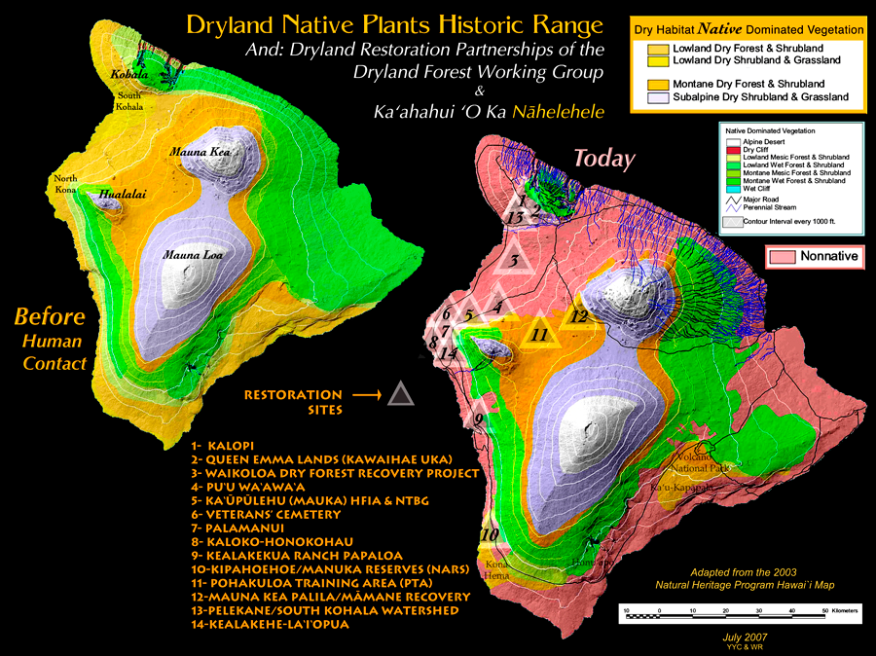

Figure 8.2 Dryland Restoration Partnerships on the island of Hawaii. Map courtesy of the Dryland Forest Restoration Group.

Another important dry forest on the leeward side of the Island of Hawaii kiawe (Prosopis pallida) forest near the community of Puako. This forest protects the village of Puako from frequent flooding and wildfires, and also produces a very unique brand of honey gathered from kiawe nectar.

Programs

There are a number of programs that support the development of forest products and services on State and private lands in Hawaii. The Forest Reserve System was established by the Territorial Government of Hawaii through Act 44 in 1903. Its primary purpose is to protect mauka forests, enabling them to provide forest products/services for makai communities and agricultural demands – sustainable water supply was the principal underlying consideration. Today the Forest Reserve System includes approximately 640,000 acres across the state and is managed to provide a suite of services for the public:

1. Protect and manage forested watersheds for production of fresh water supply for public uses now and into the future
2. Maintain biological integrity of native ecosystems
3. Provide public recreational opportunities
4. Strengthen the economy by assisting in the production of high quality forest products in support of a sustainable forest industry

Timber management areas can be found within a number of the Forest Reserves and contain economic opportunities supporting local timber and wood product industries. These timber management areas contain a variety of primarily non-native species and non-timber forest products that can be harvested for commercial purposes or small-scale salvage uses.

Other State and Federal programs that support forest product capacity, forest restoration and/or conservation needs on public and private lands are: the Forest Stewardship Program, the Tree Farm Program, Native Forest Dedication, Watershed Partnership Program, Conservation Reserve Enhancement Program, Environmental Quality Incentives Program, and others. See Appendix C: Forestry Related Assistance Programs.

Participants

The development of a sustainable forest products industry, resource restoration and conservation through landowner assistance programs, policy change, outreach and education are all important goals in Hawaii. Achieving these goals can only be accomplished through a wide variety of partnerships and expertise focusing on creative solutions to challenging endeavors. There are a number of organizations and private landowners that are engaged in forest product development and such an industry in Hawaii.

Hawaii Forest Industry Association (HFIA) is dedicated to responsible forest management. HFIA produces the annual Hawaii Woodshow, sponsors the Hawaii's Wood trademark, and serves as an advocate for Hawaii's diverse forest industry from tree planting and harvesting to creating and selling wood products (see [hawaiiforest.org/](http://www.hawaiiforest.org/)).

Private timber plantations owners, land lessees & green energy companies such as Kamehameha Schools, Parker Ranch and others have large amounts of standing timber that will play an important role in a forest products industry in Hawaii. Hawaii Mahogany Inc.

(hawaiianmahogany.com) operates a mature tree farm on Kauai that produces a variety of forest products including: animal feed, lumber, biochar & soil blends, carbon credits from tree farms and a small hydroelectric plant19. A green energy company, SunFuels Hawaii LLC, on the Big Island develops biomass-to-energy, uses gasification technology from renewable biomass feedstocks, and is examining other thermal conversion technologies suitable for the production of a renewable bio-oil to power electrical generation plants21.

Federal and nonprofit landowners such as The Nature Conservancy, U.S. National Park Service the U.S. Fish & Wildlife Service Refuge System and the Office of Hawaiian Affairs have large expanses of primarily native forests that are actively managed for a variety of forest products & ecosystems services.

Hawaii Agriculture Research Center (harc-hspa.com) is actively pursuing Acacia koa and other hardwood tree species research to identify Fusarium resistant koa, as well as koa that exhibits a straight tree growth form.

Benefits

A well managed forest products industry not only provides needed products in and outside of Hawaii but it also provides jobs and landscape level ecosystem services. Other important benefits from such an industry are those associated with biomass production for fuels (possibly reducing mainland/foreign dependency), carbon storage and sequestration and positively addressing climate change issues and related management efforts.

Valuation of forest products can be difficult if all products and services are considered. Measuring the value of water, medicinal plants, wildlife habitat, recreation, and other social considerations is not an exact science; inherently, subjectivity plays an important role depending on your particular point of view. In Hawaii and much of the Pacific, these types of forest products are very important and are often managed specifically to perpetuate their long-term sustainability.

Due to the Forest Reserve tax deferment policy in 1957, forest land greatly increased between 1961 and 1970, as did logging; total board foot production for forest products throughout the State rose from 915,000 in 1958, to 4,121,000 board feet in 19672. After the Endangered Species Act in 1973, commercial tree planting dropped from an average of 580 acres per year during the period 1956 to 1965, to only 82 acres in 19852. However, the long process of slowing the rate of extinction rate of plant and animals began. The 2004 survey "Economic Value of Hawaii’s Forest Industry in 2001” revealed that over 900 workers were employed in the Hawaii forest industry, with a corresponding payroll of $30.7 million3. This “placed the average wage rate for forest industry employees at over 50% higher than the average for farm labor”4.

We know that a multitude of benefits are derived from or positively influenced in some way by forests. Because islands function as an integrated system rather than a grouping of independent systems, it is important to understand that forest products need to be valued by more than the individual product but rather by its role in a larger system.

Threats

A principal threat to the forest products industry in Hawaii is the conversion of forest to non-forest uses. Labor and land costs are high in Hawaii and with the global economic downturn, many landowners who have suitable land to support the production of forest products, are choosing or being forced to sell instead. Keeping forests from being converted to non-forest uses is an ever-present challenge in Hawaii. As an isolated island state, concerns about food, construction material and energy security should be included in discussions about urban development on productive lands and the associated debate between expanding agriculture areas for food and/or forest products.

People living in Hawaii are dependent on imported resources for a large percentage of life sustaining needs such as food, fuel, equipment and many wood products and supplies. On the Island of Oahu, an estimated two weeks of food, water and supplies are available to support a population of more than 800,000 people if the air and sea ports are rendered non-operational. It is very important that Hawaii address self-sustainability issues, including the importation of food, fuel and forest products. The role of forest management and forest products should be central in discussions and decisions regarding how our society addresses crucial resource allocation decisions.

Another obstacle to the development and maintenance of an operational timber industry in Hawaii is port capacity. Currently, existing ports and facilities may not have the proper size, configuration or accessibility to handle large volumes of primary or processed timber products. If an increase in exportation of Hawaiian grown timber or wood products occurs, some expansion or further development of port facilities may be necessary.

Lack of access to Federal and/or State programs for private landowner loans, land management planning assistance, and marketing assistance has also impacted the development of a timber industry. Due to considerations such as scale, geographic location and local economic conditions, entities seeking to develop forest industry infrastructure in Hawaii commonly encounter challenges in obtaining capital and loans, yet their success in this regard is critical for Hawaii’s forest industry to grow.

Priority Areas for Forest Products & Carbon Sequestration

The Forest Products maps (Maps 8.1, 8.2, 8.3, 8.4 and 8.5) are based on the State’s Prime Forest Land map units. This layer was derived by analyzing environmental factors such as rainfall, elevation and soils.

|  |  |
| --- | --- |
| Forest Products Ranking | Prime Forest Land Map Units |
| High Potential | Prime 1 & Unique |
| Medium Potential | Prime 2 |
| Low Potential | National Standard |
| Poor Potential | Other areas |

State Forest Reserve acreage not included within the original Prime Forest Land map units were subsequently added and categorized as low potential in part to recognize that opportunities exist for managing “low potential” areas for considerations such as ecosystem services, salvage of resources after natural disasters, invasive species control, native species reforestation, etc. Finally, non-native commercial timber plantation areas managed by DOFAW were automatically ranked as High Potential.

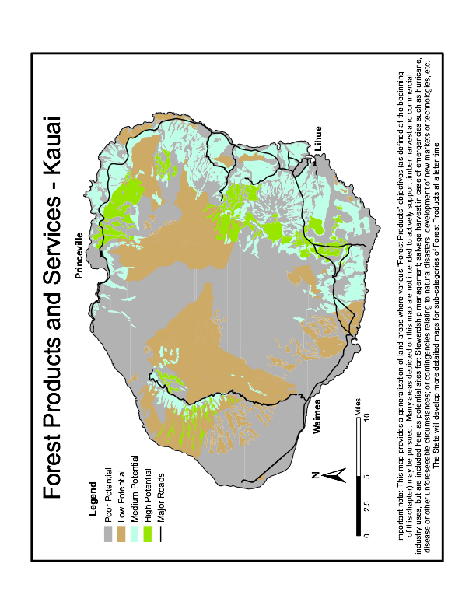

Map 8.1 Priority Area for Forest Products Island of Kauai

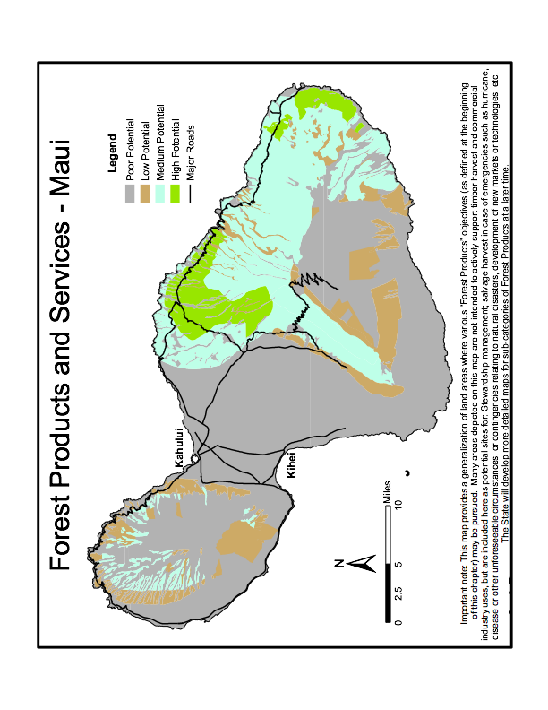

Map 8.2 Priority Area for Forest Products Island of Maui.

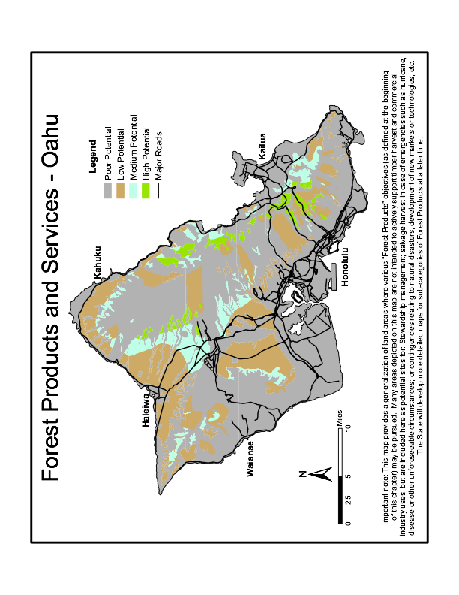

Map 8.3 Priority Area for Forest Products Island of Oahu

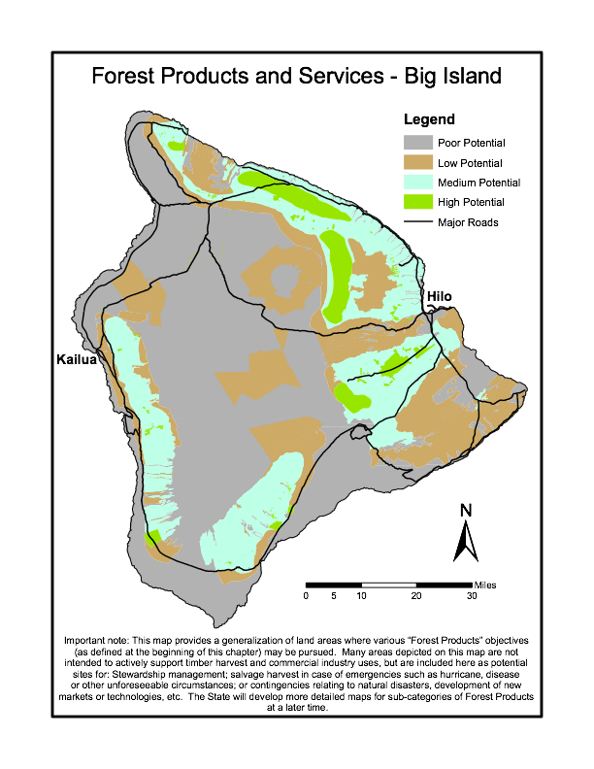

Map 8.4 Priority Area for Forest Products Island of Hawaii

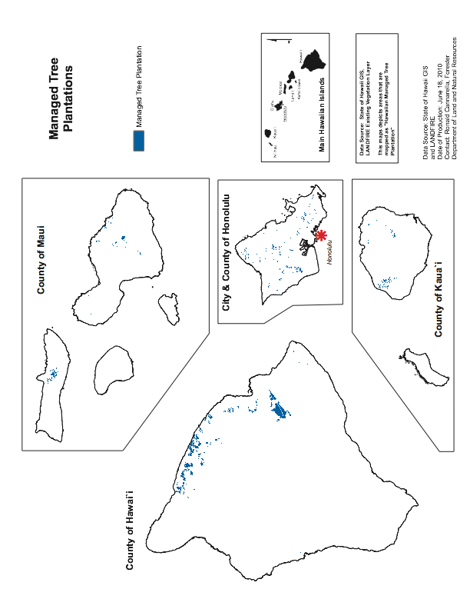

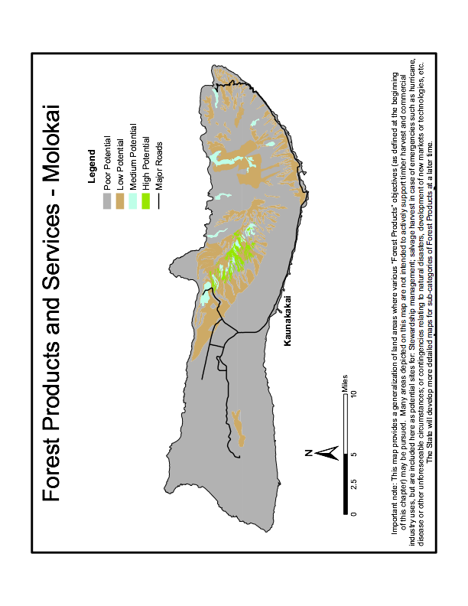

Map 8.5 Priority Area for Forest Products Island of Molokai

Map 8.6 Managed Tree Plantations

Data Gaps & Opportunities

1. Management of native forests for social and cultural objectives. For example, the State seeks to develop an Acacia koa canoe log production forest at Kapapala on the island of Hawaii.
2. Niche Carbon Markets as part of the voluntary and/or cap & trade system.
3. Studies or research to determine:
   * How much forested and agricultural land is needed to produce adequate quantities of products to support processing plants for solid wood products for electricity or biomass conversion to diesel or other fuels.
   * How do existing stands of mature commercial forest on state lands fit into the long term goal of a viable forest products industry. Sub-topics could include what are the best uses/options for commercial stands on State lands, is there a combination of biomass and solid wood plantings that would meet the needs of both developing industries.
   * Where timber resources are relative to potential markets.
   * What range of products can be produced from available species.
   * What are the characteristics of the existing industry, including logging infrastructure.
   * What are the markets (expected price and depth) for various products including high, medium and low grade hardwood lumber and other products.
   * What opportunities exist to use or sell manufacturing and forest residue. How sustainable are the various components of the timber resource.
   * New products or services suitable for Hawaii.
   * Refining or providing silvicultural practices, volume tables, wood properties, certification, establishment and management of new koa forests on fallow lands for conservation or commercial purposes, etc.
4. Hawaii needs assistance with its nascent sawmill, veneer mill & bioenergy establishment. This includes loan programs to assist private businesses in capitalizing their field equipment and processing facility needs, marketing, infrastructure development, etc. What research and development is needed to facilitate access to such loan programs.
5. Development of genetically improved or disease resistant seedling stock for non-native and native species.
6. Use of commercial forestry as a way to convert weedy, invasive species, to productive forests and native forests.
7. Complete comprehensive management plans for all State Forest Reserves - hawaii.gov/dlnr/dofaw/forestry/FRS/frplans.

Summary

Hawaii’s forests will continue to be critically important to the state’s water supply, unique plants and animals, the economy, people and their culture. Benefits of Hawaii’s forests go well beyond wood and fiber products and include aesthetic value, recreational enjoyment, specialty non-timber forest products, water conservation, improved air quality, coral reef protection and many other important resources5. Increased economic and development pressures that alter land use and management will continue to be challenges for the state’s forest product industry5. It is important that forest industry potential in Hawaii be considered from a holistic perspective in order to sustain the growth and health of the forests over the long term, as well as provision of the services and benefits associated with healthy forests. Hawaii’s forest industry must also look towards the future for new technologies, programs, and cooperative opportunities that provide alternatives fitting for Hawaii’s unique resources.

Section References

1. Hawaii Forestry Industry Association News. Hawaii’s Forest Industry: Where We’ve Been, Where We’re Going… Volume 2. Issue 7. Website: [hawaii-forest.org](http://www.hawaii-forest.org).

2. Robinson, M.E. Hawaii's Forestry Website, hawaii.gov/dlnr/hfciforest.

3. Yanagida, John F., James B. Friday, Prabodh Illukpitiya, Rusyan J. Mamiit, and Quincy Edwards. "Economic Value of Hawaii's Forest Industry in 2001." Cooperative Extension Service, College of Tropical Agriculture and Human Resources, University of Hawaii at Manoa, [www.ctahr.hawaii.edu/oc/freepubs/pdf/EI-7.pdf](http://www.ctahr.hawaii.edu/oc/freepubs/pdf/EI-7.pdf)

4. Robinson, M.E. February 2007. HFIA President’s Message.

5. University of Hawaii College of Tropical Agriculture. "Action Plan Forestry and Related Resources of Hawaii." In PDF. Honolulu, 1981.

6. State of Hawaii Department of Land and Natural Resources Division of Forestry and Wildlife. "Forest Management Plan for the Waiakea Timber Management Areas." 25 pp. Honolulu, 1998.

7. Hawaii Agriculture Research Center Nicklos S. Dudley & J. Quinn Company James E. Quinn. "Hardwood Lumber and Wood Product Market Analysis for Hawaii or Hawaii Hardwood Market Study." State of Hawaii, Department of Land and Natural Resources, state.hi.us/.../Hawaii%20Hardwood%20Market%20Study.pdf.

8. Groome Poyry Limited. "Hawaii Forestry Investment Memorandum." State of Hawaii, Department of Business and Economic Development, state.hi.us/dlnr/dofaw/pubs/Groome%20Report %201994.pdf.

9. Jaakko Poyry Consulting (Asia-Pacific) Pty Ltd. "Market Research on Commodity Wood Products from 8 Non-Native, Hawaiian Grown Timber Species." Hawaii Forest Industry Association, funded by USDA Forest Service Hawaii Forestry & Communities Initiative, state.hi.us/dlnr/dofaw/pubs/98088r.PDF.

10. State of Hawaii, DLNR Contract # 53416, Medallion Hardwoods LLC,. "Forest Industry Development Research December 15, 2006 Edited and Updated through August 2008." [hawaii.gov/dlnr/dofaw/pubs/FIDR%20Hawaii.tmp.pdf/view](http://hawaii.gov/dlnr/dofaw/pubs/FIDR%20Hawaii.tmp.pdf/view).

11. Sarmiento, Jorge L. and Steven C. Worfsy: Carbon and Climate Working Group. “A U.S. Carbon Cycle Science Plan” 1999.

12. Asner, Gregory P. et al. 2009. “Environmental and Biotic Controls over Aboveground Biomass Throughout a Tropical Rain Forest”. Ecosystems 12:261-278.

13. Lal, R. “Soil Carbon Sequestration Impacts on Global Climate Change and Food Security”. Science 11 June 2004: Vol. 304. no. 5677, pp. 1623 – 1627.

14. World Wildlife Fund. “Climate Change and Forest Carbon Sequestration”. 2002.Jill Bowling WWF International, Tel: +41-(0)22-364-9010, [jbowling@wwfint.org](mailto:jbowling@wwfint.org).

15. Natural Capitol Project - [naturalcapitalproject.org/hawaii.html](http://www.naturalcapitalproject.org/hawaii.html)

16. Yanagida, J. F., J. B. Friday. Directions for Hawaii’s Forest Industry for the Next Century, Hawai`i Forest Journal.

17. The State of Hawaii Forest Reserve System. Technical Document, December 2007. dofaw.net.

18. Smith, Matthew. U.S. Carbon Markets: Where are we now and how did we get there? The Forestry Source. February 2010. Vol. 15. No. 2. Society of American Foresters.

19. Hawaii Mahogany Inc. Investment Expansion Overview Phase I. 2010. H[awaiianmahogany.com](http://www.hawaiianmahogany.com).

20. The Environmental Protection Agency. Carbon Sequestration in Agriculture and Forestry. [epa.gov/sequestration/faq.html](http://www.epa.gov/sequestration/faq.html).

21. SunFuels Hawaii LLC. Personal communication from General Manager John Ray, March 2010.