**Invasive Species Mitigation in the East Maui Watershed: Biocontrol**

**East Maui Watershed Partnership**

**2015 – Final Report**

**January 1, 2015 – December 31, 2015**

**Prepared January 5 2015 by Dan Eisenberg EMWP Program Manager**

**State of Hawai`i**

**Hawaii Invasive Species Council**

**Hawaii PO# C51361**

**RCUH Account #4501501**

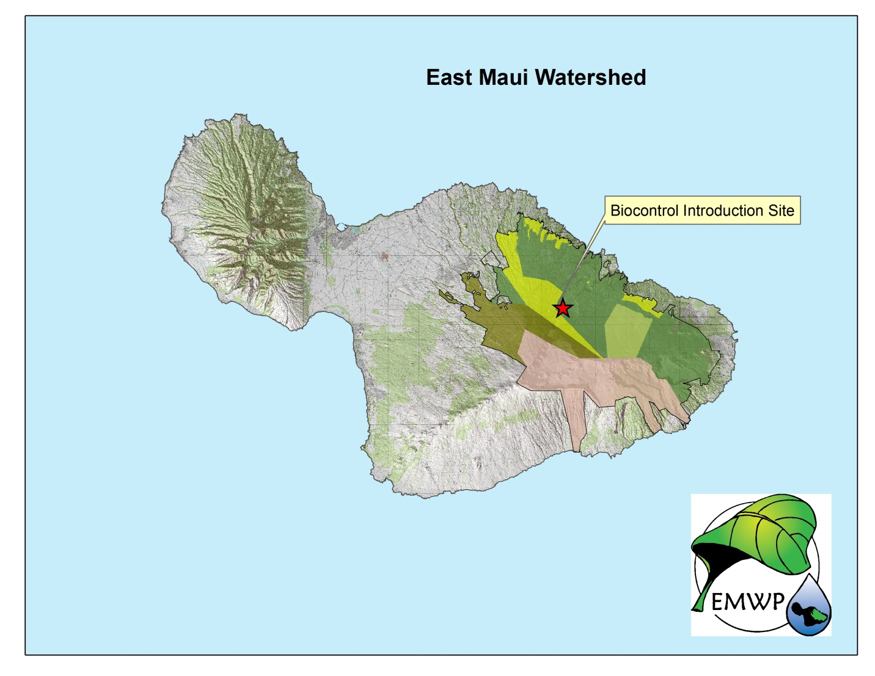

# Project Summary:

East Maui Watershed Partnership (EMWP) hopes to make landscape scale reductions to the spread of strawberry guava (*Psidium cattleianum)* to avoid further alteration of the ecology and promote a healthy watershed near a project area in Koʻolau Gap on East Maui at about 2800’ elevation. Through use of methods provided by the USDA Forest Service, EMWP proposes an effective introduction of *Tectococcus ovatus* to a remote portion of East Maui’s strawberry guava infestation which would otherwise not be inoculated with the biocontrol agent.

**Work Performed for this Project:**

**January – March 2015**

EMWP made progress this quarter planning with DLNR/DOFAW staff members to decide on the logistics of EMWP acquiring plants hosting *Tectococcus ovatus* for introduction to Koolau Forest Reserve through this project. It was decided that EMWP staff members will collect seedlings from the project site. Then introduce *Tectococcus ovatus* to those seedlings at the Maui DLNR/DOFAW baseyard. After the introduction sites are prepared, EMWP will reintroduce the seedlings to the project site.

As outlined in this project’s proposal, the *Tectococcus ovatus* introduction is scheduled for the summer months of 2015 with the hope that warmer temperatures will lead to faster growth of the biocontrol agent when population numbers are low, immediately after introduction.

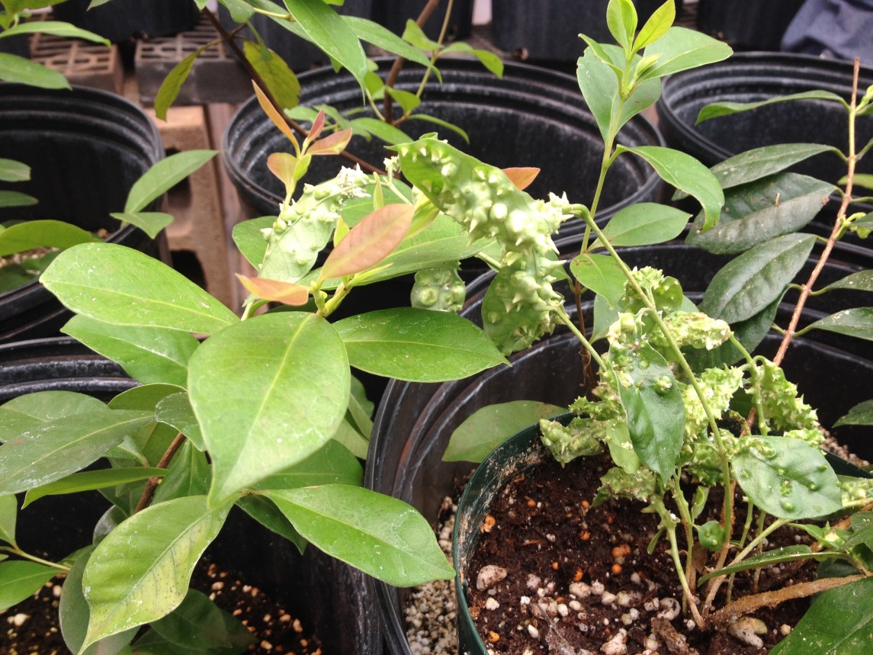

*Tectococcus ovatus* on strawberry guava at the DLNR/DOFAW Maui Baseyard.

**April – June, 2015**

EMWP made progress at the project site in Ko’olau Forest Reserve this quarter. EMWP staff members prepared six sites within a quarter acre area for introduction of *Tectococcus ovatus*. This involved cutting existing strawberry guava plants at the release site to stimulate new growth suitable for the biocontrol agent. Additionally, EMWP collected twelve seedlings from the project site and brought them to the Kahului DLNR/DOFAW baseyard, where they were potted in sterile potting medium and will be inoculated with *Tectococcus ovatus* and returned to the project site next quarter.

This work is in line with the timeline from project’s proposal. The *Tectococcus ovatus* introduction is scheduled for the summer months of 2015 with the hope that warmer temperatures will lead to faster growth of the biocontrol agent when population numbers are low, immediately after introduction.

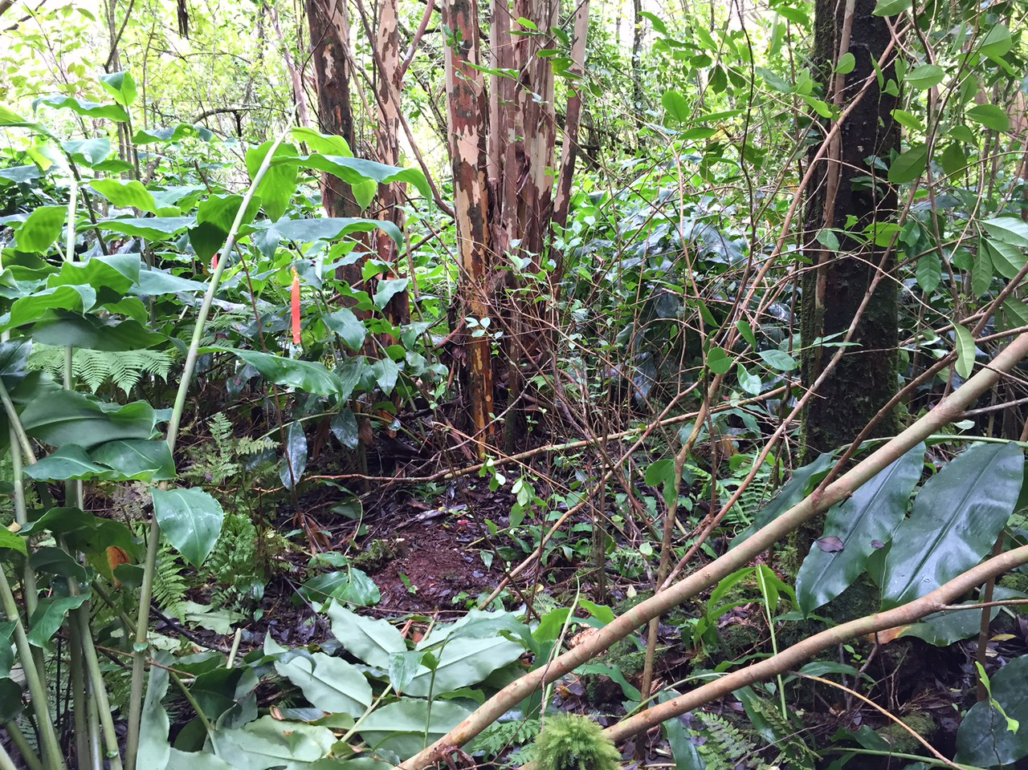

Prepared release site for *Tectococcus ovatus* in Ko’olau Forest Reserve.

**July – September, 2015**

EMWP was delayed in progress this quarter, but is still on track to complete all project deliverables by the end of the project period (next quarter). A trip to the project site was delayed due to weather and has been rescheduled for October 2015. Despite this setback some progress was made this quarter. Seedlings from the project site at the Kahului DLNR/DOFAW baseyard successfully rooted in the nursery and were inoculated with the biocontrol agent. The seedlings will be transported by helicopter to the project site and planted at the prepared sites next quarter. HISC funds for the project will be expended concurrently with this step of the project.

**October – December, 2015**

EMWP completed the remainder of the project deliverables this quarter. A trip to the project site took place on October 23, 2015. Four seedlings from the Kahului DLNR/DOFAW baseyard nursery were transported by helicopter to the project site and planted at the prepared sites. HISC funds for the project were expended concurrently with this step of the project.

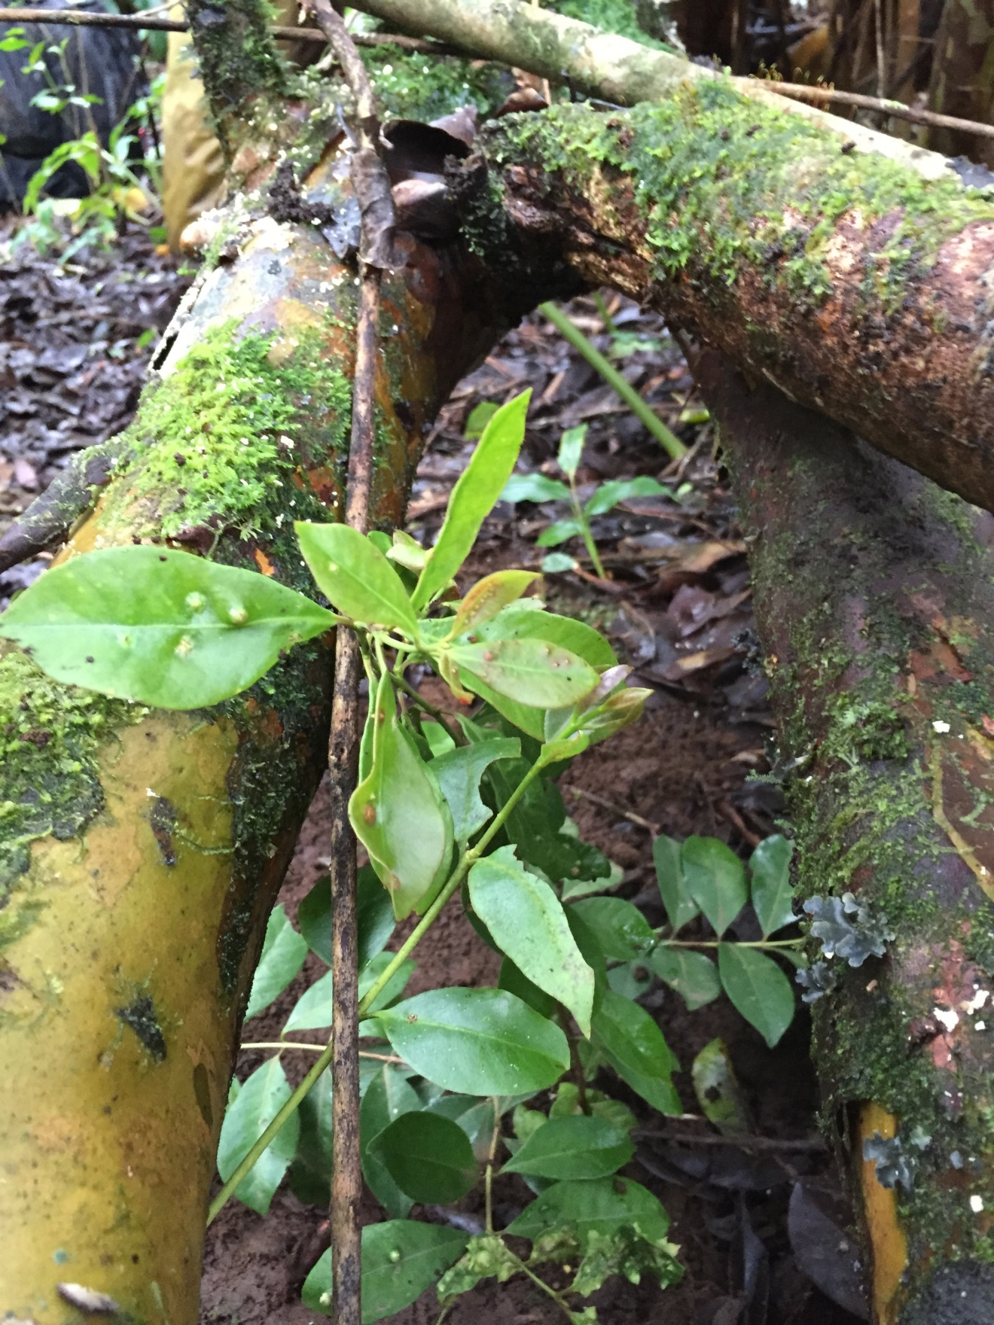

Young strawberry guava leaves resulting from site preparation which are suitable for Tectococcus introduction.

Strawberry guava seedling from nursery which hosts Tectococcus.

Detail of Tectococcus introduction at the project site.

**Metrics Table**

|  |  |  |  |  |
| --- | --- | --- | --- | --- |
|  | January – March 2015 | April – June 2015 | July – September 2015 | Oct. – December 2015 |
| Release Sites Prepared | 0 | 6 | 0 | 0 |
| Introductions of biocontrol Complete | 0 | 0 | 0 | 4 |

**Financial Report:**

