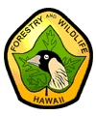
FY 2015 – MOLOKAI FOREST RESERVE – KAHILI GINGER (HEDYCHIUM GARDNERIANUM) CONTROL IN WAILAU VALLEY, ISLAND OF MOLOKAI
Prepared by: Lance De Silva, Forest Management Supervisor
Division of Forestry and Wildlife, Maui Branch

INTRODUCTION

Since the initial detection of the kahili ginger population in Wailau Valley in September of 2013, the Division of Forestry and Wildlife (DOFAW) has since increased management in the Wailau Valley area of the Molokai State Forest Reserve. Efforts targeting the control of this incipient kahili ginger population located in Wailau Valley have been identified as a key objective in preventing this habitat modifying plant from establishing within the watershed.

Management of the 5,770 acres project area that make up Wailau Valley has increased in this last calendar year, largely in part due to the funding support of the FY’15 HISC grant “Molokai Forest Reserve – Kahili Ginger (Hedychium gardnerianum) Control in Wailau Valley. This management effort is being conducted and managed primarily by Maui DOFAW staff. All helicopter services have been procured with Windward Aviation, a Maui based company. The pilots’ familiarities with the area, weather and flying conditions, and type of contract operations required for this type of work have proven to be beneficial to the overall efficiency and safety of the project. The construction of temporary landing zones and campsites near the project area has also provided work crews with better accessibility. During the grant period, the area has endured several inclement weather systems, including Storm Ana and Storm Iselle.

OVERVIEW
Since the initial efforts to control this incipient population in spring of 2014, field crew members have noticed a positive change within the project area. There has been a slight increase in natural recruitment of native understory plants due to the removal of these ginger populations. Several challenges such as the lack of dedicated funding, small staffing, rapid vegetative growth, and unpredictable weather are some of the issues that management is constantly working to mitigate and improve. DOFAW will continue to conduct aerial surveys and control work as needed to prevent this from ever establishing in the watershed. Other management efforts to improve watershed function and native habitat restoration within Wailau Valley such as installing strategic ungulate proof fencing and ungulate removal are being planned for this area.

Proposed Timeline:

Implementation Activities | Fiscal Year 2015 |  |  |  | Fiscal Year 2016 |  |  | Comments
 | 1st Qtr | 2nd Qtr | 3rd Qtr | 4th Qtr | 1st Qtr | 2nd Qtr | 3rd Qtr
Ground control work* | XX¹ | XX | XX | XX | XX | XX |  | 2 trips per quarter (5 day work trips)  *start date dependent on availability of funds  ¹Independen of HISC grant outcome, DOFAW plans to conduct one work trip in August 2014
Aerial herbicide application |  |  | XX | XX | XX | XX |  | As needed, treat any outlying populations deemed unsafe for foot access; weather conditions during this period are generally more favorable for aerial application;
Aerial Monitoring/  Surveys |  |  | XX | XX | XX | XX | XX | 2-3 flights-Continue to monitor for early detection/rapid response; easier to detect during ‘flowering’ season (late summer to early fall)
Continue assessments to determine future needs |  |  |  | XX | XX | XX | XX | Continue to document progression of control work and determine future needs

ACTIVITIES & RESULTS

Ground Control Work/Aerial Herbicide Application
Since October 2014, DOFAW field crews conducted 11 control trips into Wailau Valley; eight ground control trips and three aerial control/survey trips. In these 11 trips, field crews ground swept approximately 27 acres and aerial surveyed approximately 1,454 acres, resulting in treating 228 colonies of kahili ginger (~29,146 individual stalks treated).

As a result of DOFAW’s aerial survey, staff also located a small number of African tulip (Spathodea campanulata) trees located in close proximity to the project area within Wailau Valley. Field crews were able to control these individuals by aerial herbicide application resulting in 41 trees treated (25 mature and 16 immature).

Aerial Monitoring Surveys
DOFAW will continue to conduct aerial surveys to monitor for early detection and rapid response. A total of three primary aerial surveys were conducted within the grant period. In addition, eight supplemental trips were conducted while transporting personnel in and out of the project area.
Continue Assessments
Maintaining control efforts and seeking near zero presence of kahili ginger within Wailau Valley will remain a priority for management efforts in this area. DOFAW staff members have determined that maintenance control and survey trips must continue annually to keep this kahili ginger population at a minimum, if not, entirely controlled. We estimate that there are a few very manageable populations of kahili ginger remaining within the project area. This is due to the thick vegetative stands of uluhe fern that have made locating ginger populations on the ground very difficult. DOFAW has scheduled one trip per quarter for fiscal year 2016 and 2017 to address this issue.

APENDIX 1 – MAPS & PHOTOS
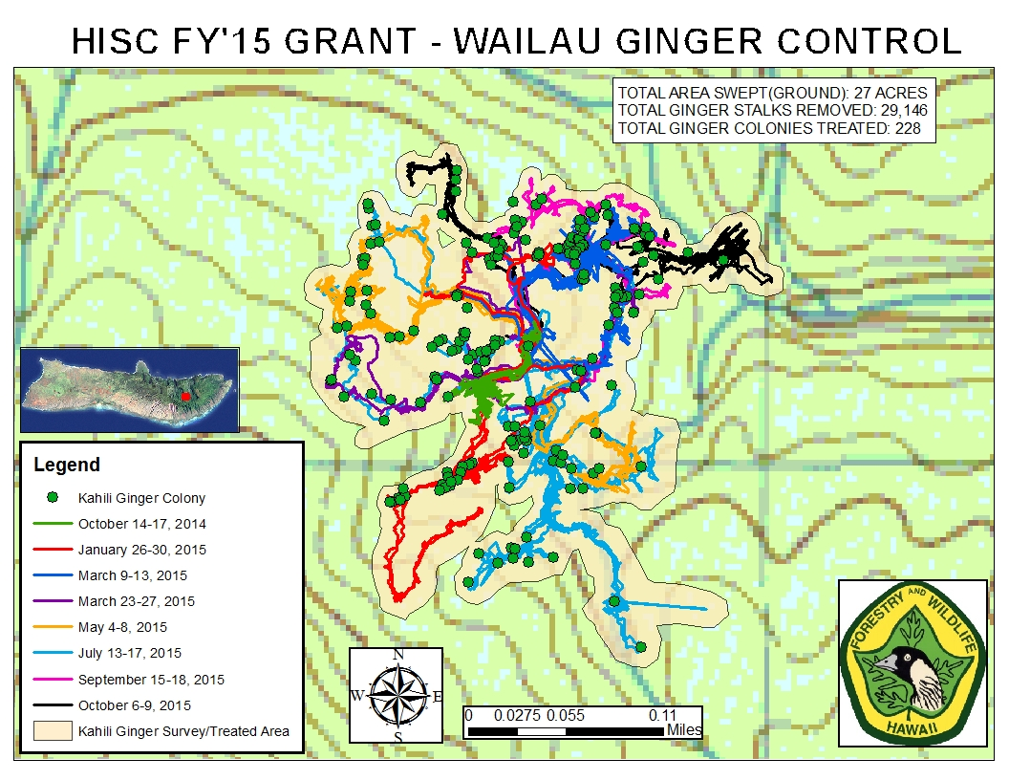
*Close up detailed map of the project area
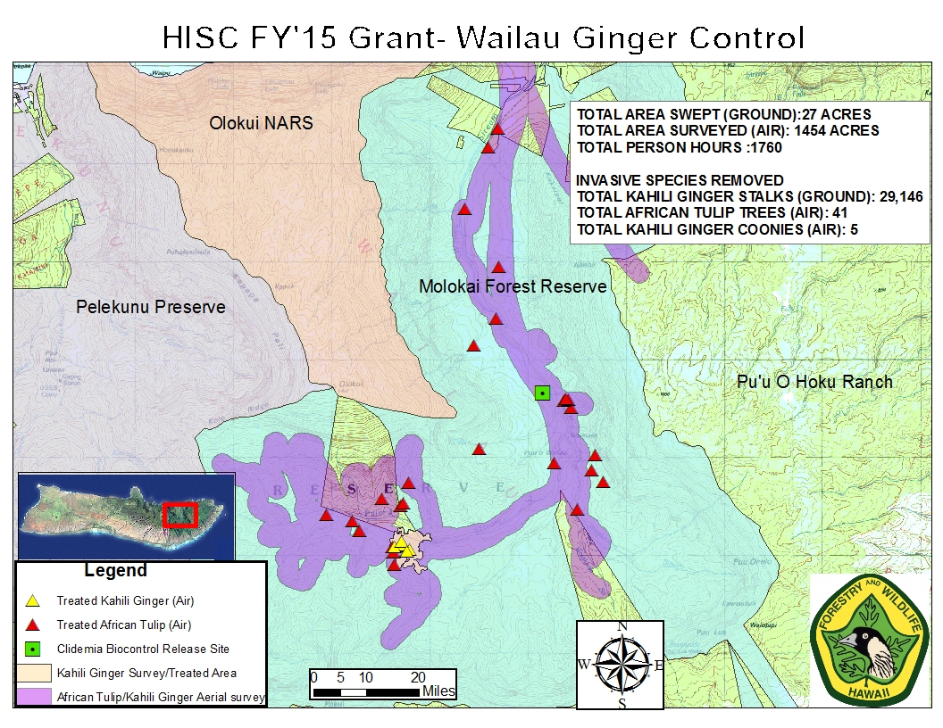
*overall view of project area and Wailau Valley (Molokai State Forest Reserve)

