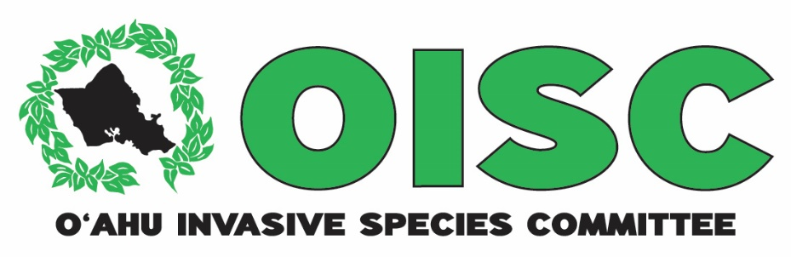
2015 Report to the
Hawaiʿi Invasive Species Council

Detection and control of Tibouchina herbacea
in Poamoho Natural Area Reserve

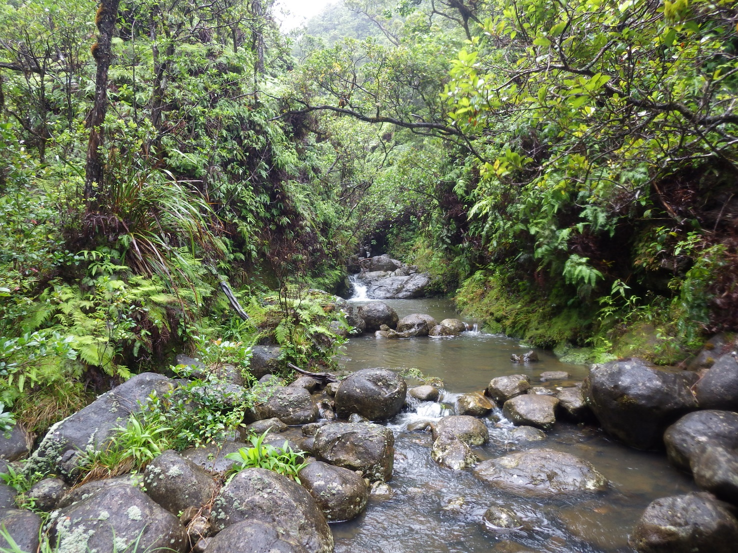
Predominantly native forest in the Poamoho Natural Area Reserve

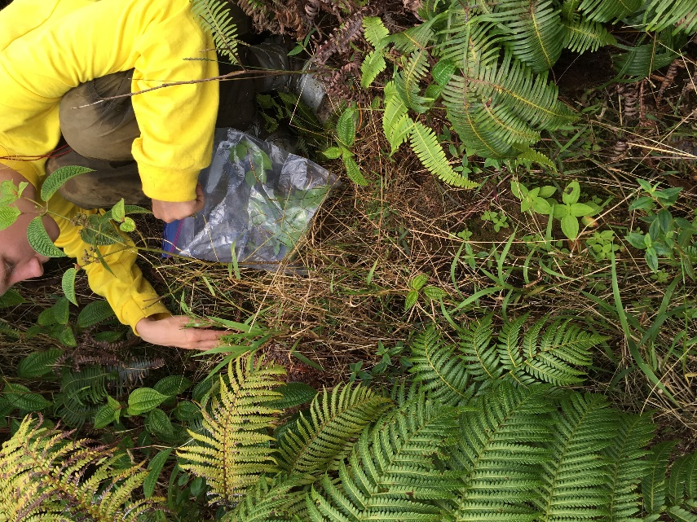
The Oʻahu Invasive Species Committee conducts surveys and control for invasive species that threaten the island’s watersheds, forests, economy, agriculture and quality of life. The OISC field crew spends 90% of their work hours either on the ground or in a helicopter looking for and removing invasive species. We target species that are not yet established on the island, but would cause major damage if not controlled. OISC operations are guided by the OISC steering committee which is made up of representatives of conservation organizations and land managers. Many of the people who serve on OISC’s steering committee today were giving up their weekends to control invasive species as volunteers when OISC was first formed back in 2002. In 2015, HISC awarded OISC, the Koʿolau Mountain Watershed Partnership (KMWP) and the Natural Area Reserve Program (NARS) $62,050 for surveys and control of cane ti (Tibouchina herbacea). OISC raised an additional $75,000 from the National Fish and Wildlife Foundation. The deliverables and accomplishments described below include HISC funded activities conducted with NFWF matching funds and reflect the work of OISC, KMWP and NARS.
Above: Bagging Tibouchina herbacea for later incineration. The red arrows point to immature plants. Below: fuzzy leaves and bright pink flowers help identify Tibouchina
[Grab your reader’s attention with a great quote from the document or use this space to emphasize a key point. To place this text box anywhere on the page, just drag it.]
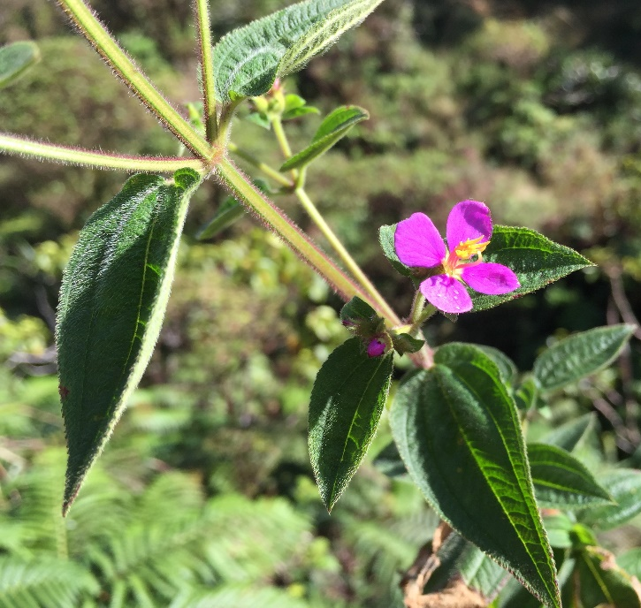
Cane ti threatens priority watershed habitat in Poamoho, an area in the northern Koʿolau Range that hosts 11 animals and 18 plants with federal status, meaning these species are vulnerable to or have a high risk of extinction. The O‘ahu Army Natural Resources Program (OANRP) discovered the highly invasive cane ti (Tibouchina herbacea) in the Poamoho region in 2008. This aggressive weed was not known to be naturalized on O‘ahu, but it is widespread on both Hawai‘i island and Maui where is it beyond the scope of eradication. Cane ti poses a major threat to Ko‘olau forests, especially the near-pristine summit regions, as it thrives in wet forest conditions, produces hundreds of tiny seeds and is spread by broken stems or via wind, birds, and pigs. We suspect that the population in Poamoho was accidentally introduced by hikers that had recently been hiking on Maui or the Big Island. Plant material capable of reproducing can be carried on shoes, clothes, and backpacks.

Cane ti spread across the mountains of west Maui in less than a decade, and it is now one of the West Maui Mountains Watershed Partnership’s main target species. Cane ti is a member of the same family, Melastomataceae, as both miconia and clidemia, two super weeds. At Poamoho, the plant was believed to be confined to a small area near the summit that has been continuously monitored since 2008. However, it was discovered in fall of 2013 that plants had spread downstream, and had been present long enough to mature and set seed. OISC, KMWP and NARS began control efforts in 2014 and were able to ramp up efforts in 2015 with HISC funds.

In 2015, OISC, KMWP and NARS surveyed 275 acres, delimiting outward from historical points and downstream from the core infestation. Crews removed or treated 1,764 immature and 17 mature plants. Delimiting was done on foot and with binoculars in areas where terrain seemed too steep or surveys may have caused too much disturbance to native vegetation. Unfortunately, the characteristics of the vegetation at Poamoho make it difficult to catch plants before they mature. The undergrowth is extremely thick and smaller plants are sometimes not visible beneath the vegetation. As soon as they become visible they are old enough to flower. OISC hopes to reduce the number of mature plants found by increasing frequency of surveys in 2016.

All crews must have dedicated gear for this species and decontaminate on a daily basis to prevent spreading plants to areas not currently infested. Inside the core infestation, crews wear Tyvek suits that can be bagged and later incinerated to ensure seeds and vegetative material are not spread. Plants are either treated on site with herbicide or hand-pulled, bagged and then later incinerated.
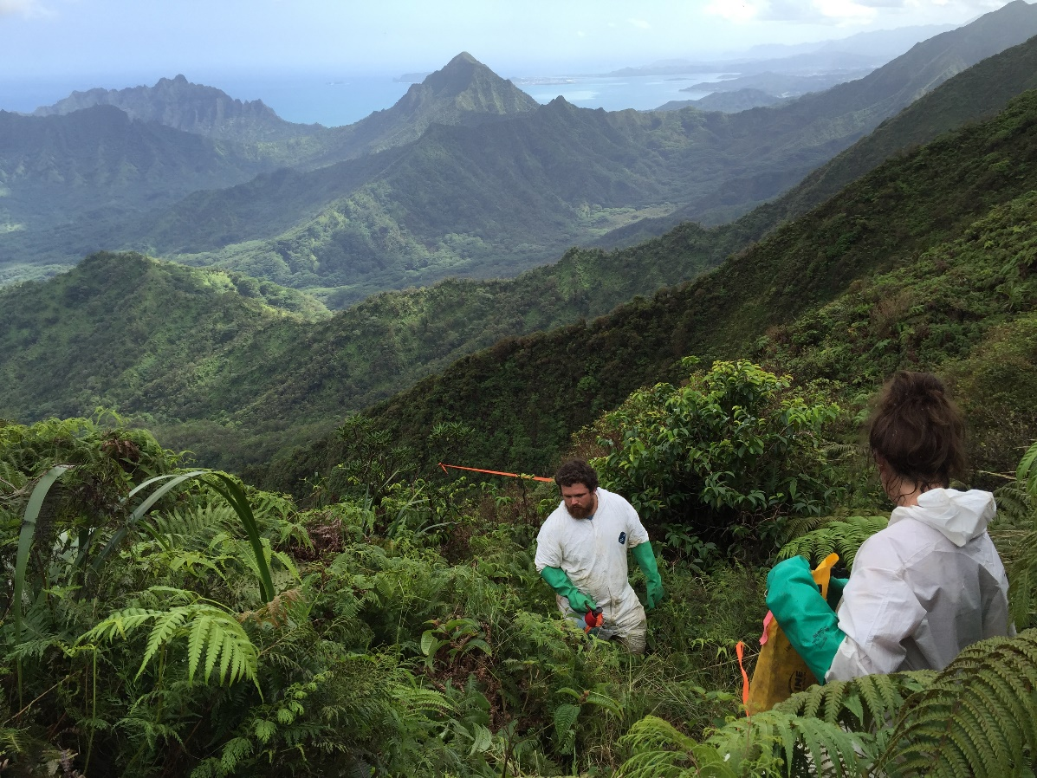
Treating plants in the core infestation. Tyvek suits help
prevent seed dispersal

Deliverables | Deliverable met?
Delimit population of cane ti in the 85-acre 200 meter survey buffer. | Yes: OISC and partners surveyed 274.59 acres including 7 miles of streambed.

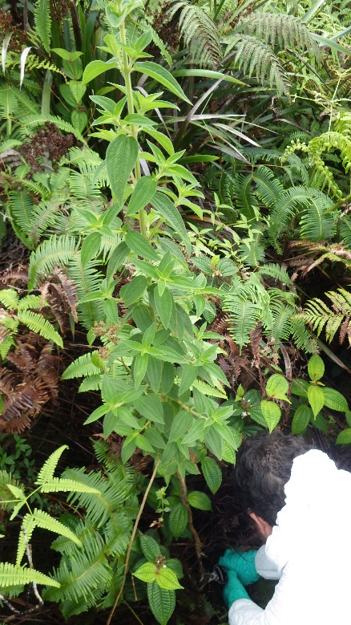
The stream that flows out of the core infestation near the summit has been thoroughly delimited. However, it is highly likely that this species has a long-lived seedbank, so the stream should be checked again. Delimiting a 200-meter radius from historical points found proved difficult due to terrain and vegetation. Thick mats of uluhe fern cover up steep dropoffs and the crews did not want to do additional damage by creating disturbance with ground surveys. We also prioritized stream surveys after an immature plant was found 2 miles from the core infestation. Much of the area was surveyed with binoculars in either for safety reasons or so as not to disturb native vegetation.
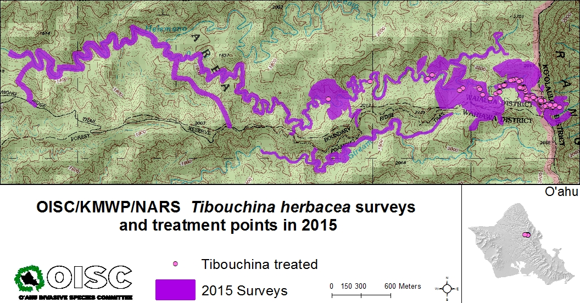
In 2016, OISC and partners have received funding from HISC to re-survey the stream and conduct control operations every other month instead of every quarter. We hope this will allow us to suppress mature plants. In the future, OISC may want to investigate employing drones as the terrain and vegetation seem to be perfect conditions to use this emerging technology. Seed bank longevity trials should also be conducted so we can estimate an eradication timeline.

