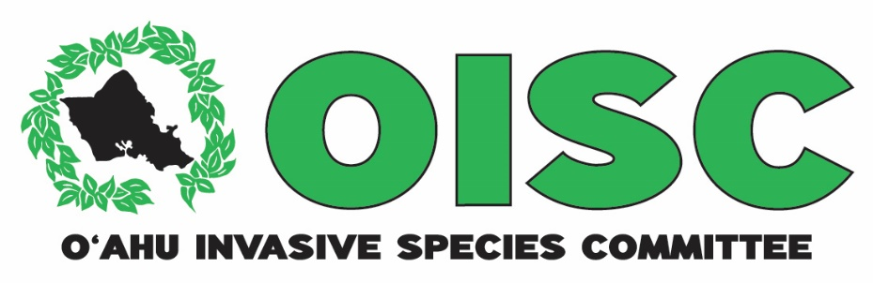
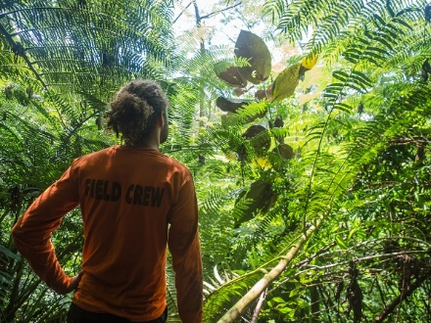
OISC field crewmember finding an immature miconia (Miconia calvescens) tree
2015 Report to the
Hawaiʿi Invasive Species Council

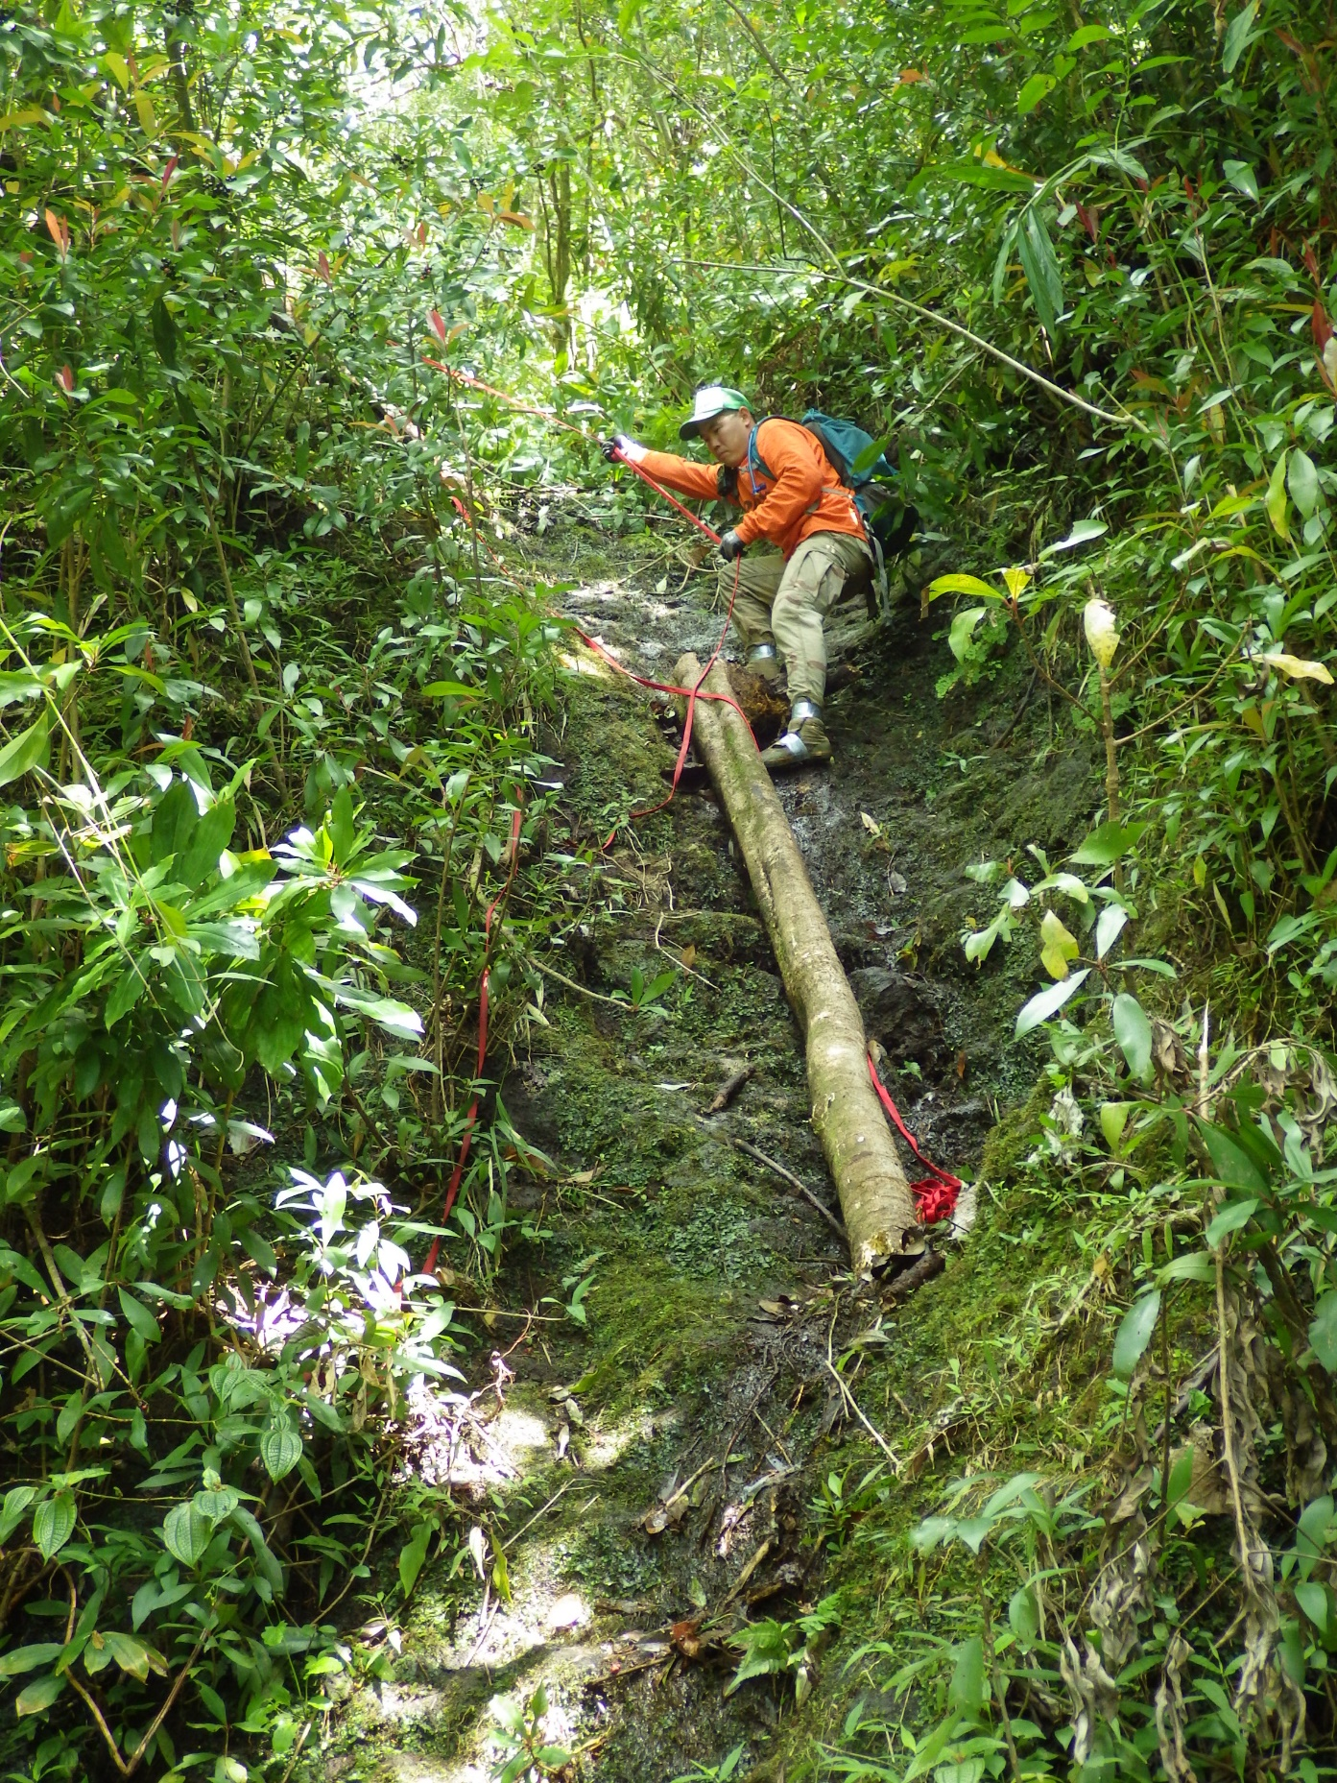
The OISC crew uses webbing to navigate steep sections on a miconia survey
The Oʻahu Invasive Species Committee conducts surveys and control for invasive species that threaten the island’s watersheds, forests, economy, agriculture and quality of life. The OISC field crew spends 90% of their work hours either on the ground or in a helicopter looking for and removing invasive species. We target species that are not yet established on the island, but would cause major damage if not controlled. OISC operations are guided by the OISC steering committee which is made up of representatives of conservation organizations and land managers. Many of the people who serve on OISC’s steering committee today were giving up their weekends to control invasive species as volunteers when OISC was first formed back in 2002. In 2015, HISC awarded OISC $833,746 for survey and control of priority invasive species and outreach. OISC raised an additional $272,389 from other sources. (Grants received from HISC and other sources for control of Tibouchina herbacea at Poamoho are discussed in a separate report). The deliverables and accomplishments described below include HISC-funded activities conducted with matching funds from multiple sources.
[Grab your reader’s attention with a great quote from the document or use this space to emphasize a key point. To place this text box anywhere on the page, just drag it.]
Miconia (Miconia calvescens)
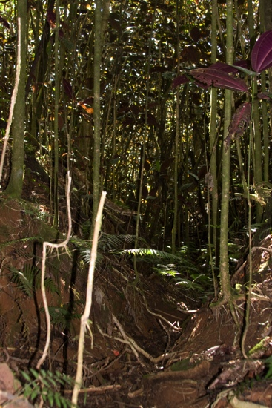
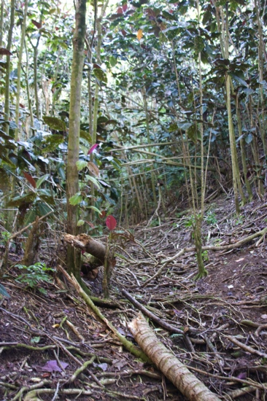
Miconia is a high-priority target for OISC because once established, it may severely degrade Oahu’s watershed. Miconia’s shallow root systems may be unable to hold soil in place during heavy rains and its unusually large leaves funnel rainwater to the ground with tremendous force. These characteristics indicate that a miconia-dominated forest will be more prone to erosion than a native one. Unfortunately, miconia seeds remain viable in the soil for up to 18 years, making this a project that requires long-term financial comittment. OISC surveys the entire estimated seed bank of miconia every three years to find and remove trees before they mature. In 2015, OISC surveyed 3,269 acres by ground and 5,127 acres by air for miconia. The crew removed 2,108 immature and 12 mature miconia trees.
Monotypic stands of miconia in Tahiti, note the lack of understory and exposed roots, a sign of erosion.
Photos: Ryan Smith

In 2015, OISC crewmembers found an immature miconia tree in the ʿAiea watershed, just off the ʿAiea Loop Trail while doing a surey for devil weed (Chromolaena odorata). There is no record of miconia being grown in this area. OISC crews immediately did aerial reconassaince and further ground surveys, but no additional trees were found.

OISC worked with Dr. James Leary of UH Mānoa CTAHR to use Herbicide Ballistic Technology (HBT) to control miconia by air in areas too steep to survey effectively. HBT allows a user to apply herbicide from a helicopter using a paintball gun apparatus. It is more efficient and safer in steep areas than other methods.

OISC’s metric for miconia control is a steady downward decline of mature trees with the eventual ability to completely suppress maturation. Unfortunately, the long-lived seedbank, heavy vegetation surveyors must negotiate and steep terrain has made it difficult to spot every tree, even for an experienced field crew. Trees are sometimes missed on the first pass. Nevertheless in 2015, only 12 mature trees were found over 9,785 acres searched. The low number of matures over such a large area indicates OISC is making headway.

Deliverable | Deliverable met?
Survey 2,400 acres by ground and 2,200 by air for Miconia calvescens and control all plants found. | Yes: OISC surveyed 3,269 acres by ground and 5,127 acres by air for miconia.

Devil weed (Chromolaena odorata)
The common name of Chromolaena odorata is “devil weed” and for good reason. It is toxic to livestock and humans and a weed of conservation and agricultural concern throughout Africa and the Pacific. In January of 2016, shortly after the funds for this proposal were dispersed, off-duty staff from the Oʻahu Army Natural Resources Program found devil weed along the ʻAiea Loop Trail. Therefore, in addition to the areas mentioned above, OISC also did signficant survey and control work in and around ʻAiea State Park and Camp Smith. Hawaiʿi State Parks and Marine Corps Base Hawaiʿi have been extremely helpful with arranging access to devil weed infested areas. The OISC field crew also responded to reports from Waiheʿe Valley residents that motocross hobbyists frequented the area and conducted a survey along roads and trails in the area. The crew did not find any devil weed. Numbers are in the chart below:

Watershed | Acres Surveyed | Immature controlled | Mature Controlled
ʻAiea | 1,434 | 1276 | 408
Kahana | 55 | 1101 | 2755
Kahuku | 71 (roadside) | 0 | 0
Paumalu (Pūpūkea) Private Property | 192 | 2 | 17
Waiheʻe | 14 | 0 | 0

OISC began discussions with Na Ala Hele to seek funding for a wash rack for the motorcross track users, but questions about permitting came up and have not yet been resolved. Additionally, the large devil weed populations in ʻAiea necessitated a refocusing of OISC’s efforts and we therefore put the creation of a plan to build a washrack at KTA on hold. OISC did attend leadership meetings with the Hawaiʿi Motorcross Association and conducted outreach at their attended their July 4th event.

Deliverable | Deliverable met?
Survey 18 acres of private land in Pūpūkea for devil weed (Chromolaena odorata) | Yes: OISC surveyed 192 acres
Survey 10 miles of roadside surveys in Kahuku and Pūpūkea | Yes: OISC surveyed 4 miles in a coastal neighborhood near the infestation. OISC conducted the other 6 miles of road surveys in ʿAiea after that population was discovered.
Survey 60 acres in Kahana | Almost: OISC surveyed 55 acres
Develop a plan to construct a wash rack in Kahuku | No: OISC began inquiries, but some permitting questions are still unanswered.

Cape Ivy (Delairea odorata)
The OISC crew has been monitoring a Cape ivy infestation in Pālehua. Through persistent treatment, the infestation is down to just 6 mature and 1,384 individual plants (when OISC first started working at this site, individual plants were too numerous to count). Cape ivy is a serious dry forest pest on Hawaiʿi Island. In 2015, OISC surveyed 125 acres and treated all plants found. In Makiki, the crew surveyed 26 acres. Unfortunately the landowner in Makiki will not allow OISC to remove the plant so the crew is monitoring it for now. The crew also surveys for miconia in that area so we are confident that if it moves into the forest, the crew will spot it during regular miconia surveys.

Deliverable | Deliverable met?
Survey and treat the Cape Ivy (Delairea odorata) infestation in Pālehua. | Yes: OISC conducted two rounds of survey and treatment.
Delimit new location in Makiki and treat all plants found. | Yes: OISC surveyed 26 acres.
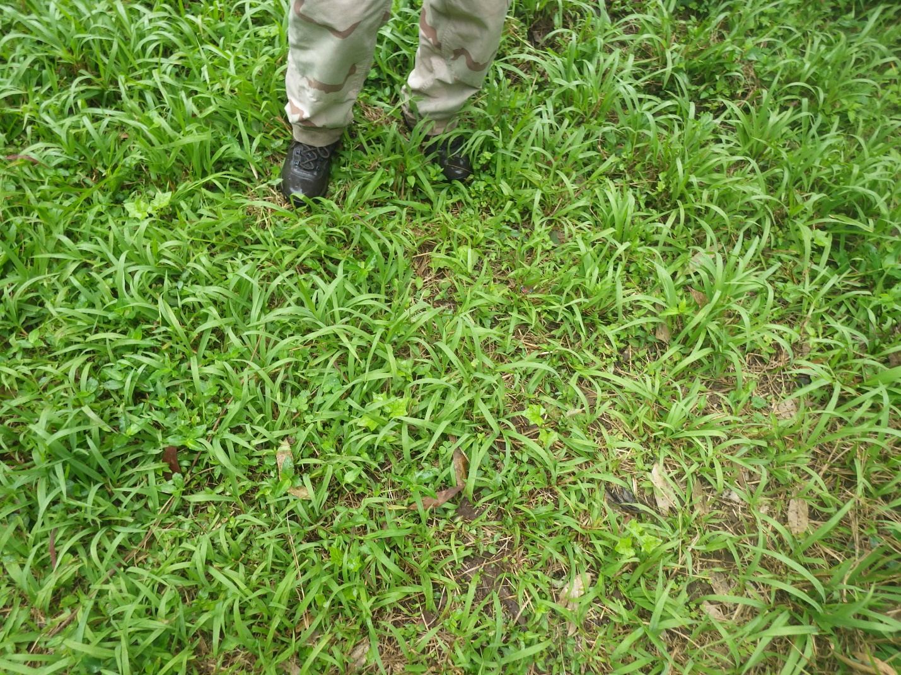
Fireweed (Senecio madagascariensis)
Devil weed popping out among the grass. Previously, numbers were so high
the crew could not count individual plants.
Fireweed is toxic to livestock and established on Maui and Hawaiʿi Island. It has made its way to Oʻahu several times now and OISC and its partners have been able to eradicate it each time. In 2015, OISC field crew conducted 240 acres of ground sureys and 136 acres of road surveys for fireweed and none was found this year. One mature was found by a partner organization.

Deliverable | Deliverable met?
Delimit new fireweed (Senecio madagascariensis) infestation in Kawailoa and control any plants found. | Yes: OISC conducted surveys once a month.
Himalayan blackberry (Rubus discolor)
Himalayan blackberry is a thorny vine that is a serious problem in the Pacific Northwest. OISC staff have been told that it was planted on public land by a resident of Pālolo for fruits and to dissuade trespassers. It spread up the valley to the point where the forest becomes more dominated by native plants than invasives. This species is difficult to control since it is resistant to available herbicides and re-grows easily from cut stems and roots. Despite these challenges, OISC has reduced the Himalayan blackberry numbers to the point where the species is becoming difficult to detect. In 2015, OISC surveyed the infestation twice and treated 62 immature plants. A mature plant has not been seen since 2011. Unfortunately, there is a 19-acre area known to have Himalayan blackberry that is spread across public and private land that OISC cannot safely control. A resident living near the infestation has made statements indicating he would harm the field crew if they work in that area. Therefore that area has not been surveyed or treated regularly.
Deliverable | Deliverable met?
Survey 32 acres for Himalayan blackberry (Rubus discolor) infestation and control all plants found. | Yes: OISC surveyed 58 acres and treated 62 immature plants. A mature plant has not been seen since 2011.

Pampas grass (Cortaderia spp.)
OISC surveyed 415 acres and found no evidence that the pampas grass growing on the cliffs above Haʿikū had re-grown after the treatment in 2011. Pampas grass is serious pest in New Zealand and California where it invades forests and streams. On Maui, pampas grass spread from cultivated plantings in residential areas as far as Haleakalā crater, where it was controlled, and to the summit of the West Maui Mountains where it is currently being eradicated. Since 2002, OISC has worked with landowners to remove cultivated pampas grass and most of them have agreed. In addition to the naturalized population in Haʿikū mentioned above, OISC removed another small naturlized population of pampas grass from Kīpapa Valley in 2008.

Deliverable | Deliverable met?
Survey 250 acres in Haʿikū Valley for pampas grass (Cortaderia spp.) to ensure treatment efficacy of historical plants and to detect new populations. | Yes: OISC surveyed 625 acres.
Remove any additional plants found on private land. | NA: None reported.

Fountain grass (Cenchrus setaceum)
Fountain grass is established at Diamond Head and Lanikai on Oʿahu. In 2015, OISC surveyed 320 acres along the Waiʿanae coast for fountain grass. Fountain grass is an OISC target because it is highly adaptable to fire and outcompetes native plants by altering the fire regimes of native forests.

Deliverable | Deliverable met?
Survey for fountain grass (Cenchrus setaceum) in ʿŌhikilolo Valley and along the Waiʿanae Coast. | Yes: OISC surveyed 320 acres along the entire Waiʿanae Coast.
Control 5-acre infestation along Pali Highway | No: Location proved too dangerous.

Glory bush (Tibouchina urvilleana)
Glory bush is a striking ornamental plant that outcompetes natives in wet forest environments. In places on Hawaiʿi Island where it is naturalized, glory bush makes its way into 30-foot high ʿōhiʿa canopy . Oʿahu residents have cooperated when OISC has asked them to remove landscape plantings of glory bush, but one naturalized population remains in Tantalus. The species grows well vegetatively but we hope the population is near to eradication. In 2015, only three immature were found.
Deliverable | Deliverable met?
Survey and treat glory bush (Tibouchina urvilleana) every six months. | Yes: OISC surveyed 31 acres. Three immature treated.

OISC decided to no longer survey and control for several species mentioned in its original HISC proposal. These are: Cissus repens, Nasella tenuissima, Melinis nerviglumis, Piper aduncum and Pennisetum villosum. OISC did not get the full amount it asked for in 2015 and the revised deliverables for the best and final offer (BAFO) left these species out. In addition, the burgeoning populations of devil weed necessitated putting more time towards that species. Although these species are concerning, they are on private land that OISC had difficulty gaining access to, or, as is the case with Piper aduncum occur in areas with staff that could control and/or monitor their populations.

Coqui frog (Eleutherodactylus coqui)
OISC provides systematic monitoring support to the Hawaiʿi Departement of Agriculture (HDOA) for early detection of coqui frogs. Coqui frogs can be stowaways on plants and other items such as vehicles, boats and construction materials from areas on Hawaiʿi Island with large coqui frog populations. OISC assists with responding to reports from the public, treatments and monitoring areas to ensure treatments were effective. In 2015, OISC conducted 28 surveys over six separate sites. OISC staff captured 43 frogs. HDOA staff has conducted separate surveys and captures, so this number does not represent the total number of coqui frogs caught on Oʿahu in 2015.

Deliverable | Deliverable met?
Assist HDOA with responding to coqui reports from the public. Survey 6 high risk sites on a quarterly basis. | Yes: OISC conducted 28 surveys total over six separate sites. 43 frogs were captured.

Little Fire Ant (LFA) (Wasmannia auropunctata)
LFA is a tiny stinging ant that is established on Hawaiʿi Island and was accidentally introduced to Oʿahu in two separate locations. OISC has assisted HDOA and the Hawaiʿi Ant Lab with surveys, treatment and outreach. OISC cut trails in advance of treatment and surveys (surveys require leaving small vials of peanut butter on the ground for 20 minutes; in tall grass they can be difficult to see). OISC also helped with the actual treatment and monitoring. With matching funds from the US Navy, OISC also conducted surveys at high-risk sites at Joint Base Pearl Harbor Hickam. No LFA was found at Joint Base.

Deliverable | Deliverable met?
Coordinate with the Little Fire Ant (LFA) Oʻahu Incident Command System to prioritize the survey of 170 high risk sites. Survey 120 of these sites and respond to public reports. | Yes: OISC sureyed 128 unique sites in 2015. No LFA was found.

Myoporum thrips (Klambothrips myopori)
Myoporum thrips have been damaging and killing Hawaiʿi’s native naio trees on the Hawaiʿi Island since they were discovered in 2009. Naio figures prominently in coastal restoration projects and is a popular ornamental for those wishing to landscape with native plants. OISC has been checking naio plants on Oʿahu continuously since 2011 as an early detection strategy for the thrips. In 2015, OISC conducted 15 spearate surveys and worked with staff from DLNR/DOFAW and the Natural Area Reseve System to write a rapid response plan for Oʿahu in the event Myoporum thrips are found.
Deliverable | Deliverable met?
Conduct 24 early detection surveys for Myoporum thrips at high risk sites. | Yes: OISC conducted 97 early detection surveys, all were negative.

Coconut Rhinoceros Beetle (CRB)
CRB is currently limited to Oʿahu and a separate CRB response team is taking the lead in the response. OISC assists where necessary. CRB damage can kill coconut and other palms.
Deliverable | Deliverable met?
Assist Coconut Rhinoceros Beetle Response Team with monitoring of traps across the island. | Yes: OISC checks and maintains 78 traps along Oʻahu’s windward coast and sends data to the CRB response team. No CRB was found in OISC maintained traps during 2015.

Early Detection
OISC’s early detection program is a partnership with the Bishop Museum. One OISC staff member is housed at the Herbarium Pacificum to identify specimens submitted by private citizens and public land managers so that they can make informed decisions about whether to control a species. One notable find submitted by the public was a New Island Record of a grass called Paspalum arundinaceum from Kaʿaʿawa Valley. The program also surveys points of introduction for new plant species. In 2015, the early detection botanist began a comprehensive survey of Hoʿomaluhia Botanical Garden. Once complete, OISC will be able to recommend to the garden which species that are just beginning to move beyond the garden and should therefore be deaccessioned.

Deliverable | Deliverable met?
Identify 150 specimens submitted by the general public, private land managers and other agencies. | Almost: the program identified every specimen submitted, but only 140 were submitted.
Conduct ground surveys at two botanical gardens and complete risk assessment reports for three botanical garden’s accession lists. | Almost: The team consisted of two employees and one left in October of 2014. OISC has not replaced the position due to reduced funding in FY 2106. About 75% of one garden has been completed. Examining the accession list for that garden was done in preparation for the survey.

Other Activities and Deliverables:
Deliverable | Deliverable met?
Respond to new species as appropriate and in consultation with OISC Steering Committee. | Yes: OISC conducted an information session on the pathogen that causes Rapid ʿŌhiʿa Death (ROD) and has collected samples of symptomatic trees and sent them to the ROD response team for testing.
Enroll 2 staff in USGS Brown Treesnake Rapid Response training on Guam. | Almost: OISC’s pest response specialist attended. The field crew supervisor declined to go because OISC was without a manager during the time of the training and she was needed on island.
Participate in statewide data workshop to review data standards and analysis. | Yes: OISC’s GIS Analyst participated in statewide data meetings.
Store the data from daily field activities in a relational and geographic database and report as part of the annual HISC report to the legislature. | Yes: The OISC field crew fill out daily field forms, the data for this report came from OISC’s database.

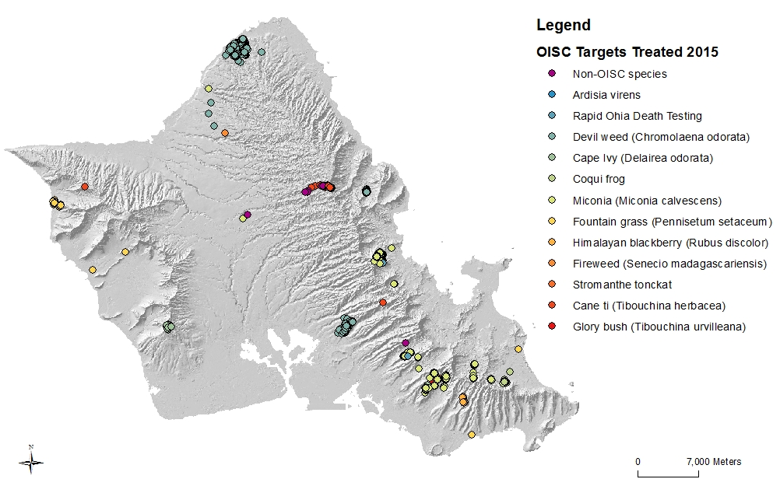
Outreach:
Species Treated in 2015
OISC recognizes that outreach is integral to invasive species management. OISC needs public support so that we can gain access to the private property we need to survey so that our eradication efforts are truly island-wide. For species like coqui frog and little fire ant, that can be transported anywhere on the island, we need the public to be our eyes and ears. We also want the public to know what they can do to help our efforts. For example, buying non-invasive plants and washing gear and equipment (especially boots) goes a long way towards preventing invasive species introductions. The table below describes how OISC’s outreach deliverables were met:
Deliverable | Deliverable met?
Codevelop a little fire ant (LFA) school activity in partnership with the Coordinating Group for Alien Pest Species and the LFA ICS outreach team. | Yes: The curriculum was developed and has been presented to 4 schools and a teacher workshop.
Create LFA costume | Yes: (see photo below)
At least 200 landowners engaged in invasive species control. | Yes: the OISC outreach specialist acquired permission for the field crew to access 220 properties.
At least 350 volunteer hours dedicated to removing invasive plants from Lyon Arboretum that are not known to have naturalized outside the Arboretum, but display weediness potential. | Yes: Despite crazy El Nino weather that required multiple cancellations, volunteers still dedicated 437 hours to survey 65 acres and remove 3,610 individual plants
At least 50 presentations or participation in events to schools, community groups and other organizations. | Yes: OISC outreach staff participated in 29 events, visited 17 schools and gave 26 presentations (total 72).
500 posts on OISC’s Facebook page | Yes: OISC Facebook, Instagram, Twitter, YouTube, Vimeo and volunteer blog have resulted in 39,000 viewings.
Assist with development and implementation of a statewide public outreach event for Hawaiʿi Invasive Species Awareness Week (HISAW). | OISC outreach specialist gave two television interviews promoting HISAW and participated in an event at the Legislature.
Design a LFA information panel to be posted on Oʿahu’s TheBus. | Yes: Panels were installed on all buses and remained throughout the month of September as part of the “Spot the Ant, Stop the Ant” campaign.
Author two articles on invasive species issues in traditional print media. | No: Finding publications to write for proved difficult.
Continue efforts to develop community-based social marketing techniques to empower motorcross users to report sightings of devil weed. | Yes: OISC attended a board meeting of the Hawaiʿi Motorcross Association as well as their 4th of July event.
Promote work of HODA and HDOH partnership “Māmalu Poepoe” early detection at ports of entry program. | No: Program has not yet begun, Outreach Specialist attended planning meetings.
Update OISC’s website with information regarding target pest and general invasive species information. | Yes: OISC’s website had nearly 19,000 views.

Private Property Access (220 properties)
With the ability to increase field operations this year, quite a bit of outreach time was focused on gaining access for miconia, devil weed and LFA surveys. This involved over 500 calls, emails and site visits to coordinate access and surveys of 220 properties and businesses. 71 of the surveys were for LFA in nursery, garden centers and private property adjacent to streams in Waimānalo. HDOA was very helpful by assisting with access to their leased properties in Waimānalo for the stream survey. OISC was denied access to only 3 properties—which we will continue reaching out to owners. In summary, access granted was 98.7% this year.

Presentations (648 people) Meetings (318) people and Trainings (61 people)
The outreach program has conducted 26 presentations this year, reaching 648 people. We also provided invasive species updates to nine neighborhood board meetings directly reaching 318 community members. Eleven presentations were specifically focused on little fire ant detection and reporting, with four presentations at public libraries during Spot the Ant, Stop the Ant Month. OISC also conducted little fire ant survey trainings for BWS maintenance staff and trained teachers how to conduct the Hoʿike activity at the Garden and Food Safety Workshop for the Kōkua Foundation’s ʿĀina in the Schools program.
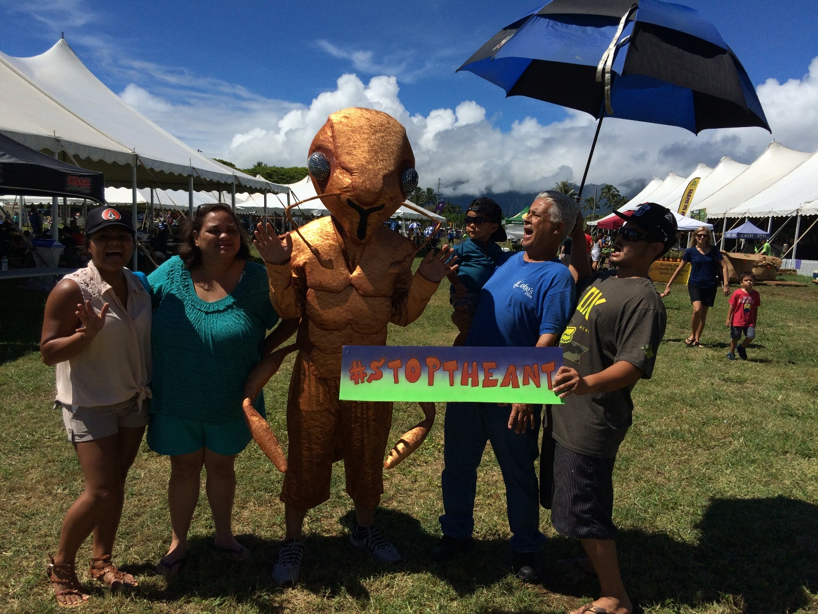
OISC’s LFA costume—the “Big Ant” at the State Farm Fair
The remainder invasive species presentations were given to various community groups around the island. Presenting to community groups has proved to be a valuable way to reach audiences that can be innovators and early adopters of invasive species prevention activities. These are the sectors of the community with which new partnerships can be forged and key community stakeholders are often found.

Events (3,081 people)
OISC participated in 29 events this year including the Hawaii State Farm Fair, Ocean Fest, Mililani Science Technology Engineering and Mathematics (STEM) night and UH Mānoa’s College of Tropical Agriculture and Human Resources (CTAHR) Oʿahu Agriculture and Environmental Awareness Day, which had the largest audience of 600 middle school children.

Interviews (251,041 people reached)
OISC gave four interviews this year: two television interviews to KITV and KHON promoting Hawaiʿi Invasive Species Awareness Week, an interview by OISC’s Field Crew Leader, Nathan Dube, to KITV during the Tantalus Community Association volunteer day which OISC participated in, and an interview on HPR’s “The Conversation” regarding little fire ants.

Hoʿike (460) and School Visits (451)
OISC has visited a total of 17 schools reaching 911 students. Four of these schools (Kailua Intermediate, Le Jardin, Waipahu High School and Highlands Middle School) participated in the Hoʿike LFA activity which presents information on invasive species and how to test and identify LFA. Hoʿike has not only raised awareness about the threats of little fire ant, but has also provided 289 property surveys. OISC has also been participating in mock job interviews at Kamehameha Schools, Waiʿanae High School and the Samuel M. Kamakau Charter School in Kāneʿohe. The mock job interviews are organized by the school to help students build interviewing skills. Through OISC’s participation students are introduced to careers in conservation. This is part of an effort to support area students, foster relationships with schools and promote OISC educational programs in local schools.

Materials (7,041,907) Website (21,630) and Social Media (39,116)
In 2015, OISC created invasive species training packets for two tour operators (Oʿahu Nature Tours and Pedal Bike Tours). The packets included a brief power point about invasive species impacts, flyers of OISC target species, decontamination protocols and how to report suspect pests. The estimated combined audience of these companies is 39,200. OISC also updated our brochure and created a new rack card for devil weed and miconia to be distributed in the ever-increasing survey area in ʿAiea. We also created the Adwall for LFA to be installed on every bus on Oʿahu for the Spot the Ant, Stop the Ant Month (September). The Adwall averages 7 million views each month. OISC also made and distributed over 2,545 little fire ant kits to the public.

We have been keeping our website up-to-date with information, not only about OISC targets, but also with emerging threats like Rapid ʿOhiʿa Death and the dengue fever outbreak on Hawaiʿi Island. We had nearly 19, 000 website visits in 2015 and are seeing spikes in visits when invasive species issues are covered in the local news. OISC also participates with www.stoptheant.org, mostly during the month of September, maintaining OISC’s Contest Page. The total web hits (statewide) for September were 3,621.
We also have been increasing our presence on social media with Facebook, Instagram and Twitter posts. OISC Facebook, Instagram, Twitter, YouTube, Vimeo, and volunteer blog have facilitated over 39,000 viewings of social media posts regarding invasive species issues on Oʿahu and across the state.

Volunteer Trips (437 volunteer hours)
OISC is very pleased to report that our volunteer trips at Lyon Arboretum have been consistently well attended. Despite missing two months of surveys this year due to inclement weather, 2015 has been a bumper year for the program. Volunteers dedicated 437 hours to survey 65 acres and remove 3,610 invasive plants. (2175 Ardisia virens and 1433 Stromanthe tonckat and 2 immature miconia).

In summary, OISC Outreach program messages have been presented to the public roughly 7,360,074 times. The OISC outreach program is dedicated to promoting our mission to prevent, detect and eradicate invasive species on Oahu through presentations to area schools and communities, creating and distributing educational materials, conducting regular volunteer trips, and by working with partner organizations’s outreach efforts.

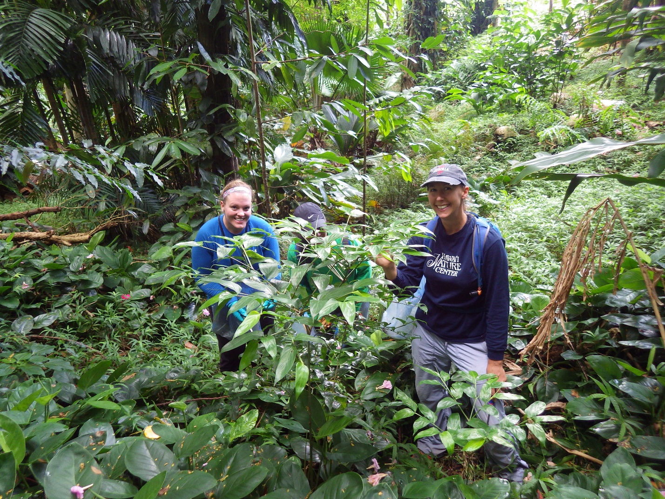
Volunteers removing Stromanthe tonckat from Mānoa Valley

