Kīholo and West Maui: Integrating Local Ecological Knowledge with Novel Scientific Tool to refine Traditional Community Based Fishing Moon Calendars (Year 1 of 2)

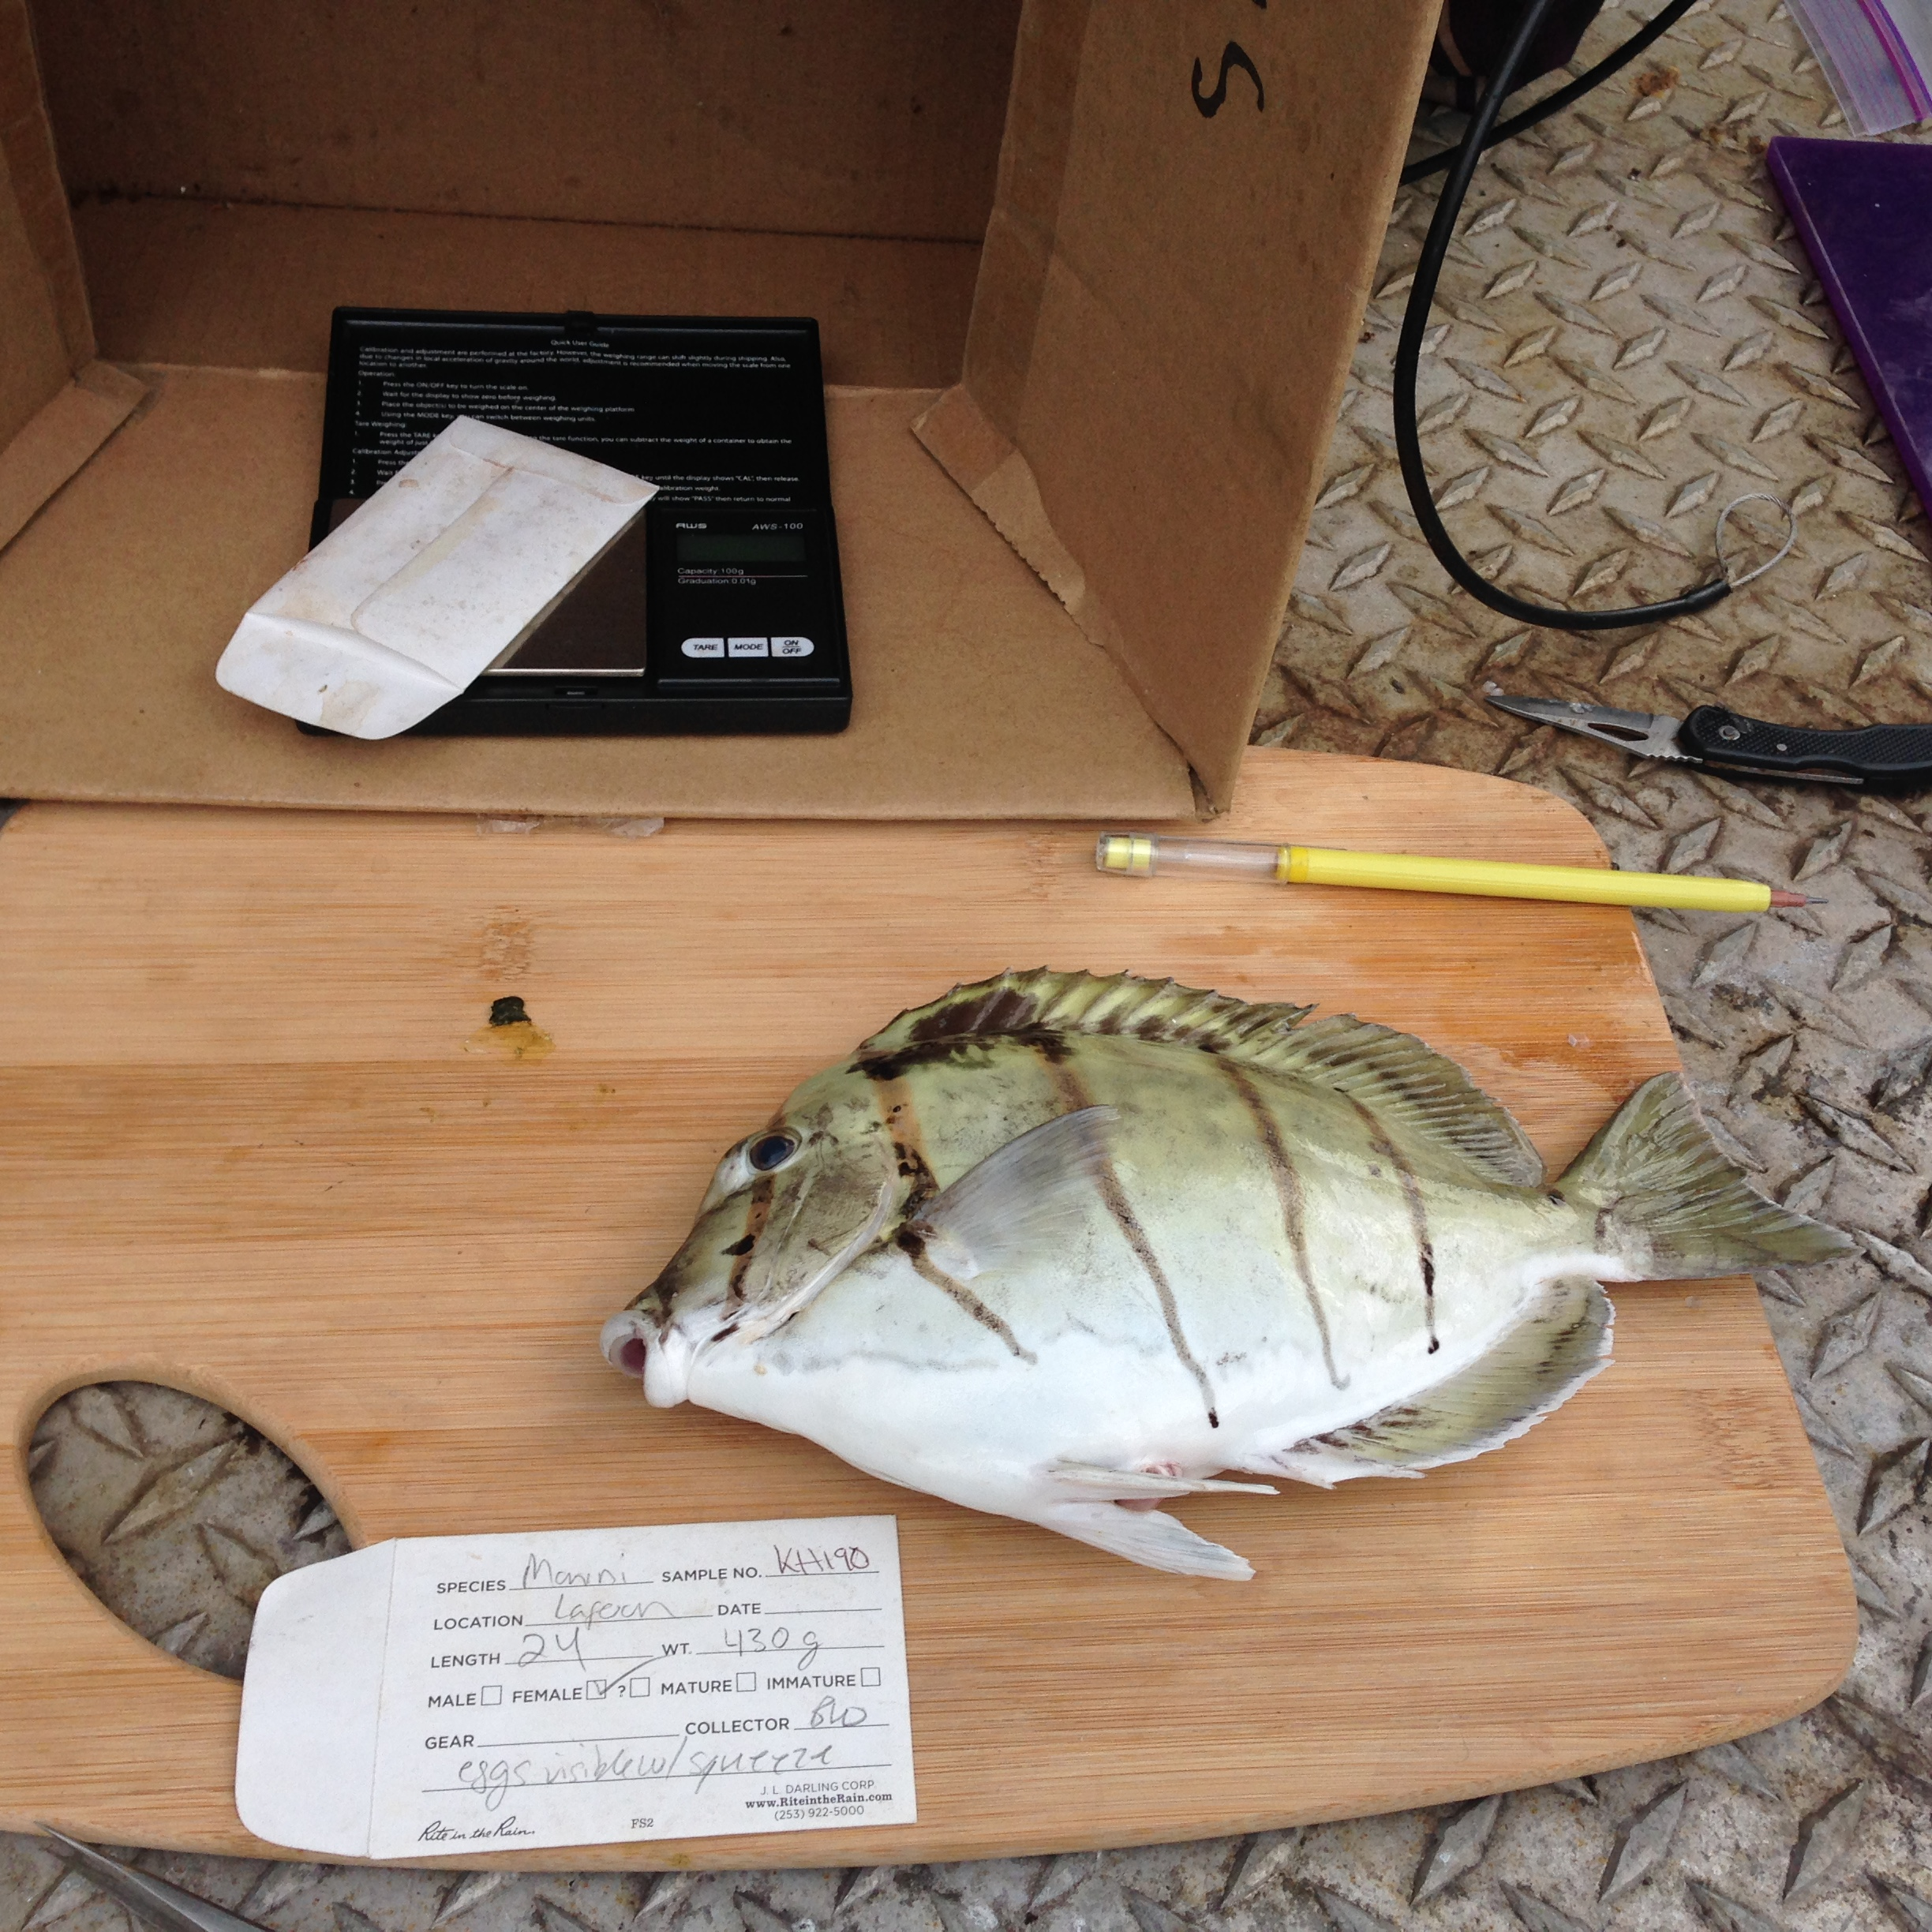

Caption: Fishermen monitoring the spawning season of Manini, Acanthurus triostegus, at Kīholo, Hawaii.

Kīholo and West Maui: Integrating Local Ecological Knowledge with Novel Scientific Tool to refine Traditional Community Based Fishing Moon Calendars (Year 1 of 2)

Eva Schemmel
Fisheries Ecology Research Lab
University of Hawaii, Manoa
Biology Department
evam@hawaii.edu

Alan Friedlander
Pristine Seas, National Geographic Society
Fisheries Ecology Research Lab
University of Hawaii, Manoa
Biology Department
friedlan@hawaii.edu

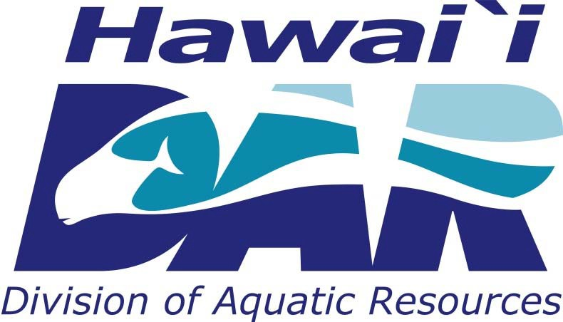

Annual Report Year 1 of 2 (March 2015)
Hawaii Coral Reef Management Grant
NOAA Coral Reef Conservation Program Award to the State of Hawaii
Department of Land & Natural Resources, Division of Aquatic Resources
Award Number: NA13NOS4820014

Table of Contents

Summary 4
Major Findings 4
Size Limits and L₅₀ 4
Spawning Seasons 4
Education & Outreach 5
Reproductive Characteristics: 6
Fecundity Assessment 6
Size Distributions and Size at Maturity (L₅₀) Methods 7
Manini Size Distributions & L₅₀ 9
Kole Size Distributions & L₅₀ 12
Spawning Seasons (Annual) and Spawn Timing (Intraseasonal) 14
Spatial Variation in Spawning Seasons 14
Comparing scientific methods for detecting spawning seasons 17
Assessment of Spawn Timing (Intraseasonal) 19
Pono fishing practices: Engaging fishermen in developing sustainable fishing practices 21
Gathering pono fishing practices and local knowledge 21
Pono Fishing Survey 21
Outreach and Educational Activities 22
Moon Calendars for Kahekili-Ka’anapali (West Maui) and Kīholo Bay (West Hawaii) 23
Deliverables and Outcomes 23
Obstacles 25
Species Collection 25
Endocrine Assays 25
Appendix 26
Tables 26
Figures 27

Summary

Through close collaborations with local communities (Kīholo, Kailapa, Kaupulehu, Polanui, Maunalua, and Hanalei) we are working to understand the variability in our marine resources. It is well understood by fishermen that fish behaviors and biology change depending on the location and island. However, the size that fish reach maturity, which informs the size of harvest, and the spawning seasons of harvested reef fish are largely unknown. The program spawning seasons was created with the help of Hawaiian communities to better undertand the size of maturity and spawning seasons of harvested fish at the community scale to help inform local fishing practices and support community based management, and subsistence fishing. Over the past year the program has focused on documenting the variability in size at maturity and spawning seasons of manini, kole, and kala across four locations. Manini were found to be model specie to understand this variabiity because of there ease of collection and immportance to local communties. Manini size at maturity was found to range from 12.7 to 16.4 cm. This size range is very large for such a small fish and is important information the state to recognize when attempting to set size limits. Spawning seasons for manini were found to be variable between locations, however we also found that the spawning season assessment may be influenced by gear type used. Kole spawning seasons were identified for Maunalua Bay to be March – May and July – August. Kole and kala were not collected at the same scale as manini due to limited abundances in study areas. We are building a database to gather spawning season information for over 50 species of nearshore fish to inform management desicions such as size limits and closed seasons. We are continuing to compare spawning season assessment methods including Gonad Somatic Index (GSI), histologicial examination of reproductive state, and endocrine assays of sex hormones. GSI and histoloigcal assessment of spawning seasons were similar and both methods were found to be good indicators of spawning timing. The endocrine analyses require further examination and the protocols need to be adjusted to determine if this method is more precise for determine spawning seasons and spawning patterns.
The program continues to receive overwhelming support from communities and we are working on innovative ways to collect fishermen knowledge and catch information to support local fisheries management decisions. With the communities we developed a fishing logbook (Lawai’a journal) to collect spawning season and catch information from active fishermen. Two moon and tide calendars were produced and disseminated to the communities to share findings from this research and to be used as tools to initiate conversations on pono fishing practices for each community.

Major Findings

Size Limits and L₅₀
- Size at maturity (L₅₀) was significantly different between locations. One of the major factors that may be causing these differences is fishing pressure. Allowing fish to reach maturity and spawn before harvest ensures population sustainability. We recommend that size limits be reevaluated for each island, and perhaps at an even finer spatial scale.
- At all locations studied, the size at maturity for manini is at or above the legal size limit (5 inches or 12.7 cm). This means that fish are legally allowed to be harvested before the have had a chance to spawn and replace themselves.
- Female kole mature at a smaller size (8.1cm) than male kole (13.6 cm) and are likely variable by location.
- Larger females contribute more to population growth than smaller females. The proportion of manini females spawning increases linearly with fish size.

Spawning Seasons
- Gonad Somatic Index and histological assessment of spawning fraction are used to determine spawning seasons. Both spawning season assessments can be used interchangeably for community based monitoring. However, the gear used to monitor spawning seasons in some reef fish may reduce our ability to detect peak spawning times. We recommend gathering local knowledge on spawning locations and fish behaviors to establish a spawning season monitoring plan.
- The spawning seasons were highly variable for manini. Manini appeared to have a distinct spawning season in West Hawaii, but nearly yearlong spawning in Maunalua and Hanalei. However due to winter swells and unfavorable fishing conditions we were not able to get manini gonads in November, December, and January from Hanalei, and in December from West Hawaii.
- Kole were found to have two spawning peaks. In Maunalua Bay, Oahu, kole spawning was bimodal with spawning peaks from March through May and July through August.
- Kala had an extended spawning season in 2014, with spawning likely occurring from May through August. Typical spawning season for kala has previously been reported to be from May-June.
- Understanding the spawning pattern or spawning cycle allows for more accurate assessments of annual spawning seasons by targeting monitoring at times or moons of spawning.
- We found that a semilunar (spawning near new and full moons) spawning cycle for manini in Maunalua Bay, Oahu. Our assessment of the spawning cycle for manini in West Hawaii and Hanalei is inconclusive based on Gonad Somatic Index (GSI) and histological assessments. This is likely due to different gear types used in those locations (mainly throw net in Kiholo and a mixture of throw net and spear in Hanalei). We are running sex steroid assays to determine if sex steroids are a better indicator of spawning cycles and if differences in the spawning periodicity exist between locations.
- Spawning occurs outside of the DAR regulated closed seasons. Outside of season spawning was observed for ‘ama ‘ama in Wailuku, Maui and Kiholo, Hawaii.

Education & Outreach
Including fishermen in fisheries assessments and monitoring increases behavioral changes towards pono or sustainable fishing practices. We have engage fishermen throughout this project for this purpose in the following ways.
- Over 600 fishermen and community members participated in the monitoring of reef fishes.
- Fish gonad samples are collected with the support of active fishermen and community members and have resulting in the start of a life history database with over 2400 individual fish from 55 species.
- A website (spawningseasons.org) and a Facebook page (www.facebook/spawningseasons) was created for increased participation and communication. We have received over 75 posts of fish gonads to facebook page and 460 fishermen regularly engaged in the website with a reach of over 6500.
- Twenty-one educational and outreach events were held from January 2014-January 2015
- The project was presented at 5 formal public conferences.
- Two spawning seasons workshops were held last year at each project location.
- A pono fishing practice survey was conducted in the fall of 2014 with 80 responses from fishermen on questions regarding harvest preferences, spawning seasons, and pono fishing practices. From this survey we made a pono fishing guide.
- New fishing logbooks, “Lawai‘a Journals,” were published in March 2015 and are being piloted with participating communties and fishermen as tools to record catch and spawning seasons of harvested fish.

Reproductive Characteristics:

Fecundity Assessment
Fecundity counts were done on manini and kole in the hydrated oocyte stage (black points) and vittelogenic oocyte stage (blue points) (for description of oocyte classification see appendix). Fecundity increased linearly with fish size for both manini (Fecundity = -191.64+Fork Length*14.267;Figure 1) and kole (fecundity = -50.47+Fork Length*4.62; Figure 2). There was a lot of variability around these fecundity counts. This may be due to differential fecundity during lunar phases or across the spawning season.

Manini
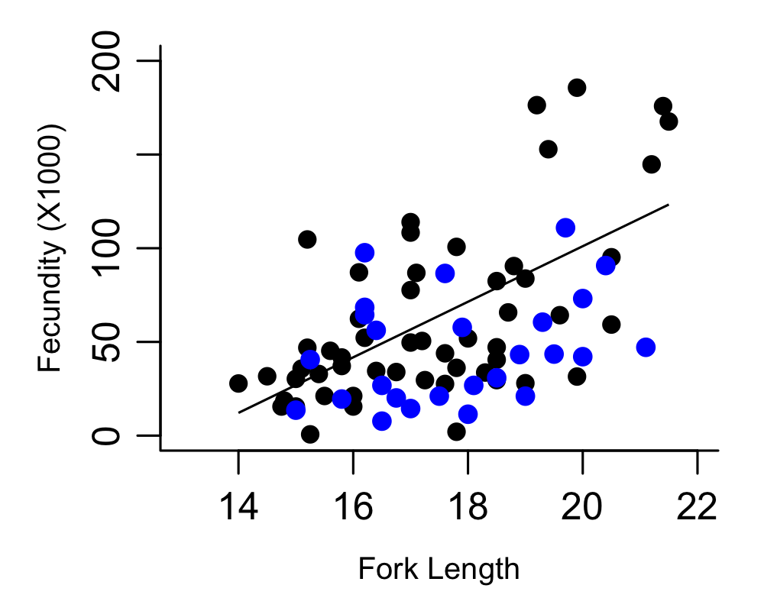
Figure 1. Manini batch fecundity of hydrated oocyte counts (black points) and vitellogenic oocyte counts (blue points).

Kole
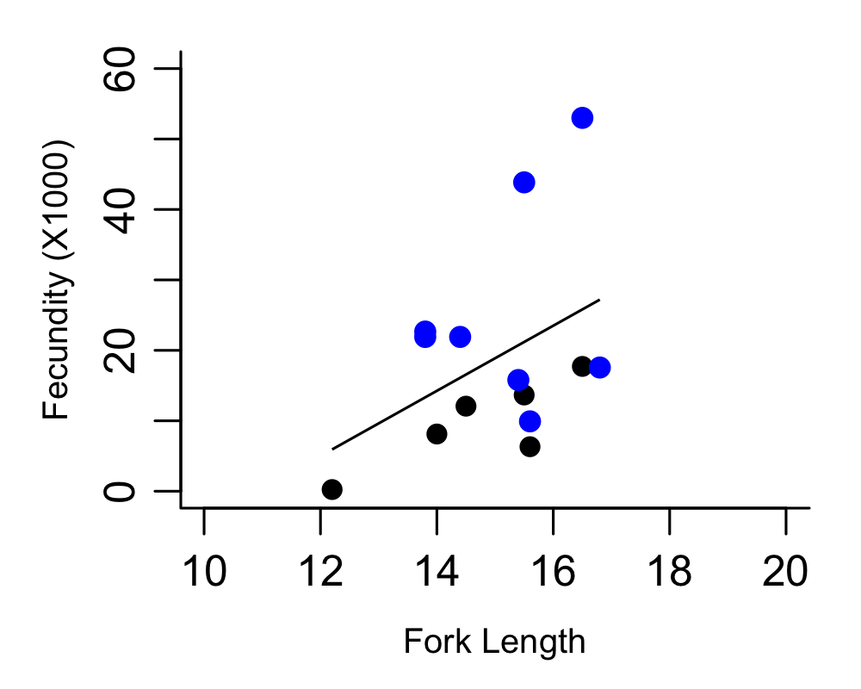
Figure 2. Kole batch fecundity of hydrated oocyte counts (black points) and vitellogenic oocyte counts (blue points).

Size Distributions and Size at Maturity (L₅₀) Methods
The size frequency of manini and kole from all locations was compared and gonad samples were collected from a wide range of sizes to determine the size at maturity. The size at maturity is determined using histological assessments of oocyte stage and the presence of spermatozoa (see appendix). Females that have vitellogenic or hydrated oocytes were considered mature. Additionally, females that had atresic oocytes were categorized as mature, as atresic oocytes are indicators of past spawning events. Males were classified at mature by the presence of spermatozoa. Size at sexual maturity (L₅₀) is reported as the size at which a regression (3-parameter, sigmoidal) of percent mature individuals in each 1 cm size class versus fork length indicates 50% of individuals are mature. The proportion of mature females at each size class is a function where

$$P= \frac{1}{1+e^{(-a(L-L_{50})}}$$

P = proportion mature females at length L

a= slope of the curve

L₅₀ = the length at 50% sexual maturity

Summary Tables of Size Distributions of Manini and Kole

Table 1. Manini size at maturity and size distributions (measured by Fork Length (FL)) by location.
Location | Gender | L₅₀ (cm) | Min (cm) | Max (cm) | Median (cm) | Mean (cm) | n
West Hawaii | F | 15.6 | 9.2 | 23.2 | 16.9 | 17.1 | 219
 | M | 15.8 | 12.5 | 22.0 | 17.3 | 17.1 | 79
Maunalua | F | 12.7 | 9.5 | 22.2 | 16.5 | 16.6 | 230
 | M | 12.2 | 10.0 | 21.5 | 16.1 | 16.0 | 297
West Maui | F | 16.4 | 12.2 | 23.0 | 17.1 | 17.0 | 26
 | M | 16.6 | 13.5 | 23.0 | 16.2 | 16.8 | 15
Hanalei | F | 13.2 | 10.0 | 20.5 | 16.5 | 16.3 | 39
 | M | 14.1 | 12.3 | 20.0 | 16.0 | 16.1 | 100

Table 2. Kole size at maturity and size distributions (measured by Fork Length (FL) by location.
Location | Gender | L₅₀ (cm) | Min FL (cm) | Max FL (cm) | Median (cm) | Mean (cm) | n
West Hawaii | F | - | 13.0 | 17.8 | 15.9 | 15.6 | 11
 | M | 14.6 | 11.9 | 18.8 | 15.1 | 15.1 | 58
Maunalua | F | 7.8 | 8.9 | 17.8 | 13.8 | 13.7 | 54
 | M | 11.9 | 9.0 | 18.5 | 14.3 | 14.3 | 50
West Maui | F | - | - | - | 11.8 | - | 1
 | M | - | 13.4 | 14.6 | 14.3 | 14.1 | 4
Hanalei | F | - | 13.6 | 18.1 | 15.7 | 15.8 | 23
 | M | - | 14.5 | 20.6 | 17.5 | 17.3 | 14

Manini Size Distributions & L₅₀
Manini varied by size across locations. West Hawaii (Kiholo) and West Maui has the largest sized manini and the largest size at maturity (L₅₀) among our study locations (Table 1, Figure 3 & Figure 4). Maunalua had the lowest size at maturity, 12.7 cm for females and 12.2 cm for males (Table 1). This is close to the 5 inch size limit regulation place on the species. At all the other locations manini reach maturity at a larger size than the regulated size. Due to the scarcity of mature sized manini in West Maui, the size of maturity of manini reported from West Maui is largely from manini taken from NW Maui (Honokahua Bay), close to the Honolua Marine Life District. The size at maturity may be higher than other areas due to limited fishing in this area and may not be representative of all West Maui locations.
Both females and males reached maturity at a similar size and had overlapping size distributions. The manini sex ratio was variable by location. In Kiholo and West Hawaii, females were preferentially sampled so the sex ratio skew is an artifact of the sampling and is not representative of the population. In all other locations, the sex ratio is assumed to be representative of the population, however, in Hanalei throw net was the main gear type used and this gear may preferentially select one gender over the other depending on the movements and behaviors of the fish.

Manini
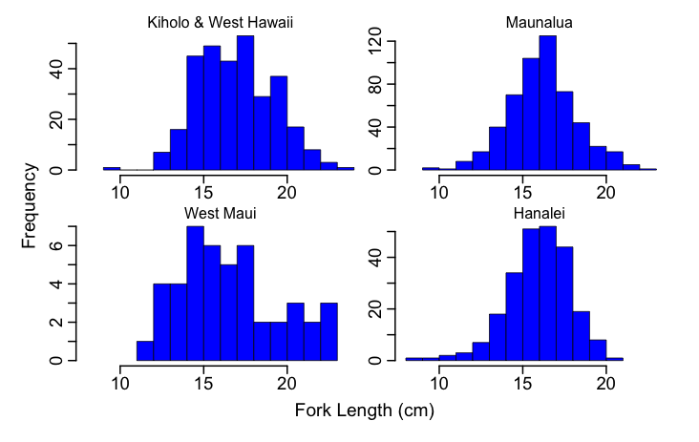
Figure 3. Manini size distributions across our study locations.

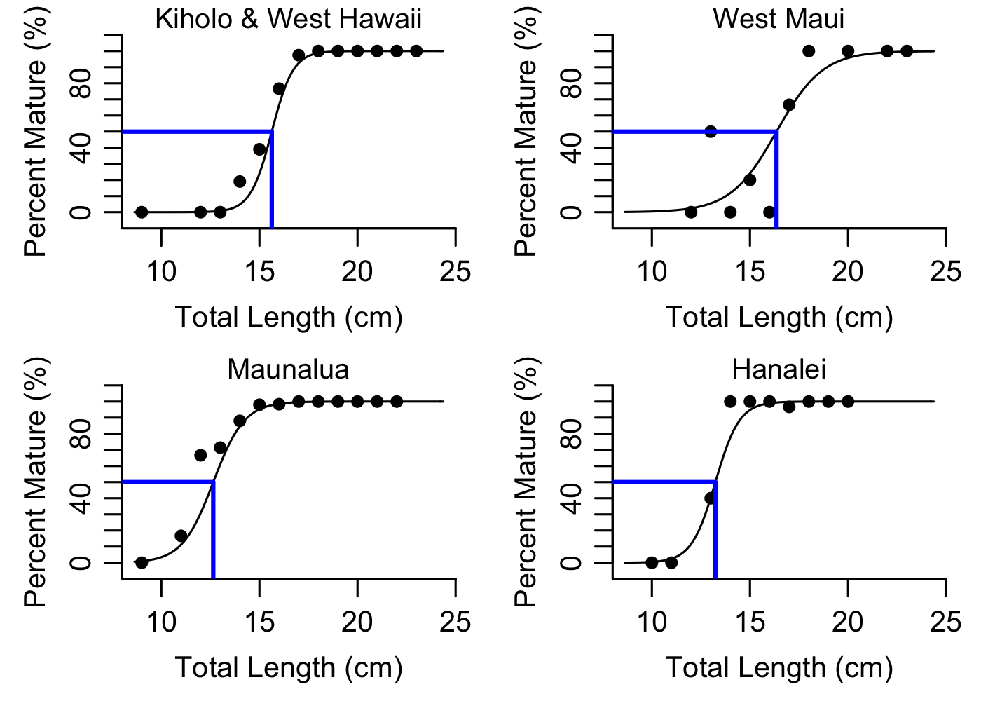
Figure 4. Size at maturity for female manini across the study locations.

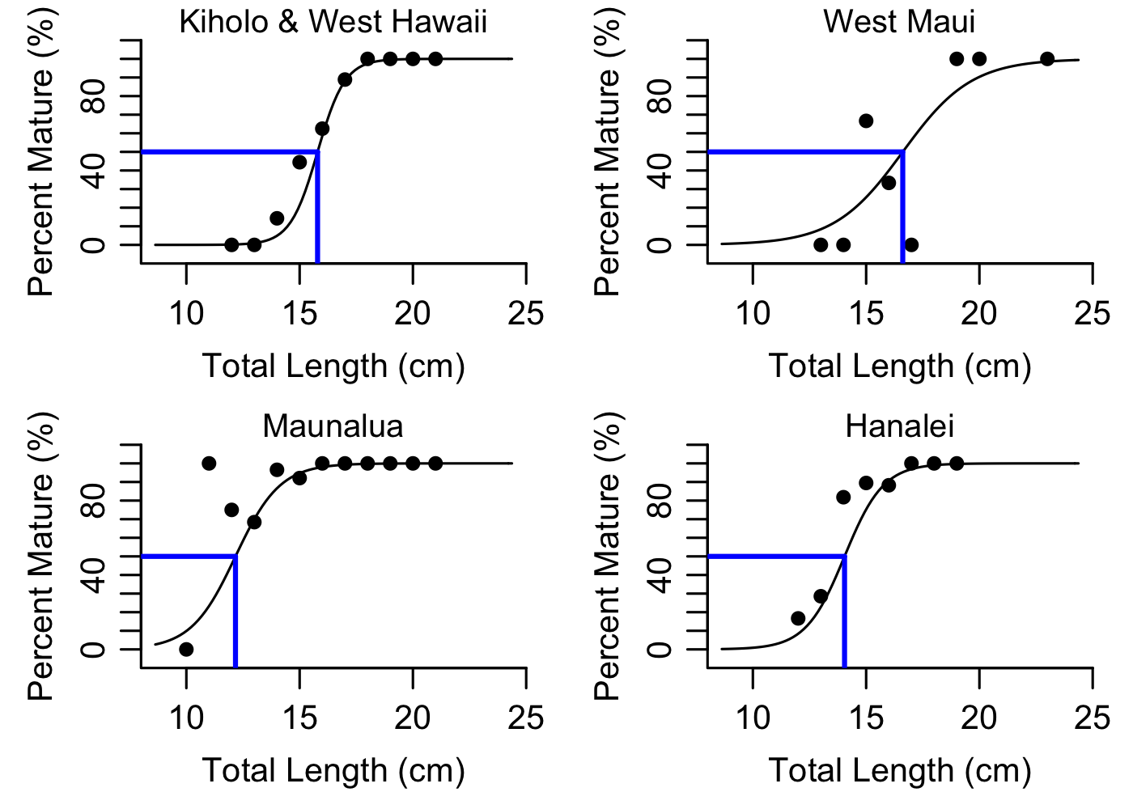
Figure 5. Size at maturity for male manini across the study locations.

Kole Size Distributions & L₅₀

The size distribution of kole was different between locations. West Maui had the smallest kole and Hanalei had the largest (Figure 6). Male kole were found to be larger than females and female kole were found to mature at a smaller size than males (Figure 7). Female kole matured around 8.1cm and male kole matured at 13.6 cm. Size at maturity of kole is likely variable by location. Unfortunately due to the skewed sex distribution in Kiholo & West Hawaii of 1:5 female to male, there was not enough female gonad samples from this location to get a female size at maturity estimate to compare female size at maturity among locations. Additionally only mature kole were found from our Hanalei samples, so no L50 estimate is available for that location. However, there was a difference in size at maturity for male kole between Maunalua Bay and West Hawaii (Kaupulehu and Kiholo). Male kole matured at a smaller size in Maunalua Bay (11.9 cm) compared to West Hawaii (14.6 cm) (Table 2). This suggests that kole size at maturity is variable by location.

Kole
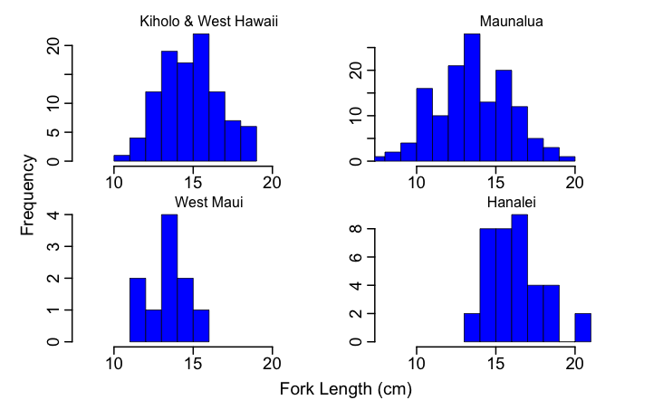
Figure 6. Kole size distributions across our study locations.

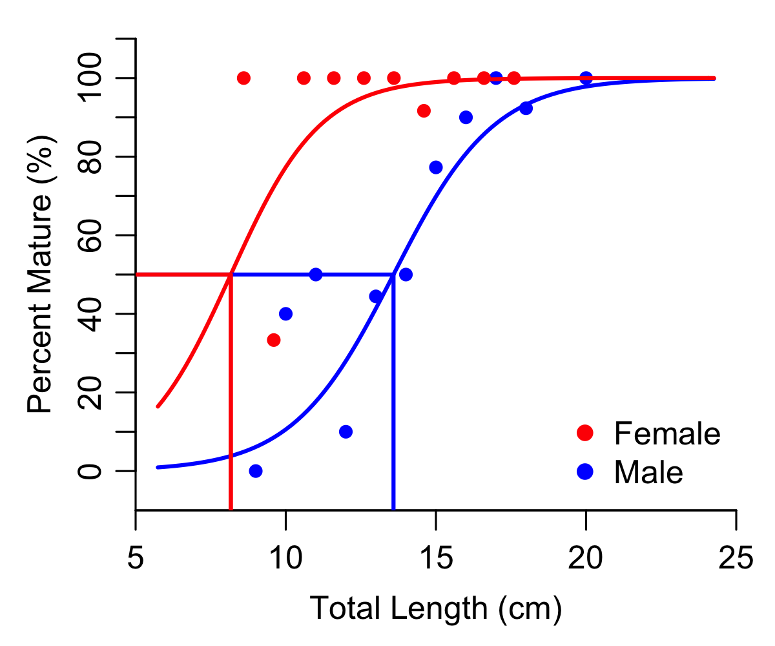
Figure 7. Kole size at maturity (L₅₀) for females (red) and males (blue). All locations are combined in this analysis.

Kala Size Distributions & Size at Maturity (L₅₀)
A total of 27 kala gonad samples (12 female, 15 male) were collected from participating fishermen. From these samples, the size at maturity of female kala was found to be 31 cm. This size at maturity is just an estimate calculated from the12 female kala.
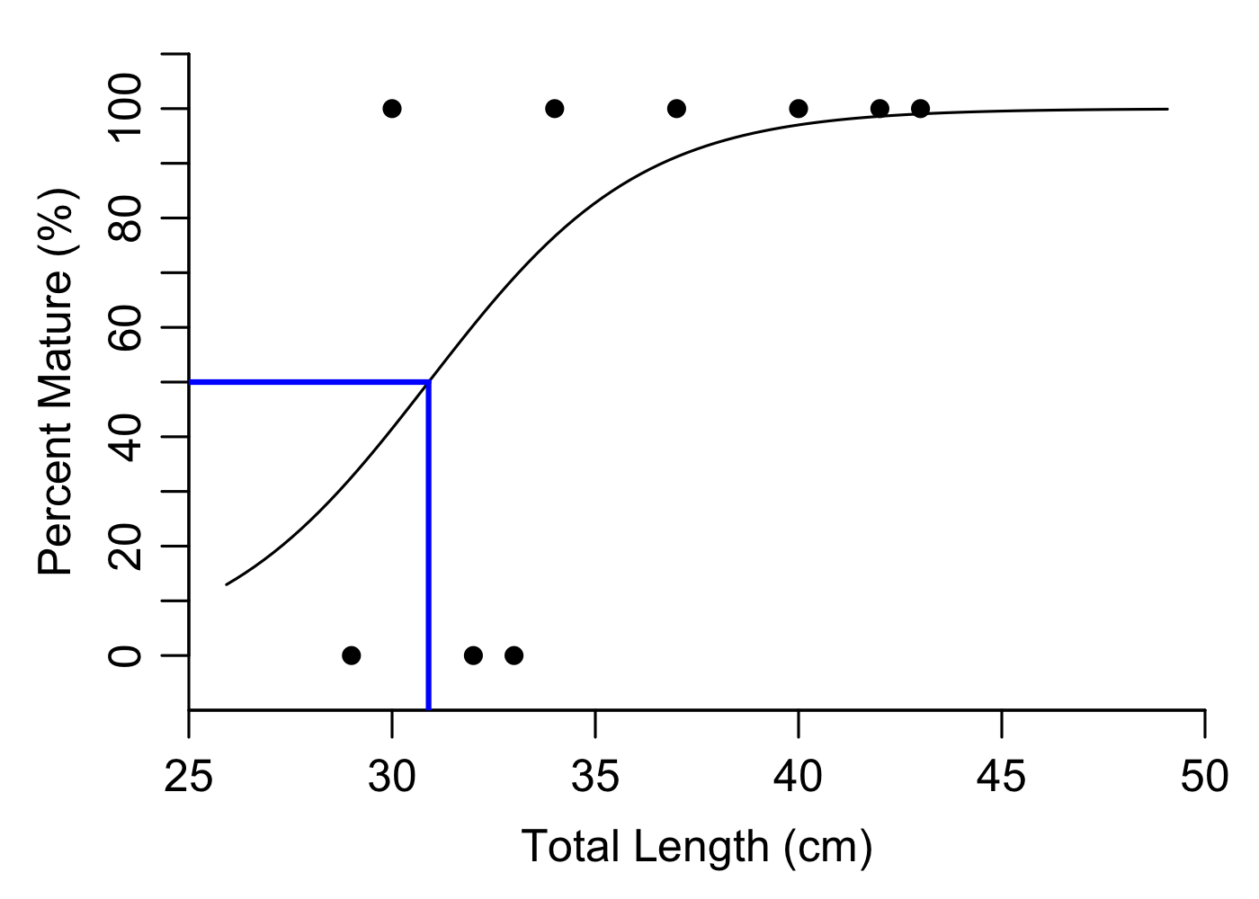

Figure 8. Female kala size at maturity from 2014 gonad samples pooled from all locations.

Spawning Seasons (Annual) and Spawn Timing (Intraseasonal)
In 2014 a spawning season assessment was done in Maunalua Bay, Kiholo & West Hawaii, and Hanalei. To determine spawning seasons, gonad samples were collected each month and the gonad somatic index (GSI) and spawning proportion (based on histological assessment) were compared and assessed to find peaks in both measures of spawning. Lunar assessment of spawning cycles for manini and kole these assessments were done during what we think is the peak spawning season for manini reef fish, from March through early June. Gonad samples from manini and kole were collected approximately every three to five days and analyzed using GSI and histological assessment of spawning proportion to determine if the spawn timing was lunar (once a lunar cycle), semilunar (twice a lunar cycle), or daily.

Spatial Variation in Spawning Seasons
Manini: Manini spawning seasons were assessed in Maunalua Bay, West Hawaii (Kiholo), and Hanalei. Year round samples were not collected in West Maui. Manini are not targeted by fishermen in West Maui and after exhaustive searching over many different sampling trips lead by local fishermen and on our own, we were not able to find any mature sized manini from Olowalu to Napili Bay. A small school of spawning sized manini was found at Honokahua Bay, however the school was small (<80 individuals), therefore we choose to only sample enough to determine size at maturity so as not to diminish the already reduced populations of manini in the area.
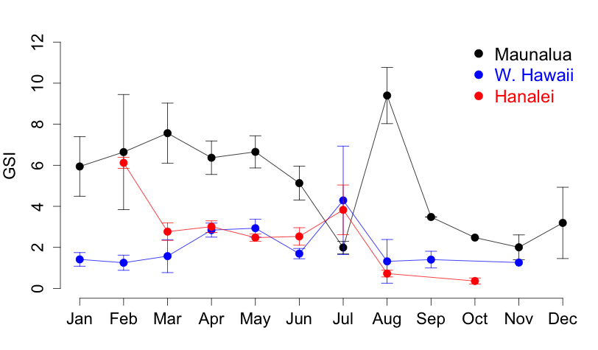
Figure 9. Manini spawning seasons for West Hawaii (Kiholo), Maunalua Bay (Oahu), and Hanalei Bay (Kauai) based on gonad somatic index (GSI).

Kole: The spawning season was assessed for Maunalua Bay, Oahu. Two spawning peaks were found, with spawning peaks from March through May and July through August. Kole were collected from Kiholo, West Maui, and Hanalei, however participating fishermen had trouble finding the gonad when the fish was immature or not spawning. From the gonad samples that were collected, GSI was also found to be high for kole in Kiholo & West Hawaii in April and May, and high in Hanalei in March and July.

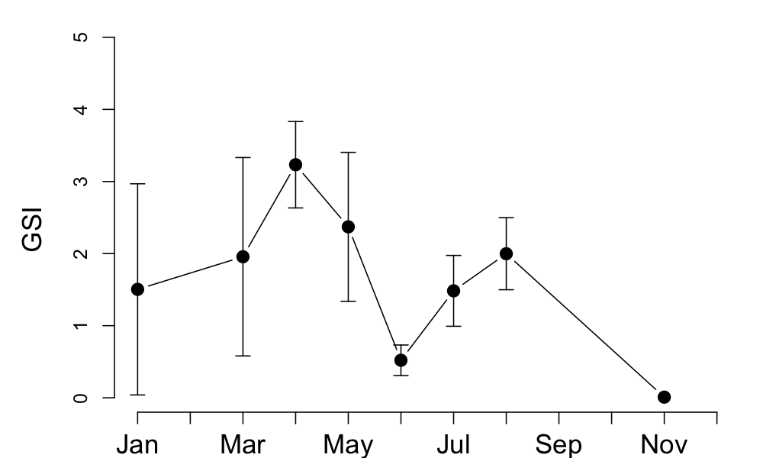

Figure 10. The spawning season for kole from Maunalua Bay (Oahu) based on gonad somatic index (GSI).

Kala: We were able to assess spawning seasonality from 27 kala gonad samples collected in 2014. This is a limited sample size, however interesting spawning season information was found. Kala have been reported to spawn in Hawaii during a short spawning period from May through June (DeMartini, Edward E., Ross C. Langston, and Jeff A. Eble. "Spawning seasonality and body sizes at sexual maturity in the bluespine unicornfish, Naso unicornis (Acanthuridae)." Ichthyological Research 61.3 (2014): 243-251). The previous spawning season estimates for kala were for windward Oahu from pooled samples collected from 2011 through 2012. Our samples were collected from February through September 2014. We found that spawning was occurring during August. This is well outside the previously reported spawning season. This suggests that there is likely annual variability in spawning seasons.

Comparing scientific methods for detecting spawning seasons
To enhance community based observations on reef fish spawning seasons we applied scientific techniques in the form of GSI, histological assessment, and endocrine assays. We compared the methods and found that GSI and histological assessment can both be used to determine spawning seasons. Monthly peaks in spawning (Figure 11) and daily spawning peaks (Figure 12) were similar for both methods. This supports the use of GSI as a community monitoring method of spawning seasons.

The endocrine assays that use gonad tissue to determine spawning timing was found to be more variable and inconclusive than histological assessment (Figure 13). This may be caused by lipids and protein interfering with the binding of the sex hormones during the assay (Enzyme-Linked Immunosorbent Assay (ELISA)). To reduce this variability, chloroform:methanol extractions of the sex hormones (estradiol, testosterone, maturation inducing hormone) are being done for samples collected in 2014 to separate the lipids and proteins from the sex hormones of interest.
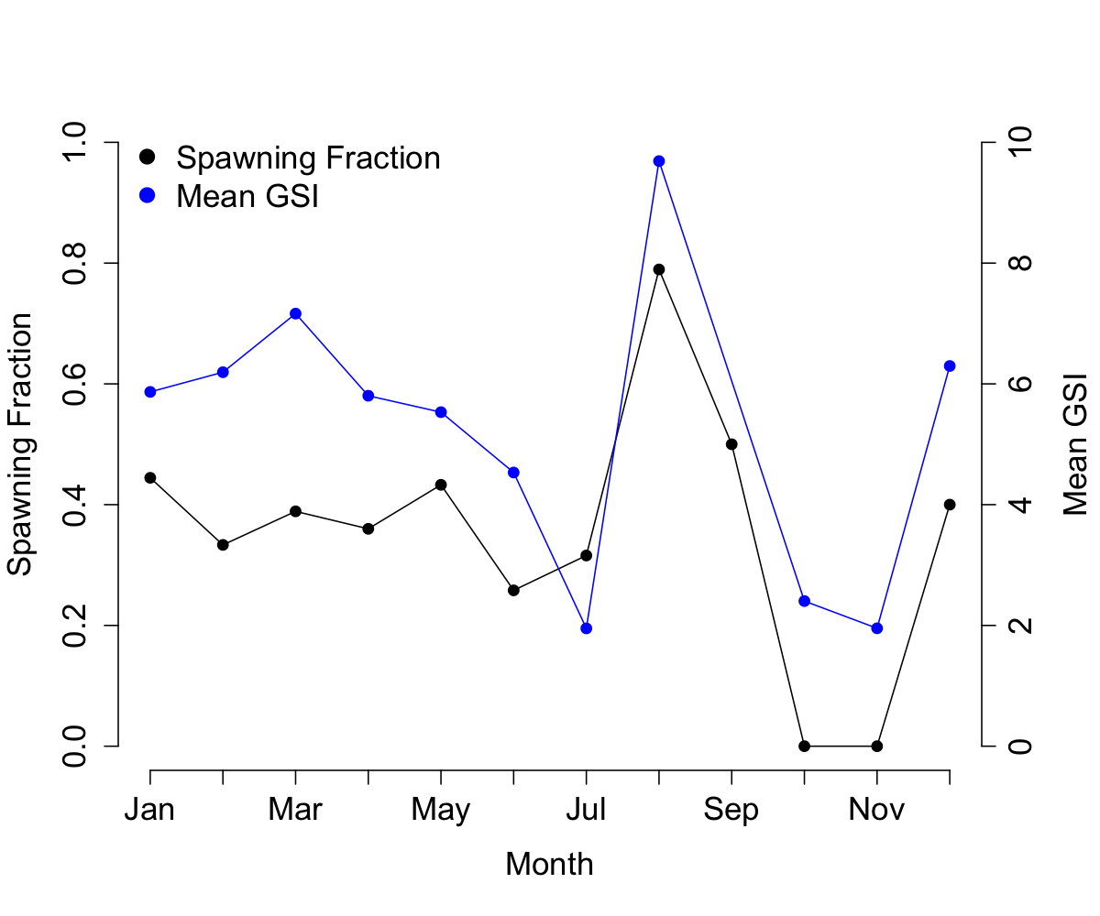
Figure 11. Comparing GSI and histological spawning season assessment for Manini from Maunalua Bay. Average GSI and spawning fraction from January 2013-December 2014.

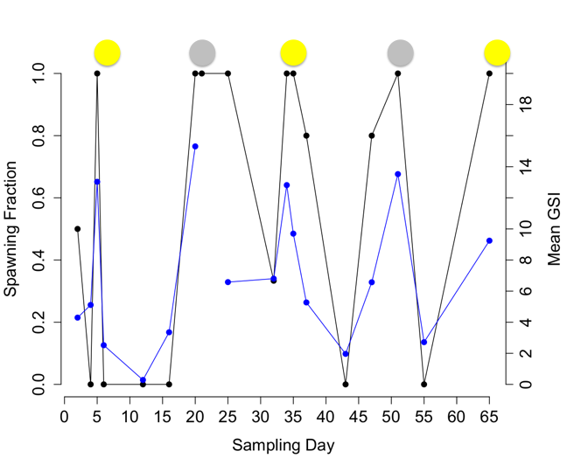
Figure 12. Comparing GSI and histological spawning season assessment for Manini from Maunalua Bay. Average daily GSI and spawning fraction from April 9th, 2014 through June 11th, 2014.

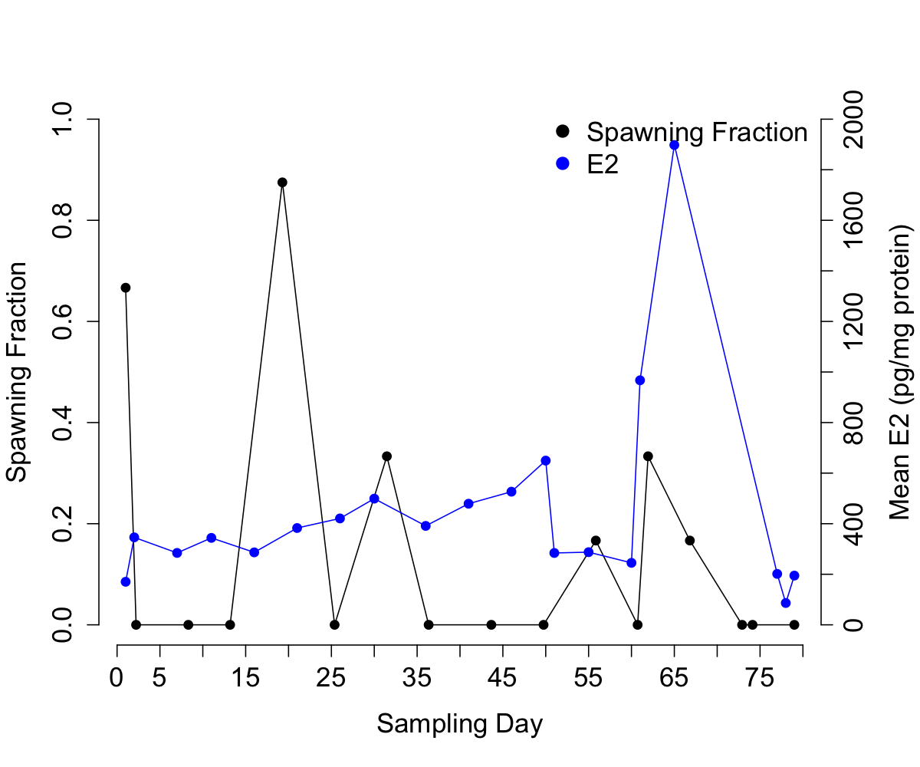
Figure 13. Comparing histological spawning season assessment (spawning fraction) and endocrine analysis of mean estradiol (E2) for Manini from Maunalua Bay. Average daily E2 and spawning fraction from April 9th, 2013 through June 26th, 2013.

Assessment of Spawn Timing (Intraseasonal)
In 2014 samples from Manini were collected approximately every three to five days for two lunar months starting on April 9th and ending on June 11th to determine the spawning timing as either lunar, semilunar, or daily. A semilunar spawning pattern was found for manini from Maunalua Bay. This pattern was not detected in Kiholo and West Hawaii or in Hanalei. The monitoring of the spawning pattern for manini may be influenced by the gear type used. In Maunalua Bay only spear fishing was done to collect gonad samples. In Kiholo and West Hawaii mostly throw net was used to collect gonad samples. Finally, in Hanalei, a combination of spearfishing and throw net was used to collect gonad samples. This finding is particularly important for establishing community based monitoring programs for reef fish.

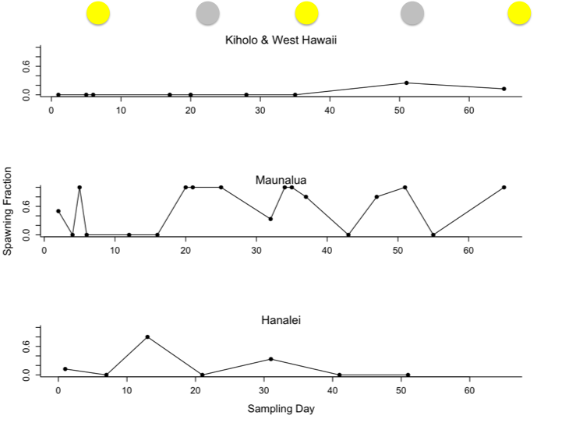
Figure 14. Spawning timing for manini from Kiholo & West Hawaii, Maunalua Bay (South Oahu), and Hanalei Bay (North Kauai). Full moons were on sampling days 7, 37, 66 and new moons were on sampling days 21 and 51
Pono fishing practices: Engaging fishermen in developing sustainable fishing practices

Gathering pono fishing practices and local knowledge
We have gathered pono fishing practices and local knowledge on harvest and spawning seasons through talk story sessions in each community and through a structured survey. We have used this information to determine pono fishing practices to share with communities (see appendix) and fishermen across the state and gather local knowledge on spawning seasons of harvested fish.

Pono Fishing Survey

We had 80 participants in our fishing practice survey last year.
They reported their top ten most targeted fish and their pono fishing practices. The top reported pono fishing practices were incorporated into a pono fishing guide (See appendix).

Top 10 Targeted Fishes:
- Jacks (ulua, papio, omilu)
- Yellowstripe and yellowfin goatfish (weke’a and weke’ula)
- Whitesaddle goatfish (kumu)
- Mullet (‘ama’ama, ououoa)
- Parrotfish (uhu, uhu uliuli, uhu palukaluka)
- Rudderfish, chub (Nenue)
- Surgeonfish (kole and manini), note: surgeonfish and Hawaiian flaigtail tied for 7th place.
- Hawaiian flagtail (aholehole)
- Other surgeonfish (maikoiko, palani, pualu) & scad (akule and opelu) note: other surgeonfish and scad tied for 9th
- Unicornfish (kala, opelu kala)

Seasonal Cycles and Fishermen Observations:
When asked if they observe seasonal cycles in fishery resources, 46.2% of fishermen surveyed answered yes. A total of 57% of fishermen reported to check their catch for eggs or milt to determine if spawning is occurring, but less than 10% record or track this information. This is a large percentage of the fishing population that holds knowledge on spawning seasons of harvested fish. We are promoting sharing of this knowledge through our online website and facebook page and through fishermen logbooks (Lawaia Journals). Additionally, we are piloting 300 logbooks with fishermen from Kiholo, West Maui, Maunalua, and fishermen across the state in an effort to gather information on catch and spawning seasons of harvested fish.

Outreach and Educational Activities
To engaging fishermen and communities in the project and raising awareness of pono fishing practices we held workshops, attended outreach events, lawai‘a camps, and community events, and presented this research at local and national symposiums The outreach events and activities are summarized below.

2014 Outreach Activities and Workshops
Jan 15 – Mililani Middle School Fishing Club – Presented pono fishing practices and taught the kids and their parents how to monitor spawning seasons.
Feb 8-10 Held workshops and sharing sessions in Kiholo and South Kohala
Feb 8 – Kawaihae Festival, South Kohala – Held a booth at the festival and encouraged fishermen participation in the project.
Feb 10 Met with Hui Aloha Kiholo and discussed project goals and shared responsibilities.
March 24 – Hilo Water Resources Meeting – Presented the research at the meeting to encourage collaborations and share project results.
April 5-6 Ocean Expo – Shared a booth with Conservation International Hawaii engage fishermen in the project.
April 26 – Hanauma Bay Birthday Bash – Shared a booth with Malama Maunalua and engaged the community in pono fishing practices.
May 10 Attended the Kohala community meeting
May14- Hanalei Presentation – Presented the moon calendar research at the Princeville Library.
May 30- June 1 – West Maui sampling trip and workshop – Collected kole and manini gonad samples.
June 21-22 –Kiholo sampling trip – Collected manini and kole gonad samples.
July 11-12 – Kiholo Lawai‘a camp – Held a spawning seasons workshop at the camp and collected gonad samples from manini.
July 15-17 Hawaii Conservation Conference – Presented the research through the Moon Phase Project panel and through an individual talk. I was awarded runner up best student talk.
July 19 – Sanctuary Classis and Keiki Fishing Day – Held a booth to engage children in pono fishing practices and checking their catch for eggs.
Aug 4 -5 – Kona IEA symposium – Presented project at the symposium.
Aug 6-7 Met with Kiholo fishermen and discussed future goals and current progress on the project.
Sept 7 – Na Kilo Aina Camp – Held spawning season workshop with elementary to middle school kids from South Kohala.
Nov 8th – Met with Polanui Hui to present current project results and to design the moon calendar.
Nov 12-14th – Western Society of Naturalists Conference – Presented Moon Calendar research as was awarded runner up best student conservation talk.
Nov 21 - Met with Ann Rosinski to talk about makaii watch and spawning seasons.
Nov 22-23 Kiholo Lawai‘a Camp – Held spawning seasons workshop during the camp and collected manini, u‘u, and aholehole gonad samples.

2015 Outreach Activities and Workshops
Feb 7 Polanui meeting – Distributed Moon Calendars to community members. Members will use calendars to start conversations on local fishing practices and raise awareness on Polanuiʻs misson.
Feb 13-15 Malama Makalii Festival – Held a booth at the festival to encourage participating in the project and share results with local fishermen and families of South Kohala and North Kona.
Feb 24 Kiholo - aholehole sampling with bart and keo – tablet meeting
Feb 27 Pacific Islands Climate change meeting – Presented at the symposium as a member of the Stakeholder Driven Adaptation Panel.
March 17 Attended the Fisheries Forum – Handed out Lawai‘a Journals to participating fishermen.

Moon Calendars for Kahekili-Ka’anapali (West Maui) and Kīholo Bay (West Hawaii)
- A 2015 Moon and Tide Calendar was published for the Polanui Community and West Maui. This calendar includes local and scientific knowledge on fish spawning seasons and size at limits. It also highlights Hawaiian measurements, and watershed dynamics. It was developed through a collaboration between the Polanui community, UH Manoa Fisheries Ecology Research Lab, the Ridge to Reef Initiative, DAR, and Maui Nui. The calendars are being used as outreach tools by the Polanui Community to approach fishermen and highlight pono fishing practices for the area.
- A 2015 seasonal poster was published for West Hawaii that includes observations on fish spawning seasons and size limits along with observations on seasonal cycles of the area that were made by community members. Additionally we worked with the community to modify and print an observational poster for communities to use to record their seasonal observations during local workshops and gatherings. The seasonal poster and observation poster is used as an educational tool by Kaupulehu, Kiholo, and Kailapa communities, among others.

Deliverables and Outcomes (How did this project address critical management needs?)
- This project has increasing community-based resource management and conservation in the Hawaiian Islands by identifying local pono fishing practices and combining this traditional knowledge with scientific techniques. These pono practices include lunar harvest patterns for certain species to protect spawning schools. We have already seen these practices being incorporated into the communities. For example, fisherman are checking the reproductive status of the fish that they harvest and tracking spawning seasons in their logbooks. Additionally, behavioral changes have been reported from community monitors. One example is a throw net fisherman seen releasing milting fish (a sign that spawning is occurring) back into the ocean and including catch and release categories in local fishing tournaments.

- Local information on fish spawning and reproduction along with pono fishing practices was disseminated to the community to further community-based stewardship. One way we achieved this goal is through a detailed moon calendar for the West Hawaii and West Maui for 2015. Another way we achieved this goal is through local outreach events were we stressed the importance of harvesting outside of spawning seasons and appropriate harvest sizes.
- This project has provided valuable reproductive characteristics (L50, fecundity, spawning seasons) that are needed to update management size limits and closed seasons for several nearshore fishery species. This project is also continuing this research to assess the spatial and temporal variation in these reproductive characteristics to provide a better context for coral reef management decisions, particularly as they pertain to local management. We are achieving this through gonad collection of priority species at our study sites over several years. We are creating a database of this information for long term monitoring and analysis of spatial and temporal variation in reproductive characteristics.
- We collaborated with communities, fishermen, Conservation International’s Hawaii Fish Trust, NOAA Papahanaumokuakea Marine National Monument, NOAA Hawaii Islands Humpback Whale National Marine Sanctuary, and the Hawaii Division of Aquatic Resources (DAR) to encourage the application of this knowledge to advise and hopefully improve current and future coral reef fisheries management decisions. We achieve these collaborations through several meetings, joint outreach events, joint Moon Calendar development, and research assistance.

Obstacles

Species Collection
Kole were collected rigorously, however fewer than expected gonad samples were collected from participating fishermen due to the difficulty in finding the gonads in non-spawning fish. In kole the gonad tissue is very small (<0.01 grams) during non-spawning months and in immature fish. We are working with fishermen to resolve this obstacle.

Kala were not collected rigorously. Many of the local fishermen were against the collecting of kala at the sample sizes that are needed to determine spawning seasonality and spawning pattern. Additionally, not many gonad samples were donated from participating fishermen because the kala are cooked without gutting the fish first. We were able to collect 27 kala gonad sample in 2014 and we are using this information to compare to the previously done research on Kala in Hawaii by DeMartini et al 2014. From these samples we were able to estimate a size at maturity for females and we did find that kala spawning seasons are variably on an annual scale.

Endocrine Assays
The endocrine assay was affected by the lipids in the gonad samples. We are working on an extraction protocol that will separate out the sex hormones of interest from lipids and proteins in the gonad sample. This method, if successful, will be the first of its kind to detect sex hormones from gonad tissues. We will use this method to determine the sex hormone concentrations from manini gonad samples collected in 2014 to compare this method for detecting spawning timing with GSI and histological assessment methods.
Appendix

Tables

Table 1. Histological classification of oocyte development.
- Reproductive State | - Gonad Stage | - Diagnostics
- Undeveloped | - Chromatin nucleolar | - Large nucleus (germinal vesicle) surrounded by a thin layer of cytoplasm. Stains darkly and uniformly with Toluidine Blue.
- Undeveloped | - Perinucleolar | - The germinal vesicle increases in size and nucleli appear at its periphery. The cytoplasm stains uniformly with Toluidine Blue.
- Developing | - Cortical alveoli | - Appearance of cotical alveoli (yolk vesicles) in the cytoplasm and formation of the vitelline membrane.
- Mature- Spawning Capable | - Vitellogenic | - Appearance of yolk proteins. The oocyte dramatically increases in size.
- Mature-Spawning Capable | - Hydrated 1 | - Beginning of hydration (coalescence of yolk granules and migration and dissolution of the nucleus). Oocyte shape round.
- Mature- Spawning Capable | - Hyrdated 2 | - Oocyte fully hydrated. Oocyte shape irregular.
- Mature-  - Spent (Regressing) | - Atresic | - Presence of retained oocytes post spawning. Atresic oocytes lose their spherical appearance and the membrane breaks down. Post ovulatory follicles (POFs) present.
- Mature-Regenerating | - Chromatic nucleolar, Perinucleolar, Cortical alveoli | - Oocytes in various stages. No vitellogenic oocytes present. The ovary wall is thick and the ovary may contain unabsorbed material from past spawning events.

Figures

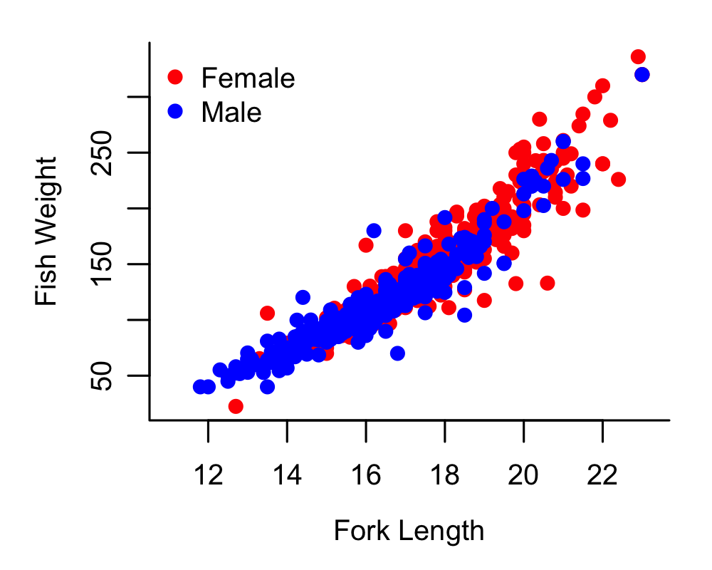
Figure 1. Manini weight/length relationships for all locations combined.

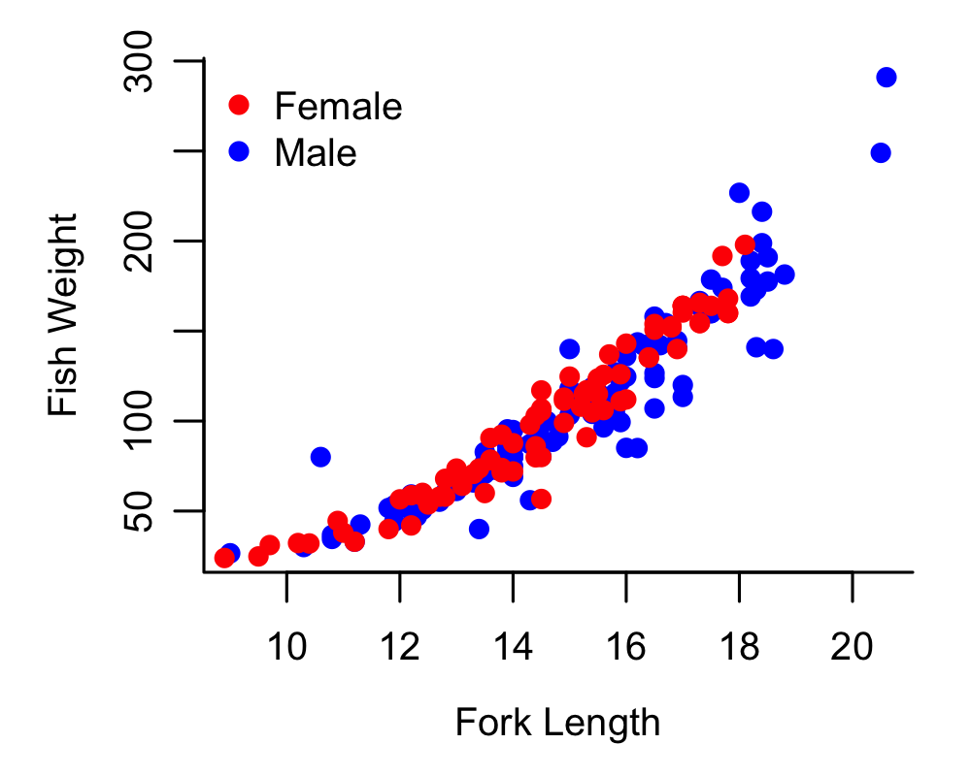

Figure 2. Kole weight/length relationships for all locations combined.

Pono Fishing Guide
