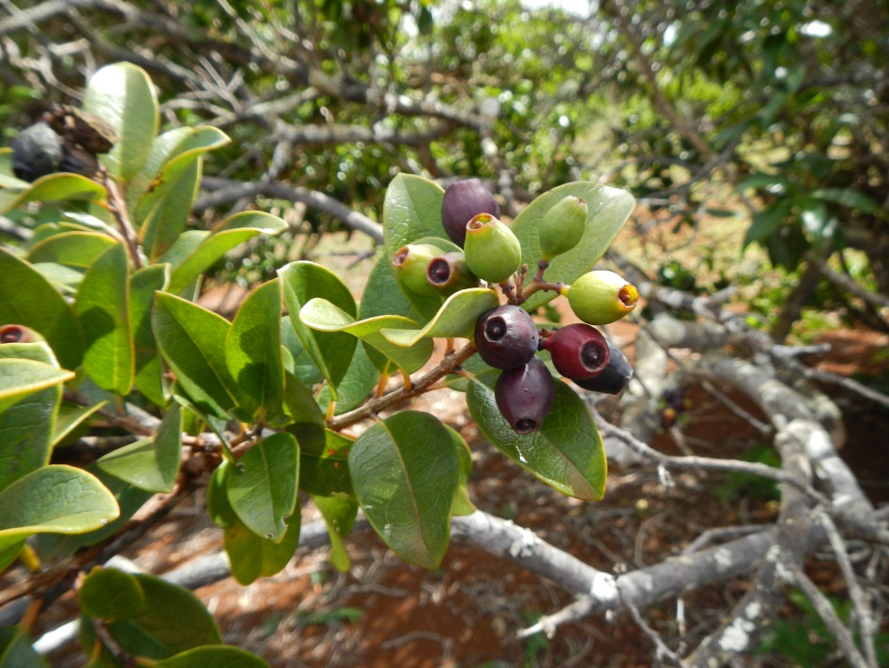
Kānepu‘u Preserve, Lāna‘i, Hawaiʻi
Long-Range Management Plan
Fiscal Years 2017-2022

Submitted to the
Department of Land & Natural Resources
Natural Area Partnership Program
and
Pūlama Lānaʻi

Submitted by

The Nature Conservancy – Hawai‘i Operating Unit

February 2016

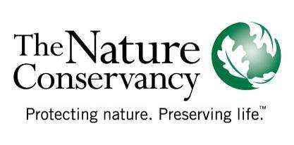

CONTENTS

EXECUTIVE SUMMARY 1
ANNUAL DELIVERABLES SUMMARY 4
RESOURCE SUMMARY 5
General Setting 5
Flora and Fauna 5
MANAGEMENT 7
Management Considerations 7
Management Units 12
Management Programs 13
Program 1: Non-native Species Control 13
A. Ungulate Control 13
B. Invasive Plant Control …………..…………… 15
C. Small Mammal Control, Invertebrate Pest, Pathogen Prevention & Control 16
Program 2: Fire Control 17
Program 3: Restoration, Research and Monitoring 17
Program 4:Community Outreach 17
ENVIRONMENTAL REVIEW COMPLIANCE 18
BUDGET SUMMARY 19
BUDGET TABLE 20

Table 1. Overview of Kānepu‘u Preserve Accomplishments by Programs, FY11-FY15 (5 Years) 3
Table 2. Deliverables Summary 5
Table 3. Important Weed Species in Kānepu‘u Preserve 17

Appendix 1. Rare Native Species of Kānepu‘u Preserve………………………………………………………………………………………….21

Figure 1. Location of Kānepu‘u Preserve, Lānaʻi 4
Figure 2. Kānepu‘u Preserve units and natural communities. 8
Figure 3. Deer proof plastic mesh fence at Paomaʻi 2. 9
Figure 4. Units fenced for zero tolerance of animals. 10
Figure 5. Self-guided trail. 11
Figure 6. The self-guided trail offers the opportunity for visitors to view rare dryland forest species. 11
Figure 7. Lama is the dominant native species along the self-guided trail. 12
Figure 8. Plaque dedicated to Lāna‘i Kupuna. 12
Figure 9. Olopua resprouting from the base (L); Lama and alahe'e seedlings naturalizing in deer-free subunits. 13
Figure 10. Kānepu‘u and Kahue units and natural communities. 13
Figure 11. Deer outside of the Kānepu‘u perimeter fence. 14
Figure 12. Retrofit to extend height of Lapaiki fence. 15
Figure 13. Native groundcovers like ‘ilima and ‘uhaloa recover after deer removal (right of picture, inside Lapaiki crossfence). Note large number of deer prints outside of fence (left of picture). 15
Figure 14. Invasive plant specialist Pat Bily demonstrates how to treat Passiflora suberosa. 16
Figure 15. Evidence of rat predation on nā‘ū. 17
Figure 16. TNC brought dryland restoration expert Butch Haase from Moloka‘i Land Trust to Kānepu‘u to offer suggestions to staff and subawardee crew on enhanced passive and active restoration. 19

EXECUTIVE SUMMARY
The Nature Conservancy of Hawai‘i (TNCH) is an affiliate of The Nature Conservancy (TNC), an international private, non-profit organization based in Arlington, Virginia. The mission of The Nature Conservancy is to conserve the lands and waters on which all life depends. Since 1980, TNC has protected more than 200,000 acres of natural lands in Hawai‘i and works with other public and private landowners to protect the islands’ key watersheds. TNC manages a statewide network of 14 preserves totaling 40,000 acres and works in 19 coastal communities to protect the coral reefs and near-shore waters of the main Hawaiian Islands.

The State’s Natural Area Partnership Program (NAPP) is an innovative program that aids private landowners in the management of their native ecosystems. NAPP provides matching funds ($2 state to $1 private) for the management of qualified private lands that have been permanently dedicated to conservation. On Lāna‘i, TNCH manages the Kānepu‘u Preserve, which was first approved for NAPP funding in 1992, and soon thereafter TNCH implemented the management programs described in our initial plan, Kānepu‘u Preserve FY1992-FY1997 Long-Range Management Plan (LRMP). In 1997, NAPP funding for a new six-year period was reauthorized following a renewal procedure which included the preparation of an updated plan (Kānepu‘u Preserve FY1998-FY2003 Long-Range Management Plan) and environmental assessment (Final Environmental Assessment for Kānepu‘u Preserve Natural Area Partnership, 1997). NAPP funding was again reauthorized for FY2005 through 2010 and for FY2011 through FY2016. In 2014, the NAPP program implemented the use of a streamlined, data-driven spreadsheet to propose and report on deliverables.

TNCH is currently seeking reauthorization of NAPP funding for the next six-year period for the programs described within this Kānepu‘u Preserve FY2017–FY2022 Long-Range Management Plan. This plan continues the programs implemented under the previous plans and environmental assessments. Herein, we request $120,000 in matched state funds for the six years spanning FY2017–FY2022. This plan was prepared in compliance with the NAPP agreement between the state, TNCH, and Hawai‘i Administrative Rules Chapter 13-210.

We successfully implemented the resource management projects of the most recent six-year long-range plan. See Table 1.

Table 1. Overview of Kānepu‘u Preserve Accomplishments by Programs, FY11-FY15 (5 Years)
 | Indicator | Measure of Success
Ungulate Control
Total animal catches |  | - 226 axis deer removed  - 24 mouflon sheep removed
Miles of fence installed maintained or replaced in Kānepu‘u  Units deer free |  | - .62 miles of perimeter fence around Paoma‘i 2 unit completely replaced with deer-proof plastic mesh  - .44 miles of fence installed to form the Awalua subunit  - .45 miles of fence installed to form the Kahue iki subunit  - .10 miles of fence installed to form the Polihua subunit  - .55 miles retrofitted to extend height, Lapaiki subunit  - 8.13 miles of fence maintained monthly and/or semimonthly  - 4 fenced subunits are deer free and 2 others are nearly deer free
Invasive Plant, Invertebrate and Small Mammal Control
Acres and total numbers of priority invasive plants treated or removed |  | - Christmasberry, lantana, corky passion vine, guinea grass and plantain treated regularly across 4 -5 acres
Partner support  Small mammal traps |  | - MISC swept areas just outside preserve and treated 25 fountain grass  - 10-15 rat traps maintained around Gardenias
Resource Monitoring
Fire Control |  | - 10 foot wide corridors maintained along fences  - Boundary fences mowed as needed
Rare Species Protection and Research
Numbers of new rare taxa discovered and/or mapped |  | - Rare plant surveys conducted annually by PEP  - 39 new rare taxa locations for Bobea sandwicensis (3), Nesoluma polynesicum (29), Reynoldsia sandwicensis (7)
Number of research projects supported in Kānepu‘u |  | - Access support was granted to PEPP for Gardenia and other rare plant monitoring
Community Outreach
 |  | - New self-guided interpretive trail installed

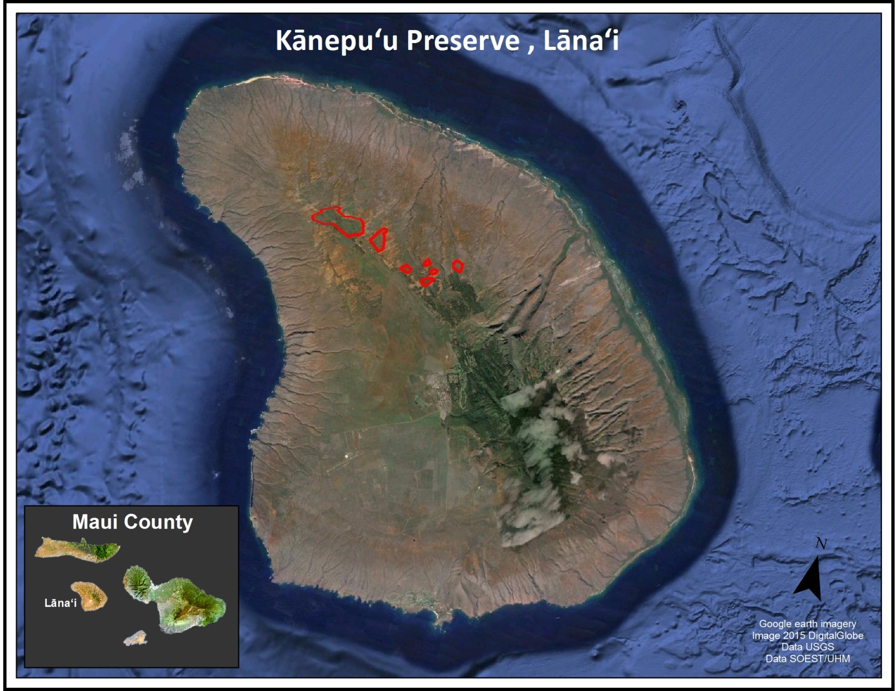
Figure 1. Location of Kānepu‘u Preserve, Lānaʻi

TNCH’s conservation priorities are focused in areas with the highest conservation value and feasibility of success. We continue a scaled-back management effort at Kānepu‘u due to budgetary constraints. Management programs have been contracted out since FY2005. We have been actively seeking other entities to assist us with management of the preserve. In the meantime, TNCH continues to carry out ungulate, weed, and fire control programs by partnering with a local contractor or grantee, and working with local community members. One local community member in particular, Bob Hera, and his team of volunteers contributed substantially to the progress described above. TNC Maui staff oversee and occasionally supplement management activities carried out by the contractor or grantee and local community members.

ANNUAL DELIVERABLES SUMMARY
The annual deliverables listed below are approximate, and are derived directly from the NAPP deliverables spreadsheet (also attached), for easy reference.

Table 2. Deliverables Summary
UNGULATE CONTROL
Subunit | Threat |  | Current Status |  |  |  | Goal Action |  |  | Goal Quantity of Action |  | Frequency
Kahue iki | Deer/Sheep |  | Maintenance at zero |  |  |  | Hunts |  |  | As Needed |  | As Needed
Lapaiki | Deer/Sheep |  | Decreasing |  |  |  | Hunts |  |  | As Needed |  | As Needed
Awalua 1 | Deer/Sheep |  | Decreasing |  |  |  | Hunts |  |  | As Needed |  | As Needed
Polihua iki | Deer/Sheep |  | Maintenance at zero |  |  |  | Hunts |  |  | As Needed |  | As Needed
FENCE WORK
Fence Section |  | Goal Action |  |  |  | Goal Meters for Action |  |  |  |  | Frequency
Kānepu‘u Unit |  | Inspect/maintain |  |  |  | 5745 |  |  |  |  | Quarterly
Kānepu‘u Internal Fence |  | Inspect/maintain |  |  |  | 891 |  |  |  |  | Bi-monthly
Lapaiki Exclosure |  | Inspect/maintain |  |  |  | 291 |  |  |  |  | Bi-monthly
Kānepu‘u Exclosure |  | Inspect/maintain |  |  |  | 255 |  |  |  |  | Bi-monthly
Paoma‘i 2 Unit |  | Inspect/maintain |  |  |  | 896 |  |  |  |  | As possible
Kahue Unit |  | Inspect/maintain |  |  |  | 2712 |  |  |  |  | Quarterly
Kahue iki |  | Inspect/maintain |  |  |  | 1002 |  |  |  |  | Bi-monthly
Polihuaiki |  | Inspect/maintain |  |  |  | 196 |  |  |  |  | Bi-monthly
Awalua 1 |  | Inspect/maintain |  |  |  | 1096 |  |  |  |  | Bi-monthly
WEED CONTROL
Subunit | Species Targets |  |  |  | Action |  |  | Acres of Survey |  | Weed Status |  | Frequency
Kānepu‘u iki | Passiflora suberosa, Schinus terebinthifolius, Lantana camara |  |  |  | Ground sweep and control |  |  | 1 |  | Constant |  | Monthly
Lapaiki iki | Schinus terebinthifolius, Lantana camara, Passiflora suberosa |  |  |  | Ground sweep and control |  |  | 1 |  | Constant |  | Monthly
Polihua iki | Schinus terebinthifolius, Lantana camara, Plantago lanceolata, Megathyrsus maximus, Passiflora suberosa |  |  |  | Ground sweep and control |  |  | 3 |  | Decreasing |  | Monthly
Kahue iki | Schinus terebinthifolius, Lantana camara, Passiflora suberosa |  |  |  | Ground sweep and control |  |  | 4 |  | Increasing |  | Monthly

SPECIES MONITORING
Species | # species expected | Proposed Action | Frequency
Sanfrelan | 6 | Check | Quarterly
Nespol | 55 | Check | Quarterly
Bobsan | 10 | Check | Quarterly
Reysan | 10 | Check | Quarterly
Garbri | 11 | Check | Quarterly

RESOURCE SUMMARY

General Setting
Kānepu‘u Preserve was established in November 1991 through a perpetual conservation easement with Castle and Cooke. In 2012, Larry Ellison, through his company Lāna‘i Resorts LLC doing business as Pulama Lāna‘i, purchased 98 percent of Lāna‘i from Castle & Cooke, Inc., which includes the lands on which Kānepu‘u Preserve lies. The conservation easement transfers with the landowner, and TNC continues to manage the preserve. The preserve was created to protect and enhance the olopua/lama (Nestegis/Diospyros) dryland forest that once covered large portions of the lowlands on Maui, Moloka‘i, Kaho‘olawe, and Lāna‘i. Today, Kānepu‘u Preserve contains the last major remnant of this rare dryland forest community. See Figure 2.

The climate at Kānepu‘u is relatively dry. Rainfall averages 71 cm. (28 in.) per year and falls primarily in the rainy season from November through March. Additional moisture comes in the form of fog that condenses on vegetation. Tradewinds are accelerated by funneling between the upwind islands of Moloka‘i and Maui. These strong and nearly constant winds increase evaporation of moisture, vegetation loss, and soil erosion in and around Kānepu‘u. In some places, over six feet of soil has been lost. These degraded areas usually have little vegetation and are therefore even more susceptible to additional erosion. Many of the eroded areas are characterized by a hard pan substrate that appears unsuitable for plant establishment. Other eroded areas are comprised of dunes of wind-blown soil that may shift with the season.

The preserve is comprised of seven separate larger units that range from 13 to 368 acres in size and total 590 acres (Figure 2). Major threats to the preserve’s native vegetation are introduced game animals (axis deer and mouflon sheep), cattle, rapid soil erosion, wildfire, and a number of invasive alien (non-native) plants. Much of this area was protected from 1911 through 1935 by fencing and other efforts carried out by George Munro, the then ranch manager for the area. Subsequent ranchers removed these fences. From 1970 to 1989, dedicated volunteers and the Hui Mālama Pono O Lāna‘i built four small fenced exclosures that helped protect patches of native forest and associated rare plants. Without these efforts, the last remnants of this rare Hawaiian forest type would probably have been destroyed.

Flora and Fauna
Two plant communities dominate Kānepu‘u Preserve: the native closed-canopy olopua/lama dryland forest and an alien shrubland. Some sections of the preserve are bordered by a windbreak of non-native trees. Areas of bare soil occur throughout the preserve.

The native forest canopy is dominated by lama (Diospyros sandwicensis) and olopua (Nestegis sandwicensis). The canopy also contains non-native Christmas berry (Schinus terebinthifolius) and up to 12 native species including ‘ohe makai (Reynoldsia sandwicensis), ‘ahakea (Bobea sandwicensis), ‘āla‘a (Pouteria sandwicensis), and ‘aiea (Nothocestrum latifolium). The understory has been severely damaged as a result of historical grazing and few native species remain. Common understory weeds include lantana (Lantana camara), scarlet sage (Salvia coccinea), corky passion vine (Passiflora suberosa), and several grasses including dallis grass (Paspalum dilatatum) and molasses grass (Melinis minutiflora). Figure 2 shows the current natural communities of the Kānepu‘u Preserve.

Eleven rare plant taxa have been reported in Kānepu‘u Preserve; six of these are listed as federally endangered. However, two of these listed species, along with another with no federal status, are known only from historical records and have not been seen in Kānepu‘u Preserve since 1930 (Appendix 1). The three endangered plant species currently in the preserve are: the fragrantly flowered Gardenia brighamii or nā‘ū, sandalwood or ‘iliahi (Santalum freycinetianum var. lanaiense), and the ma‘o hau hele (Hibiscus brackenridgei). The Lāna‘i populations of Gardenia brighamii account for approximately 2/3 of all known Gardenia brighamii plants in the wild. It is believed that the ma‘o hau hele was planted in the preserve and may not have occurred there naturally. Bonamia menziesii was also known from the preserve but has not been seen since 2008.

Two native birds frequent Kānepu‘u Preserve: the pueo (short-eared owl, Asio flammeus sandwichensis) and the kōlea (Pacific golden-plover, Pluvialis fulva). Eleven non-native birds are also found in the preserve’s forest and open areas. At least ten different land snail taxa were identified in a subfossil sample found in the preserve.

Kānepu‘u Preserve’s arthropod fauna has been the subject of sporadic research over the years. Studies and collections have found 153 different insect species, nineteen spiders, two isopods and one species of amphipod. Native taxa include a pyralid moth, mirids, drosophilids (fruit flies), yellow-faced bees, sphecid wasps, bark lice, endemic flightless moths, the endemic Hyles sphinx moth and a Blackburn’s Sphinx moth.
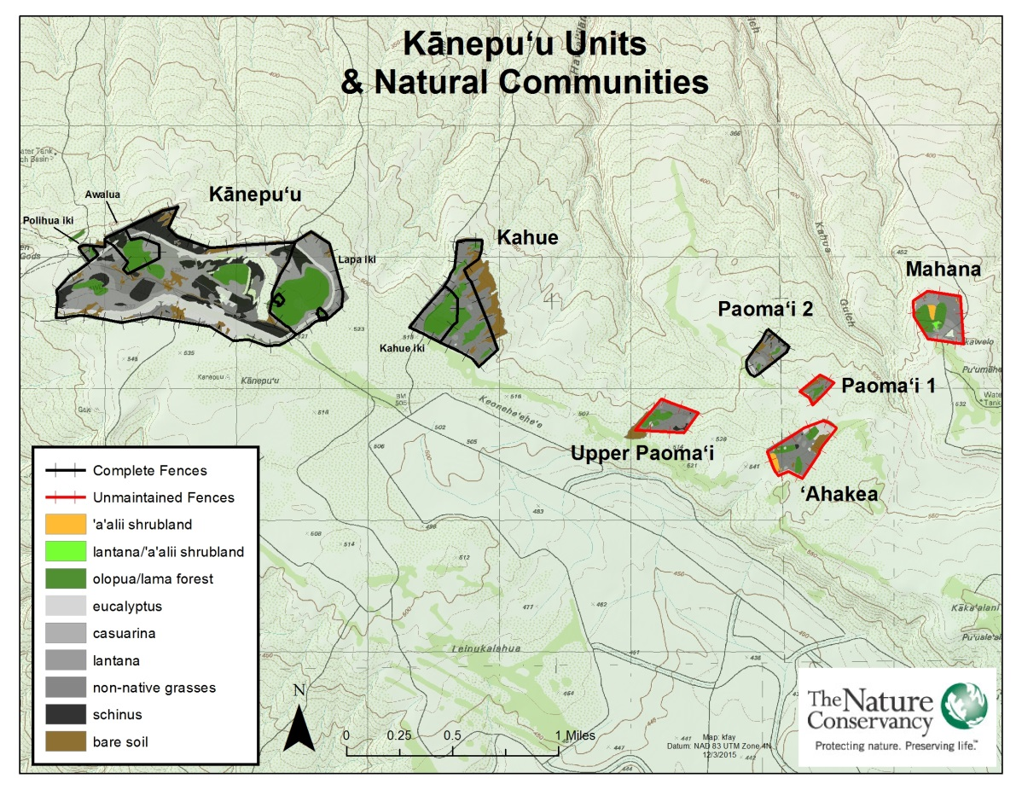
Figure 2. Kānepu‘u Preserve units and natural communities.

MANAGEMENT

Management Considerations
Animal Ingress
The lands surrounding Kānepu‘u Preserve support sustained-yield sport hunting of axis deer and mouflon sheep. Efforts to fence and maintain all seven units in an ungulate free status have been unsuccessful due to persistent, salt-laden winds degrading the fences. Small, biologically rich areas within the larger units have been fenced and maintained at very low to zero ungulate levels. Additional funding could pay for replacement of perimeter fencing around the five remaining units. One option that TNC is currently investigating is the integrity of high quality deer-proof plastic mesh fencing, installed at 8 feet and stretched across stainless wire and/or high density polypropylene line. This type of fence was installed at Paomaʻi 2 in 2014 and has held up well against the elements and deer pressure.(Figure 3).

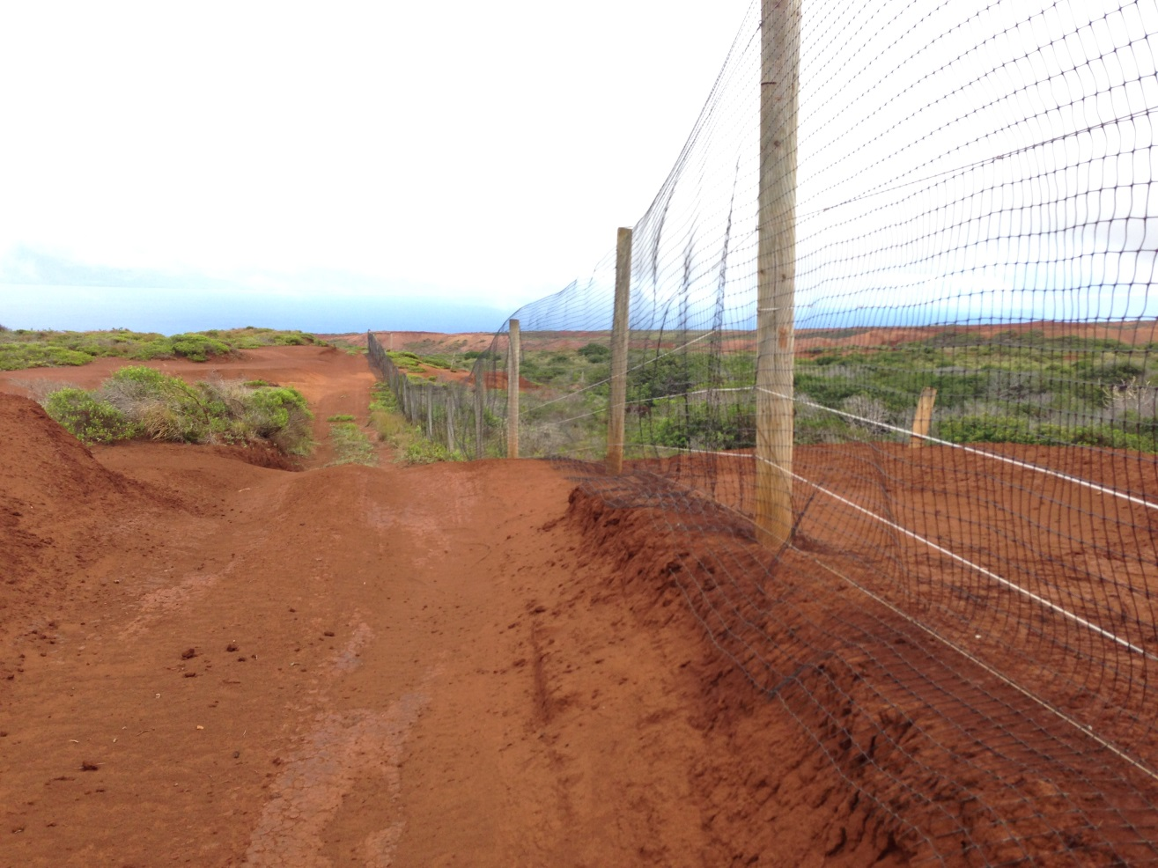
Figure 3. Deer proof plastic mesh fence at Paomaʻi 2.

Environment and Historical Fencing
Due to past deforestation and grazing by animals, massive wind and rain erosion remains a major threat to our fences. Erosion problems caused by heavy rains are often the focus of fence maintenance efforts. We have learned that once the galvanizing on the 12.5 gauge fence wire becomes noticeably corroded, the wire fails quickly (within about 6 months). Salt spray, carried three miles inland and up to Kānepu‘u Preserve's 1,700-foot elevation, seems to be the largest corrosive factor, as well as the constant sandblasting from adjacent eroded mineral soils. Professional fence builders and natural area managers surmise that the dry environs of Kānepu‘u, exacerbated by drought, have allowed salt spray to stick to the wire rather than being washed clean by rains. Only where a tall shrub, tree, or fence post protects wire from the salt spray is corrosion minimal or non-existent. The corrosion appears accelerated where the fence is downwind from an unvegetated area; this is probably due to soil particles constantly battering the fence. While we considered re-vegetation as part of the fence protection program, it appears that only tall vegetation will protect the fence however, this poses other problems to fence maintenance. In 1992, TNC completed installation of a 6’3” tall deer fence around each of the seven patches of forest to prevent further damage by grazing animals. From 1996 through 2001, various sections of fence were replaced due to severe corrosion from harsh environmental conditions. In 2002 and 2003, the fences around the two most biologically important units (Kahue and Kānepu‘u) were upgraded to stainless steel wire in an attempt to fend off corrosion problems. In FY2014 TNC replaced 998 meters of fence around the Paoma‘i 2 unit with experimental plastic mesh designed to withstand 900 lbs. of pressure and has a 20 year lifespan. See Figure 4. TNCH may decide to replace or retrofit the fencing for the other units at a later date.

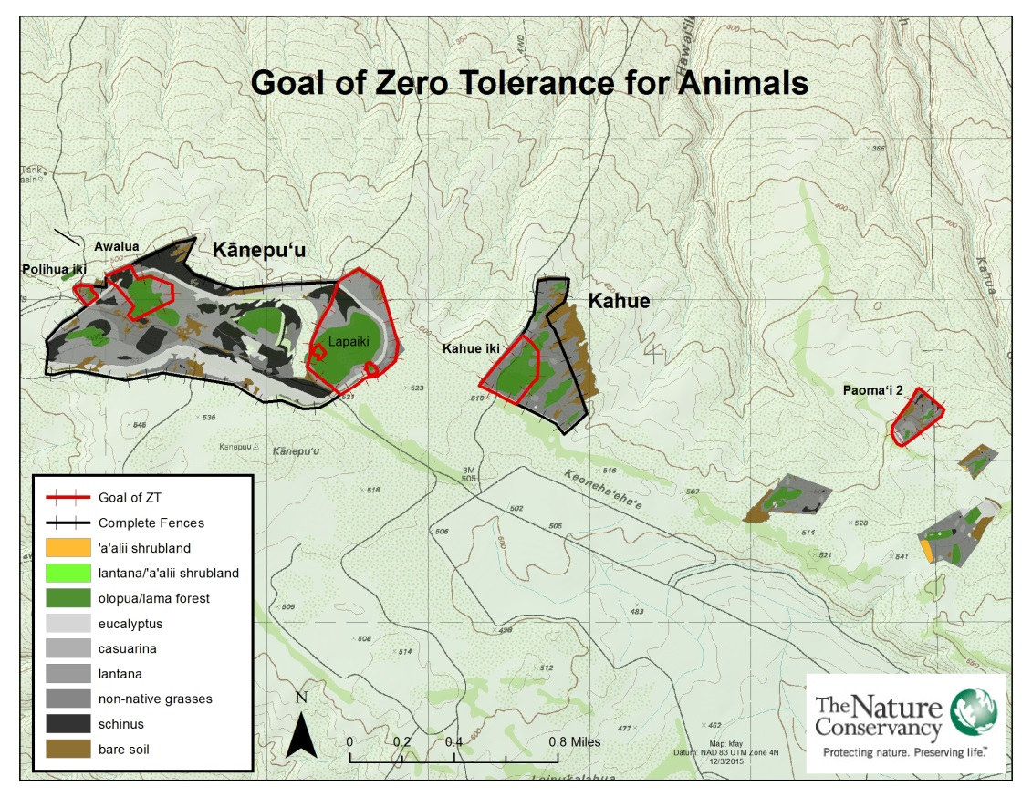
Figure 4. Units fenced for zero tolerance of animals.

Access
All units of the preserve are accessible by dirt roads, although four-wheel drive vehicles are needed during wet weather. Some of the outer unit roads show signs of increased erosion. Unit boundaries, fence lines, and firebreaks are mostly accessible via tractors or other equipment. Access to the preserve is generally obtained through abandoned pineapple field roads, which may change over time. The preserve is easily accessible on foot. Mapped corridors that link the seven preserve units were established to satisfy county subdivision requirements and do not represent road access between units.

Community
The Lāna‘i community and other members of the public were involved at Kānepu‘u before it was a TNC preserve. As such, interpretive opportunities for the community and the public will continue as feasible. A 750-meter self-guided trail that was originally established in the Kānepu‘u unit in 1997 along the main road was decommissioned in 2008 as it did not allow for viewing of native ecosystems. In FY2014 a new self-guided interpretive trail was officially opened along Polihua Road at the Polihua iki subunit of the main Kānepu‘u Unit .
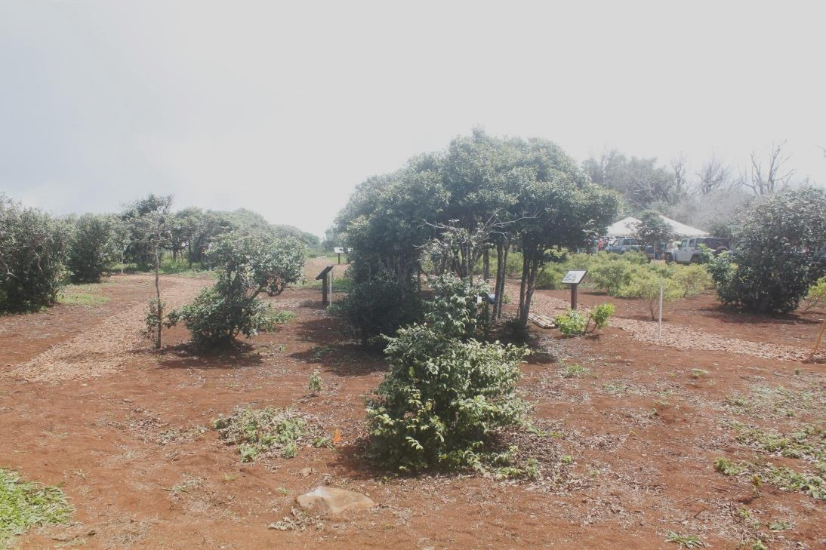
Figure 5. Self-guided trail.

The trail offers the public an opportunity to view rare and native dryland forest species that otherwise would be difficult to see in Hawai‘i. This trail was dedicated to the Lāna‘i Kupuna who played a role in the early days of Kānepu‘u, with a successful dedication ceremony held in April 2014.

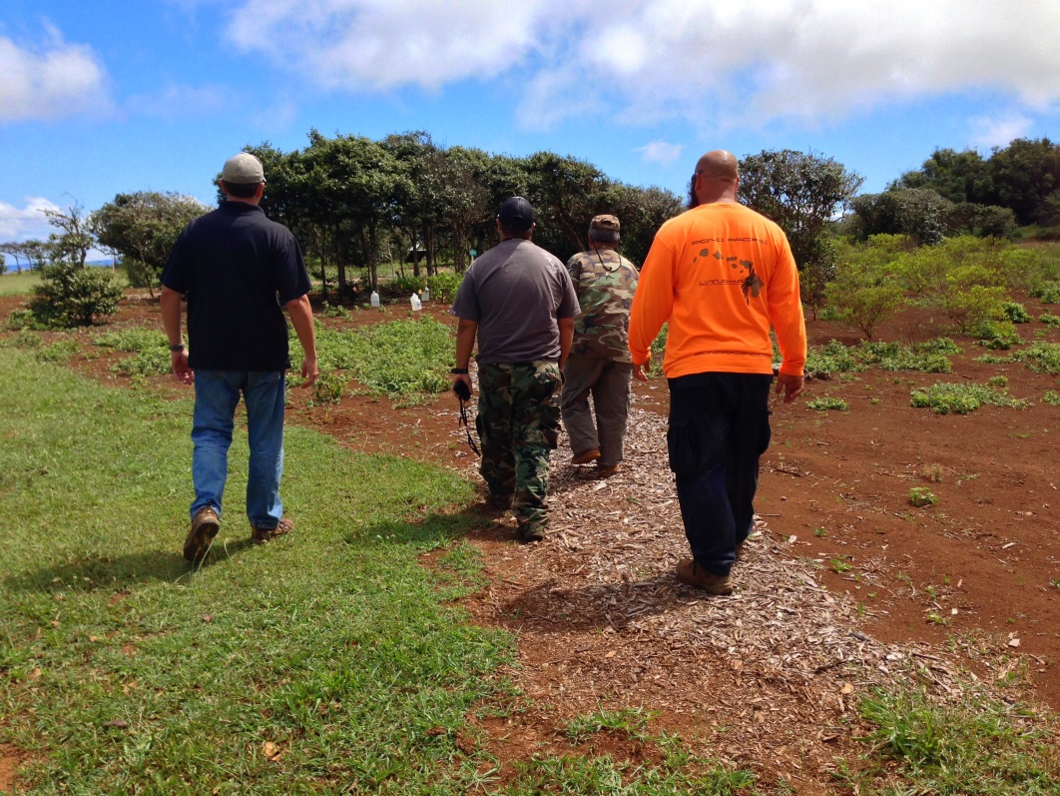
Figure 6. The self-guided trail offers the opportunity for visitors to view rare dryland forest species.

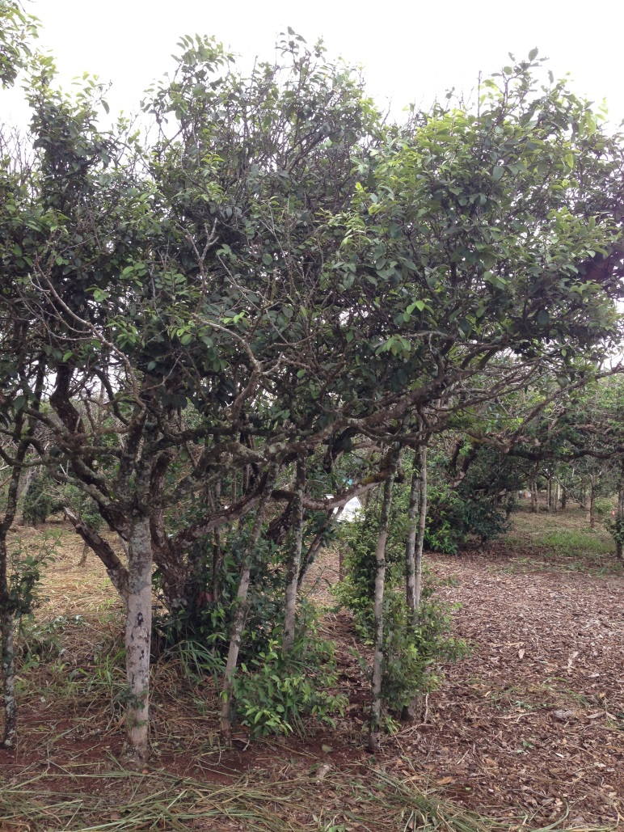
Figure 7. Lama is the dominant native species along the self-guided trail.

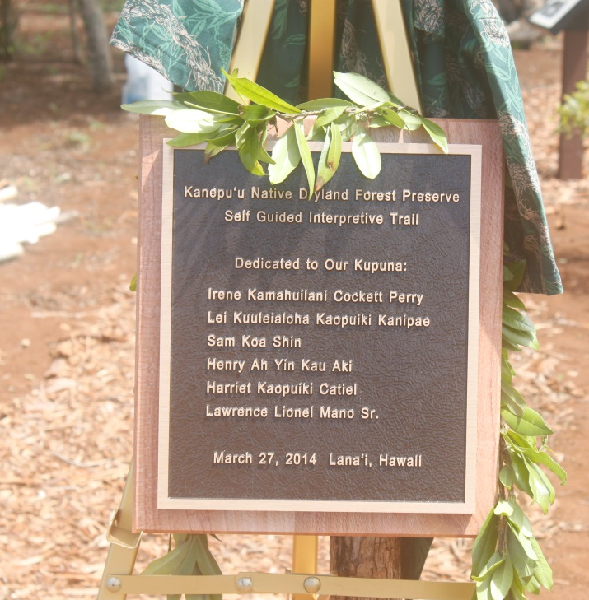
Figure 8. Plaque dedicated to Lāna‘i Kupuna.
TNC continues attempts to forge bonds with the local community and encourages the subawardee to seek out youth and other Lāna‘i residents who may be interested in holding a stewardship position at Kānepu‘u Preserve in the future.

Native Plant Revegetation
Over the past ten years, we have noted the increasing presence of native tree seedlings of many species (previously deer had eaten seedlings). Moreover, mature trees, formerly stripped of leaves and branches to the height a deer can reach, are now re-sprouting from the base.

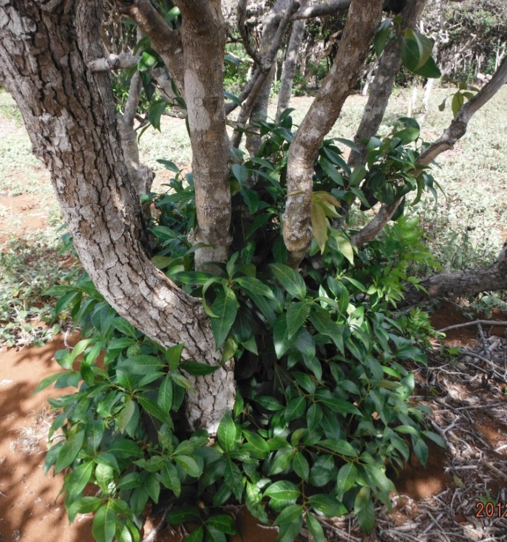
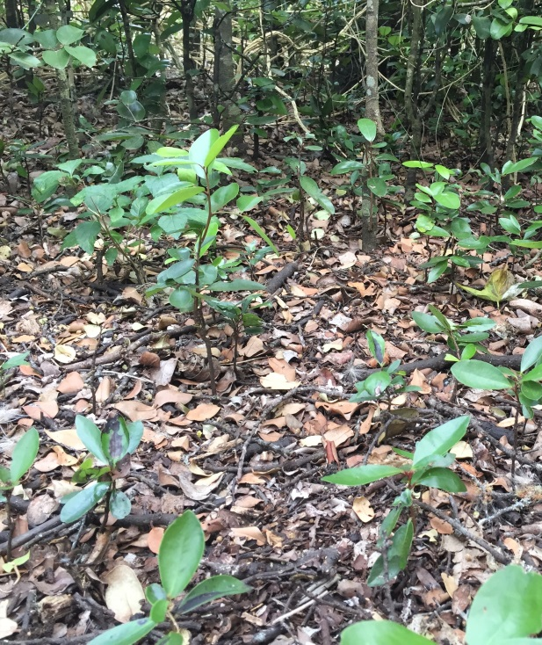

Figure 9. Olopua resprouting from the base (L); Lama and alahe'e seedlings naturalizing in deer-free subunits.

A central challenge of conservation in Hawai‘i is to integrate stewardship of native resources with community development, planning, corporate/landowner needs, and the priorities of the grass-roots community. Because of the history of community grass-roots involvement at Kānepu‘u, we initiated a capacity building effort in 1998 with the Hui Mālama Pono O Lāna‘i and other interested groups. The goal was to increase their organization effectiveness and develop a solid fundraising track record so that eventually they could become the managers of Kānepu‘u Preserve. To date, no community group has demonstrated the financial, administrative, and management capacity to manage Kānepu‘u Preserve. TNCH believes that a community-based organization will provide the best solution for long-term management of the preserve. Should a suitable group present itself during the course of this six-year plan and with landowner approval, TNCH will consider a management partnership with the new entity.

Management Areas/Units
The preserve is divided into seven main units.
- Kahue unit has the highest diversity of rare plants. Kahue iki, a subunit in Kahue, is deer free and serves as an outplanting location for the Plant Extinction Prevention Program. It contains Santalum, Gardenia, Bobea, Nesoluma, Reynoldsia and Myoporum among the Nestegis and Diospyros community. See Figure 7.
- Kānepu‘u unit has the largest patches of native forest, including three enclosed subunits that are managed for zero tolerance ungulates: Polihua iki (where the self-guided interpretive trail is located), Awalua 1, and Lapaiki. The Lapaiki subunit is 64 acres and has two one-acre exclosures inside where invasive plant removal is focused in order to maintain the integrity of the dense native canopy and communities. Kānepu‘u unit is dissected by a public road allowing easy access to the Polihua iki interpretive trail. Kānepu‘u unit is home to at least nine Gardenia brighamii, which are an important seed source for the Plant Extinction Prevention Program. See Figure 7.
- ‘Ahakea unit has rare plants and patches of native forest.
- The three Paoma‘i units contain nice patches of forest, but these are quite small. Paoma‘i 2 was recently re-fenced and cleared of deer.
- The Mahana unit is the most distant unit and is also biologically the lowest priority for management and restoration. See Figure 3.
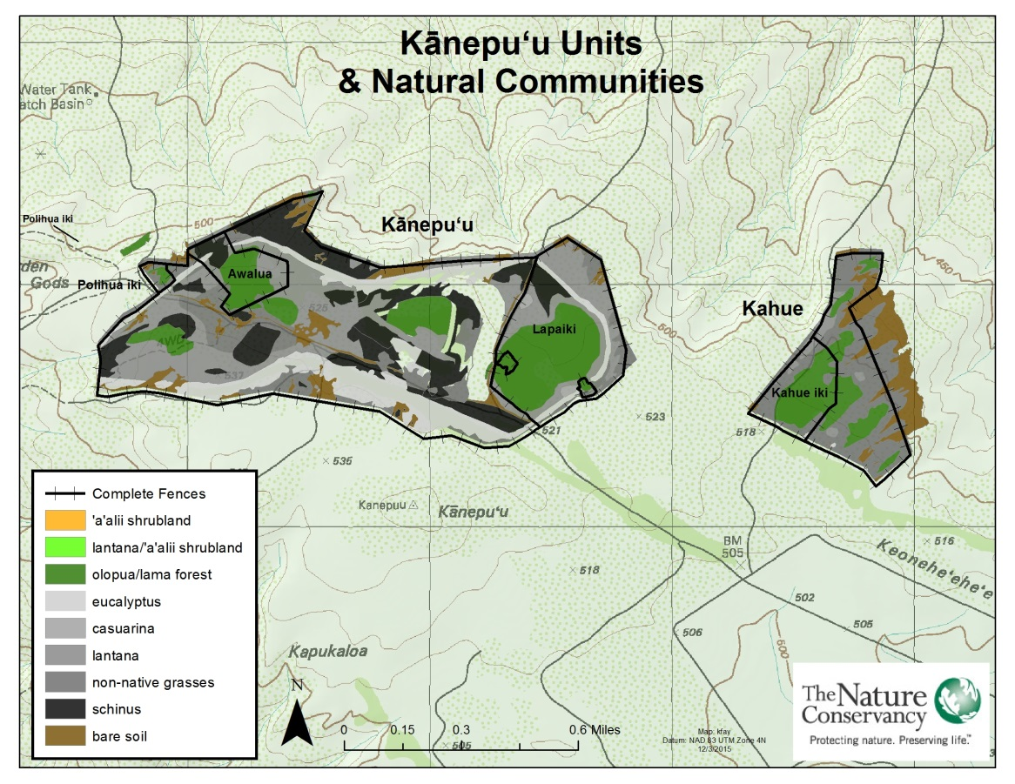
Figure 10. Kānepu‘u and Kahue units and natural communities.

Management Programs
For each program listed in the following section, we identify a major goal and discuss the management methods and/or any management issues. Activities and costs for FY2017–FY2022 are also listed.

Program 1: Non-native Species Control

A. Ungulate Control
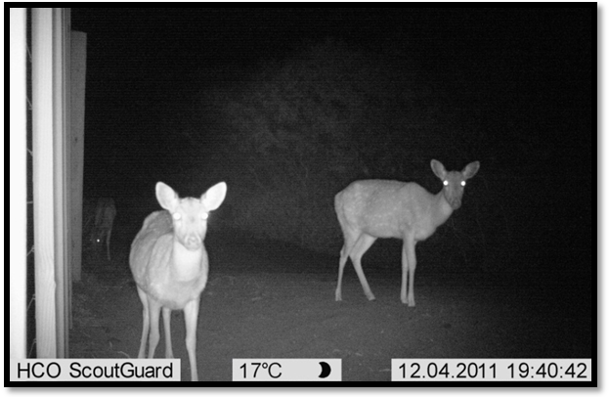
Figure 11. Deer outside of the Kānepu‘u perimeter fence.

Program Goals
- Control and reduce axis deer and mouflon sheep in the non-native dominated Kahue and Kānepu‘u fenced units;
- Eliminate all axis deer and mouflon sheep from the native dominated subunits (Figure 4);
- Continue to exclude axis deer and mouflon sheep in all units. (There are no feral pigs or goats on the island of Lāna‘i.)

Program Description
The two most biologically important units (Kahue and Kānepu‘u) are entirely surrounded with stainless steel wire fencing; while four of the other five units are surrounded by ineffective, aging, galvanized and bezinal fencing. The Paoma‘i 2 unit fence was completely replaced with deer-proof plastic mesh in 2014. Management activities continue to focus on the removal of axis deer from both the Kahue and Kānepu‘u units. Mouflon sheep have occasionally been found and removed in some units.

In FY08, a short section ~ .5 mi of 6’, Bezinal-coated deer-proof fence was installed from the main Kānepu‘u gate to the Lapaiki fence line in order to increase the effectiveness of ungulate removal (Figures 12 and 13). In FY2012, 18 acres within the main Kānepu‘u unit were enclosed, forming a new subunit , Awalua 1 (Figure 7). In FY13 the height of this fence was extended to six feet using plastic mesh. In FY2014, TNC replaced 998 meters of fence around the Paoma‘i 2 unit with experimental plastic mesh designed to withstand 900 lbs. of pressure and has a 20 year lifespan. See Figure 4.

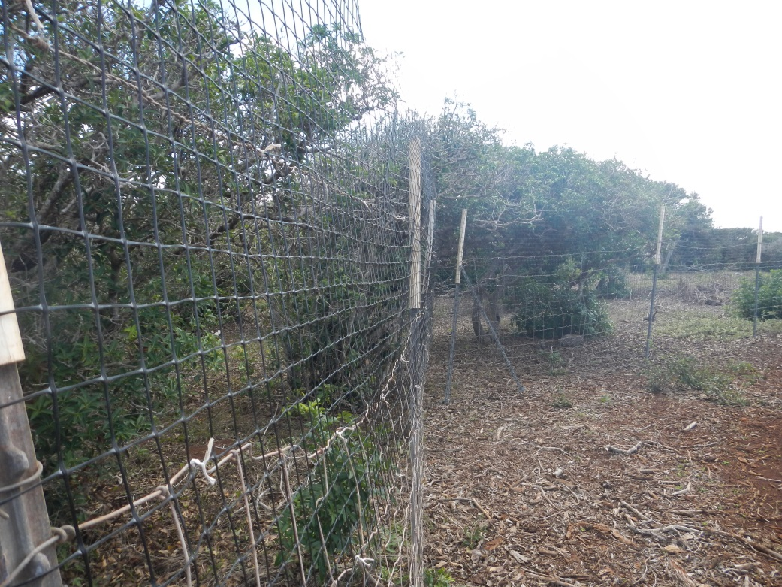
Figure 12. Retrofit to extend height of Lapaiki fence.

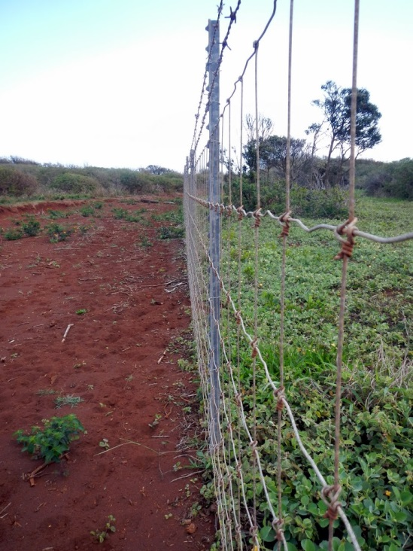
Figure 13. Native groundcovers like ‘ilima and ‘uhaloa recover after deer removal (right of picture, inside Lapaiki crossfence). Note large number of deer prints outside of fence (left of picture).

We will assess the need for additional fencing to facilitate deer removal throughout the next six-year period.

Ungulate Control Activities
Years 1-6 (FY2017-22):
- Inspect Kānepu‘u and Kahue boundary fences once per quarter. Inspect periodically for any weather-induced soil erosion which may require mitigation.
- Inspect Kahue iki, Lapaiki, Polihua iki and Awalua 1 subunit fences monthly.
- Repair fences where damaged in other selected units as time permits.
- Conduct periodic hunts in Kānepu‘u & Kahue units, with the goal of complete removal of all animals from fenced native-dominated subunits (Figure 4).
- Install new fencing, as deemed necessary, to replace degraded fencing and/or to break up existing units into smaller units to facilitate deer removal from native-dominated ecosystems.

The ungulate control program represents an estimated 60% of the overall effort and budget in this long-range management plan.

B. Invasive Plant Control

Program Goals
- Conduct weed control monthly in and adjacent to the Lapaiki and Kahue iki subunits.
- Encourage volunteer groups to remove weeds within or surrounding high quality patches of native vegetation.

Program Description
A number of non-native plants are well established in the preserve. We will continue to encourage volunteer groups (e.g., high-school groups, trail and mountain clubs, hunters) to hand-pull and mechanically control weeds in high quality patches of native vegetation.

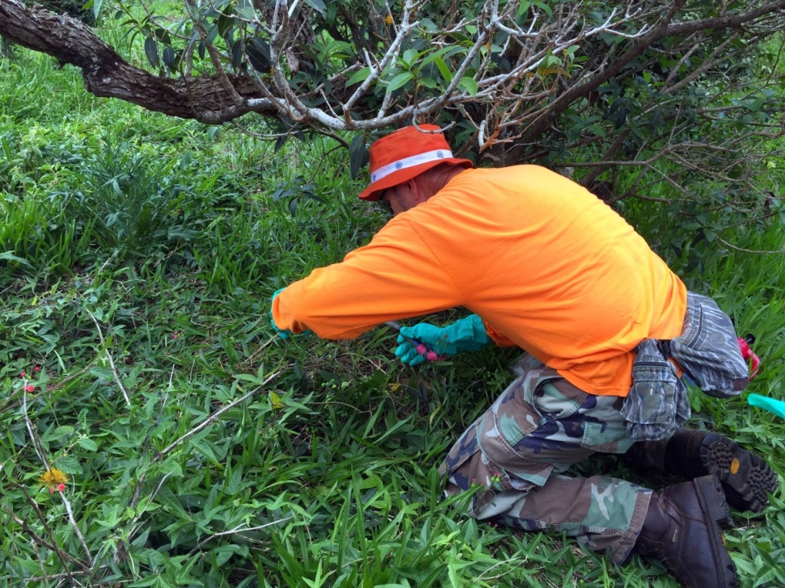
Figure 14. Invasive plant specialist Pat Bily demonstrates how to treat Passiflora suberosa.

Invasive Plant Control Activities
Years 1-6 (FY2017-22):
- Conduct priority weed control in high quality patches of native vegetation on a monthly basis.
- Support efforts to remove potentially harmful incipient weeds currently found outside the preserve that could potentially impact Kānepu‘u.
- Work with Invasive Species Committees (as supported by landowner) to develop regional initiatives for incipient weeds.

Table 3. Important Weed Species in Kānepu‘u Preserve
Priority Weed Species

Schinus terebinthifolius | Christmasberry
Lantana camara | Lantana
Passiflora suberosa | Corky passion vine
Megathyrsus maximus | Guinea grass

B

The invasive plant control program represents an estimated 20% of the overall effort and budget in this long-range management plan.

C. Small Mammal Control
This program has been reduced significantly due to the elimination of on-island preserve staff and our subsequent inability to check bait stations as frequently as needed to run an effective control program. However, Hank Oppenheimer, Maui County coordinator for the Plant Extinction Prevention Program (PEPP), maintains small exclosures with rat traps around some Gardenia seedlings and notes a significant positive impact of doing so.

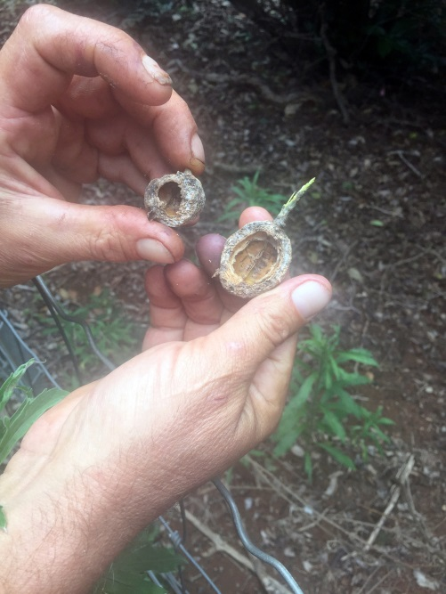
Figure 15. Evidence of rat predation on nā‘ū.

Years 1-6 (FY2017-22):
- Set rat traps around key rare species as time allows.

The non-native species control program represents an estimated 2% of the overall effort and budget in this long-range management plan.

Program 2: Fire Control

Program Goal
- Prevent fires in the preserve.

Program Description
Wildfire is a major threat and has diminished the extent of native vegetation in the preserve in the past. Vehicle traffic along roads passing through or near the preserve is the primary source of ignition. Nevertheless, TNC is required to accommodate public access through the preserve along these or suitable alternate roads. A 10-15 foot wide swath of cleared vegetation along the fence line of each preserve unit will be maintained as a fuel break for fire prevention where feasible.

Fire Control Activities
Years 1-6 (FY2017-22)
- Maintain mowed fuel breaks along perimeter fence lines of Kānepu‘u and Kahue units.

The fire control program represents an estimated 18% of the overall effort and budget in this long-range management plan.

Program 3: Rare species, Restoration, Research and Monitoring

Program Description
This program has been reduced due to prioritize scarce resources in other areas and previously reduced funding. TNC will work with Plant Extinction Prevention Program on restoration and outplant efforts at Kānepu‘u Preserve as needed. We plan to use Maui staff to perform rare plant monitoring incidental to other preserve activities and provide logistical assistance to researchers as staff time and budget permits. In addition, PEPP maintains small exclosures around Gardenia seedlings, conducting small-scale rat and weed control. We will continue to support PEPP in such efforts. TNC will continue to seek advice and assistance with restoration in areas where ungulates have been removed, with the goal of increasing restoration efforts should more resources become available.

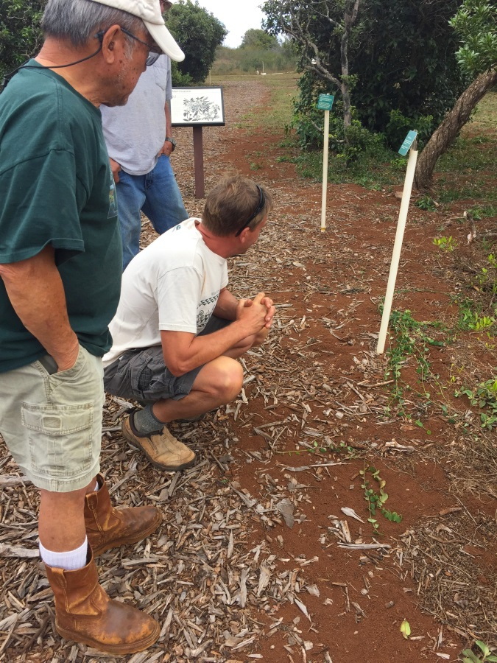
Figure 16. TNC brought dryland restoration expert Butch Haase from Moloka‘i Land Trust to Kānepu‘u to offer suggestions to staff and subawardee crew on enhanced passive and active restoration.

The restoration, research and monitoring program represents an estimated 10% of the overall effort and budget in this long range management plan.

Program 4: Community Outreach

Program Description
This program has been reduced due to the elimination of on-island TNC staff. No major activities or expenditures are proposed. As time allows we will continue to build the capacity of qualified and interested groups to assist with the management of the preserve. The Nature Conservancy and our efforts at Kānepu‘u get exposure to the Lāna‘i community and visitors by way of the Polihua iki self-guided trail, which is now a highlighted destination through the Pūlama Lāna‘i guided mobile application for smartphones (http://www.appszoom.com/iphone-app/lanai-guide-tapjg.html?ref=list_referer).

The community outreach program represents less than 1% of the overall effort and budget in this long-range management plan.

ENVIRONMENTAL REVIEW COMPLIANCE
All actions being proposed for reauthorization in this long-range management plan are substantially similar to, and relevant to, the actions previously considered in the Final Environmental Assessment of Kānepu‘u for which we received a "Finding of No Significant Impact" from DLNR on January 29, 2009, following an initial FONSI issued for similar management activities in 1997. Pursuant to Hawai‘i Administrative Rule 11-200-13 (Consideration of previous determination and accepted statements), all environmental review obligations under the Hawai‘i Revised Statutes (Ch. 343) have been fulfilled. In addition, management activities including fencing, ungulate control, weed control, fire control, and related items are covered under Conservation District Use Permit (CDUP) LA-2535, originally issued in 1992 but confirmed as valid for ongoing management on August 1, 2011 by DLNR’s Office of Conservation and Coastal Lands.

BUDGET SUMMARY
The table in the next section summarizes the six-year budget for the Kānepu‘u project. Through the NAPP program, the State of Hawai‘i will provide funding for a substantial portion of the costs outlined in this long-range plan, and TNC will match State funds at a 2:1 level. Due to recent State budget cuts, TNC will provide additional private funds in order to fund the full scope of activities outlined in this plan. Recognizing current state budgetary constraints, we have not included routine, annual increases for most of the program activities described above or inflation.

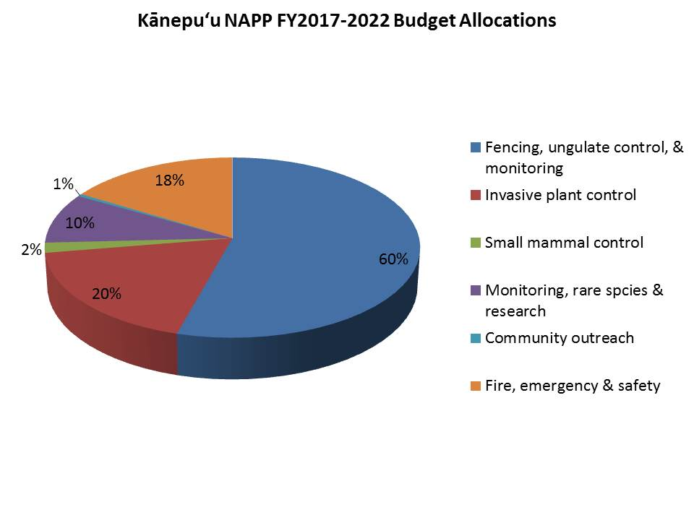
TNC’s Maui Nui terrestrial operation maintains a full time base staff of 5 to 6 full-time exempt employees plus occasional interns. This number may fluctuate depending on the use of contractors vs. staff to complete deliverables. These staff are primarily focused on Maui but periodically work on Lāna‘i and Moloka‘i whose programs are supervised by the Maui Nui office. A significant portion of the deliverables in this plan is carried out through a contractor. Technical and annual planning support is also included, and other island support staff may charge a small portion of their time to this project. The Nature Conservancy's annually negotiated fringe benefits rate will also accrue on all salary costs.

The NAPP portion of this budget does not include miscellaneous project-related costs such as vehicle expenses. NAPP funds will cover a portion of staff or subaward expenses to conduct fence checks/maintenance and ungulate/weed removal and miscellaneous project-related field supplies. TNC routinely provides trainings for staff to improve job performance, and in addition to these trainings, supervisory staff regularly attend meetings in Honolulu.

An overhead rate is included (subject to slight change each year) to recognize TNC’s indirect costs for facilities, accounting, legal, and other administrative support. The NAPP program will pay only 10% of TNC’s overhead rate of 21.8% (FY16), leaving the remainder as a portion of TNC's one-third match.

BUDGET TABLE
 | FY2017 | FY2018 | FY2019 | FY2020 | FY2021 | FY2022 | Total
Labor and Fringe | 5,000 | 5,000 | 5,000 | 5,000 | 5,000 | 5,000 | 30,000
Supplies | 1,500 | 1,500 | 1,500 | 1,500 | 1,500 | 1,500 | 9,000
Subcontracts | 20,000 | 20,000 | 20,000 | 20,000 | 20,000 | 20,000 | 120,000
Travel | 773 | 773 | 773 | 773 | 773 | 773 | 4,638
Subtotal | 27,273 | 27,273 | 27,273 | 27,273 | 27,273 | 27,273 | 163,638
Overhead (10%) | 2,727 | 2,727 | 2,727 | 2,727 | 2,727 | 2,727 | 16,362
TOTAL | 30,000 | 30,000 | 30,000 | 30,000 | 30,000 | 30,000 | 180,000
 | FY2017 | FY2018 | FY2019 | FY2020 | FY2021 | FY2022 | Total
Kānepu‘u Budget | 30,000 | 30,000 | 30,000 | 30,000 | 30,000 | 30,000 | 180,000
TNC Match (1/3) | $10,000 | $10,000 | $10,000 | $10,000 | $10,000 | $10,000 | 60,000
NAPP Request (2/3) | $20,000 | $20,000 | $20,000 | $20,000 | $20,000 | $20,000 | $120,000

APPENDIX 1
RARE PLANTS OF KĀNEPU‘U PRESERVE

SCIENTIFIC NAME | COMMON NAME | FEDERAL  STATUS | IUCN STATUS
Bidens micrantha ssp. kalealaha | Ko‘oko‘olau | E
Bobea sandwicensis | ‘Ahakea |  | V
Bonamia menziesii |  | E | CE
Gardenia brighamii | Nā‘ū | E | CE
Haplostachys munroi
Hibiscus brackenridgei ssp. brackenridgei¹ | Ma‘o hau hele | E
Nesoluma polynesicum | Keahi |  | V
Nothocestrum latifolium | ‘Aiea | PE | E
Polyscias sandwicensis | ‘Ohe |  | NT
Santalum haleakalae var. lanaiense | ‘Iliahi | E | V
Vigna owahuensis |  | E

(a) Federal Status:
E= Endangered
PE= Proposed Endangered

(b) IUCN Status:
V= Vulnerable
CE= Critically Endangered
NT= Near Threatened

