Hawaii Invasive Species Council FINAL Report Fy15

January 2016

Proposal Title: Supplies in Support of Aquatic Invasive Species Outreach Efforts

Content area: Public Outreach

Applicant: PI: Brian Neilson, DAR Biologist

Previous PI: Frazer McGilvray, DAR Administrator
DLNR, Division of Aquatic Resources

Project Deliverables:

Deliverable 1: Produce brochures for the general public regarding aquatic invasive species (Accomplished).
Outcomes:
- AIS Program Brochure: A glossy pamphlet was produced highlighting the DLNR Aquatic Invasive Species Program and invasive threats. This has been a popular handout at public events. It’s also been an important communication/promotion tool to provide to State Legislators and new leadership at DAR and DLNR.
- Stop The Invasion Invasive Algae Brochure. An older brochure was updated with a more appealing design format and messaging. The brochure focuses on invasive algae distribution, impacts to coral and fish, and current management techniques.
- Invasive Mullet ID Ruler: A new outreach brochure was created identifying the invasive mullet and native mullet species. This can be distributed to local fisherman to promote the use of invasive mullet for bait and consumption as an alternative to the native mullet.
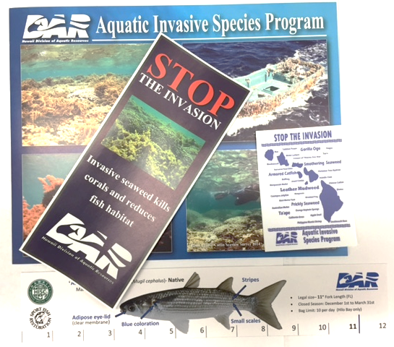

Deliverable 2: Produce information to educators to promote the invasive species topics (Accomplished).

Outcomes:
- Created a “Stop the Invasion” brochure focusing on invasive algae threats and management.
- Created new logo: “Stop the Invasions” and produced stickers.
- Printed “Eyes of the Reef” stickers for our citizen science workshops.

Deliverable 3: Number of people reached through informational (Accomplished)

Outcomes:
- The AIS Team participated in over 20 outreach events in 2015, such as invasive algae clean-ups, Invasive Species Awareness Week, Eyes of the Reef Trainings, Earth Day celebrations, Science Alive! At the Bishop Museum, and Invasive Algae workshops and community events in Molokai.
- We estimate that we reached over 2000 people with our educational materials. We were also able to reach several State Legislators with our informational brochures.

