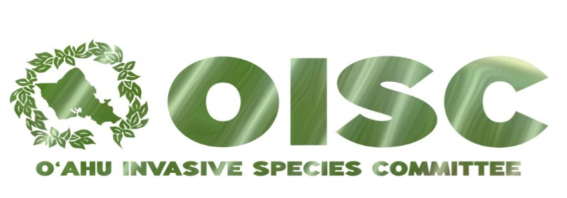

2018 Report to the
Hawaiʿi Invasive Species Council

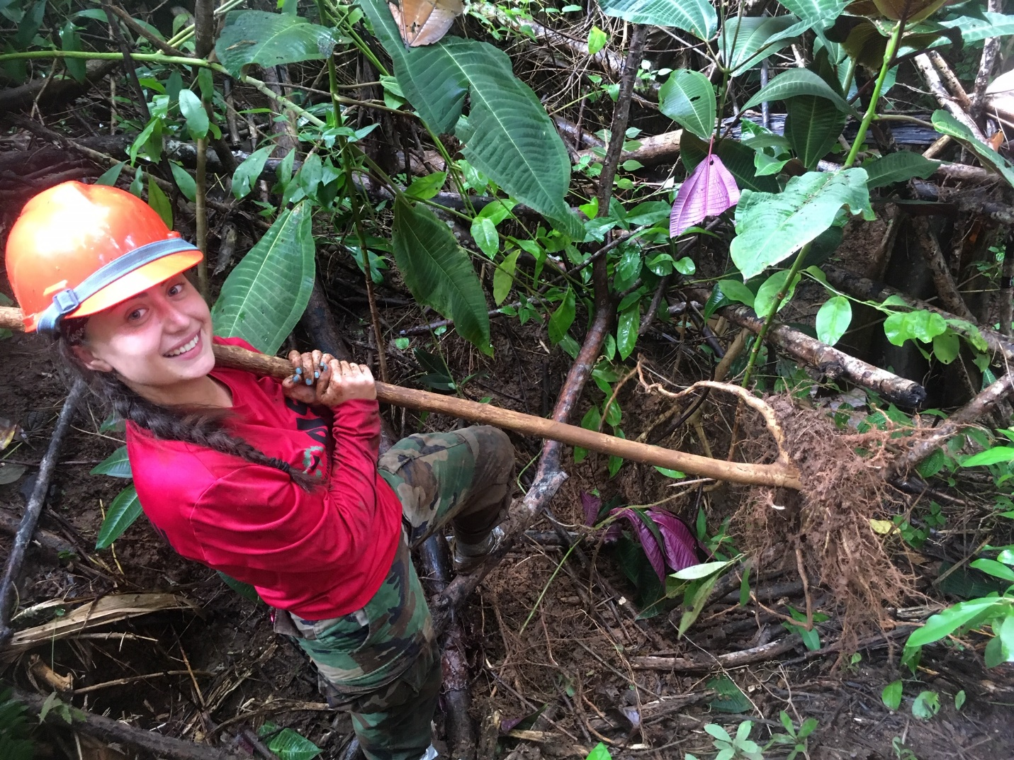
Removing Miconia calvescens by hand

The Oʿahu Invasive Species Committee (OISC) protects Oʿahu’s watersheds, ecosystems and agriculture by preventing harm from invasive species before those species become uncontrollable. The OISC field crew conducts surveys and control for invasive species that have not yet become abundant enough to damage the island’s agriculture and ecosystems, but likely would cause harm if not controlled. By removing invasive species before the effects are felt, we can prevent expensive and costly remediation measures later.
[Grab your reader’s attention with a great quote from the document or use this space to emphasize a key point. To place this text box anywhere on the page, just drag it.]
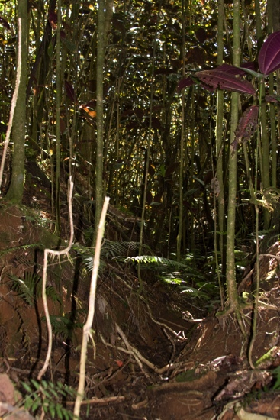
OISC operations are guided by the OISC steering committee which is made up of representatives of conservation organizations and land managers. Many of the people who serve on OISC’s steering committee today were giving up their weekends to control invasive species as volunteers when OISC was first formed back in 2001. In 2018, HISC awarded OISC $623,090 for survey and control of priority invasive species and outreach. OISC raised an additional $523,517 from other sources. The deliverables and accomplishments described below include HISC-funded activities and leveraged funds.

In 2018, OISC continued steady progress towards stopping the spread of species like miconia (Miconia calvescens), devil weed (Chromolaena odorata), cane ti (Tibouchina herbacea) Himalayan blackberry (Rubus discolor), glory bush (Tibouchina urvilleana) and Cape ivy (Delairea odorata). We also continued our work with the multi-agency working group on early detection for Rapid ʿŌhiʿa Death (ROD). OISC partnered with the Hawaiʿi Department of Agriculture to conduct treatments for coqui frog (Eleutherodactylus coqui) and monitor for coconut rhinoceros beetle (Oryctes rhinoceros) along the Windward coast. OISC responded to a public detection of Myoporum thrips and organized a multi-agency delimiting effort that surveyed major naio populations across the entire island in only one week. OISC also continued to present invasive species information to students, teachers, the landscape industry, recreational groups and others.
Above: Miconia destroys the understory and promotes erosion, this photo is from Tahiti where miconia has taken over vast amounts of forest.

Miconia (Miconia calvescens)
Miconia is a high-priority target for OISC because once established, it may severely degrade Oahu’s watershed. Miconia’s shallow root systems may be unable to hold soil in place during heavy rains and its unusually large leaves funnel rainwater to the ground with tremendous force. These characteristics indicate that a miconia-dominated forest will be more prone to erosion than a native-dominated one. Unfortunately, miconia seeds remain viable in the soil for up to 21 years, making this a project that requires long-term financial comittment. OISC’s strategy is to survey the entire estimated seed bank of miconia every two to three years to find and remove trees before they mature.

In 2018, OISC conducted miconia surveys in 16 different watersheds across 3,240 acres by ground and 3,608 acres by air totalling 6,849 acres. The crew removed 1,821 immature and 7 mature miconia trees. There were no significant buffer extensions or new populations found in 2018. The systematic control of miconia has prevented the type of single-species stands that occur in Tahiti as in the photo above.
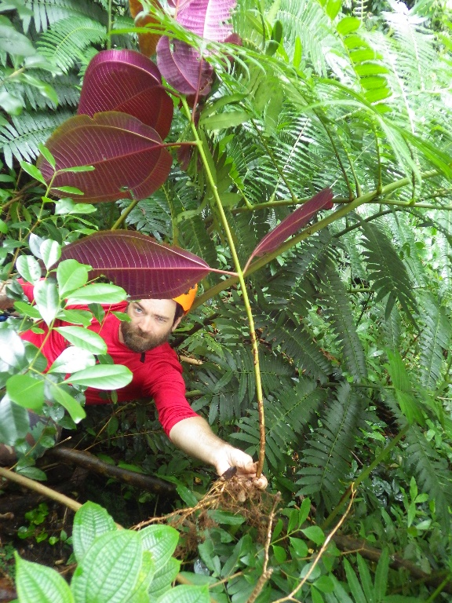
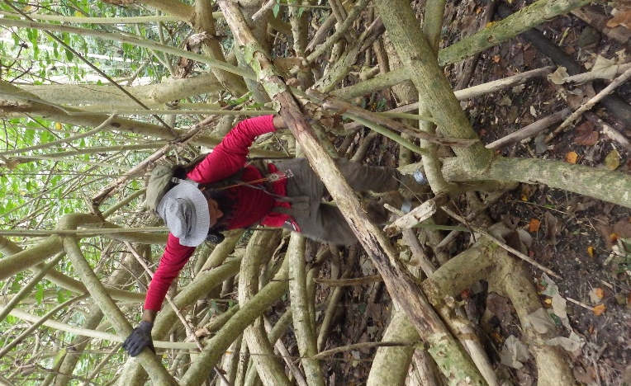

Left: Removing Miconia calvescens growing on slopes so steep the crew must rappel to reach the plants. Right, Negotiating a hau tangle: a type of difficult vegetation often seen on surveys. Despite the shady conditions that most other plants cannot tolerate, miconia is still able to grow.
The long-lived seedbank makes this species difficult to eradicate. Trees are sometimes missed because of thick vegetation and we have not been able to meet our goal of preventing maturation of trees in all waterseheds. However, we have been able to prevent this species from establishing. When OISC first began surveys in 2002, we removed 40 mature and 3,347 immature trees from 2,042 acres. In 2018, OISC removed 7 mature trees over 6,849 acres, a drop in mature trees per acre of 95%.

Devil weed (Chromolaena odorata)
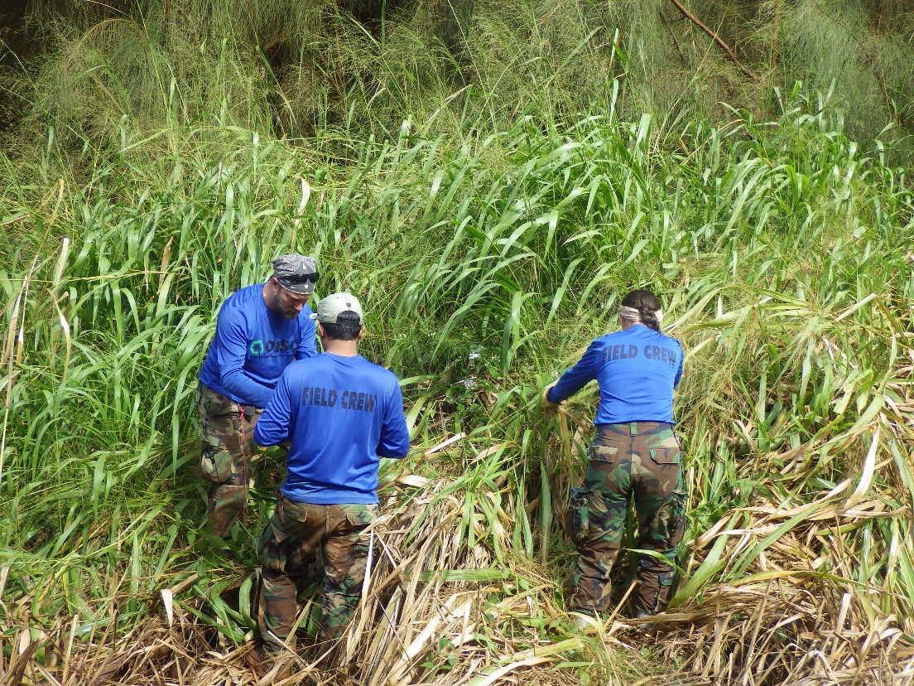
The common name of Chromolaena odorata is “devil weed” and for good reason. It is toxic to livestock and humans and a weed of conservation and agricultural concern throughout Africa and the Pacific. Populations of this species are currently known to occur at the Kahuku Training Area, in ʿAhupuaʿa ʿO Kahana State Park, Camp Smith, ʿAiea, Malaekahana and Pūpūkea.
Removing mature devil weed (Chromolaena odorata) from a clump of guinea grass. Most plants cannot survive in guinea grass.

In 2018, OISC followed up on a report received in December 2017 of Chromolaena in Mākaha valley and found no additional plants, although plants were later found in areas of the valley that were not part of the survey. We do not believe that large patches of C. odorata occur in Mākaha valley, but rather that there were multiple introductions due to the ability of this species to hitchhike on clothing. C. odorata plants were detected in two new watersheds in 2018, Malaekahana and Pūpūkea. The infestations here are too large for OISC to be able to eradicate island-wide. This species has therefore become too much for OISC to manage and we are working with partners to come up with an exit strategy. In total, OISC surveyed 2,881 acres by ground and 439 acres by air.

Rapid ʿŌhiʿa Death: (Ceratocystis spp.)
Rapid ʿŌhiʿa Death (ROD) is a forest disease caused by two species of fungal pathogen within the genus Ceratocystis. The pathogen has killed ʿōhiʿa trees across thousands of acres on Hawaiʿi Island. In 2018, OISC performed early detection aerial surveys over 101,218 acres of Oʿahu‘s ʿōhiʿa forest. OISC had planned to conduct 2 complete surveys of ʿōhiʿa forest in the Koʻolau and Waiʻanae Ranges, but was only able to complete one due to extremely poor weather that cancelled flights at the beginning of the year. The work on Oʿahu is part of a statewide effort that is conducting early detection using the same methodology on all islands and is done in close cooperation with DLNR/DOFAW.

During the surveys, OISC field crew identified an area of forest with mortality that may have been ROD. Trees in the area were sampled and tested negative for ROD. As a result of the statewide outreach surrounding this disease, OISC received several reports of dead ornamental ʿōhiʿa. OISC responded to these reports and has submitted samples from an additional 15 watersheds. All the samples submitted tested negative for ROD.

Cape Ivy (Delairea odorata)
Cape ivy invades dry forests on the Big Island and can smother native plants. The OISC crew has been monitoring and controlling a Cape ivy infestation in Pālehua in the Waiʻanae Mountains. Through persistent treatment, the infestation has been drastically reduced from patches that were too numerous to count to only 150 individual immature plants and zero mature plants. In total, OISC surveyed 78 acres. The acres surveyed is not as high as the expected outcome listed in our HISC proposal because OISC decided to forego one of the scheduled surveys in order to conduct a sweep of Mākaha Valley to look for Chromolaena odorata.

The field crew also conducted rappelling operations in some areas due to the steep terrain. Rappelling is a time-intensive activity that does not cover as much ground as regualar survey sweeps. A chart showing the decline in plants is below.

Year | Mature | Immature | Acres
2018 | 0 | 150 | 78.85
2017 | 1 | 503 | 217.59
2016 | 1 | 1,365 | 291.36
2015 | 6 | 1,384 | 126.11

Himalayan blackberry (Rubus discolor)
Himalayan blackberry is a thorny vine that is a serious problem in the Pacific Northwest. OISC staff have been told that it was planted on public land by a resident of Pālolo for fruits and to dissuade trespassers. It spread up the valley into the native ʻōhiʻa forest, threatening our native species. Himalayan blackberry is difficult to control since it is resistant to available herbicides and re-grows easily from cut stems and roots. Despite these challenges, OISC has drastically reduced Himalayan blackberry numbers. OISC conducted 29 acres of surveys in 2018. This number is less than the expected outcome because the number of plants was so small, a full 50 acres of surveys was not necessary. OISC has reduced the number of Himalayan blackberry from 2,724 plants in 2008 to only 5 immature plants in 2018.

Cane ti: (Tibouchina herbacea)
Cane ti threatens priority watershed habit at in Poamoho, an area in the northern Koʿolau Range. The O‘ahu Army Natural Resources Program (OANRP) discovered the highly invasive cane ti (Tibouchina herbacea) in the Poamoho region in 2008. This aggressive weed was not known to be naturalized on O‘ahu, but it is widespread on both Hawai‘i island and Maui where it is beyond the scope of eradication. On these islands, cane ti forms dense thickets that crowd out native plant growth and suppress regeneration of ʿōhiʿa. In 2018, OISC surveyed 27 acres and removed 19 mature and 919 immature plants from Poamoho.

Glory bush (Tibouchina urvilleana)
Glory bush is a striking ornamental plant that outcompetes native plants in wet forest environments. In places on Hawaiʿi Island where it is naturalized, glory bush makes its way into 30-foot high ʿōhiʿa canopy. Oʿahu residents have cooperated when OISC has asked them to remove landscape plantings of glory bush, and one naturalized population was treated in the Tantalus area. The species grows well vegetatively but the population is near to eradication. OISC synced the surveys for this species with miconia surveys in the same area that are scheduled for 2018. Over 21 acres of surveys, no plants were found.

Fountain grass (Cenchrus setaceum)
Fountain grass is a fire-prone grass that may increase the frequency and intensity of wildfires. OISC worked with DOFAW to treat a new detection of this species in the Waiʻanae Kai Forest Reserve. OISC also conducted road surveys along the Waiʻanae Coast on days that are too rainy for backcountry forest surveys. In total OISC completed 857 aerial acres and 413 ground acres of surveys, removing a total of 553 plants.

Coqui frog (Eleutherodactylus coqui)
OISC provides monitoring support to the Hawaiʿi Department of Agriculture (HDOA) for early detection of coqui frogs. Coqui frogs can be stowaways on plants and other items such as vehicles, boats and construction materials from areas on Hawaiʿi Island with large coqui frog populations. OISC assists with responding to reports from the public, treatments and monitoring areas to ensure treatments were effective. In 2018, OISC captured 3 mature and 1 juvenile coqui frog in Waimanālo. OISC also treated a private property for coqui frog in cooperation with the property owner. OISC sprayed citric acid and the property owner removed vegetation in order to deprive the frogs of habitat. HDOA staff have conducted separate surveys and captures, so this number does not represent the total number of coqui frogs caught on Oʿahu in 2018.

Little Fire Ant (LFA) (Wasmannia auropunctata)
LFA is a tiny stinging ant that is established on Hawaiʿi Island and was accidentally introduced to Oʿahu in two separate locations. In 2018, OISC assisted HDOA and the Hawaiʿi Ant Lab with survey and treatment. OISC maintained trails in advance of treatment and monitoring surveys in Waimānalo and assited with monitoring surveys in Mililani. OISC conducted early detection surveys at 31 sites that included retail nurseries, community gardens, sites at Joint Base Pearl Harbor Hickam and responses to reports from the public. Of these suveys, LFA was found at three sites where it was subsequently treated. The number of sites did not meet the proposal deliverable because the LFA lead at OISC resigned in July. We are working on filling the position.

Myoporum thrips (Klambothrips myopori)
Myoporum thrips have been damaging and killing Hawaiʿi’s native naio trees (Myoporum sandwicense) on Hawaiʿi Island since they were discovered in 2008. Naio figures prominently in coastal restoration projects and is a popular ornamental for those wishing to landscape with native plants. A member of the public identified Myoporum thrips damage and posted it to social media on November 23, 2018. OISC immediately mobilized partners and was able to strategically survey naio across the whole island. Thrips damage was found at isolated sites between Pearl Harbor and the Honolulu Zoo. OISC is currently working with landowners to treat positive sites.

Coconut Rhinoceros Beetle (Oryctes rhinoceros)
Coconut rhinoceros beetle (CRB) is currently limited to Oʿahu and a separate CRB response team is taking the lead in the response. OISC assists where necessary. CRB damage can kill coconut and other palms and is a widespread problem on other Pacific Islands. In 2018, one CRB was found in a trap in Waimānalo. That area is now monitored by the main CRB program that operates out of the Hawaiʻi Department of Agriculture.

Mamalu Poepoe Program:
OISC conducts surveys at Honolul International Airport for the Mamalu Poepoe Program, a partnership between the Hawaiʻi Department of Transportation and the Hawaiʻi Invasive Species Council to conduct early detect at airports. OISC conducted trap checks for Africanized Honey Bees and Coconut Rhinoceros Beetle at the airport but did not detect either of those species.

Brown Tree Snake:
OISC assisted the US Navy and Hawaiʻi Department of Agriculture with trap checks and maintenance for brown tree snakes at Joint Base Pearl Harbor. No brown tree snakes were detected.
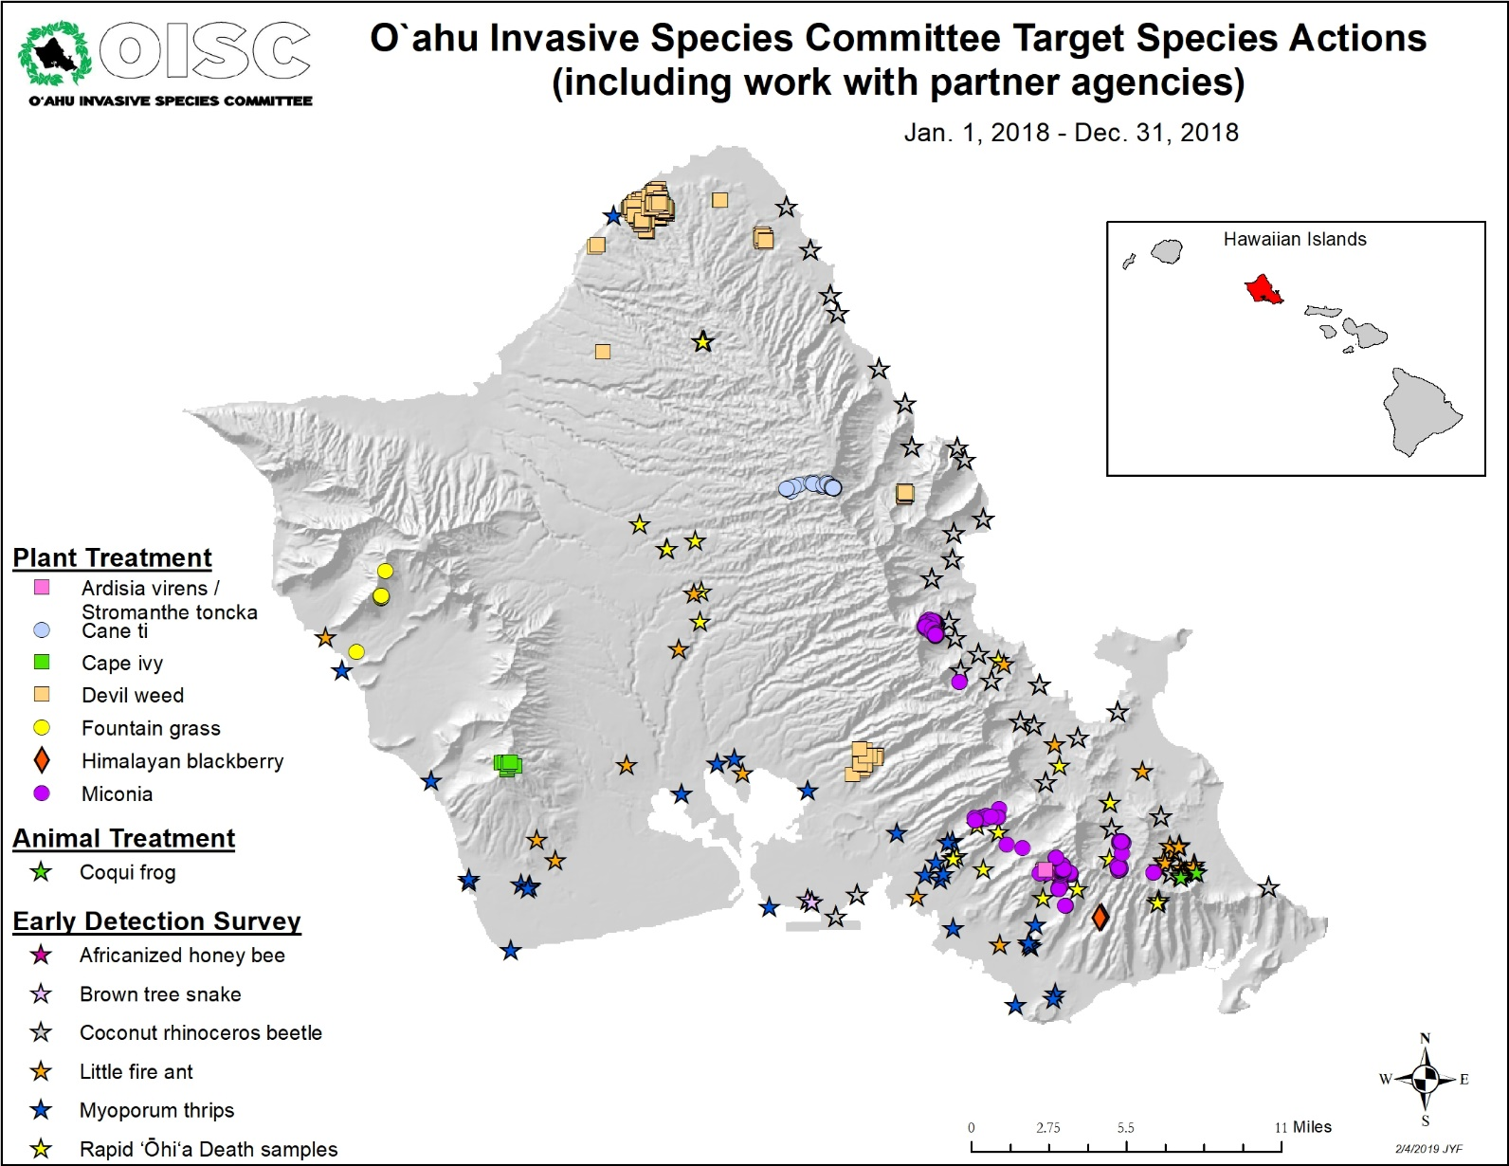
Outreach:
OISC recognizes that outreach is integral to invasive species management. OISC needs public support so that we can gain access to the private property we need to survey so that our eradication efforts are truly island-wide. For species like coqui frog and little fire ant, that can be transported anywhere on the island, we need the public to be our eyes and ears. We also want the public to know what they can do to help our efforts. For example, buying non-invasive plants and washing gear and equipment (especially boots) goes a long way towards preventing invasive species introductions.
The OISC outreach program is dedicated to promoting our mission to prevent, detect and eradicate invasive species on O‘ahu through presentations to area schools and communities, creating and distributing educational materials, conducting regular volunteer trips, and by working with partner organizations’ outreach efforts. The total audience reached for OISC in 2018 was 79,665. Excluding the volunteer trip, website and social media, OISC’s reach was 58,223 people. The Outreach Program also works to secure access for the field crew. There are three members of the outreach team: the Outreach Specialist, the OISC ISFA III Outreach/Education and the Access & Data Entry Associate.

Table 1: 2018 Outreach Totals
Outreach Type | Number of events | Audience
Article Authored or Contributed | 4 | 49,320
Distributed Product | 3 | 1,185
Event | 30 | 1,185
Little Fire Ant Classroom Activity (days) | 28 | 834
Presentation | 28 | 1,193
School Visit | 17 | 577
Social Media (posts) | 224 | 12,237
Training | 2 | 18
Volunteer Trip | 8 | 72
Website (postings) | 12 | 9,133
Total | 356 | 75,754

Comparative Totals for General Outreach from 2017: The tables below illustrate a trend for increased outreach in events, and especially in presentations and school visits. These are good areas to increase as they tend to be the highest quality direct outreach and OISC will work to maintain these levels in 2019. There have been decreases in our on-line outreach. This is due to a reduction on posts on social media (Facebook & Instagram). There was a 6% reduction in website visitors in 2018 and can be correlated by the decreased posts on social media that drive people to website. Even though this is more indirect outreach, it is important outreach tool to more widely distribute information and elevate the general awareness of invasive species issues. The decreases in Neighborhood Boards meetings and distributed products are areas whose varied numbers are out of OISC control. Distributing products are opportunistic and on request, and the neighborhood board meeting attendance is out of OISC control.

Comparative Outreach Trends from 2014-2018:

Hoʻike Little Fire Ant Activity: OISC has implemented the Hoʻike Little Fire Ant Activity for the past three and half years with one person dedicating 35% of their time to leading this activity and occasionally assisting with outreach events. This activity has been an effective and efficient tool to gather ant samples from across the island as well as an excellent citizen scientist activity that is popular with educators and students. In 2018, the goal was to reach 9 schools and that goal was exceeded by reaching 13 schools. We would like to see a greater return in student samples and will work on this aspect in 2019.

In total, OISC received 14 data sets in 2018. Part 1 of the Hoʻike LFA activity was also presented to 3 community/student organizations: the Hawaiʻ Nature Center, Club Z! Tutoring, and Waimānalo District Park after-school participants. While OISC went to 12 schools, the class sizes were smaller. The low percentage of return is also contributed to the Kahuku Middle School. There were 267 students that received the first part of the Little Fire Ant classroom activity, but only 15 samples were submitted. Removing Kahuku, the rest of the schools have a 49% return rate.

Private Property Access: In 2018, thanks to the added efforts of the Outreach Access & Data Entry Associate and the ground efforts of the field crew for door-to-door surveys, 399 surveys were completed clearing 78% of our requested access with approximately 1,632 calls, emails, and site visits made.

ACCESS PERMISSIONS EFFORTS FOR JAN 1 –DEC 31, 2018
487 | Unique properties
78% | Percent of properties that we requested access and completed surveys.
Yes | 243 | 48%
Not Needed | 156 | 31% (Able to be cleared from adjacent properties or from road)
No | 3 | 1%
Pending | 107 | 21% (Contacted, waiting for response)

VOLUNTEER: OISC leads a group of volunteers to remove two invasive species at Lyon Arboretum: Ardisia virens and Stromanthe tonckat. OISC had a total of 390 volunteers for this program. There is a 67% decrease in plants per acre from 2014 to 2018 of 67%.

Spot the Ant, Stop the Ant Month:
OISC worked with the other Invasive Species Committees (ISCs) and the Coordinating Group on Alien Pest Species (CGAPS) on the Stop the Ant Month Campaign in October. We attended 3 events that month and distributed Little Fire Ant (LFA) kits at various events and to four libraries to have kits available to the public. The Hoʻike LFA Activity was presented to 3 schools and part 1 was presented to 3 community groups. Twenty-nine public samples were submitted for ID from September 01, 2018 – December 31, 2018.

WEBSITE (8,379) AND SOCIAL MEDIA (7,944)
New likes and new followers for social media platforms rose in 2018. OISC’s engagement rate of 12% is still well above industry standards. OISC’s reach and engagement fell, probably due to a decline in the number of posts. On-line presence will be addressed and improved in 2019 with the help of field crew posting to Instagram and Outreach Specialist putting more effort toward Facebook posts. Engagement is the number of times (not people) messages have been liked, commented or clicked on. Reach is how many times our messages have been served to social media feeds for engagement. For example: how many times our message has shown up on a Facebook, Instagram or twitter feed.

Table 8: Social Media Audience Trends 2015-2018
 | 2015 | 2016 | 2017 | 2018 | % increase in 2018 from 2017
Facebook |  |  |  |  | Facebook
New likes |  | 18 | 108 | 154 | 43%
reach | 38910 | 85012 | 88583 | 44536 | -50%
engagement | 4035 | 4511 | 5565 | 4849 | -13%
Instagram |  |  |  |  | Instagram
New Followers |  | 39 | 164 | 537 | 227%
engagement | 105 | 514 | 2225 | 1940 | -13%
Twitter |  |  |  |  | Twitter
New Followers |  | 28 | 75 | 94 | 25%
engagement | 412 | 429 | 508 | 458 | -10%
Impressions | 7956 | 14437 | 10122 | 10364 | 2%

