# HISC FY2019 Final Report: Biocontrol of high priority invasive plants

Tracy Johnson and Nancy Chaney

Institute of Pacific Islands Forestry, PSW Research Station, USDA Forest Service

Ellyn Bitume

Pacific Cooperative Studies Unit, University of Hawaii at Manoa

## Summary

During 2019 our program continued developing potential biological controls for key invasive plants, particularly albizia and melastomes, with the goal of mitigating widespread negative impacts on Hawaiian forests and watersheds. Exploration for natural enemies of albizia (*Falcataria moluccana*) has shifted from geographically broad surveys across the tree’s native range (Indonesia and Papua New Guinea) to focus on the Moluccas, the highly biodiverse center of origin for albizia, where natural enemies of particular interest are found. Collaborating with two Indonesian universities, we have begun evaluations of two promising species: a stem boring weevil and a leaf galling mite. In 2019 we also renewed partnerships in Brazil and Costa Rica with the aim of final testing and import of several known natural enemies of *Miconia calvescens*, *Clidemia hirta* and other invasive melastomes.

## 2019 Highlights

* Three trips to Indonesia to develop projects at IPB University (Bogor) and Pattimura University (Ambon), initiating formal agreements, plans and permits for collaborative biocontrol research conducted with local technicians and students, and supporting eventual export of potential biocontrol agents to Hawaii.
* Field and lab studies begun near Ambon for evaluation of stem weevils and leaf galling eriophyid mites, two damaging natural enemies prioritized for biocontrol development.
* Completed curation of Coleoptera (beetles) collected 2015-17 from albizia in Indonesia and PNG, and established collaborations to identify our two first priority agents.
* Continued molecular analysis of genetic samples of albizia from its native and invaded ranges to determine the source of the invasive populations in Hawaii.
* Draft Environmental Assessments for release of biocontrol agents for miconia and cane tibouchina were completed and published in collaboration with DLNR and HDOA.
* Travel to Brazil and Costa Rica to reestablish university collaborations for developing several promising biocontrols for invasive melastomes.
* Surveys in Brazil located new sources of fruit gall wasps under development for biocontrol of clidemia and miconia.

## Background

Biological control of invasive plants has a long and successful history in Hawaii. Through careful scientific screening, researchers have selected insects and pathogens that feed exclusively on target weed species to manage population abundance and spread. In Hawaii, where albizia overwhelms and degrades native ecosystems and threatens homes, businesses, and public infrastructure, almost no natural enemies can be found limiting the plant. This contrasts starkly with the abundance of insect and disease damage observed during surveys in its native range of Papua New Guinea and Indonesia, where albizia is a minor part of the forest. The goal of biocontrol will be to identify host-specific natural enemies which can be released in Hawaii to restore the ecological balance exerted on albizia in its native range. Examples of successful biocontrol of Australian *Acacia* trees in South Africa, where they are invasive, further support the promise of this management option for albizia.

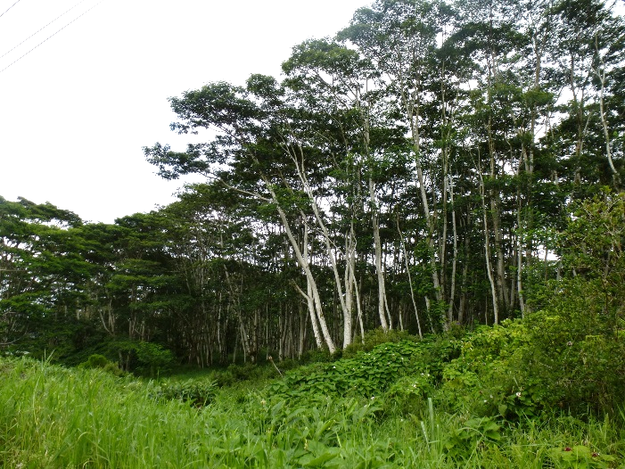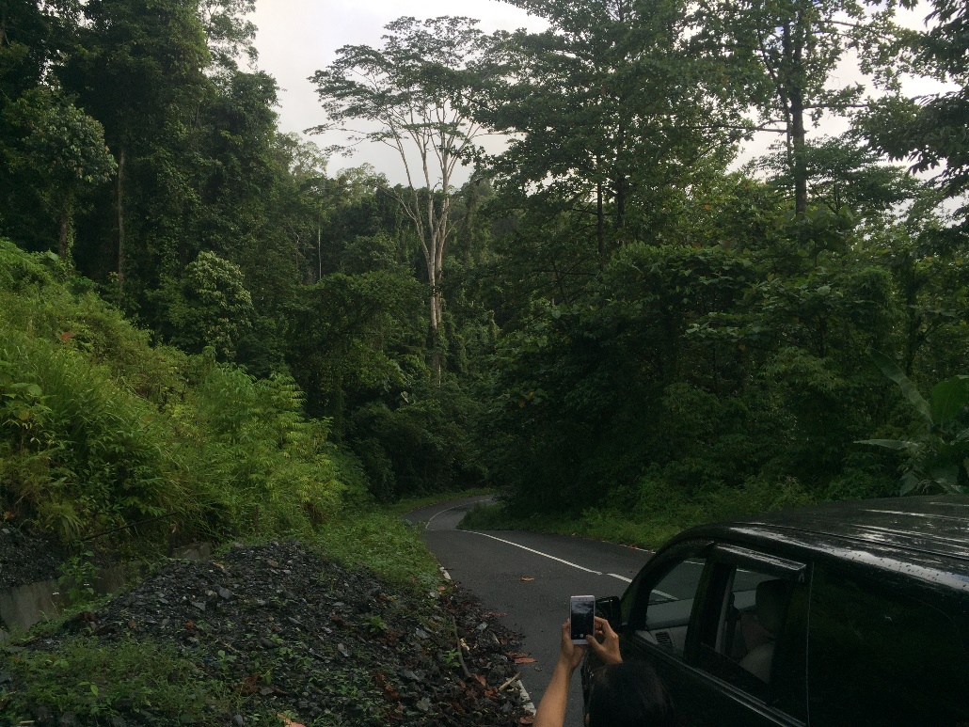 *Albizia invading agricultural lands in Hawaii (left); and as an isolated tree in the Moluccas, Indonesia (right).*

Following on surveys for natural enemies in Costa Rica and Brazil in the early 2000s, our biocontrol program has focused on developing selected agents which appear to hold the greatest promise for impacting miconia and other weedy melastomes. Initial studies by teams of students and post-docs in the native range generated a wealth of information on biology, host range and impact of agents on miconia. As resources and knowledge of each species’ biology have allowed, agents have been brought to Hawaii for evaluation in quarantine facilities managed by the Forest Service or the Hawaii Department of Agriculture. In 2016 we completed testing a butterfly species that appears to hold the most promise among leaf-feeding enemies of miconia. We have been facilitating work at Hawaii Department of Agriculture with logistical support, and Clemson University, through a co-authored USDA grant, to develop a nematode that severely galls Miconia species and related melastomes in the native range. Our overall strategy for miconia biocontrol is to develop a suite of agents that attack different parts of the plant, with the goal of damaging miconia in multiple ways to lower its overall fitness.

Another invasive melastome of major importance in Hawaii, *Clidemia hirta*, has been a target of biocontrol efforts since the 1970s, but remains poorly controlled in Hawaiian forests. Our project with Clemson evaluates the shoot galling nematode, *Ditylenchus gallaeformans*, which also attacks miconia. We also are studying of a fruit galling wasp discovered in 2015 in the course of studies of a related wasp (discovered on *Miconia calvescens* in 2007 by a HISC-funded post-doc). We have successfully reared and begun specificity testing with the clidemia wasp. These little known wasps (*Allorhogas* spp.) open a new opportunity for managing a critical life stage of invasive melastomes – their bird-dispersed seeds. Their galling severely deforms each fruit and disrupts normal seed production, with potential to significantly reduce the spread. A similar agent has been under study for miconia, but has been technically challenging to rear because it requires fruiting trees, which are difficult to grow in quarantine. In contrast, we have been able to rear the clidemia wasp on potted clidemia. Successful rearing and testing of this species is expected to yield important insights that will help with the miconia wasp.

Meanwhile some of our collaborations outside Hawaii have begun to generate new potential agents for other high priority weeds. A decade of research by CABI in the United Kingdom has culminated in identification and host range testing of a promising natural enemy of Himalayan ginger, a chloropid fly, whose larvae bore into the developing ginger stems, stunting plants and preventing flowering and seed set. Another agent, developed by USDA-ARS in Florida for biocontrol of Christmas berry, the Brazilian shoot-feeding thrips *Pseudophilothrips ichini*, was released in Florida in 2019 and is under review for release in Hawaii. In this case Hawaii Department of Agriculture will likely take the lead, however USFS staff will make important contributions to developing the environmental assessment for this agent and preparations for release and monitoring on Hawaii Island.

## Progress in Albizia biocontrol

In 2019 we focused the search for albizia biocontrol agents within the Moluccas, the diverse islands at the center of albizia’s range. Ambon, Maluku Province, Indonesia, is situated with ready access to many populations of albizia and its natural enemies in their native habitats, including diverse primary forests, secondary forest remnants and agroforestry plots. Through 2019 and early 2020 we made three trips to initiate biocontrol work in Ambon with partners at Pattimura University and IPB University. These collaborations will be instrumental for thorough evaluations of multiple potential biocontrol agents, and for facilitating permits to export live agents to quarantine in Hawaii for further testing.

In 2019 we prioritized two especially promising natural enemies of albizia, partnering with faculty and students from Pattimura University to survey field sites on the islands of Seram and Ambon. A weevil that bores and kills small stems was collected from numerous sites on both islands. Techniques for rearing the weevil in cut stems have been tested and will eventually allow us to culture the insect in quarantine. The weevil has been tentatively identified as a species of *Solobrachis* in the tribe Colobodini, subfamily Molytinae.

We also located source sites for an eriophyid mite that galls leaves, sometimes heavily. The mite has been tentatively identified as a new species of *Adenocolus*. We were able to spread mites from one tree to another, with damage detectable about two weeks after transfer. The life histories of the weevil and eriophyid and their association with albizia at widespread sites suggest that both are likely to be narrowly host-specific. These two species will be reared and evaluated for host specificity and impact by students in Ambon from Pattimura University and IPB University.

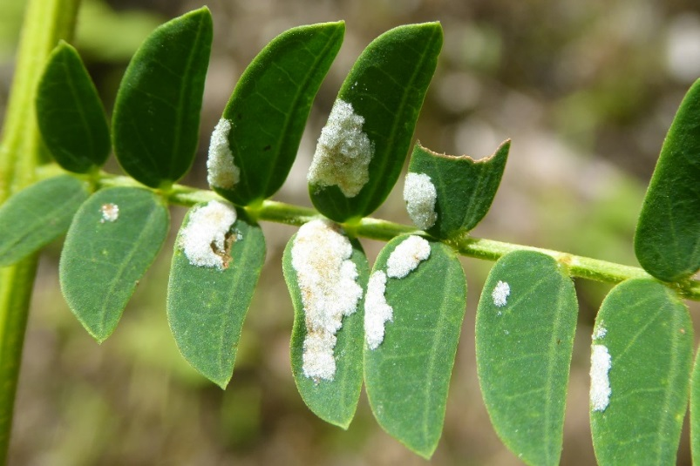 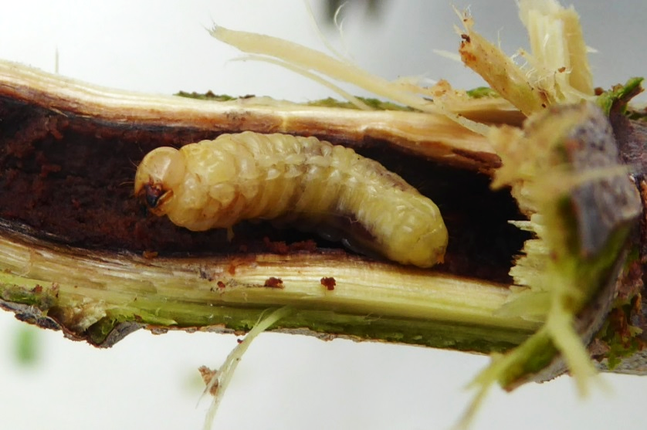

*Leaflet galls caused by eriophyid mites (left) and a stem-boring weevil in a woody twig (right) from Molucca Islands.*

We have begun growing potted albizia trees in outdoor shade houses in preparation for rearing and host specificity testing the albizia stem weevil at the Volcano quarantine facility. Further work in Hawaii awaits refinement of procedures for rearing the weevil at Pattimura University, and export and import permits to transfer live weevils from Indonesia. Hawaiian plants for host specificity testing will include ecologically and culturally important members of the Fabaceae family, with an initial focus on the native *Acacia koa*, which we have under propagation.

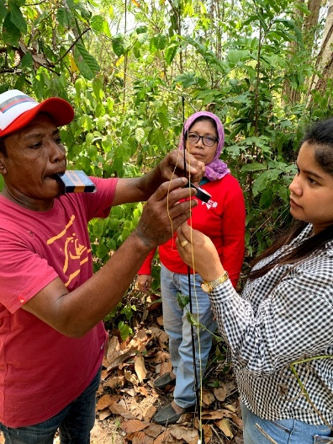 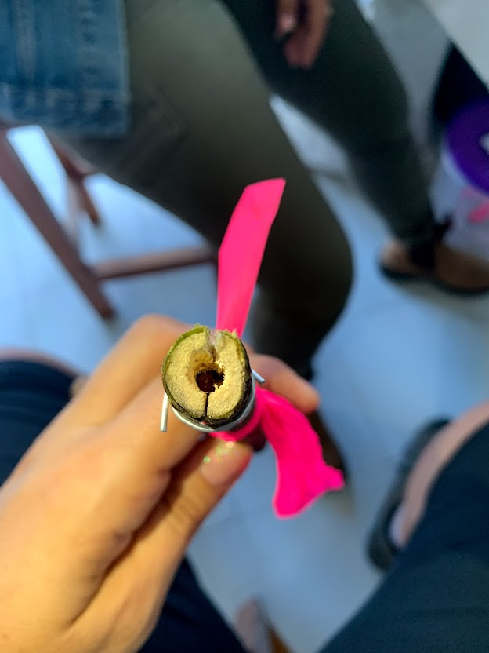

*Fixing equipment to survey albizia branches with Dr. Audrey Leatemia and technicians from Pattimura University near Ambon (left); a drilled stem used to rear weevil larvae (right).*

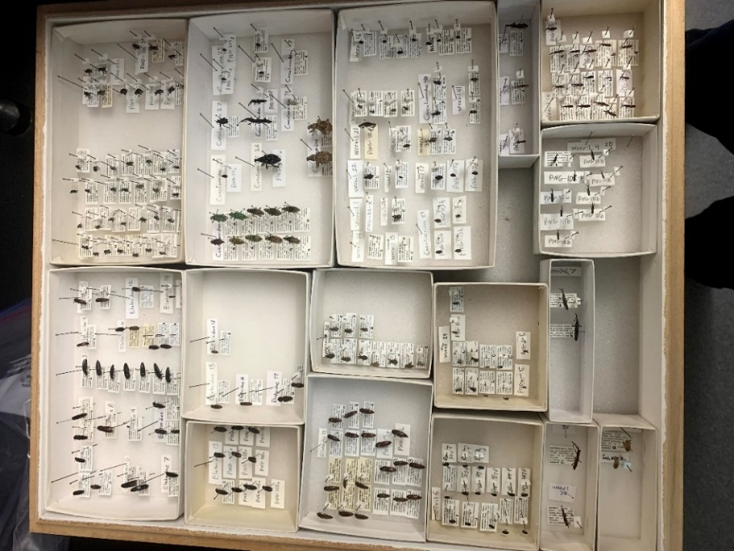Exploration for natural enemies of albizia was conducted extensively in Papua New Guinea and Indonesia in 2015-2017. These trips helped initiate collaborations with local scientists and universities and resulted in a large collection of insects found on albizia. In 2019 we processed and pinned all the beetles, identifying over 25 families of Coleoptera. Among three key families that are of major importance as natural enemies of trees, we have approximately 45 species of Chrysomelidae (leaf beetles), 14 species of Cerambycidae (longhorn beetles), and over 50 species of Curculionoidea (weevils). Identification of specimens to genus and species is the next goal.

To best match Hawaii’s invasive albizia with natural enemies from its original source, we collected leaves extensively across Hawaii and the native range (Indonesia and Papua New Guinea) and extracted a total of 243 genomic DNA samples. During 2019 we have been sequencing DNA after PCR (polymerase chain reactions) with markers adapted from literature on related plants. Thus far, a nuclear externally transcribed spacer marker (ETS) has provided informative data, while chloroplast markers have not yielded enough variation to be useful. We are working to identify a second informative marker to check against emerging results with ETS.

One of several drawers of pinned Coleoptera specimens collected from albizia across its native range.

## Progress in Melastome biocontrol

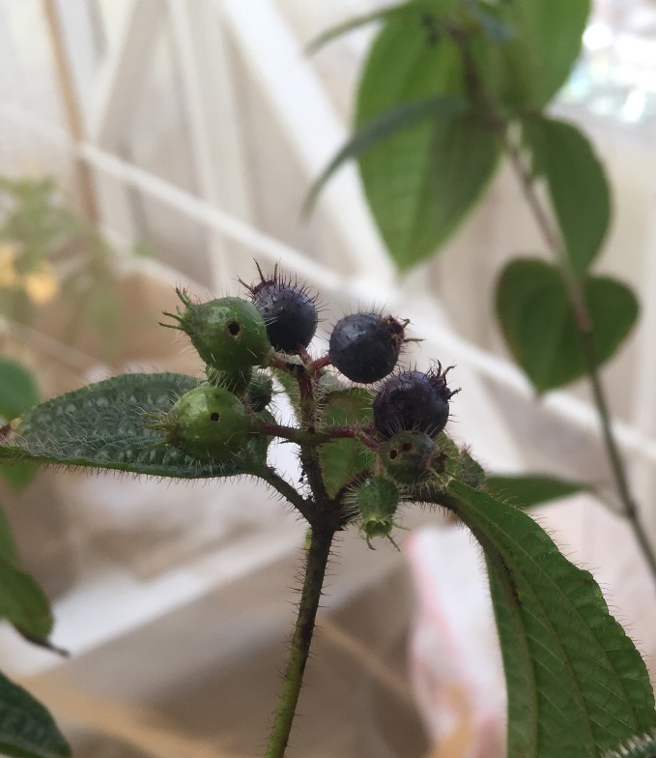Fruit gall wasps discovered by our program offer promising new tools for managing spread of the two worst melastome invaders in Hawaii, miconia and clidemia. The wasps lay eggs in flower buds, and their growing larvae alter normal fruit development, producing enlarged, hardened fruit containing galls in place of seeds. The two species, *Allorhogas granivorus* on *Miconia calvescens* and *Allorhogas clidemiae* on *Clidemia hirta*, are very likely extremely specific to their host plants. In expanded surveys in 2019, both were found widely in southern Brazil, including on the campus of our collaborator at Universidade Regional de Blumenau. We now have an abundance of sites that can serve as sources of wasps for further research. Pending permits to export from Brazil, we will resume testing the wasps in our Hawaii quarantine, where we previously have reared *A. clidemiae* successfully.

Fruits galled by Allorhogas clidemiae

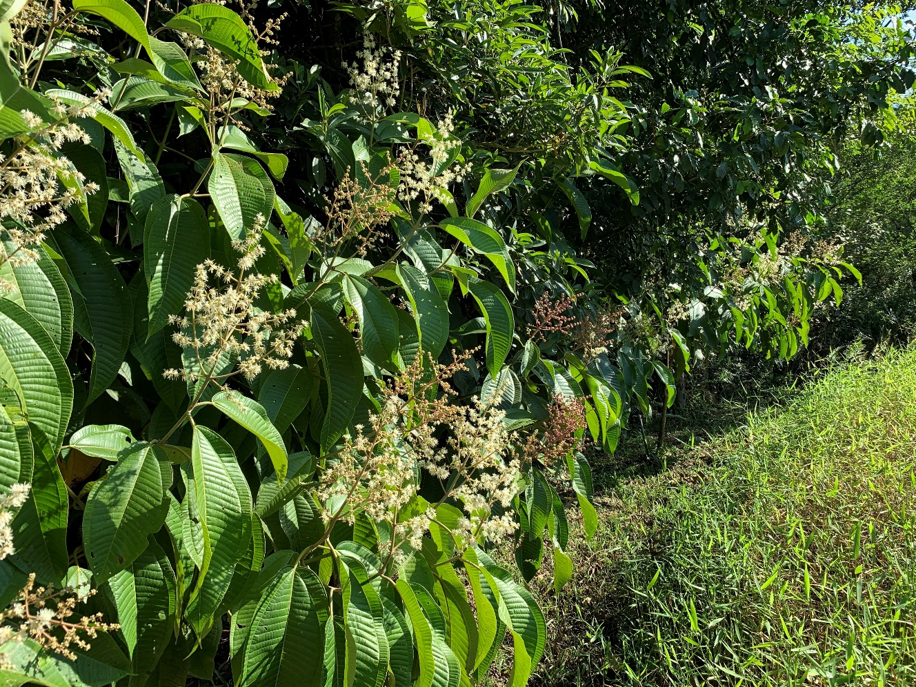

Miconia planted for study and rearing of fruit gall wasps at Universidade Regional de Blumenau, Brazil.

The fruit gall wasps have not been found in Costa Rica, but other promising agents for both miconia and clidemia are well known from our earlier work there. In early 2020 we resumed collaborations with Universidad de Costa Rica for further development of high priority insects and pathogens, including the miconia butterfly *Euselasia chrysippe*, miconia fruit weevil *Anthonomus monostigma*, miconia leaf fungus *Coccodiella miconiae*, and gall forming nematode *Ditylenchus gallaeformans*, which utilizes both clidemia and miconia.

Over the past year there has been substantial progress toward release of two melastome biocontrol agents developed by our program, with publication in early 2020 of Draft Environmental Assessments for the Brazilian beetle *Syphraea uberabensis*, which defoliates *Tibouchina herbacea* and related weeds (<http://oeqc2.doh.hawaii.gov/The_Environmental_Notice/2020-01-23-TEN.pdf>), and the miconia butterfly *Euselasia chrysippe*, whose larvae feed in large groups causing extensive leaf damage(<http://oeqc2.doh.hawaii.gov/The_Environmental_Notice/2020-04-23-TEN.pdf>).

## Acknowledgments

Our program depends on generous collaborators at universities in Indonesia (Purnama Hidayat and Audrey Leatemia), Brazil (Marcelo Vitorino and Robert Barreto) and Costa Rica (Paul Hanson and colleagues). Ken Puliafico organized collaborations and conducted surveys to initiate the albizia biocontrol project from 2015-2017. We are grateful for recent taxonomic contributions from Valle Rogers, Rolf Oberprieler, and Biljana Vidovic. Barrett Baca has supplied critical technical support. In addition to funding from the Hawaii Invasive Species Council, our projects have been supported by USDA Forest Service International Programs, SWCA and the Hawaii Department of Transportation, and the University of Hawaii Pacific Cooperative Studies Unit.

## Travel supported by HISC funds

Three trips by Ellyn Bitume to Indonesia for albizia natural enemies research ($15,600)

One trip by Tracy Johnson to Costa Rica and Brazil for melastome natural enemies research ($5,800)

One trip by Valle Rogers (CA - HI) to assist albizia insect collection curation ($1,700)