Hawaii Invasive Species Council
Data Reporting Guidelines for FY22 Funded Projects

Introduction
As part of your HISC funding award, you are required to submit spatial data twice annually, and a narrative report within 30 days of the completion of your project. There is no template for your final narrative report: simply provide a written account of how funds were spent and how your proposed goals and deliverables were (or were not) achieved. Please also include a record of all travel paid for using HISC funds (destination, purpose, and cost).

IF YOUR PROJECT DOES NOT MANAGE SPATIAL DATA YOUR ONLY REQUIREMENT IS THE FINAL NARRATIVE REPORT. IF YOU DO MANAGE SPATIAL DATA PLEASE USE THE GUIDELINES BELOW.

For spatial data reporting, all HISC projects will use standard reporting periods of:
· January 1-June 30 (data due to HISC by August 1) and
· July 1-December 31 (data due to HISC by February 1).
These reporting periods will repeat every year, and data should be reported for a given period regardless of where you are in your project timeline. For example, if you were to begin expending funds on November 10, you will need to submit your data for November 10-December 31 by February 1. You would then submit your data for January 1-June 30 on August 1.

If you manage a project that relies on multiple funding sources, you will report on the total achievements of your project across all funding sources rather than prorating your achievements by funding source. This makes the reporting process easier for you as a project manager and allows us to show the leveraged impact of HISC funding.

The following is to serve as a guideline for submitting your data to HISC. To standardize reporting, you only need to submit an MS Excel or Google Sheets file, exported from ArcGIS, of efforts organized by State House and Senate districts. Your report needs to contain the following metrics within the table and must meet all of the guidelines below in order to ensure data can be summarized across projects:

District_# | Program | Start_Date | End_Date | Genus_species | Survey_Ac | Treat_Ac | Nawa_Ac | Total_Ind | Imm_Ind | Mat_Ind | Trend | Goal | POC | Restrictions | Comments

District_# - State of Hawaii legislative district; i.e. House or Senate district # (e.g. House 1, Senate 1, etc.)
Program – Your program or project name (e.g. BIISC)
Start_Date - <short date format>
End_Date - <short date format>
Genus_species – Use the full latin binomial (e.g., Miconia calvescens). Do not use shortened field codes (e.g., Miccal)
Survey_Ac - Total acres surveyed for this species in reporting district
Treat_Ac - Total acres treated for this species in reporting district
Nawa_Ac -
Total_Ind - total number of individuals treated
Imm_Ind – Number of immature individuals controlled
Mat_Ind – Number of mature individuals controlled
Trend - This is a qualitative assessment based on the expert opinion of the managing organization. Assessment should consider:
  - New island records
  - Presence absence
  - Time needed to eradicate
  - Seed-bank longevity
  - Completeness of data
  - Change in number of mature plants
  - Change in number if immature
  - Timeframe
  - Density/ acre
  - Capacity/effort/acres surveyed
  - Percent of resurvey complete
  - Rate of spread
The following is a list of all acceptable inputs for “Species Trend”
· Never Detected – Monitoring
· This species in this area has been surveyed for at some level and the threat is not known and was never known
· Zero Detection – Monitoring
· This species in this area was once present and was reduced to undetectable levels
· Homestretch – maintenance
· This species in this area is at a level where it is close to being undetectable
· Infestation – decreasing
· The footprint and/or density of this species in this area is decreasing
· Infestation – increasing
· The footprint and/or density of this species in this area is increasing
· Containment of Infestation
· The footprint and/or density of this species in this area staying the same due to our management actions
· Unknown – Unsurveyed
· This species in this area has an unknown status and no one has surveyed for it to date

Goal – The species goal is your program's unique goal for the areas in which you perform management. The following is a list of acceptable inputs for “Species Goal”
· Survey
o The species has never been detected, but efforts to detect any potential populations are to be completed
· Zero Detection – Monitoring
o This species in this area was once present and was reduced to undetectable levels
· Containment of Infestation
o The footprint and/or density of this species in this area is staying the same due to management actions.
· Island-wide Eradication
o Complete removal of all individuals and seed on an island-wide scale.
· Statewide Eradication
o Complete removal of all individuals on a statewide scale. Species may or may not have have occurred on multiple islands.

POC – Point of Contact/Person responsible for data.
Restrictions – Restricted OR Unrestricted. Generally all data submitted to HISC will be polygon data at the level of political district, and is considered viewable by the public. If you submit data that should not be shared publicly, use the “Restricted” designation and we will contact you before using this data in maps or reports.
Comments – Comments

For those who have databases created by Natural Resource Data Solutions (NRDS), there have been a few tools developed to assist with reporting. See below for datasheet template as well as a data aggregation tool and tutorial. Instructions for using the Reporting and Data Aggregation Tool are below. For projects that do not use NRDS databases, review the instructions below and adapt accordingly to perform a join analysis that joins your data to the State House and Senate district shapefiles. These shapefiles can be found within HISC_Reporting.mdb or downloaded from ArcGIS online.

  - The final output that you send to HISC will be a single MS Excel or Google Sheets file. You may also send in the appropriate ArcGIS shapefiles instead of exporting your data to a spreadsheet file - if you prefer.

  - IMPORTANT - Please use the following naming convention for the filename/s you submit: REPORTPERIOD-ORG-SUBJ.EXT e.g. 20200701-1231-BIISC-HISC FY21 Data Report.xls

  - Please send your file to: Randy Bartlett (randal.t.bartlett@hawaii.gov).

Tools Developed
1. Shapefile template: https://www.dropbox.com/s/l99z2f09w9ah2k3/hisc_reporting_template.zip?dl=0
2. Spreadsheed template: https://www.dropbox.com/s/berc7omu7oiazzv/hisc_reporting_template.xls?dl=0
3. HISC Reporting and Data Aggregation Tool: https://www.dropbox.com/s/ev5mt6f12wr01gg/Hisc_reporting_full.exe?dl=0
4. HISC Reporting Tool Front End
https://nrds.io/hisc/Hisc_reporting_front_end.exe

Using the HISC Reporting and Data Aggregation Tool
- Install HISC_Reporting.mdb (available at the link above)
- Open the database from the shortcut
- Set Trusted location (see below, Setting Trusted Location)
- File Location
  - C:/Fieldwork/HISC_reporting
- Files
  - hisc_reporting_front_end - Front end forms, reports, code hisc_reporting_front_end
  - Hisc_reporting.mdb - Backend geodatabase -hisc_reporting
  - HISC_Reporting.mxd - map
- Feature classes
  - Weed_point - weed points used in reporting framework (though it is titled “weed_point” it is also for non weed data)
  - Weed-polygon - weed polygons used in reporting framework (though it is titled “weed_polygon” it is also for non weed data)
  - Report_unit - legislate units intersected and overlapped - each polygon has both house and senate values
  - Report_unit_all - legislative units merged- there is a polygon for each unit.

Prepare the Geospatial files
These instructions are to use the existing State House and Senate management units as decided during the 2016 data hui. These can be easily modified for other management units.

- Perform a spatial join on report_unit to weed_point using the spatial join (analysis) geoprocessing tool.
  - Target Feature = your local weed points
  - Join Feature = “report_unit”
  - Output feature class = “weed_point” (you will overwrite the weed_point feature class in C:/Fieldwork/HISC_reporting/hisc_reporting.mdb

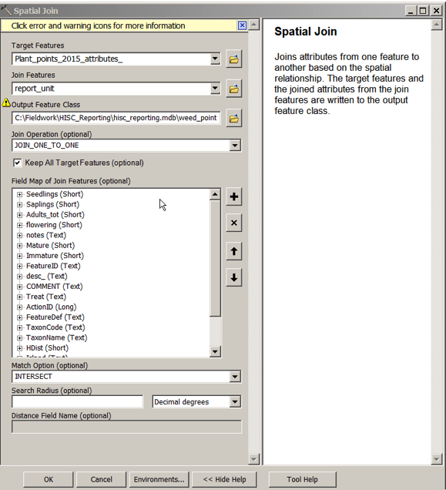
- Use the Intersect to split up the polygons by unit
  - (select a subset or it will take forever)
  - Make sure report_unit is on top

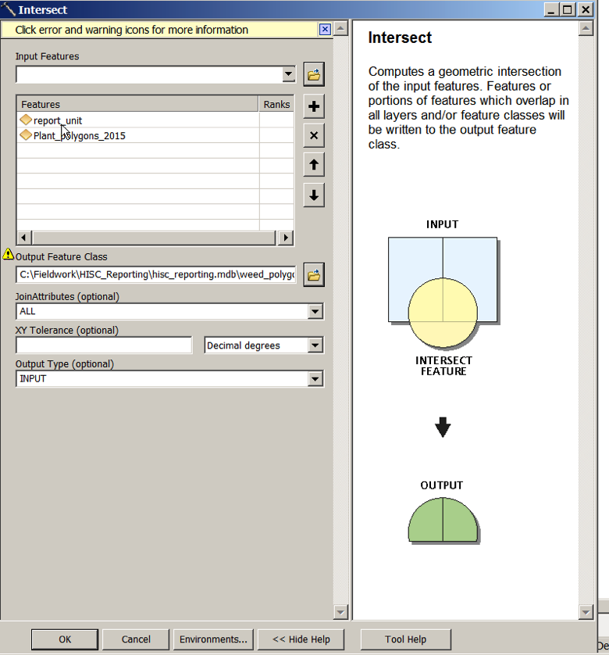
- Make sure both weed_points and weed_polygons have a “featureid” field that is the GIS connector field

Running reports
If there is a new database relink the tables by connecting to the current backend. You must have the NRDS database for this to work. For users that do not have an NRDS database, adapt the instructions below as necessary to run a report and export an Excel file with the relevant data.

How to Relink tables

- Set the dates
- Set the program
- Set the project
- Identify any missing GIS files. These will impact the
- Run the report

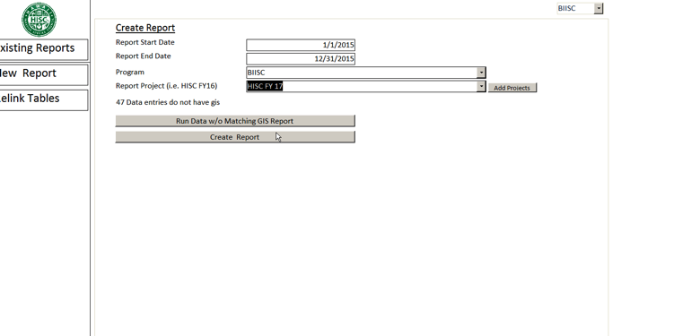

- Check that all GIS data has been associated with points and polygons

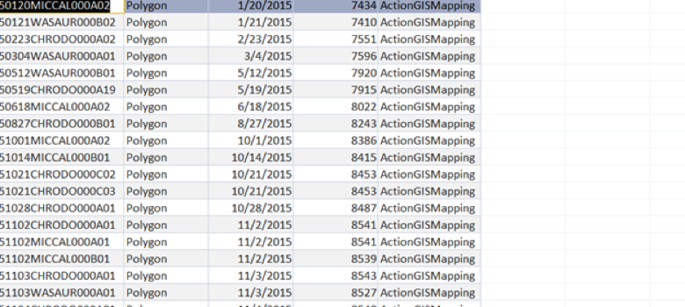
- Run the report
  - It will not run if a report for those dates, project, unit exists
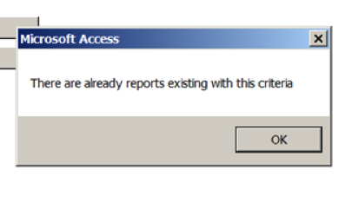

- Save the report
- Open the report and update the trends, goals, and comments
- Export the report to excel

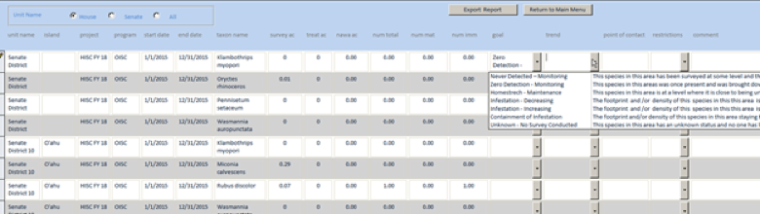

Open an existing report
- Click a report
- Open it
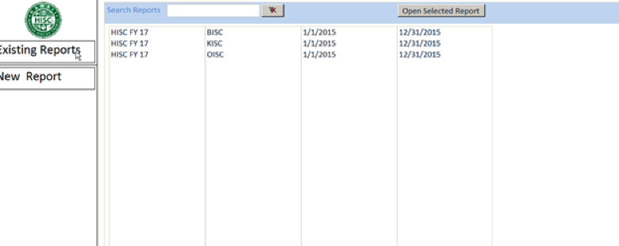

Import an existing report
- Choose Import Report
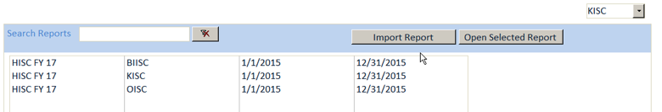
- Navigate to report to import
- It will only import if the fields are consistent

Visualizing Report Data in GIS Desktop
- The data is stored in a personal geodatabase.
- The House and Senate units are related to the report units
- To view data use the identify tool and click on a unit. Data will pop up.
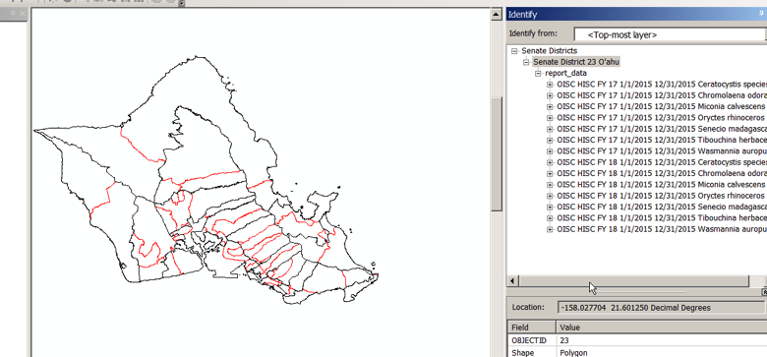
- To symbolize create a join between the unit layer and the report_data table. You may need to use definition queries to isolate distinct time periods.
- Join to the report_unit_all feature class

Setting Trusted Location
- Turn off the security warning/ Set Trusted Locations
- Click the file tab at the top of the screen

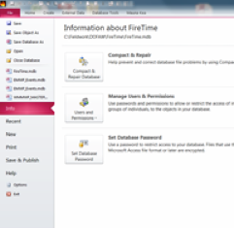
- Choose options on the left side menu
- Choose trust center
- Choose trust center settings
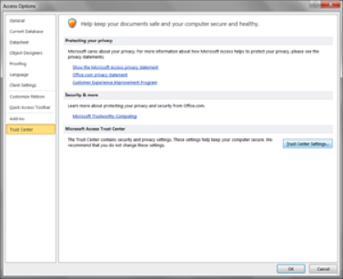
- Click trusted locations
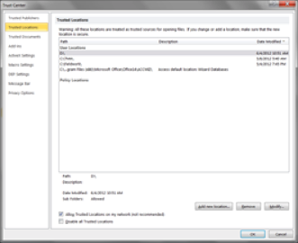
- Click add new location
- Add new location
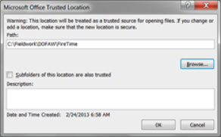
- Navigate to c:/Fieldwork/HISC_Reports

Relink Tables
- Choose the relink tables tab
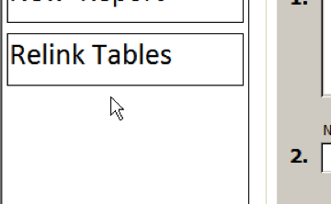

- Choose broken link or all links if you are resetting and existing path
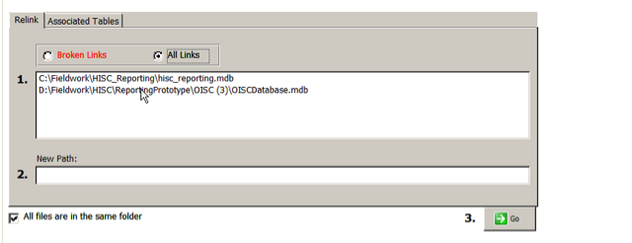
- Choose the pathway that needs to be reconnected
- Navigate to the database
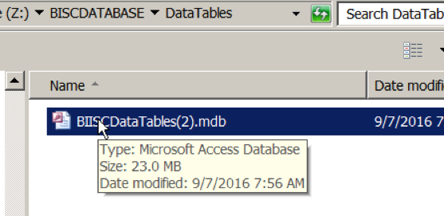

- Hit Go

