HISC Grant #C11720 Account #4505725: Detection and Control of Invasive Species on the Island of Hawaii

**Final Report to the Hawaii Invasive Species Council**

**Detection and Control of Invasive Species on the Island of Hawai`i**

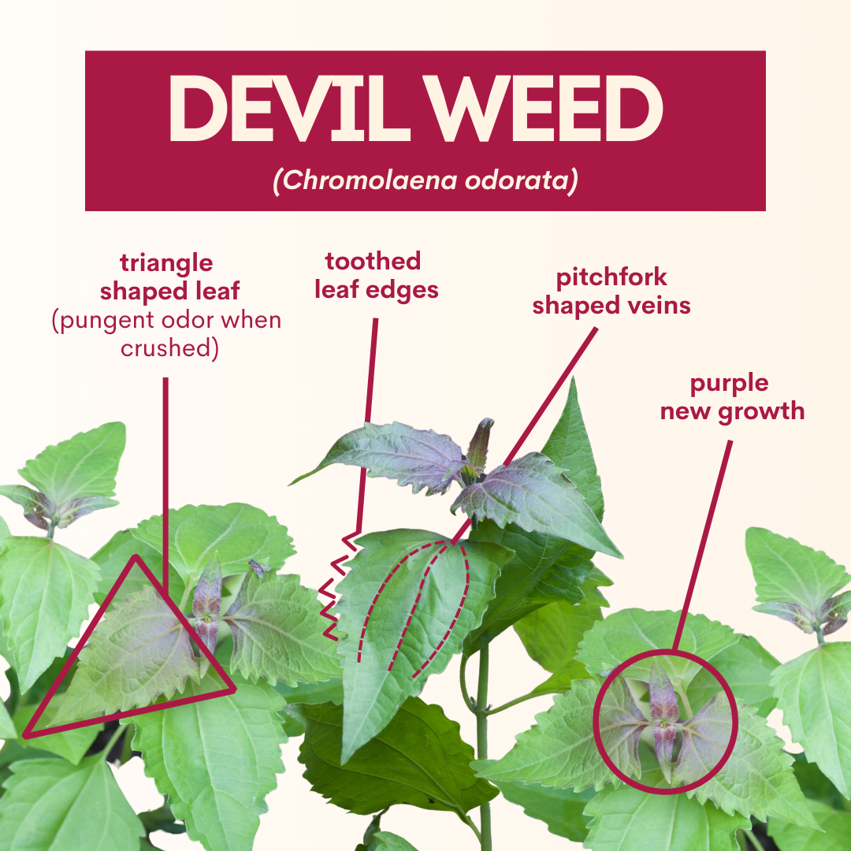

Big detection event of 2021—Devil Weed, a listed noxious weed, was detected on Hawaii Island for the first time.

Invasive species are among the greatest threats to the health of our native forests, agricultural economy, and way of life on the island of Hawaii. The Big Island Invasive Species Committee is a project of the Pacific Cooperative Studies Unit (PCSU) with the University of Hawai‘i. BIISC brings together stakeholders in conservation, agriculture, transportation, and policy fields to find mutually beneficial solutions. BIISC thereby plays a key role in Hawaii's Interagency Biosecurity Program, ensuring there is a high level of agency awareness, effective early detection and response capacity, and meaningful community engagement to effectively evaluate risk, prioritize targets, and develop innovative strategies to address invasive species threats across the island of Hawaii.

One of BIISC’s key Biosecurity roles is to ensure that there is effective early detection and response capacity on the island of Hawaii. BIISC staff provide constant surveillance for new invasive plants, animals – and more recently, pathogens – and we document new island records every year. We conduct formal risk analyses of terrestrial plants, pests, diseases, commodities and pathways to ensure we are addressing urgent, important, and resolvable issues. We utilize interagency and community partnerships to maximize efficiency in control efforts and broaden the knowledge base and investment in our operations. We are ready to act when new threats slip through our state's pre-border biosecurity programs, and when agencies need expanded capacity and partnership to respond.

**2021 Objectives:**

1. Support Hawaii's Biosecurity Program through ongoing active surveillance, assessment, and control of new invasive species and the development of productive partnerships.
2. Continuously improve and standardize our methods and the risk assessments used to prioritize our efforts on the island of Hawaii.
3. Detect and respond to newly introduced invasive plants and animals soon enough that eradication is cost effective.
4. Work steadily toward the eradication of well-vetted invasive plant target species.
5. Facilitate the on-island response to the Queensland Longhorn Beetle by coordinating researchers and agriculturalists with an interest in managing the pest.
6. Assist with research and management of the Two-lined Spittlebug.

**2021 Expected Outcomes and Accomplishments:**

* 100 miles of roadsides will be surveyed for new species.
  + 454 miles of roadsides, or 11,531 acres, were surveyed for new species. This increase was due to a restructuring of the program that clarified priorities and standards for planning survey routes, collecting data, and assessing targets. These surveys, combined with reports solicited from the public through outreach channels, resulted in the detection of three new locations of BIISC eradication targets and one new noxious weed species near the end of the year, *Imperata cylindrica*, or Cogon Grass. Notably, the first-ever detection of Chromolaena was an incidental find on the weekend by the BIISC manager, and social media outreach was responsible for the detection of six new locations of target species.
* Approximately 2,000 plants will be controlled on 1,500 acres of survey transects.
  + BIISC Plant Crew controlled 17,282 eradication target plants, including 3,301 mature plants, on 2,145 acres of surveys (see Table and Figures). This high number is driven primarily by the new detection of Devil Weed (6,194 plants) and ongoing control of Moluccan Raspberry (6,391 plants). These were followed by abundant Cotoneaster and Photinia populations of about 2,000 plants each, while the remaining populations of 300 or fewer plants. Buddleia fell into the single digits, with just 1 mature and 4 juvenile plants found on 82 acres of surveys, and Foxglove surveys turned up no plants this year at all.
  + In addition, BIISC controlled over 32,000 plants with the goal of containment or local control. This included over 16,000 Phenax hirtus plants, the mystery plant of Kaloko Mauka (Upland Kona), that looks worrisomely similar to mamaki, which is also abundant in the area. This number also included over 5,000 albizia and an array of invasive species on Natural Area Reserves or Hawaii National Guard lands, where BIISC is contracted to conduct routine weed maintenance work.
* BIISC will respond to new detections and reports of high-risk plants within 30 days. Rapid response to new wildlife and arthropod outbreaks will be negotiated with the appropriate lead agency.
  + BIISC reported the first island detections of the noxious weeds Devil Weed and Cogon Grass to the Hawaii Department of Agriculture within 30 days. HDOA will take the lead on Cogon Grass control, as it is a listed noxious weed, and BIISC has reached maximum capacity on plant targets.
  + BIISC was able to respond to dozens of reports of Devil Weed following information campaigns, confirming or rejecting the reports and beginning to set up survey appointments, within 30 days.
  + BIISC forwarded reports of rabbits and axis deer to DOFAW and HDOA, facilitated delivery of rabbit traps to residents, and conducted one night of axis deer surveys. No axis deer have been confirmed on Hawai`i Island since 2014.
* Six of our eleven target species will be advanced toward eradication according to timelines laid out in the BIISC Target Species Action Plan.
  + In 2021 our eradication target list grew to 14 species.
  + All 14 were surveyed and assessed, and control operations were performed on all except for two of the newest additions (12 species controlled).
  + Among the 12 species for which control operations were performed, the mature plant density in 2021 was reduced from the previous year for all species except for Ilex, which remained constant and Cotoneaster, which increased by a small, non-significant amount. Mature plant density of Foxglove remained at zero for a second year. Overall, 12/14 were advanced toward eradication.
  + While this represents successful continued forward momentum, BIISC was unable to meet all of the benchmarks for the eradication timelines stated in our action plan due to short staffing in 2021. Speeding up the rate of control operations by covering more ground with more people improves the odds of successful eradication, by reducing the risk that the species spreads to new locations before we can get rid of it. Boosting the funding and staffing for the plant crew is critical to eradicating our current slate of species so that we can add the new, worthy targets currently waiting on deck.
* BIISC will publish 12 assessments of potential target species. Standardized methods and the risk assessment procedures used to prioritize target species will also be published on the BIISC website by the end of 2021.
  + BIISC completed 18 assessments, published on the new BIISC website. Of these, four became eradication targets. Five more ranked highly enough in invasiveness, impacts, and technical feasibility to be added as eradication targets, however, BIISC lacks the resources to go after them.
  + BIISC presented our revised target species prioritization process to CGAPS and at the Hawaii Conservation Conference.
* Rabbits in one 20-acre colony in West Hawaii will be suppressed to undetectable levels.
  + This project was not undertaken due to a lack of staff and delays in receiving funds.
* Working group meetings will be convened quarterly to coordinate and communicate research on the Queensland Longhorn Beetle.
  + One working group was convened in April, 2021. At that meeting, it was decided to put working group meetings on hold. A USGS lab had hired a full-time entomologist, a former BIISC employee, to work with farmers who have detected suspect QLB damage and was providing specimens directly to USDA Agricultural Research Service (PBARC), where staff were funded to develop a PCR test to identify QLB larvae. Further, the CTAHR Invasive Pest mini-conferences were providing an excellent venue for reporting out research results, so for 2021 the QLB coordination and research needs were well-covered.
  + QLB was detected by USGS staff north of the Wailuku River for the first time in 2021, in Kukui Trees 15 miles north of the nearest known site in Hilo.
  + The PBARC PCR test developed by Sheina Sim has proven effective at detecting QLB DNA from both larvae and frass samples.
* BIISC will contribute up to 80 hours of outreach program time and 80 hours of planning in support of expanded management of the Two-Lined Spittlebug (TLSB).
  + BIISC developed ten social media posts explaining the biology, impacts, and how to report Two-Lined Spittle Bugs, and revised and updated the 2020 TLSB brochure.
  + BIISC participated in the monthly TLSB working group, conducted a site visit to an impacted ranch, and distributed information regarding TLSB legislation.
  + BIISC also developed ranching-specific information on Devil Weed, which could take advantage of openings created by the TLSB, for social media and print formats for distribution to cattle ranchers.

BIISC Detection and Control Work 1/1/2021-12/31/2021



**Species in Phases 3 (Monitoring and Control) or 4 (Final Stage)**

These species are on-track to be eradicated. Mature plant densities are approaching zero as nearly all mature plants have been removed, and few new populations have been found. Juvenile plants will continue to emerge for years, requiring ongoing monitoring to exhaust the seedbank. Digitalis, or foxglove, was found very early, with only three mature plants controlled the first year--numbers too low to provide meaningful density data, so counts are shown for that species.

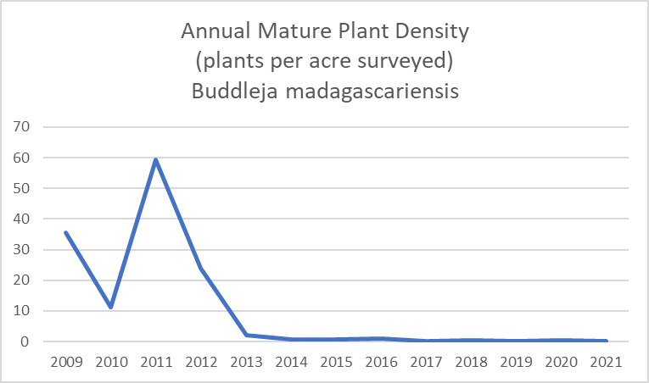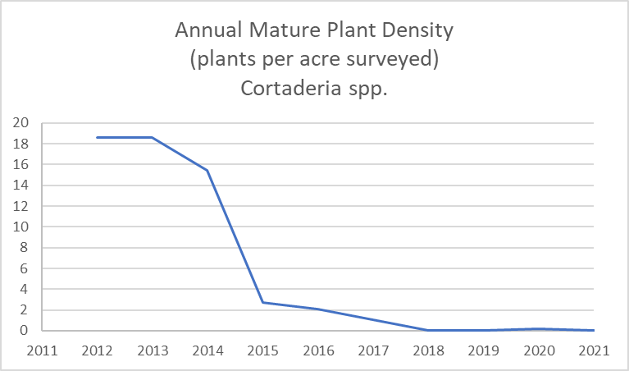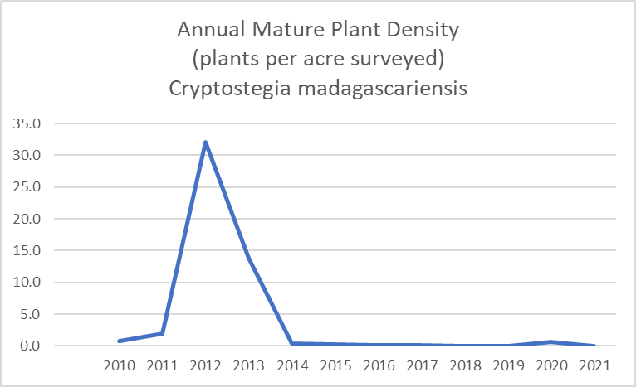

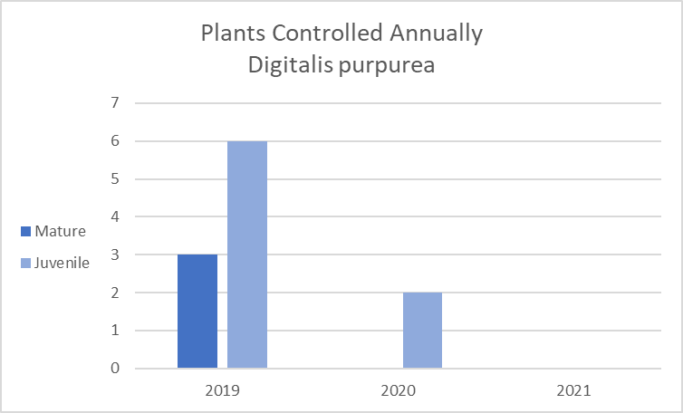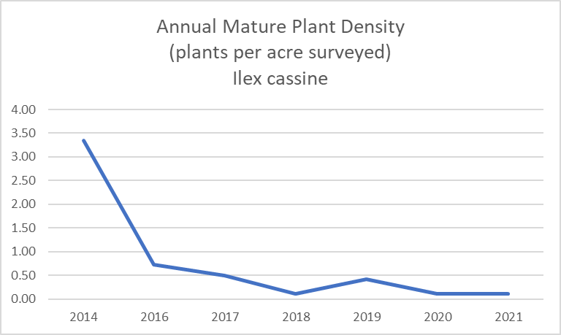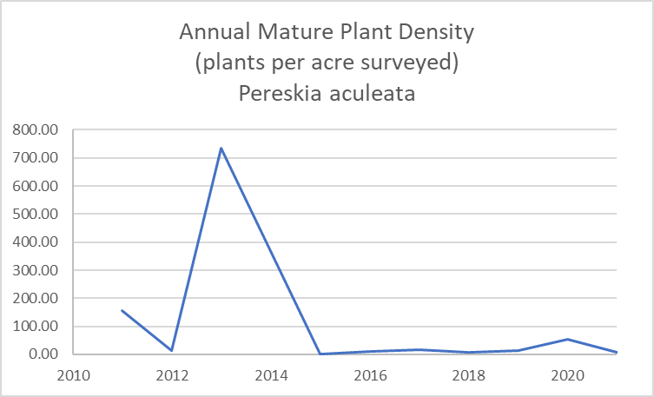

0

**Species in Phases 1 (Initial Suppression) or 2 (Control)**

In the early stages of control, numbers and density fluctuate year over year as new populations are found, or because it takes multiple years to treat the full extent of larger populations. The only known infestation of Pereskia, for example, had been driven down to zero for two years, when a large new population was found in 2017, starting the cycle over again. This cycle WILL repeat, as **Pereskia has been recently popularized among plant collectors, and is being actively smuggled into the state, traded via informal networks, and shared by friends**. The Markhamia data represents populations that were each found in a different year. Rather than trends, Markhamia work prior to 2021 is best understood as distinct efforts in each of three new areas, while the very small 2021 data bar includes all three sites—strong progress! In contrast, it took years to complete each sweep of the Rubus and Photinia infestations. Photinia clearly shows a reduction in mature plant density during the second sweep, while Rubus appears unchanged, with approximately the same number of mature plants per acre in 2016-2018, and 2019-2021. This count-based data is belied by a significant reduction in size of the plants being treated in each of the two sweeps. Not shown, the combined canopy cover of all Rubus plants treated has been reduced from 100 acres to five acres during the two periods. Devil Weed, which has an initial mature plant density of over 700 plants per acre treated, is not shown, as there has been only one year of data collected, and treatment has not yet commenced on our other two new target species, Giant Burmese Honeysuckle and Bandicoot Berry.



