HISC FY 2021 Funding Report
Title: Outreach and extension for Rapid ‘Ōhi‘a Death
Fiscal year: December 1, 2020 - March 31, 2022
Funding amount: $44,113.00
Principal Investigator: JB Friday, UH Mānoa CTAHR

Overview

When we wrote this proposal, in the spring of 2020, we anticipated that COVID would be over shortly and we would return to in-person events. Because this was not the case, we pivoted to doing more online and virtual educational events, with a couple of in-person events. Major educational events are listed below. We did not need to make significant changes in the budget, as most of the budget was to support the educational specialist, who began in October 2020.

Outreach Education Events

2020 Wreath Making Workshop

The 2020 Wreath Making Workshop was hosted virtually in November to begin the holiday season. Every year our wreath-making workshops are hosted before the holidays to share with others how to make ʻōhiʻa-free wreaths using other native or non-native plants. These workshops were often hosted in person but due to the COVID-19 pandemic, the 2020 wreath-making workshop was hosted virtually. Although it was preferred to host in-person workshops we found the virtual workshops to be fun and innovative as well as broaden our audience reach. Participants joined us from other island in Hawaiʻi and across the mainland U.S. Some participants hosted wreath-making parties at home with their families and/or close friends and others used alternative materials such as plastic bags to make their wreaths. The transition to using a virtual platform to host our workshops added more creativity and engagement to the experience.

Because the COVID-19 pandemic was heavily impacting our communities, we encouraged participants to use foliage they had available at home in their yards. This reduced their need to be out in the community and be creative with what they had at home. The outcome of this practice was that participants learned what they had in their yards they could use the make wreaths and/or other things such as lei.

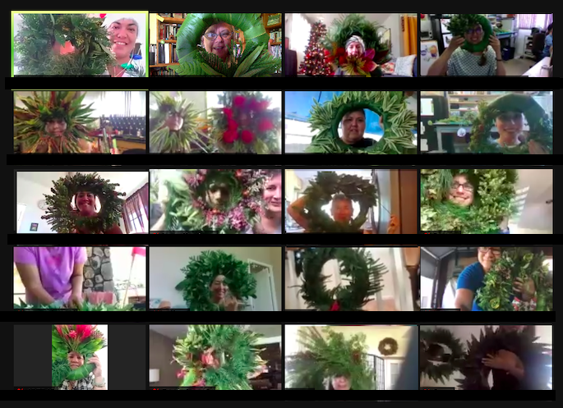
2020 Wreath Making Workshop: (insert caption)

2021 ROD Outreach Workshop -

The 2021 Rapid ʻŌhiʻa Death Outreach Workshop was hosted virtually due to the COVID-19 pandemic. The shift to using a virtual platform to host our annual workshop enables us to broaden our participation reach and utilize creative ways to engage with our audience. The Rapid ʻŌhiʻa Death outreach workshop is geared toward professionals working with ROD through science and communication. The event enables scientists and outreach education professionals to come together and share their work with each other. Science presenters share about the current efforts happening around their research and outreach professionals share how the use creatively articulates the scientific findings to our communities to raise ROD awareness. The workshop ran once a week for five weeks. Each weekly session included two science talks and two extension talks, for a total of 20 presentations. In total, 81 people attended the workshops, with most attending 3 or more sessions. Attendees came from Hawai‘i Island, Maui, Lana‘i, O‘ahu, Kaua‘i, and the mainland. In a follow-up survey 7 months after the workshop, participants reported that each directly reached a median of 28 new people with the science information they learned at the workshop and directly reached a median of 25 people using the communication techniques they learned at the workshop.

2021 Native Plants Month -
The Rapid ʻŌhiʻa Death outreach education team created a social media campaign, for the 2021 Native Hawaiian Plants Month, that featured a native plant daily during the month of April. The social media posts were designed on Canva and included images and information about the featured native plant. Extension Forester J. B. Friday provided the images and information used for each media post and Hawaiʻi Island ROD Education Specialist Hōkū Pihana created the post designs. The daily posts were scheduled for both the ROD Facebook (facebook.com/RapidOhiaDeath) and Instagram (instagram.com/ohialife) pages using the Facebook business suite tools.
The social media campaign opened with posts that featured the various native trees found in Hawaiʻi. The month opened with Māmaki, sharing information about its uses, environment, ecological relationships, and physical characteristics. The proceeding posts shared similar information about ʻOhe mauka and ʻOhe makai, Alaheʻe, and Hala. The posts then transitioned into featuring the different native shrubs and ground cover such as ʻŌlapa or Lapalapa, Naupaka Kauahiwi and Kahakai, and ʻOhe Naupaka and ʻOhe Makai sharing the same information about each shrub of ground cover as we did with the native trees. The team posted a total of 25 times for the month.
The week leading up to ʻŌhiʻa Lehua Day and in honor of Hauʻoli Lā Honua (Earth Day) the Rapid ʻŌhiʻa Death outreach education team partnered with Kilo Books Hawaiʻi to do a 7-day giveaway contest for those who posted their favorite ʻōhiʻa lehua picture based on the theme of the day. Each day would highlight a different growth stage of the lehua blossom. People posted pictures based on the lehua growth stage of the day throughout the week and at the end of the week winners were selected to win the giveaway prizes donated by Kilo Books Hawaiʻi. Finally, in honor of ʻŌhiʻa Lehua Day, April 25th, 2021, we highlighted the environmental and cultural importance of ʻŌhiʻa to Hawaiʻi. On that day we also hosted a special virtual tour of a native forest on Instagram Live that has been viewed 519 times. The month then closed with a final post highlighting the Koa. The 2021 Native Hawaiian Plants Month social media campaign shared the special native plants of Hawaiʻi and their importance to our natural environment, communities, and culture.

2021 Native Plants Month: Facebook Business Suite Analytics Data

Trends - Facebook & Instagram - page reach
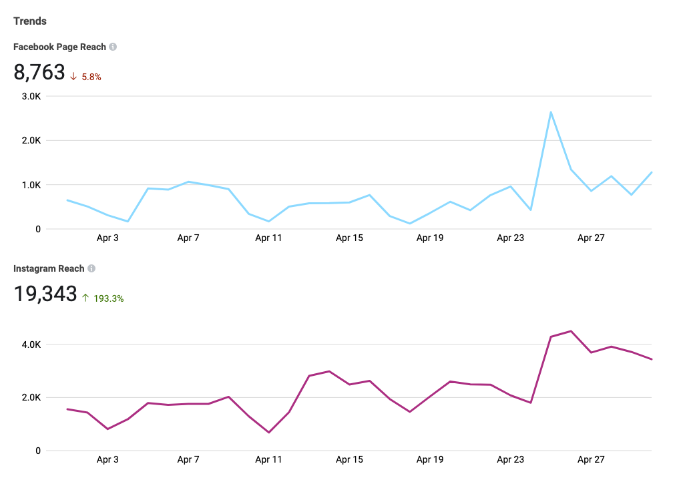
Content: Facebook & Instagram - post reach; top performance
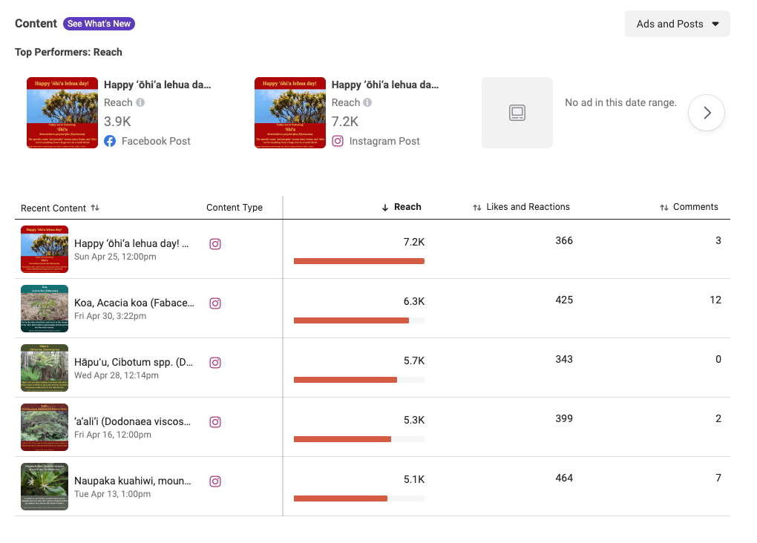

Top Performer: Reach - Facebook & Instagram
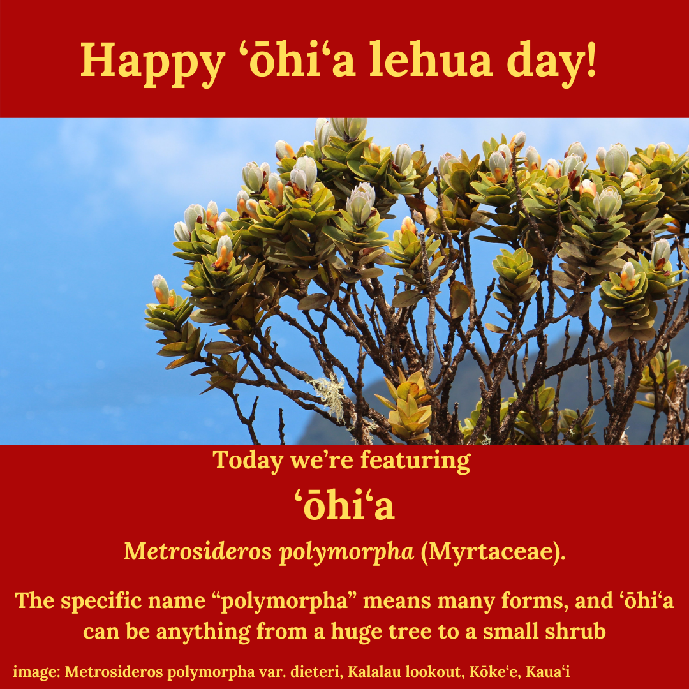
Total reach: FB - 3,900; IG - 7,200

2021 Lei Making Workshops –
In May 2021 we hosted three ‘ōhi‘a-free lei making workshops. These were designed to encourage people to use other native and local plants in lei making while giving ‘ōhi‘a a break from collecting. Participants learned different styles of lei making and responsible collection of lei materials.

Hosted: May 7, 14, and 28th, 2021
Attendees:
May 7 – 27 people (5 surveys completed, 19% completion rate)
May 14 – 29 people (18 surveys completed, 62% completion rate)
May 28 – 36 people (20 surveys completed, 56% completion rate)
Total: 92 attendees (43 surveys completed, 47% average completion rate)

Knowledge Change -
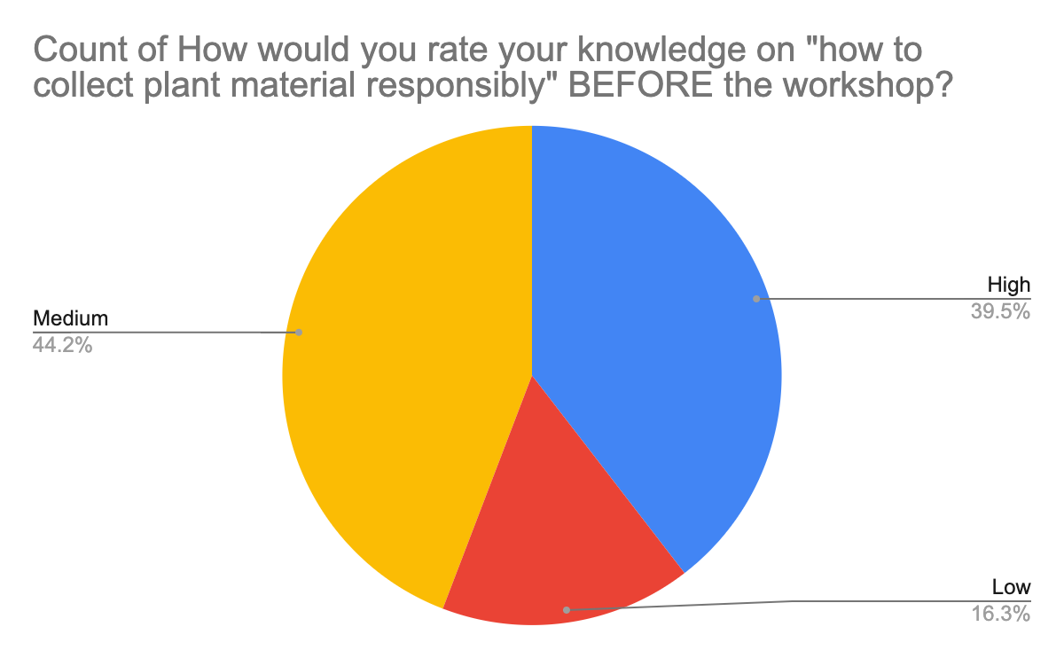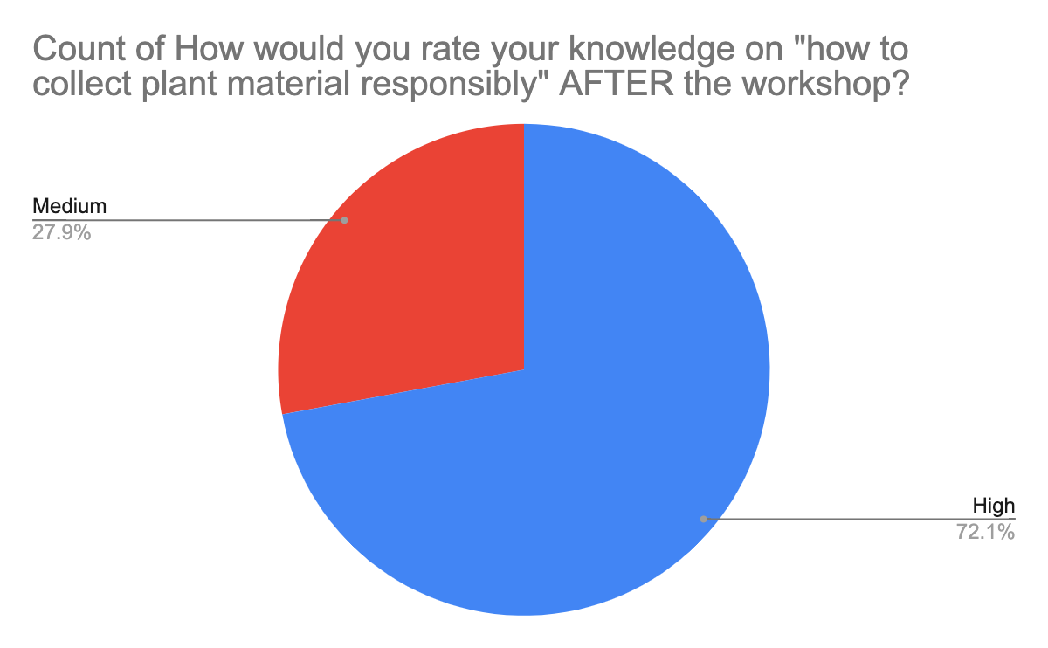
2021 ʻōhiʻa-free lei-making workshop

2021 ʻŌhiʻa Love Fest -
The 2021 ʻŌhiʻa Love Fest was hosted virtually from November 3rd - 6th, 2021. This year's theme was Celebrating our Native ʻŌhiʻa Forests; Kinikini Ka ʻŌhiʻa, Ola Mau Nā Ululāʻau Hawaiʻi - Multitudes of ʻŌhiʻa, perpetuate the health and wellness of our native forests. This theme celebrated our native ʻōhiʻa forests through virtual experiences that provided our attendees with the tools and resources they need to take action in their communities to perpetuate ʻōhiʻa growth and abundance. We hosted a set of virtual field days in ‘Ōhiʻa forests in Volcano, Pu‘uwa‘awa‘a, Hawai‘i Loa, Mānoa, and Koke‘e and are in the process of posting longer versions of these videos to YouTube (https://www.youtube.com/user/HawaiiRREA (UH forestry extension), https://www.youtube.com/channel/UC1zeQ-RS-9Gd7sbjLjVYGjQ (KISC), and https://www.youtube.com/channel/UCIsW_btZFLfq_uSjjbgVw6Q (Rapid ‘Ōhiʻa Death program).

Each workshop was designed to share information and resources about ʻŌhiʻa that enabled people to identify ʻōhiʻa seeds, sustainably gather them, and grow them to seedlings that can be planted in their ʻāina or within their communities. See https://www.youtube.com/watch?v=yKwphjeIPnA for our video on how to plant an ʻŌhiʻa tree. To complement the workshop series, we also led a social media campaign that shared about the various Arbor Day events happening across the state and hosted another Kilo Books Giveaway for our followers. Collectively, the virtual design of the 2021 ʻŌhiʻa Love Fest is intended to use different virtual platforms to engage attendees, reach a broader audience, and take action within our communities to promote the health and productivity of our native ʻŌhiʻa forests.

We had a total attendance count of 249 (survey results of n=124) for the entire festival with our largest number of attendees present during the Tour of Hawaiiʻs Forests (ttl = 131). The primary responses from our attendee survey showed more people were interested in taking action in their families and communities to support ʻōhiʻa life by planting more ʻōhiʻa, sharing information with family and friends, and/or participating in ʻōhiʻa advocacy efforts. Results from our survey also showed a significant increase in knowledge about ʻōhiʻa after attending our event (p-value: 0.001). In conclusion, we found there to be many benefits to hosting the ʻŌhiʻa Love Fest virtually yet we did recognize the importance of in-person learning exchanges and experiences.

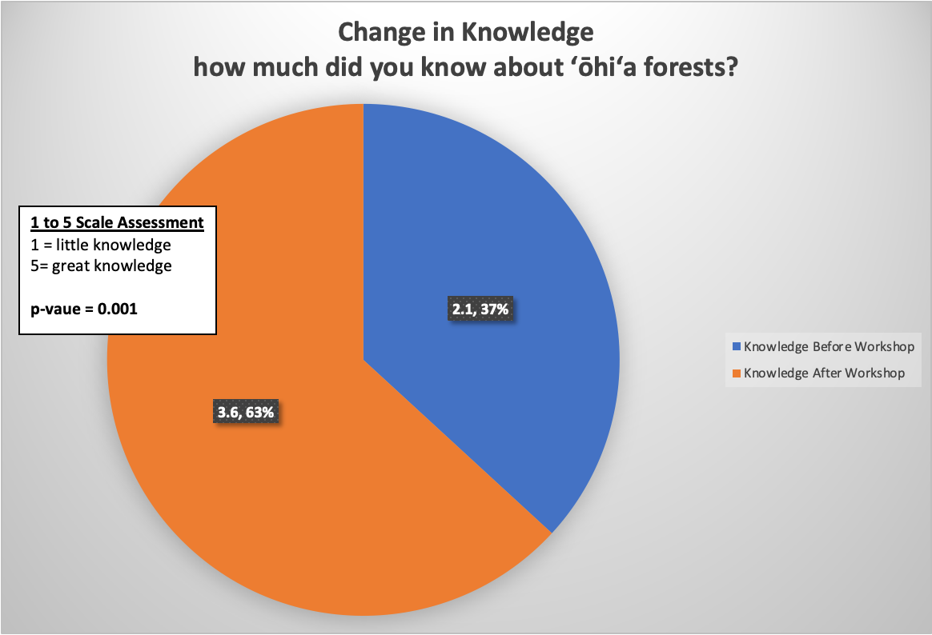
2021 ʻŌhiʻa Love Fest - knowledge change

2021 Wreath Making Workshops -

We hosted two ʻŌhiʻa-free wreath making workshops in December 2021. While ʻŌhiʻa Christmas wreaths are beautiful and significant in Hawai‘i, we are encouraging people to use other native and local plants in their home made Christmas wreaths. Participants responded that they will use what they learned to make more ʻŌhiʻa-free wreaths, teach others to make these wreaths, and reduce the use of single-use plastics in their wreaths.
