DAVID Y. IGE  GOVERNOR OF HAWAII |  | ELIZABETH A CHAR, MD  DIRECTOR OF HEALTH

STATE OF HAWAII

DEPARTMENT OF HEALTH

P. O. BOX 3378

HONOLULU, HI 96801-3378

Hawaii Invasive Species Council (HISC) Research and Technology Grant Program

2020 FY Final Grant Report

Wolbachia Outcrossing, Cytoplasmic Incompatibility Testing, and Colony Maintenance for Hawaii Lineage Ae. aegypti and Ae. albopictus Mosquitoes

Introduction

Within Hawaii, the Ae. albopictus and Ae. aegypti mosquitoes are invasive species that pose a significant risk to public health. These species are capable of transmitting arboviral diseases, such as dengue, chikungunya, and Zika. HDOH currently attempts to control these mosquitoes through the use of breeding site source reduction and chemical pesticides. An alternative approach to controlling these invasive species includes implementing an Insect Incompatibility Technique (IIT).

The success of an IIT based tool is dependent on the fitness of the IIT males used. Fitness of Culicid males correlates directly with female selection, male survivorship, male dispersal, and mate finding success. To maintain or enhance fitness in laboratory reared individuals, it is recommended to collect a foundational population that is relatively equivalent in genetic diversity to the population that is targeted for control. Maintaining a high level of genetic diversity in the laboratory reared populations of Ae. albopictus and Ae. aegypti is essential in developing an IIT-based tool in which the fitness of the IIT males is at least proportionately equivalent to that of the wild-type male when released.

To enhance the future utility of these tools through the approximate equivalence of fitness to the wild-type males, the Hawaii Invasive Species Council (HISC) funded the Hawaii Department of Health’s (HDOH) Vector Control Branch (VCB) and the developer of the IIT mosquitoes, MosquitoMate, to perform collections of Ae. albopictus and Ae. aegypti lines originating from Hawaii and to perform the Wolabachia outcrossing at the funding level of $61,989. As Ae. albopictus occurs on all of the main Hawaiian Islands, collections were conducted to the extent possible across at least five to ten sites on two islands, Oahu and Hawaii Island, for the development of a genetically diverse baseline biotype from which the Hawaii lab reared cytoplasmically incompatible strain was developed and is maintained by MosquitoMate. Because the known extent of Ae. aegypti in Hawaii is only on the island of Hawaii, collections of this species were performed exclusively there. Collections of Ae. aegypti were also focused on five to ten geographically distinct sites to help maintain a level of genetic diversity in the lab reared population that approaches equivalence to that of the Hawaiian meta-population.

Management and dispersal of funds were managed and coordinated by the Department of Land and Natural Resource’s (DLNR) Division of Forestry and Wildlife (DOFAW) as they were also awarded similar funds within the grant cycles regarding the control of established and invasive Culex quinquefasciatus mosquitoes that are known to transmit avian disease to Hawaii’s native honeycreeper bird species.

Awards were granted to HDOH in August of 2019 with the intention to begin collections in the spring of 2020. However, due to the redeployment of VCB staff to other roles within HDOH to assist with the COVID-19 response, a one-year extension of the grant was provided to the project.

Methods

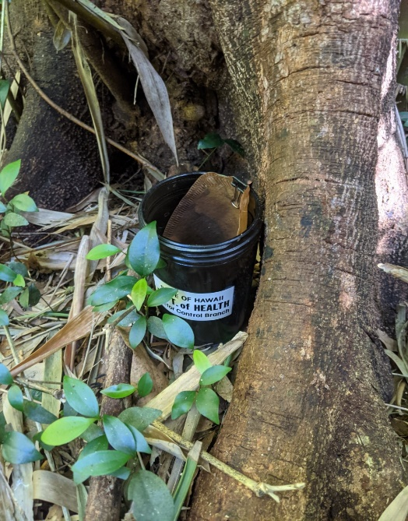
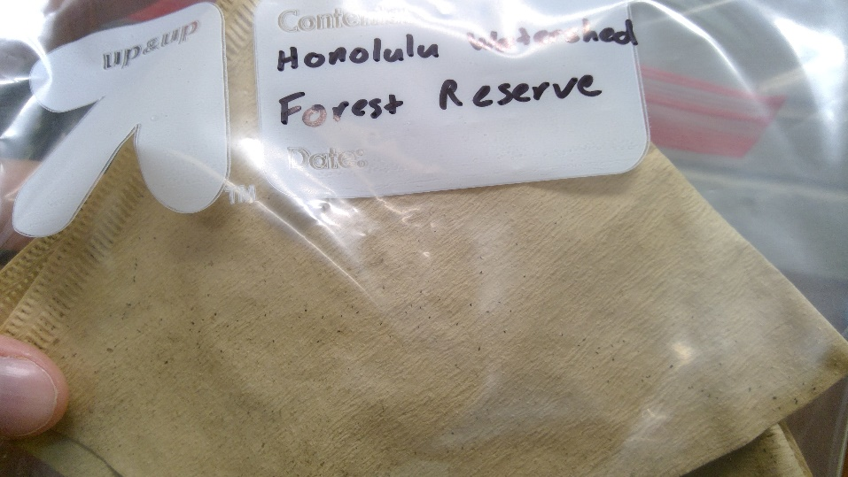
Collections of the Ae. albopictus lines were completed on both Oahu and Hawaii Island in the spring of 2021 and the collection of the Ae. aegypti line was completed concurrently on Hawaii Island. The eggs of these species were collected through the use of mosquito ovicup traps (Figure 1) lined with mosquito egg papers (Figure 2). These ovicups are filled with hay or grass infused water that attracts female mosquitos to lay their eggs upon the egg papers with the intention of the eggs hatching into the nutrient rich environment. Before the eggs are allowed to hatch, the traps are collected by VCB staff, the egg papers are allowed to steadily dry over the course of a few days to preserve the eggs, and the egg papers are submitted to the MosquitoMate laboratory for Wolbachia outcrossing.
Figure 2 - Mosquito egg papers
Figure 1 - Mosquito Ovitrap
Collections on Oahu occurred at seven locations across the island in February 2021. These locations include the ʻEwa Forest Reserve, the Pūpūkea Forest Reserve, the Hauʻula Forest Reserve, the Honolulu Watershed Forest Reserve, the Manoa Public Library, the DLNR DOFAW Insectary in Kailua, and HDOH Vector Control Offices in Halawa. In total, 102 egg papers were collected and submitted to MosquitoMate. Following the first generation that was hatched and reared within their laboratory, it was confirmed that all mosquito eggs collected were of the species Ae. albopictus.

Collections on Hawaii Island occurred at numerous locations in both east and west Hawaii in March and early April and were sent to MosquitoMate on 4/16/21. Ae. albopictus eggs were present at and obtained from all geographic areas throughout the island while Ae. aegypti were limited to southwestern areas of the island; collection locations targeting Ae. aegypti included Manuka Park, Miloli’i community, Hookena Beach Park, Kealekekua Bay, Honaunau, and the Painted Church in Captain Cook Hawaii. Following the first shipment, MosquitoMate confirmed both species had been successfully reared and established from the collection sites. A second collection of eggs took place again in early June (shipped 6/21/21) focusing again on the southwestern portion of the island to attempt to supplement the Ae. aegypti colony that was established with limited numbers from the initial shipment.

Following the rearing of the two Ae. albopictus collections, the two populations were combined to allow for the establishment of one population with broad genetic diversity from across the Hawaiian Islands.

Following the submission of the mosquitoes to MosquitoMate, a line of Wolbachai transinfected Hawaii Ae. albopictus were developed by first clearing the Hawaii line of vertically transferred Wolbachia strains using the antibiotic tetracycline. Antibiotic clearing is unnecessary in the Ae. aegypti biotype line as they naturally do not vertically transfer Wolbachia. After Wolbachia cleared lines of Hawaii Ae. albopictus and Ae. aegypti biotypes were developed and stabilized, the males from these Hawaii lines were then outcrossed with conspecific females from the Wolbachia transinfected lines that had previously been developed by MosquitoMate. These lines harbor Wolbachia strains that cause reproductive failure of lab-reared/wild-type crosses (via Cytoplasmic Incompatibility) in these species; wPip in Ae. albopictus and wAlbB in Ae. aegypti. To maintain Hawaii specific biotype genetics for both species, the daughters of the outcrossed individuals were then backcrossed with males of the Ae. albopictus and Ae. aegypti Hawaii biotypes.

Results

Successful mosquito colony development was performed by MosquitoMate following receiving the mosquito egg papers. By September 2021, the colony of Ae. albopictus mosquitoes had been reared to a population size where antibiotic treatment was allowed to be performed. Antibiotic treatment is required for 4-5 generations for Ae. albopictus to ensure that the vertically transmitted Wolbachia is completely cleared. Following the generations of antibiotic treatment, the Hawaii line will be outcrossed with the MosquitoMate Zap mosquitoes and backcrossed with the antibiotic treated males from the Hawaii line to preserve the genetics of the Hawaii line. The Ae. aegypti line had also been reared to a population size where outcrossing with the incompatible Wolbachia line was able to continue.

MosquitoMate will maintain the colony until proper regulatory steps are cleared to return the mosquitoes back to Hawaii for release. These regulatory steps include both federal and state requirements that are concurrently being addressed by both HDOH and MosqutioMate. These steps include:

- Receiving a pesticide label to allow the Wolbachia mosquito product to be used within Hawaii. MosquitoMate has submitted registration applications with EPA for both species to be used within Hawaii and a registration decision is expected in spring 2022. MosquitoMate has also made similar contact with the Hawaii Department of Agriculture (HDOA) regarding the registration of the product in Hawaii if it receives the EPA registration for the Wolbachia mosquito product.
- The performance of an environmental assessment in compliance with NEPA/HEPA and the use of state funds to perform such a mosquito control action. HDOH has received a HISC grant award to complete the environmental assessment in FY 2022.
- Listing these species on the appropriate approved species import list from HDOA and receiving an import permit from HDOA to return the mosquitoes to Hawaii for release. HDOH and DLNR jointly submitted an import and listing of species application to HDOA in July 2021 for Ae. albopictus, Ae. aegypti, and Culex quinquefasciatus.
- Acquisition of funds to mass produce the male Wolbachia mosquito product to be released into the environment to suppress wild mosquito species, if deemed appropriate following the environmental assessment and review of the import application by HDOA.

