Documenting spatio-temporal variation in mosquito populations to further landscape-level mosquito control to protect avian and human health
Lisa H Crampton, Roy Gilb, Allison Cabrera, and Adam Vorsino
March 21, 2022
Introduction

Kauai’s endemic forest birds are at critically low numbers, with three species numbering <1000 individuals. These declines coincide with the increased prevalence of avian malaria, vectored by Culex mosquitoes on the Alakai Plateau - the primary refuge for Kauai’s native forest birds - strongly implicating disease in these declines. Similarly, avian malaria was linked to the failure of a recent translocation of Kiwikiu on Maui, suggesting that malaria is invading ever-higher elevations. Climate change has likely altered density and permanence of larval habitat, increasing distribution and abundance of Culex in critical high-elevation forest bird habitat that used to be mosquito-free. Concurrently, Aedes japonicus, an important potential vector of human and avian diseases, invaded the Plateau. Without concerted action to control these vectors, the demise of several forest bird species is imminent, and a surge in human diseases possible.
Innovations in landscape-level mosquito suppression can efficiently halt avian declines and protect human health. Incompatible Insect Technique (IIT) uses Wolbachia, a common endosymbiotic bacterium of arthropods, to engender infertility through cross-matings. Sustained releases of male mosquitoes infected with incompatible Wolbachia suppress wild populations. To gain regulatory approval for initial releases in Hawaii, and achieve successful deployment and suppression, key ecological parameters of wild target mosquito populations (e.g., distribution and density) must be assessed. A key finding from our HISC-funded work and work by other partners is the tremendous variation in these parameters within and among years and sites. For FY21, we investigated this variation by sampling three sites at different elevations on Kauai for an entire year (previously we sampled one site for a whole year and multiple sites for shorter durations). American Bird Conservancy provided funding fall sampling and HISC provided money for spring and summer sampling.
AIMS
(1) examine spatial and temporal variation in relative densities of host-seeking and gravid adult mosquitoes, and spatial variation in larval mosquito prevalence, within and adjacent to critical forest bird habitat on the Alakai Plateau, Kauai
(2) investigate disease prevalence of adult mosquitoes in sites within and adjacent to critical forest bird habitat on the Alakai Plateau, Kauai

(3) locally control mosquitoes in and near forest bird habitat by trapping and larval removal
(4) assess infection rates by avian malaria in birds
(5) conduct public outreach on danger of introduced mosquitoes to bird and human health and potential for IIT to mitigate this risk

Methods
We assessed relative abundance of adult and larval mosquitoes at three sites differing in elevation and precipitation within and adjacent to endangered forest bird habitat on Kauai (Aim 1). All three sites were sampled for six nights, approximately every 6 weeks for one year (8x/yr). At each site, we trapped mosquitoes using 8 BG (CO2) and 8 active GT (gravid) traps. CO2 traps catch pre-reproductive females seeking a blood meal, whereas gravid traps catch reproductive females seeking to lay eggs. An IIT release will target females in between these two stages so it is important to know where and when each are found. We correlated these data with forest habitat metrics derived from already-collected LiDAR imagery that covers all sites. In Aug-Oct we sampled larval mosquito habitat on transects to document successful reproduction and larval prevalence.
We collected 30 adults per trap type per visit for genetic (to screen for Plasmodium relictum) and future genomic and isotopic analysis by USGS, USFWS, and University of Hawaii to study elevational migration patterns and determine source locations (Aim 2).
By trapping and collecting adult mosquitoes, we will locally control them in and near forest bird habitat (Aim 3). We controlled larvae by applying Bti to larval pools.
We screened forest birds for presence of avian malaria. We mistnetted birds at all three sites during the breeding season. After weighing, measuring and banding the birds, we took blood samples that will be analyzed with genetic techniques at Northern Arizona University for P. relictum.
Deliverables

- 8 CO2, 8 active gravid traps and 4 passive gravid traps run at each of 3 sites for 1 week, 8 times (~every 6 weeks) to determine spatio-temporal variation in relative abundance of adult mosquitoes by breeding status (approx 3360 total trap nights).

We surveyed each of three sites 8 times between February 2021 and 2022 with eight active gravid (GT) and eight CO2 traps. We ran passive gravid traps during the breeding season only.

- 500 m of larval habitat sampled at each of 3 sites, twice, to determine relative abundance of larvae.
We sampled over 500m of larval habitat at Camp 10, Koke’e, and Halepa’akai using dipping cups, visually checking the cup for larvae, and bringing back any larvae to the office to rear and identify.

- Larval and adult mosquitoes collected for disease and isotope analysis (estimate we will collect a several dozen larvae and several hundred adults).
We collected over 300 adult mosquitoes, mostly from the Camp 10 site, but also from the Kokee site (few from HPK). We collected a few dozen larvae for species identification.

- Disease analysis conducted to determine prevalence of Plasmodium in ~ 500 mosquitoes and ~60 birds.
In progress. 882 samples were sent in ethanol to USGS in summer 2021 for dissection and future genomics studies. USGS then sent dissected samples to NAU for malaria assays, but staff turnover at the facility has hampered progress.

- Map of sites sampled and presence of adult and larval mosquitoes in and adjacent to forest bird habitat on the Alakai Plateau as a function of season.
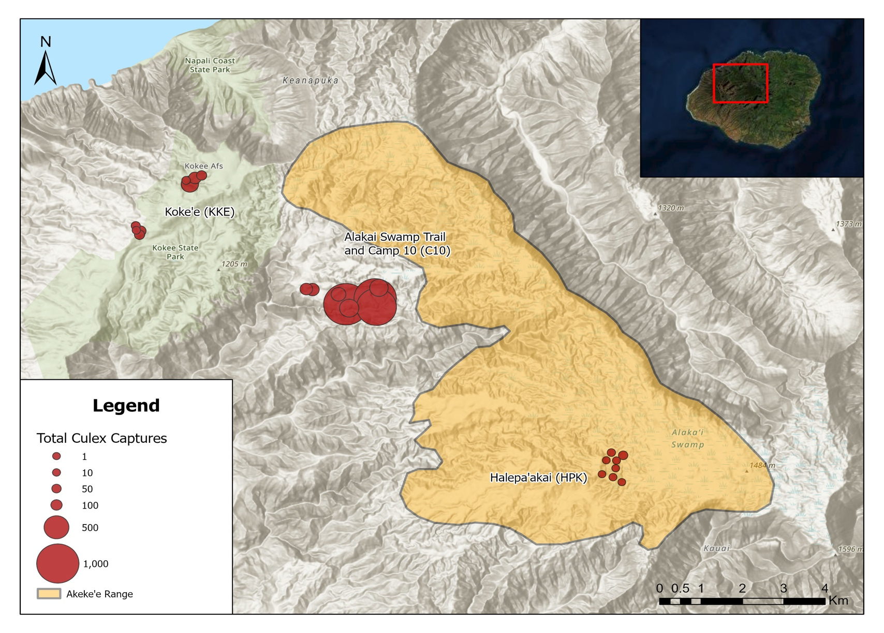
Figure 1. Culex captures per trap at three study areas on the Alakai Plateau between in 2021 and early 2022.

We caught Culex mosquitoes at all three study areas on the Plateau between February 2021 and February 2022, with most captures from three traps at the Camp 10 study area (Figure 1).
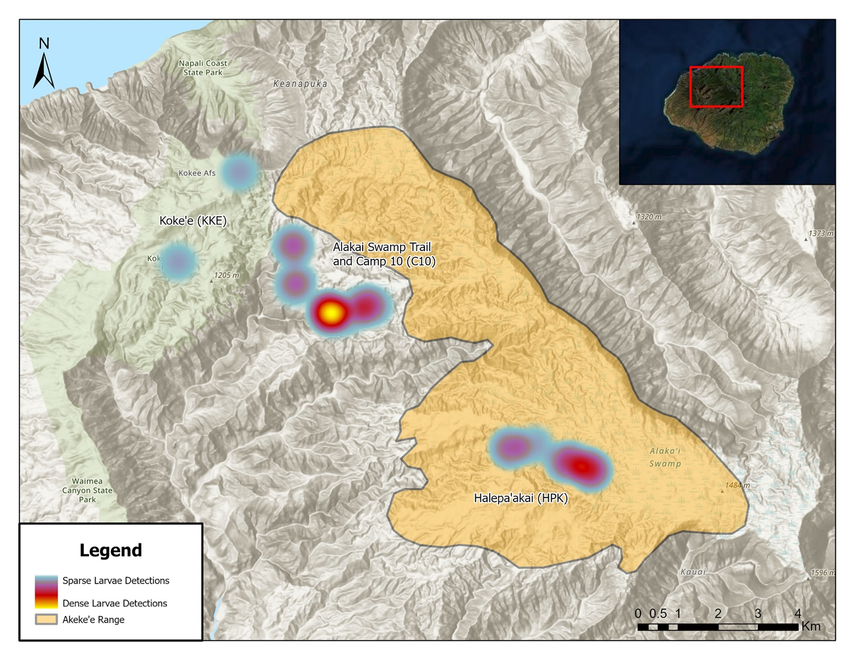
Figure 2. Locations of pools with Culex and Aedes larvae on the Alakai Plateau in 2021 and early 2022

We found many larval pools in our study areas (Figure 2). Not all larvae were Culex, however. At Halepaakai, we found only Aedes larvae, except at our camp. At Kokee, we did not identify larvae to species. At Camp 10, all larval pools hosted Culex larvae and were treated with Bti to kill them.
- Graphs of relative mosquito abundance per site over time.
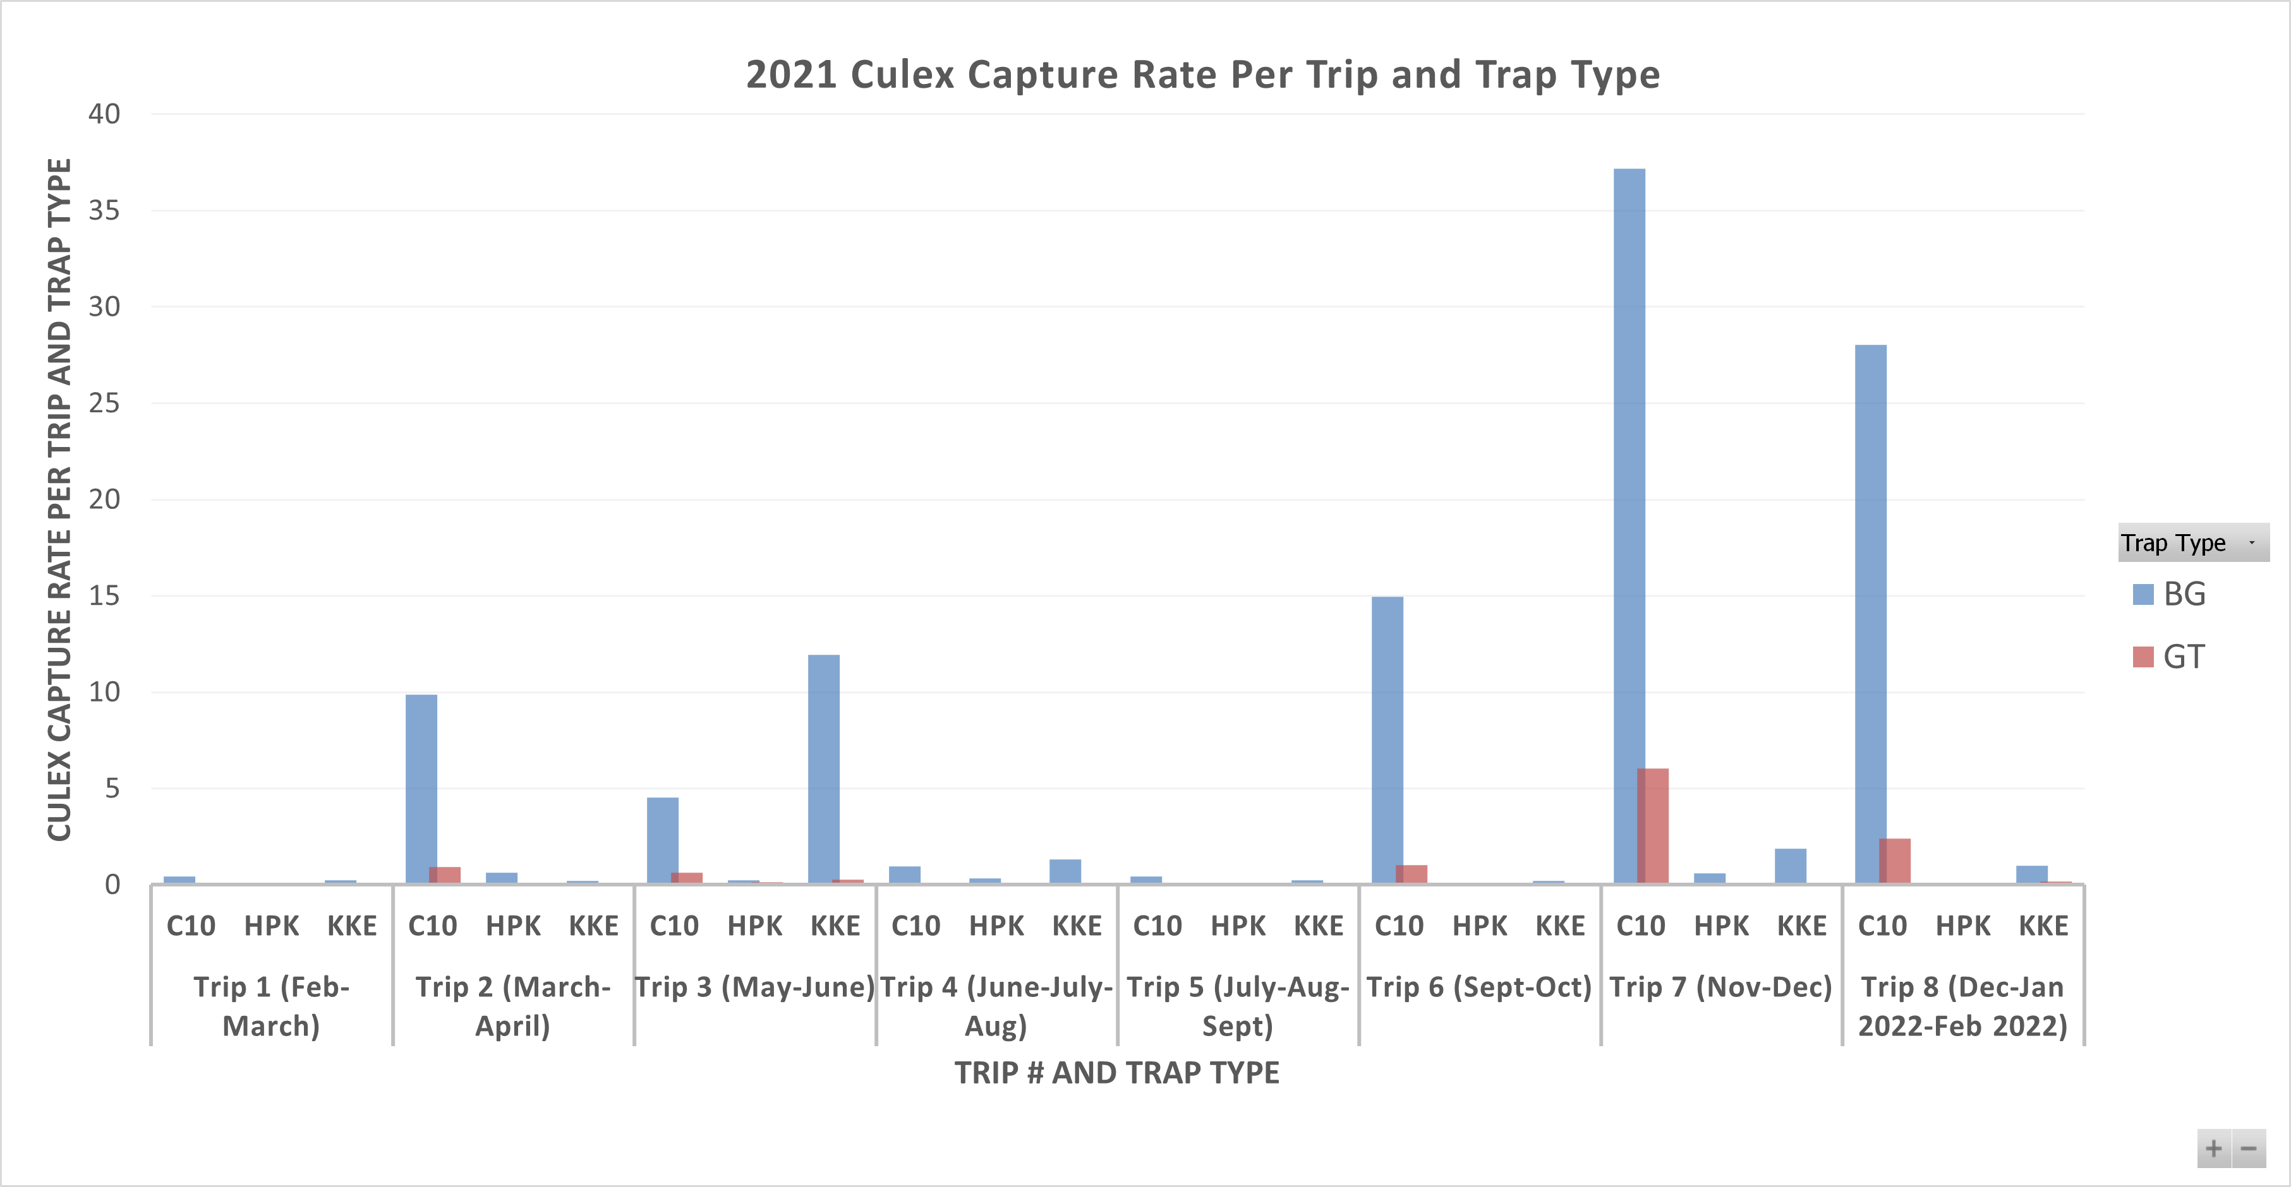
Figure 3. Capture rate (# caught per trap per night) of Culex mosquitoes in two different trap types (BG and GT) at three study areas [Camp 10 (C10), Halepaakai (HPK), and Kokee (KKE)] on the Alakai Plateau in 2021 and early 2022.

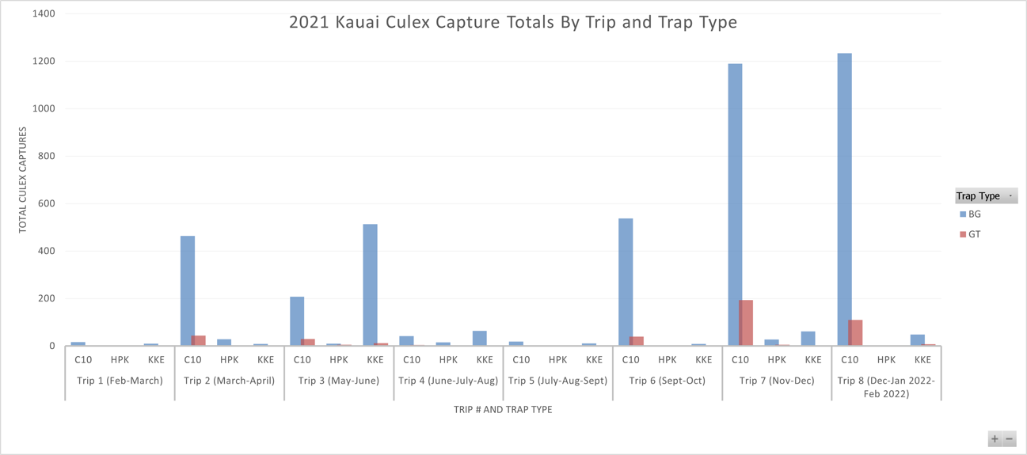
Figure 4. Total captures of Culex mosquitoes in two different trap types (BG and GT) at three study areas [Camp 10 (C10), Halepaakai (HPK), and Kokee (KKE)] on the Alakai Plateau in 2021 and early 2022.

Mosquito capture rates (# caught per trap per night; Figure 3) and total mosquito captures (Figure 4) were low in February-March 2021 (Trip 1), moderately high in the spring (Trips 2 and 3), low through the summer and early fall (Trips 4-5), moderately high on Trip 6 in September-October, then surged in November through early February 2022 (Trips 7 and 8). As in past years, more mosquitoes were caught in BG traps than gravid traps, but in fall 2021 we caught record numbers in gravid traps relative to other times we have used that trap type (Figures 3 and 4).

- Analysis of factors including site, date, and LiDAR-derived forest habitat metrics that may affect mosquito density in time and space.
A hierarchical Bayesian framework as applied in a generalized linear mixed model was used to model Culex quinquefasciatus probability of occurrence in response to variance in topographic classification , trap type (a three level categorical variable describing the type of trap used [Biogents BG-trap, Biogents Gravid Aedes Trap (GAT) of a modified Reiter’s Gravid Trap from Bioquip (GT)]) and six continuous variables representing the mean monthly temperature at collection, the variance in temperature ($Δ$ temperature), the maximum TWI at 100, 250 and 500 meters, and the average TWI at 1.65 kilometers. This distance was used here as it is the median trapping distance identified in Lapointe (2008). This analysis included data from both 2021 (present grant) and fall 2020 (last year’s HISC grant). Temperature data were measured in the field or downloaded from the Climate Atlas of Hawaii (Giambelluca et al. 2014). All TWI variables were calculated using the 5m DEM in the R package terra (Hijmans 2021). The approximate length of a collection period was determined using the night length variable and used as a group specific term as it varies by the seasonal period of the collections. The formulation of the initial generalized linear mixed model (prior to variable selection) used in this analysis is below.
$$\begin{matrix}{\text{NumCulex}}_{i} & ∼N\left(μ,σ^{2}\right) \\ μ & =α_{j[i],k[i]}+β_{1}(\text{MeanTemp})+β_{2}(\text{DeltaTemp}) + \\ & β_{3}({\text{TrapType}}_{\text{GAT}})+β_{4}({\text{TrapType}}_{\text{GT}})+β_{5}(\text{Evapotranspiration}) + \\ & β_{6}(\text{VegCoverFraction})+β_{7}(\text{Diff_Radiation})+β_{8}(\text{TWI_100mMAX}) + \\ & β_{9}(\text{TWI_250mMAX})+β_{10}(\text{TWI_500mMAX}) \\ α_{j} & ∼N\left(μ_{α_{j}},σ_{α_{j}}^{2}\right)\text{, for Moon_Fraction j = 1,}…\text{,J} \\ α_{k} & ∼N\left(μ_{α_{k}},σ_{α_{k}}^{2}\right)\text{, for Min_Night k = 1,}…\text{,K}\end{matrix}$$
Models were developed using the rstanarm package (Goodrich et al. 2020) in R vers. 4.0.3 (Team 2020). The rstanarm package uses a Hamiltonian Markov Chain Monte Carlo sampling technique as applied to a linear regression framework (Goodrich et al. 2020). A Bayesian framework was applied for two reasons, because the equivalent frequentist mixed model approach (even with transformation) violated the assumption of normally distributed residuals, and because the Bayesian approach allowed for a model which characterizes the variance in C. quinquefasciatus density across sites with probability estimates, allowing for a more transferable assessment.
In this approach, weekly informative normal (location: 0, scale: 2.5) priors on the intercept were estimated and applied using rstanarm. Models were fit assuming a negative binomial distribution with 3,000 iterations across four chains. The first 1,500 iterations were used as warm-up projections. Convergence and fit was assessed by means of the effective sample size (>2000 for all parameters), ensuring that $R ̂$ is < 1.05, and inspection of residual plots (Gelman et al. 2013).
Variable selection was conducted using the projpred package (Piironen et al. 2020). To select the most important variables in the assessment a model was developed with all variables and weakly informative horseshoe priors (Piironen and Vehtari 2017). As this method does not work with a negative binomial distribution, a Poisson model was used to infer variables of significance. After model fitting a leave one out cross-validation approach was applied using a forward selection approach. Only the top performing variables were selected for the prediction. Visualizations and tables were developed using the packages bayesplot (Gabry et al. 2019) and SJplot (Ldecke 2021).
The models shows that BG traps capture more Culex mosquitoes than GATs, which collect slightly more mosquitoes than gravid traps (Figure 5, Appendix 1). The model allows for a relationship to be developed between these capture rates, which would allow one to predict how many mosquitoes would be caught at a given site if a different trap type had been used. This approach will aid with standardization of monitoring across the Islands.
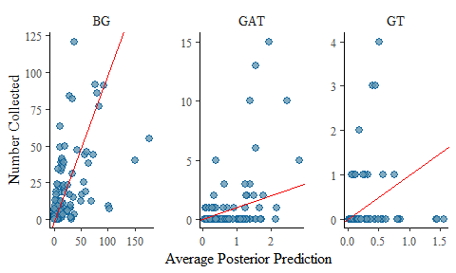
Figure 5. Numbers of Culex captured by different trap types on the Alakai Plateau, Kauai.
Furthermore, more Culex mosquitoes are caught when TWI (total wetness index), evapotranspiration and mean temperatures are high, but temperature is relatively constant, and vegetative cover is more sparse (Appendix 1).
As an example of how this model can be used in the future one can assume various inputs that match the variables used in this assessment. For instance, if two completely hypothetical collections occurred on a ridge (very low topographic wetness index) and stream (high topographic wetness index), both using a BG-trap, at 16$​^{o}C$, with a temperature $Δ$ of 9.5$​^{o}C$, a moon fraction of 50%, and a collection length of 705 minutes, one would expect a maximum of 12 more C. quinquefasciatus collected at a stream versus a ridge.
This assessment can also be projected outside of specific sites. For instance, when applied to a raster set of similar variables or “climate space”, it can be used to assess the mean predicted collections for each pixel as defined over an average collection night. It is hypothesized that this model could be used to inform future C. quinquefasciatus control via targeted pesticide and/or Insect Incompatibility Technique (IIT) overflooding ratio applications at various sites in and around the areas sampled.

- One press release, 12 social media posts, 4 outreach events, 5 classroom presentations, 1 public speaking engagement, 1 educational material (e.g., video).

We actively promoted understanding among local people of the effects of mosquito-borne diseases on forest birds and human health, and the importance of IIT for disease reduction and recovery of forest birds. We wrote a press release about akikiki declines, we maintained an active blog and social media posts, and we engaged the public through several virtual presentations and four in person presentations. We have designed a sign to post in public places about the importance of birds and the threat of mosquito-borne diseases.

- One presentation to the Hawaii conservation community (e.g., at Hawaii Conservation Conference or Hawaii Forest Bird Symposium).

Due to the pandemic, we did not attend very many conferences this year. However, we made a presentation about our akikiki and akekee modeling work at the Hawaii Conservation Conference, and our more informal presentations (e.g., Forest Fridays, DLNR brownbag, HISAM) were well attended by the conservation community in Hawaii.

Literature Cited
Gabry, Jonah, Daniel Simpson, Aki Vehtari, Michael Betancourt, and Andrew Gelman. 2019. “Visualization in Bayesian Workflow.” J. R. Stat. Soc. A 182 (2): 389–402. https://doi.org/10.1111/rssa.12378.
Gelman, Andrew, John B. Carlin, Hal S. Stern, David B. Dunson, Aki Vehtari, and Donald B. Rubin. 2013. Bayesian Data Analysis, Third Edition. CRC Press.
Giambelluca, Thomas W, Xiufu Shuai, Mallory L Barnes, Randall J Alliss, Ryan J Longman, Tomoaki Miura, Qi Chen, et al. 2014. “Evapotranspiration of Hawai‘i Final Report.” University of Hawaii at Manoa.
Goodrich, Ben, Jonah Gabry, Imad Ali, and Sam Brilleman. 2020. “Rstanarm: Bayesian Applied Regression Modeling via Stan.”
Hijmans, Robert J. 2021. Terra: Spatial Data Analysis. Manual.
Lapointe, D. A. 2008. “Dispersal of Culex Quinquefasciatus (Diptera: Culicidae) in a Hawaiian Rain Forest.” Journal of Medical Entomology 45 (4): 600–609. https://doi.org/10.1093/jmedent/45.4.600.
Ldecke, Daniel. 2021. sjPlot: Data Visualization for Statistics in Social Science. Manual.
Piironen, Juho, Markus Paasiniemi, Alejandro Catalina, and Aki Vehtari. 2020. Projpred: Projection Predictive Feature Selection. Manual.
Piironen, Juho, and Aki Vehtari. 2017. “Sparsity Information and Regularization in the Horseshoe and Other Shrinkage Priors.” Electronic Journal of Statistics 11 (2): 5018–51. https://doi.org/10.1214/17-EJS1337SI.
Team, R Core. 2020. “R: A Language and Environment for Statistical Computing. R Foundation for Statistical Computing.” Vienna, Austria.

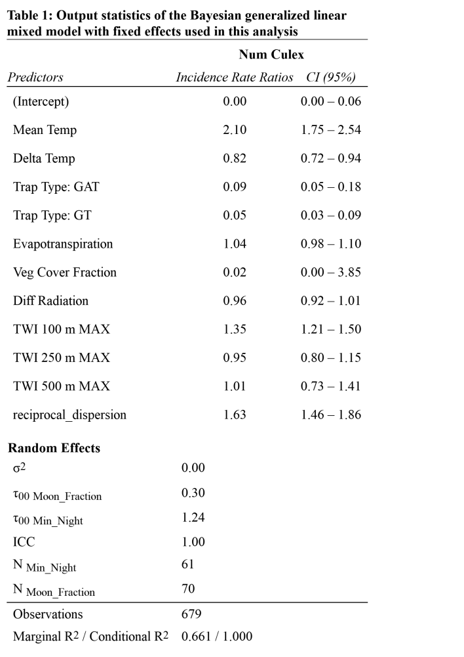
App 1

