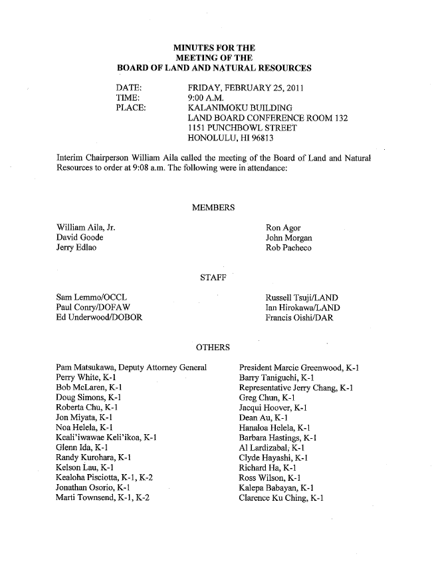

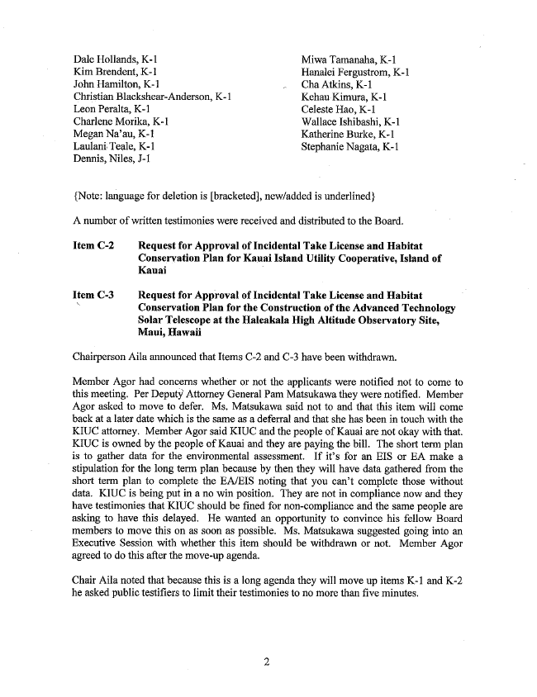

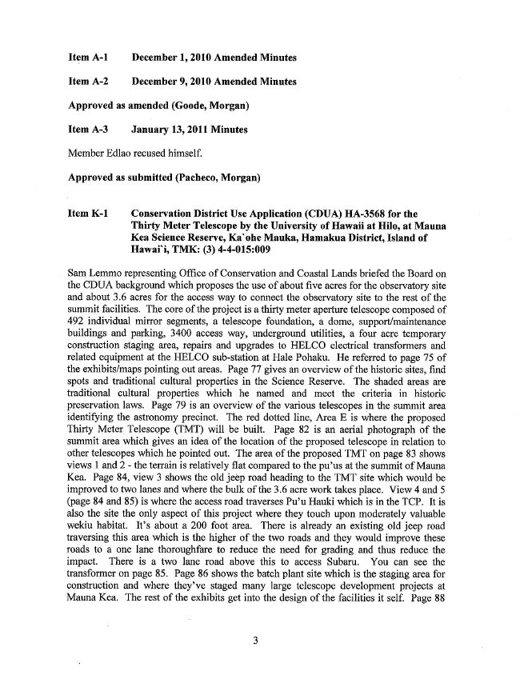
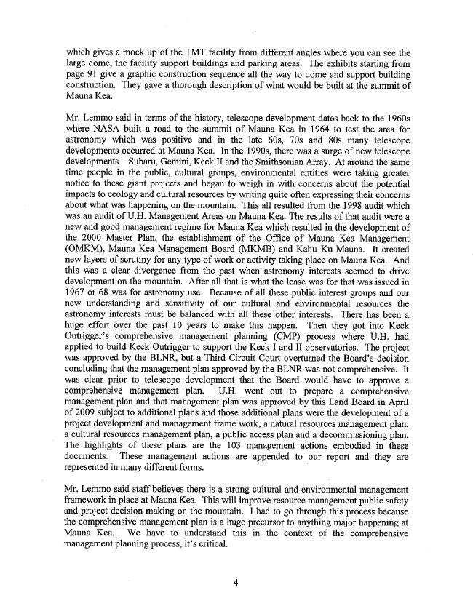

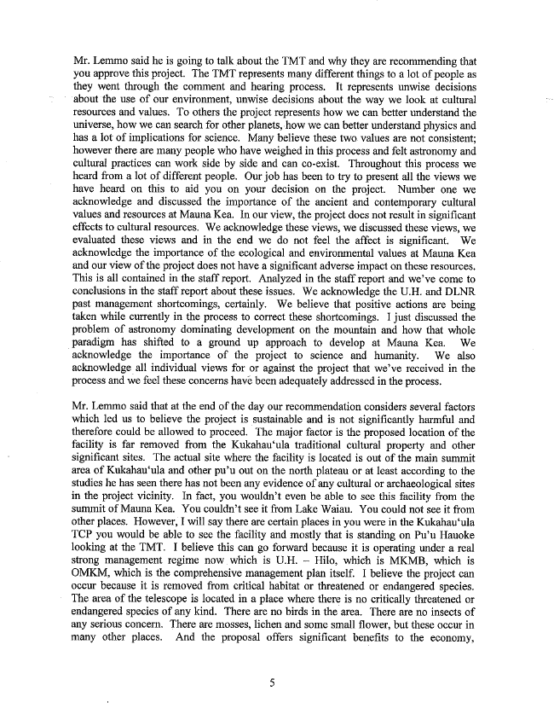

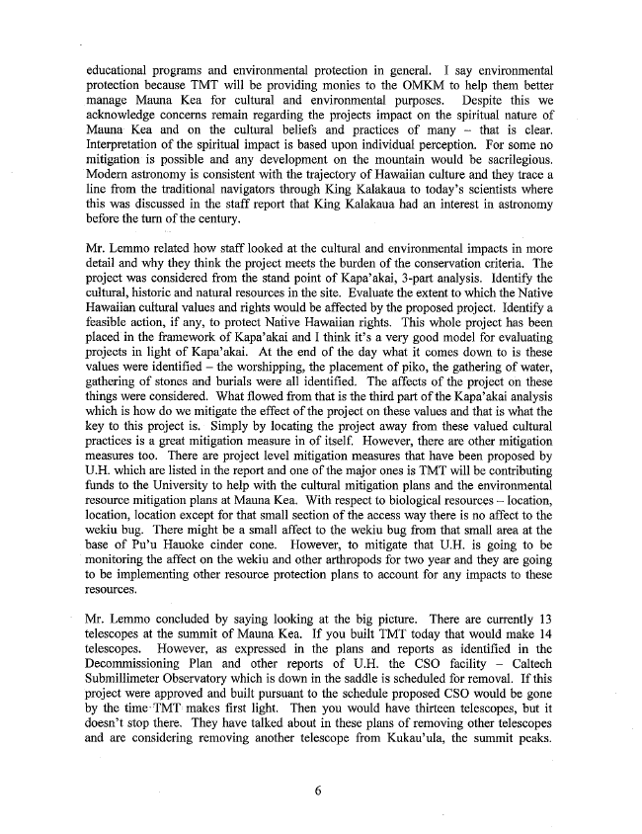
educational programs and environmental protection in general. I say environmental protection because TMT will be providing monies to the OMKM to help them better manage Mauna Kea for cultural and environmental purposes. Despite this we acknowledge concerns remain regarding the projects impact on the spiritual nature of Mauna Kea and on the cultural beliefs and practices of many — that is clear. Interpretation of the spiritual impact is based individual perception. For some no mitigation is possible and any development on the mountain would be sacrilegious. Modern astronomy is consistent -with the trajectory of Hawaiian culture and they trace a line from the traditional navigators through King Kalakaua to t0day’s scientists where this was discussed in the staff report that King Kalakaua had an interest in astronomy before the turn of the century. .
Mr. Lemmo related how staff looked at the cultural and environmental impacts in more detail and why they think the project meets the burden of the conservation criteria. The project was considered from the stand point of Kapa’akai, 3-part analysis. Identify the cultural, historic and natural resources in the site. Evaluate the extent to which the Native Hawaiian cultural values and rights would be affected by the proposed project. Identify a feasible action, if any, to protect Native Hawaiian rights. This whole project has been placed in the framework of Kapa’akai and I think it’s a very good model for evaluating projects in light of Kapa’akai. At the end of the day what it comes down to is these values were identiﬁed — the worshipping, the placement of piko, the gathering of water, gathering of stones and burials were all identiﬁed. The affects of the project on these things were considered. What ﬂowed from that is the third part of the Kapa’akai analysis which is how do we mitigate the effect of the project on these values and that -is what the key to this project is. Simply by locating the project away from these valued cultural practices is a great mitigation measure in of itself. However, there are other mitigation measures too. There are project level mitigation measures that have been proposed by U.H. which are listed in the report and one of the major ones is TMT will be contributing funds to the University to help with the cultural mitigation plans and the environmental resource mitigation plans at Mauna Kea. With respect to biological resources — location, location, location except for that small section of the access way there is no affect to the wekiu bug. There might be a small affect to the wekiu bug from that small area at the base of Pu’u Hauoke cinder cone. However, to mitigate that U.H. is going to be monitoring the affect on the Wekiu and other arthropods for two year and they are going to be implementing other resource protection plans to account for any impacts to these
resources.
Mr. Lemmo concluded by saying looking at the big picture. There are currently 13 telescopes at the summit of Manna Kea. If you built TMT today that would make 14 telescopes. However, as expressed in the plans and reports as identiﬁed in the Decommissioning Plan and other reports of U.H. the CSO facility — Caltech Submillimeter Observatory which is down in the saddle is scheduled for removal. If this project were approved and built pursuant to the schedule proposed CSO would be gone by the time-TMT= makes ﬁrst light. Then you would have thirteen telescopes, but it doesn’t stop there. They have talked about in these plans of removing other telescopes and are considering removing another telescope from Kukau’ula, the summit peaks.

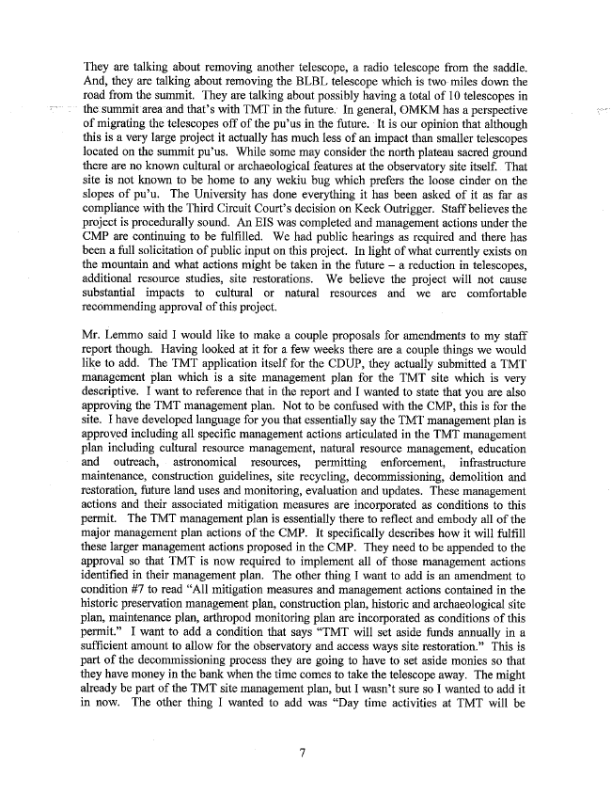
They are talking about removing another telescope, a radio telescope from the saddle. And, they are talking about removing the BLBL telescope which is two-miles down the road from the summit. They are talking about possibly having a total of I0 telescopes in the sunn"nitareaand that’s with TMT in the future; In general, OMKM has a perspective of migrating the telescopes off of the pu’us in the future. alt is our opinion that although this is a very large project it actually has much less of an impact than smaller telescopes located on the summit pu’us. While some may consider the north-plateau sacred ground there are no known cultural or archaeological features at the observatory site itself.. That site is not known to be home to any wekiu bug which prefers the loose cinder on the slopes of pu’u. The University has done everything it has been asked of it as far as compliance with the Third Circuit Court’s decision on Keck Outrigger. Staff believes the project is procedurally sound. An EIS was completed and management actions under the CMP are continuing to be fulﬁlled. We had public hearings as required and there has been a full solicitation of public input on this project. In light of what currently exists on the mountain and what actions might be taken in the future — a reduction in telescopes, additional resource studies, site restorations. We believe the project will not cause substantial impacts to cultural or natural resources and we are comfortable recommending approval of this project.
Mr. Lemmo said I would like to make a couple proposals for amendments to my staff report though. Having looked at it for a few weeks there are a couple things we would like to add. The TMT application itself for the CDUP, they actually submitted a TMT management plan which is a site management plan for the TMT site which is very descriptive. I want to reference that in the report and I wanted to state that you are also approving the TMT management plan. Not to be confused with the CMP, this is for the site. I have developed language for you that essentially say the TMT management plan is approved including all speciﬁc management actions articulated in the TMT management plan including cultural resource management, natural resource management, education and outreach, astronomical resources, permitting enforcement, infrastructure maintenance, construction guidelines, site recycling, decommissioning, demolition and restoration, future land uses and monitoring, evaluation and updates. These management actions and their associated mitigation measures are incorporated as conditions to this permit. The TMT management plan is essentially there to reﬂect and embody all of the major management plan actions of the CMP. It speciﬁcally describes how it will fulﬁll these larger management actions proposed in the CMP. They need to be appended to the approval so that TMT is now required to implement all of those management actions identiﬁed in their management plan. The other thing I want to add is an amendment to condition #7 to read “All mitigation measures and management actions contained in the historic preservation management plan, construction plan, historic and archaeological site plan, maintenance plan, arthropod monitoring plan are incorporated as conditions of this permit.” I want to add a condition that says “TMT will set aside funds annually in a sufﬁcient amount to allow for the observatory and access ways site restoration.” This is part of the decommissioning process they are going to have to set aside monies so that they have money in the bank when the time comes to take the telescope away. The might already be part of the TMT site management plan, but I wasn’t sure so I wanted to add it in now. The other thing I wanted to add was “Day time activities at TMT will be

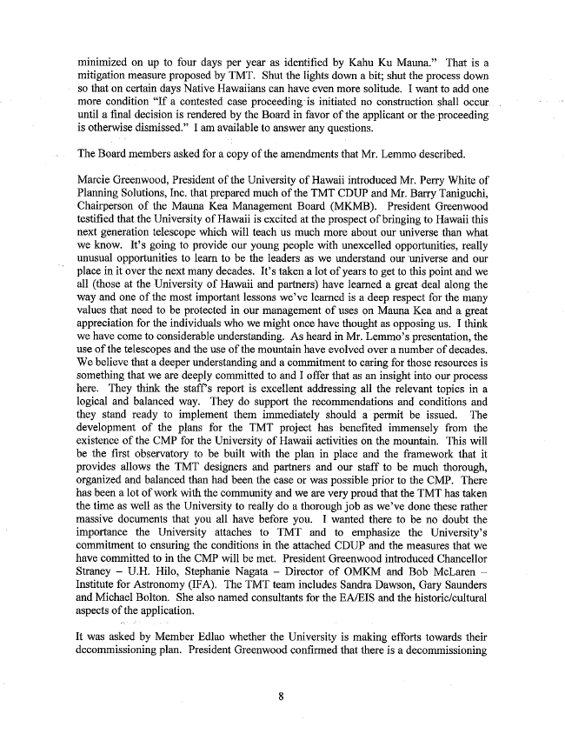
minimized on up to four days per year as identiﬁed by Kahu Ku Mauna.” That is a mitigation-measure proposed by TMT. Shut the lights down a bit; shut the process down so that "on certain days Native Hawaiians can have even more solitude. I want to add one more condition “If a contested case initiated no construct-ion shall occur. until a ﬁnal decision is rendered by the Board in favor of the applicant or the --proceeding is-otherwise dismissed.” I am available to answer any questions.
The. Board members-asked for a copy of the amendments that Mr. Lemme described.
Marcie Greenwood, President of the University of Hawaii introduced Mr. Perry White of Planning Solutions, Inc. that prepared much of the TMT CDUP and Mr. Barry Taniguchi, Chairperson of the Mauna Kea Management Board (MKMB). President Greenwood testiﬁed that the University of Hawaii is excited at the prospect of bringing to Hawaii this next generation telescope which will teach us much more about our universe than what We know. It’s going to provide our young people with unexcelled opportunities, really unusual opportunities to learn to be the leaders as we understand our ‘universe and our place in it over the next many decades. It’s taken a lot of years to get to this point and we all (those at the University of Hawaii and partners) have learned a great deal along the way and one of the most important lessons we’ve learned is a deep respect for the many values that need to be protected in our management of uses on Mauna Kea and a great appreciation for the individuals who we might once have thought as opposing us. I think we have come to considerable understanding. As heard in Mr. Len1mo’s presentation, the use. of the telescopes end the use of the mountain have evolved over a number of decades. We believe that a deeper understanding and a commitment to caring for those resources is something that we are deeply committed to and I offer that as an insight into our process here. They think the staff’ s report is excellent addressing all the relevant topics in a logical and balanced way. They do support the recommendations and conditions and they stand ready to implement them immediately should at permit be issued. The development of the plans for the TMT project has beneﬁted immensely from the existence of the CMP for the University of Hawaii activities on the mountain. This will be the ﬁrst observatory to be built with the plan in place and the framework that it provides allows the TMT designers and partners and our staff to be much thorough, organized and balanced than had been the case or was possible prior to the CMP. There has been a lot of work with the community and we are very proud that the TMT has taken the time as well as the University to really do a thorough job as we’ve done these rather massive documents that you all have before you. I wanted there to be no doubt the importance the University attaches to TMT and to emphasize the University’s commitment to ensuring the conditions in the attached CDUP and the measures that we have committed to in the CMP will be met. President Greenwood introduced Chancellor Straney — U.H. Hilo, Stephanie Nagata — Director of OMKM and Bob McLaren Institute for Astronomy (IFA). The TMT team includes Sandra Dawson, Gary Saunders and Michael Bolton. She also named consultants for the EA/EIS and the historic/cultural aspects of the application.
It was asked by Member Edlao whether the University is making efforts towards their decommissioning plan. President Greenwood conﬁrmed that there is a decommissioning

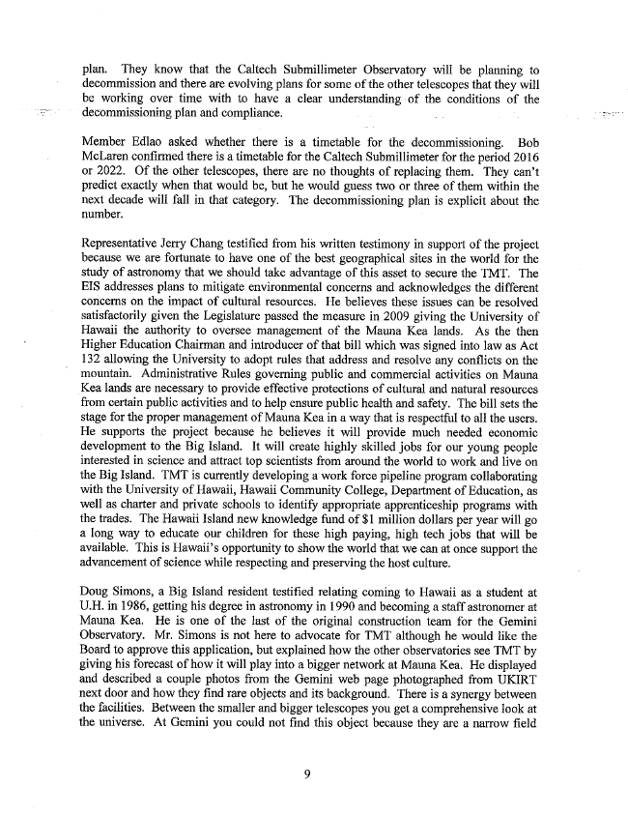
plan. They know that the Caltech Submillimeter Observatory will be planning to decommission and there are evolving plans for some of the other telescopes that they will be working over time with to have a clear understanding -of the conditions of the decommissioning plan and compliance. s .. .
Member Edlao asked whether there is a timetable for the decommissioning. Bob McLaren conﬁrmed there is a timetable for the Caltech Submillimeter for the period 2016 or 2022. Of the other telescopes, there are no thoughts of replacing them. They can’t predict exactly when that would be, but he would guess two or three of them within the next decade will fall in that category. The decommissioning plan is explicit about the number.
Representative Jerry Chang testified from his written testimony in support of the project because we are fortunate to have one of the best geographical sites in the world for the study of astronomy that we should take advantage of this asset to secure the TMT. The EIS addresses plans to mitigate environmental concerns and acknowledges the different concerns on the impact of cultural resources. He believes these issues can be resolved satisfactorily given the Legislature passed the measure in 2009 giving the University of Hawaii the authority to oversee management of the Manna Kea lands. As the then Higher Education Chairman and introducer of that bill which was signed into law as Act 132 allowing the University to adopt rules that address and resolve any conﬂicts on the mountain. Administrative Rules governing public and commercial activities on Mauna Kea lands are necessary to provide effective protections of cultural and natural resources from certain public activities and to help ensure public health and safety. The bill sets the stage for the proper management of Mauna Kea in a way that is respectful to all the users. He supports the project because he believes it will provide much needed economic development to the Big Island. It will create highly skilled jobs for our young people interested in science and attract top scientists from around the world to work and live on the Big Island. TMT is currently developing a work force pipeline program collaborating with the University of Hawaii, Hawaii Community College, Department of Education, as well as charter and private schools to identify appropriate apprenticeship programs with the trades. The Hawaii Island new knowledge fund of $1 million dollars per year will go a long way to educate our children for these high paying, high tech jobs that will be available. This is Hawaii’s opportunity to show the world that we can at once support the advancement of science while respecting and preserving the host culture.
Doug Simons, a Big Island resident testiﬁed relating" coming to Hawaii as a student at U.H. in 1986, getting his degree in astronomy in 1990 and becoming a staff astronomer at Mauna Kea. He is one of the last of the original construction team for the Gemini Observatory. Mr. Simons is not here to advocate for TMT although he would like the Board to approve this application, but explained how the other observatories see TMT by giving his forecast of how it will play into a bigger network at Mauna Kea.' He displayed and described a couple photos from the Gemini web page photographed from UKIRT next door and how they ﬁnd rare objects and its background. There is asynergy between the facilities. Between the smaller and bigger telescopes you get a comprehensive look at the universe. At Gemini you could not ﬁnd this object because they are a narrow ﬁeld

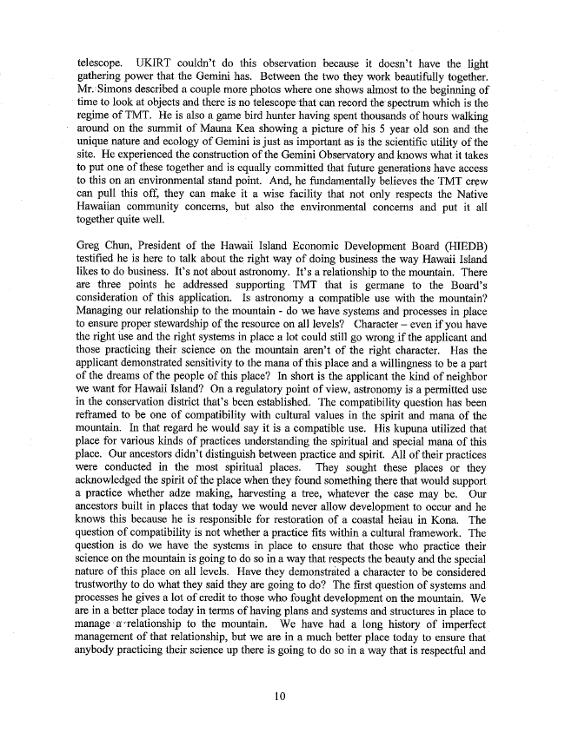
telescope. UKIRT c0uldn’t do this observation because it doesn’t have the light gathering power that. the Gemini has. Between the two they work beautifully together. Mr;1*Simons described a couple more photos where one shows almost to the beginning of time to look at objects and there is no telescopeithat can record the spectrum which is the regime of TMT. He is also a game bird hunter having spent thousands of hours walking around on the summit of Mauna Kea showing a picture of his 5 year old son and-the unique nature and ecology of Gemini is just as important as is the scientiﬁc utility of the site. He experienced the construction of the Gemini Observatory and knows what it takes to put one of these together and is equally committed that future generations have access to this on an environmental stand point. And, he fundamentally believes the TMT crew can pull this off, they can make it a wise facility that not only respects the Native Hawaiian community concerns, but also the environmental concerns and put it all together quite" Well. '
Greg Chun, President of the Hawaii Island Economic Development Board (HIEDB) testiﬁed he is here to talk about the right way of doing business the way Hawaii Island likes to do business. It’s not about astronomy. It’s a relationship to the mountain. There are three points he addressed supporting TMT that is germane to the Board’s consideration of this application. Is astronomy a compatible use with the mountain? Managing our relationship to the mountain - do we have systems and processes in place to ensure proper stewardship of the resource on all levels‘? Character — even if you have the right use and the right systems in place a lot could still go wrong if the applicant and those practicing their science on the mountain aren’t of the right character. Has the applicant demonstrated sensitivity to the mana of this place and a willingness to be a part of the dreams of the people of this place? In short is the applicant the kind of neighbor we want for Hawaii Island‘? On a regulatory point of view, astronomy is a permitted use in the conservation district that’s been established. The compatibility question has been reframed to be one of compatibility with cultural values in the spirit and mana of the mountain. In that regard he would say it is a compatible use. His kupuna utilized that place for various kinds of practices understanding the spiritual and special mana of this place. Our ancestors didn’t distinguish between practice and spirit. All of their practices were conducted in the most spiritual places. They sought these places or they acknowledged the spirit of the place when they found something there that would support a practice whether adze making, harvesting a tree, whatever the case may be. Our ancestors built in places that today we would never allow development to occur and he knows this because he is responsible for restoration of a coastal heiau in Kona. The question of compatibility is not whether a practice ﬁts within a cultural framework. The question is do we have the systems in place to ensure that those who practice their science on the mountain is going to do so in a way that respects the beauty and the special nature of this place on all levels. Have they demonstrated a character to be considered trustworthy to do what they said they are going to do‘? The ﬁrst question of systems and processes he gives a lot of credit to those who fought development on the mountain. We are in a better place today in terms of having plans and systems and structures in place to manage --a"-~'relationship to the mountain. We have had a long history of imperfect management of that relationship, but we are in a much better place today to ensure that anybody practicing their science up there is going to do so in a way that is respectful and
10

