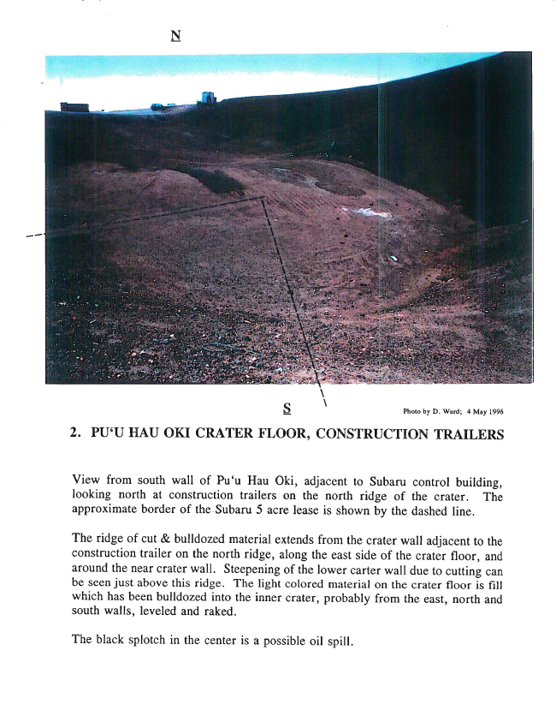
5 Photo by D. Ward; 4 May 1996
2. PU‘U HAU OKI CRATER FLOOR, CONSTRUCTION TRAILERS
View from south wall of Hau Oki, adjacent to Subaru control building, looking north at construction trailers on the north ridge of the crater. The approximate border of the.Suban1 5 acre lease is shown by the dashed line.
The ridge of cut & bulldozed material extends from the crater wall adjacent to the construction trailer on the north ridge, along the east side of the crater ﬂoor, and around the near crater wall. Steepening of the lower carter wall due to cutting can be seen just above this ridge. The light colored material on the crater ﬂoor is ﬁll which has been bulldozed into the inner crater, probably from the east, north and south walls, leveled and raked.
The black splotch in the center is a possible oil spill.

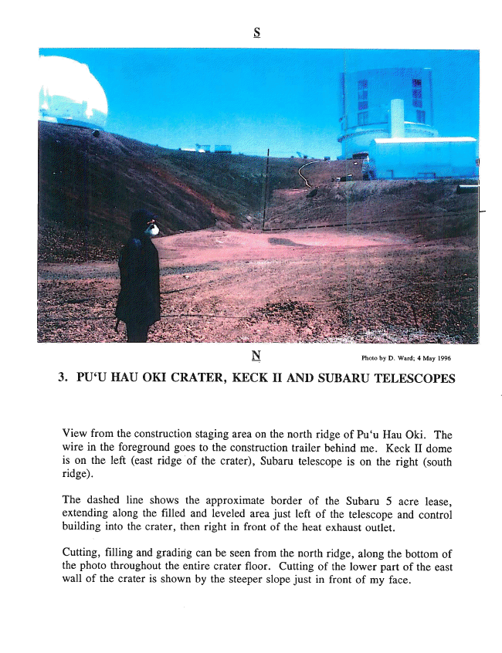
H Photo by D. Ward; 4 May 1996
3. PU‘U HAU OKI CRATER, KECK II AND SUBARU TELESCOPES
View from the construction staging area on the north ridge of Hau Oki. The wire in the foreground goes to the construction trailer behind me. Keck II dome
is on the left (east ridge “of the crater), Subaru telescope is on the right (south ridge).
The dashed line shows the approximate border of the Subaru 5 acre lease, extending along the ﬁlled and leveled area just left of the telescope and control building into the crater, then right in front of the heat exhaust outlet.
Cutting, ﬁlling and grading can be seen from the north ridge, along the bottom of the photo throughout the entire crater ﬂoor. Cutting of the lower part of the east wall of the crater is shown by the steeper slope just in front of my face.

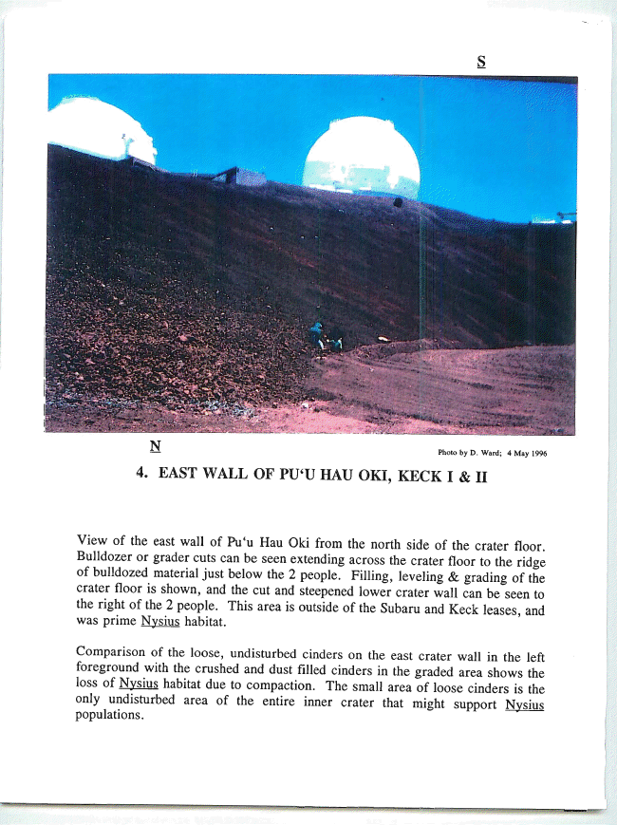
Photo by D. Ward; 4 May 1996
4. EAST WALL OF PU‘U HAU OKI, KECK I & II
View of the east wall of Hau Oki from the north side of the crater ﬂoor. Bulldozer or grader cuts can be seen extending across the crater ﬂoor to the ridge of bulldozed material just below the 2 people. Filling, leveling & grading of the crater floor is shown, and the cut and steepened lower crater wall can be seen to
the right of the 2 people. This area is outside of the Subaru and Keck leasee; was prime Nysius habitat.
Comparison of the loose, undisturbed cinders on the east crater wall in the left foreground with the cmshed and dust ﬁlled cinders in the graded area shows the loss of Nysius habitat due to compaction. The small area of loose cinders is the
only undisturbed area of the entire inner crater that might supportvN‘y—sius populations.

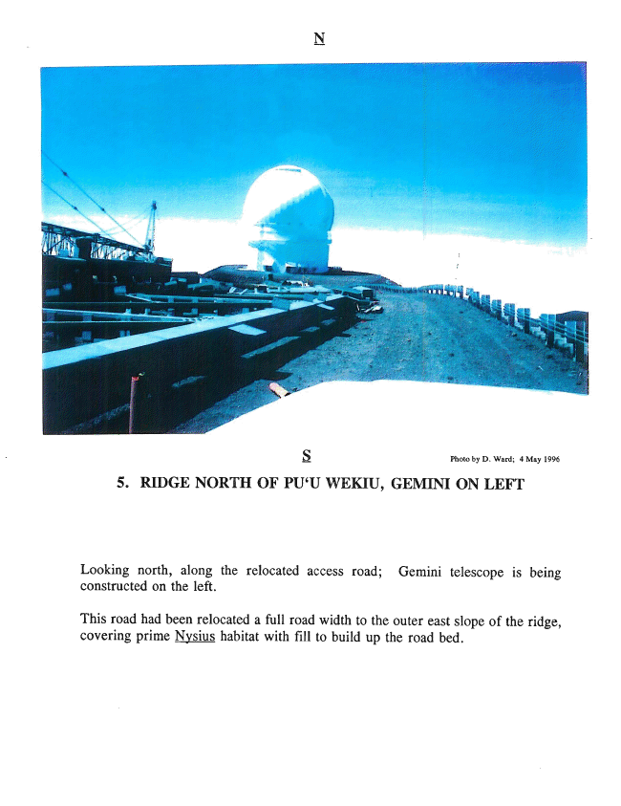
S; Photo by D. Ward; 4 May 1996
5. RIDGE NORTH OF PU‘U WEKIU, GEMINI ON LEFT
Looking north, along the relocated access road; Gemini telescope is being constructed on the left.
This road had been relocated a full road width to the outer east slope of the ridge, covering prime Nysius habitat with ﬁll to build up the road bed.



