United States Department of the Interior
National Park Service
National Register of Historic Places Registration Form

This form is for use in nominating or requesting determinations for individual properties and districts. See instructions in National Register Bulletin, How to Complete the National Register of Historic Places Registration Form. If any item does not apply to the property being documented, enter "N/A" for "not applicable." For functions, architectural classification, materials, and areas of significance, enter only categories and subcategories from the instructions.

- Name of Property
Historic name: _________NA__________________________________
Other names/site number: __ NA_____________________
Name of related multiple property listing:
________NA___________________________________________________
(Enter "N/A" if property is not part of a multiple property listing
____________________________________________________________________________
- Location
Street & number: __4578 Kahala Avenue___________________________
City or town: Honolulu________ State: _Hawai’i____ County: _Honolulu_____
Not For Publication: Vicinity:

____________________________________________________________________________
- State/Federal Agency Certification
As the designated authority under the National Historic Preservation Act, as amended,
I hereby certify that this nomination ___ request for determination of eligibility meets the documentation standards for registering properties in the National Register of Historic Places and meets the procedural and professional requirements set forth in 36 CFR Part 60.
In my opinion, the property ___ meets ___ does not meet the National Register Criteria. I recommend that this property be considered significant at the following
level(s) of significance:
___national ___statewide ___local
Applicable National Register Criteria:
___A ___B ___C ___D

Signature of certifying official/Title: Date
______________________________________________
State or Federal agency/bureau or Tribal Government

In my opinion, the property meets does not meet the National Register criteria.

Signature of commenting official: Date

Title : State or Federal agency/bureau
or Tribal Government

______________________________________________________________________________
- National Park Service Certification
I hereby certify that this property is:
entered in the National Register
determined eligible for the National Register
determined not eligible for the National Register
removed from the National Register
other (explain:) _____________________

______________________________________________________________________
Signature of the Keeper Date of Action
____________________________________________________________________________
- Classification
Ownership of Property
(Check as many boxes as apply.)
Private:
X

Public – Local

Public – State

Public – Federal

Category of Property
(Check only one box.)
X
Building(s)

District

Site

Structure

Object

Number of Resources within Property
(Do not include previously listed resources in the count)
Contributing Noncontributing
______2_______ _____________ buildings

_____________ _____________ sites

_____________ ________1____ structures

_____________ _____________ objects

______2_______ ________1_____ Total

Number of contributing resources previously listed in the National Register ____NA_____
____________________________________________________________________________
- Function or Use
Historic Functions
(Enter categories from instructions.)
___ DOMESTIC _____
____Single Dwelling__
___________________
___________________
___________________
___________________
___________________

Current Functions
(Enter categories from instructions.)
____ DOMESTIC ____
____ Single Dwelling _
___________________
___________________
___________________
___________________

_____________________________________________________________________________
- Description

Architectural Classification
(Enter categories from instructions.)
_LATE 19TH & 20TH_
_CENTURY REVIVALS_
_Tudor Revival______
___________________
___________________
___________________
___________________

Materials: (enter categories from instructions.)
Principal exterior materials of the property: __WOOD______________________

Narrative Description
______________________________________________________________________________
Summary Paragraph

The residence at 4578 Kahala Avenue, located in the Kahala suburb of Honolulu, is a single-story Tudor Revival home with elements of Craftsman detailing. Completed in 1935, the wood-framed residence has a steeply-pitched hip roof with prominent steep-pitched cross gables and lap siding that flares where it meets the rough stone base. The 2,630 square-foot, asymmetrical footprint of the house is an approximate 55’ x 40’ rectangle with projecting elements on all sides. The front (south) façade is dominated by the large, dark shake roof with exposed rafter tails and a simple stuccoed chimney. Tall, narrow, multi-light casement windows fill the lower wall area and the front door is inset into the larger of the two cross gables. The house sits approximately forty feet from Kahala Avenue and slightly east of the center of the 13,504 square foot parcel. A carport and attached former servants quarters is located near the northwest corner of the lot behind a fence and gate that blocks it from public view. An aging and non-contributing trellis structure sits along the rear (north) property line. The house is in excellent condition and retains a high level of historic integrity on the exterior, as does the site. The interior has undergone renovations that appear to have kept the floor plan mostly intact but have covered much original fabric. The residence has had no additions but a formerly open lanai at the rear was enclosed with French doors early in its timeline.

___________________________________________________________________________
Narrative Description

The house at 4578 Kahala Avenue is a one-story, single family residence, located in the exclusive Kahala neighborhood on the eastern side of the Island of Oahu. The house is within the ahupua‘a of Waikiki, in the moku of Kona. The lot is a 90’ x 150’ rectangle (.31 acres) surrounded on three sides by neighboring properties, fronting Kahala Avenue, and across the street from the western end of Maunalua Bay near the access to Hunakai Beach. The vehicular drive is located along the western edge of the property and is paved with six-inch square smooth brick pavers arranged in a stacked bond pattern south of a fence and gate. Similar pieces of the smooth brick pavers in random sizes laid in a random pattern are found behind the gate to, and in front of, the carport. These tiles are likely original, having been referenced in a 1947 sales notice. A six foot high concrete masonry unit (CMU) wall runs along the western boundary of the parcel. The northern boundary is enclosed by both a CMU wall and a wood fence and a lava rock wall is along the eastern parcel edge. Three concrete steps begin near the southeast corner of the parcel, connecting to a stamped three foot wide concrete walk that slowly curves towards the front door of the house. The concrete appears to have been painted green at some point but the color is now very faded and patchy. Concrete that matches the sidewalk in color and texture can be found at the trellis and along the exterior south wall of the rec room.

The asymmetrical massing of the house is rectangular at its core with projections at the bedrooms, kitchen, and at the cross gables. The steeply-pitched, wood shake, hipped roof shape is somewhat complicated. The primary hip spans the main living areas and turns north to enclose the master bedroom at the rear. A hipped extension turns east from the master bedroom gable to cover the adjacent rear bedroom at the northeast corner of the house. A second lower hip extends from the southeast corner of the main roof to enclose the front bedroom. The kitchen roof hips to the rear of the house and is in plane with the west portion of the primary roof. Between the master bedroom the kitchen hipped roofs, the primary room changes to a lower pitch over the lanai. The overhangs vary, from no overhang at the front rake of the cross-gables to four feet above the windows at the master bedroom, front bedroom, and kitchen – where the overhangs extend two feet beyond the otherwise consistent two foot wide overhangs for added weather protection at the windows. The overhangs have exposed rafters with Craftsmen-style, flat-cut rafter tails except at the two cross gables, which have narrow boxed eaves along their sides.

The chimney is located near the center of the main roof element on the north side. There is no interior evidence of a fireplace, either in the living room, or in the limited accessible view into the attic space. 1940s home sale ads, which provide a detailed description of the home do not mention a fireplace, so it is possible it is a faux chimney added to enhance the Tudor appearance.

The foundation is pier and post with an eighteen-inch high crawlspace. The foundation walls are CMU faced with rough lava rock. Wood latticework can be found at ventilation and access points. No construction drawings were located, but early Sanborn Fire Maps show the house is constructed of wood and is assumed to be conventionally framed. The exterior is clad in eleven inch wide horizontal lapped siding, with each board flaring a half-inch from top to bottom – except the bottom two boards that flare two inches each. The lap siding extends seamlessly into the front cross gables where it terminates at the roof line into flush rake boards.

The interior walls are believed to have been sheathed in vertical tongue and groove boards. It appears these have been covered (rather than replaced) throughout most of the house with a thin overlay of either plywood or Masonite that has been skim coated with a textured plaster or plaster-like material. The floors throughout the house have been overlaid with newer wood plank flooring. Investigation has shown that the original wood floors were covered in the living room and therefore may also be extant in other rooms in the house.

The living room has an eighteen foot tall peaked ceiling with four raised tie trusses with two diagonal braces (or struts) but no kingpost. The bottom of the trusses are at ten feet above the floor and beams are exposed along the length of the north and south walls of the room. The 8’-6” tall ceiling in the adjacent lanai is original tongue and groove. The ceilings in the other rooms in the house are 8’-10” high and finished with a shallow coffer and crown molding that are believed to be modern additions. The exception is the small en-suite bath, which has lower eight foot flat ceilings. Recessed lighting and air conditioning vents are also located in the ceilings.

The house is approached from the south across the broad, flat lawn that slopes up slightly near the road. The concrete walkway leads to the front door that is inset into the larger of the two cross gables located on the front façade of the home. The cross gable at the door is 10’-4” wide and outset from the front wall six feet with lapped siding that wraps the entirety of the gable’s exposed surfaces. A small arched vent is located near the apex of the gable. A small stoop with a single curved concrete step is flanked by the 2’-8” side walls formed by the cross gable that taper from a five foot opening at the exterior end to four feet at the doorway. The small porch alcove has a segmental arch ceiling that is echoed in the door itself. The five-plank boarded door has a small leaded light with a diamond pattern, typical of the Tudor style that echoes the segmental arch of both the door and the porch alcove. The original door hardware is also extant.

The smaller second cross gable is located to the west of the doorway gable. It is also completely sheathed in lapped siding, has no front overhang and narrow boxed side gables, and has a small arched vent near the top. This cross gable projects approximately two feet from the front wall and is nine feet wide. Centered on its front there is a tall two-sash casement window topped by a glazed fanlight with a simple sunburst with four radiating bars. The front façade of the house has three additional windows; two three-sash casement windows are located near the east and west ends, and a four-sash casement is located between the cross gables. Throughout the home, windows are outset from the exterior walls and trimmed in simple flat board box frames.

The west façade is bisected by the fence and gate leading to the rear yard. To the south of the gate is a single two-sash casement window. North of the fence the kitchen projects from the main massing of the house. This two foot projection has a south face that is uninterrupted lapped siding. The west facade showcases the flare at the building base and holds a small double-hung window. The north side of the kitchen projection features a replacement French door that is inset in the wall and accessed by two wood steps. To the east of the door are a pair of wood double-hung windows.

The projection at the northwestern portion of the house contains the master bedroom, rear bedroom and smaller of the two baths. Between the bedroom projection and the kitchen are the doors to the lanai. The interior of the lanai is accessed by three pairs of French doors that are not original. Two original concrete steps that are 20’-6” long span the distance between the master bedroom and kitchen walls. The brick-tiled area located outside the lanai matches that of the front driveway. The paving turns up along the foundation of the master bedroom to form a tile curb approximately four inches tall.

Windows at the master bedroom are a pair of wood, double-hungs on the west side and a triple grouping of double-hungs on the north side. Next to the triple arrangement are a pair of double-hungs that are located in the adjacent rear bedroom. Turning the corner to the east façade, there is another pair of double-hungs in this same bedroom and a single double-hung in its en-suite bath. All the windows in these two bedrooms and bath are sheltered by the roof line that extends an additional two feet below the line of the adjacent overhang.

The remainder of the east elevation holds a second bathroom that has two single double-hung windows and the front bedroom that has a double hung pair. These windows are also sheltered by the lowered roof line, which extends nearly the entire length of this portion of the house. A wood fence located near the front bedroom’s east window separates the front from the back yard. A water heater enclosure is located between the front bedroom and bathroom windows and two air conditioning units sit under the front bathroom windows.

The windows throughout the house are original, as are many of wood-framed screens and window operating hardware on the casement windows. Some of the original screen frames have been inset with an aluminum screen frame and the wood screens have all been replaced at all the double-hung windows. All components are in fair to good condition, depending on their location. Most of the window damage appears to be around the casements’ crank mechanisms.

The house was built with a detached two-car garage and servant’s quarters. In 1979 the servant’s quarters were expanded to include a rec-room and an open carport was added at the south end. The current proportions of the rec room, its finished floor elevations, and areas where green painted concrete slab is evident, indicate the rec-room is the original garage. The entire structure was placed under a single hipped wood shake roof and the servants’ quarters and rec-room sheathed in board and batten. All windows in this building are now jalousies.

Interior
The front entry door opens into a small vestibule that has a small closet on the west side that sits within the porch projection of the cross-gable. A five foot wide, seven foot high rounded arch with flat wood trim provides the transition from the vestibule into the living room. The approximate 16’ x 28’ living space has a peaked ceiling with four trusses, each with two diagonal braces. Connections at the top and bottom chords are covered with decorative wood blocks. A small windowed bump-out at the southwest corner of the room reflects the smaller cross gable, including an indication of the roof pitch at the sides of the extension. There are three additional openings in the living room: a matching rounded arch with flat wood trim leads into the former dining room on the west wall, a six-foot wide cased opening with a pair of French doors that pocket into the north wall leading to the lanai, and a three foot wide cased opening on the west wall that provides access to the bedrooms and baths.

The former dining room, located adjacent to the living room at the front (south side) of the house is a simple rectangular room with the arched entry into the living room as well as a cased opening into the kitchen. The 8’-10” high beamed ceiling has decorative wood blocks at the ends of each beam shaped like Roosevelt-style rafter ends.

The kitchen is located at the northwest corner of the home. It has an exterior door at its northwest corner that opens into a small mudroom that is separated from the main kitchen area. Other openings lead into the dining room and the lanai. The kitchen appears to have mostly original cabinetry, including a built-in hutch with an arched niche along the west wall. The cabinets have tongue and groove plank doors with small egg-shaped silvered pulls (not original) and exposed hinges. There are glass-fronted upper cabinets along the southern wall. Newer cabinets are distinguishable from the original by the interior construction of the doors and the lack of an astragal, which is present on the original cabinet doors. The island and the lower cabinets around the sink and near the refrigerator appear to all be replacements. The countertops have been updated with a brown granite throughout.

The lanai, directly to the east of the kitchen, was originally open along its north wall but was enclosed with screen in 1939 according to building department records. The decorative arch at the top of each opening and the center post are considered original. The rectangular panel attached to the exterior of the arch that covers the top of the arch to near its spring point is believed to have been added in 1939. Angular battens decorate the exterior of the panel. The three pairs of double French doors are a more modern addition. The floor of lanai was originally tiled and it is unknown if the tile is extant under the modern wood floor.

Along the east wall of the lanai is a door leading to the laundry room. This room has tongue and groove walls and ceiling, except for the lower portion of the east wall where a plumbing wall has been furred to accommodate the washer and dryer plumbing. The south wall of the lanai holds the pocketing French doors to the living room, and is the location, along its track, where you can see the original wood flooring beneath the more modern wood plank flooring.

The bed and bathroom wing is entered through a cased opening in the east wall of the living room. The front bedroom is to the right (south), with the remainder of the rooms to the left. A telephone niche is located in the west wall and original built-in shelves with original hardware that are located around the bend in the hall, low in the south wall. As previously noted, there are two bedrooms at the northwest end of the house, each with their own small closet. Two bathrooms are located adjacent to the bedrooms, one is an en-suite and the other is entered from the hallway. Both baths are original to the house but it is unclear whether both were originally full baths - conflicting newspaper articles say the house had either one-and-a-half baths or two. The en-suite bath has been totally remodeled, with no visible original fabric, whereas the larger hall bath, also mostly remodeled, retains a wall of built-in cabinets with a vanity along the east wall. Most of the interior doors in the bed and bath wing appear to be original and are wood, single panel, some of which have original hardware.

The house has undergone relatively few changes over the years and retains the seven aspects of integrity. The property retains integrity of location in that it has not been moved. Design integrity is retained and intact because no additions or significant alterations have been made to the house. The setting remains the much the same, with the lot retaining its original size and the surrounding parcels remaining in their residential usage, although many of the houses have changed, grown significantly in size, and property-fronting walls are now commonplace. Integrity of materials and workmanship have also been maintained, which contributes to the historic feeling of the entire property.

_________________________________________________________________
- Statement of Significance

Applicable National Register Criteria
(Mark "x" in one or more boxes for the criteria qualifying the property for National Register
listing.)

- Property is associated with events that have made a significant contribution to the broad patterns of our history.

X

- Property is associated with the lives of persons significant in our past.
- Property embodies the distinctive characteristics of a type, period, or method of construction or represents the work of a master, or possesses high artistic values, or represents a significant and distinguishable entity whose components lack individual distinction.

- Property has yielded, or is likely to yield, information important in prehistory or history.

Criteria Considerations
(Mark “x” in all the boxes that apply.)

- Owned by a religious institution or used for religious purposes

- Removed from its original location

- A birthplace or grave

- A cemetery
- A reconstructed building, object, or structure

- A commemorative property

- Less than 50 years old or achieving significance within the past 50 years

Areas of Significance
(Enter categories from instructions.)
___ ARCHITECTURE_
___________________
___________________

Period of Significance
__1935_____________
___________________

Significant Dates
___NA_____________
___________________

Significant Person
(Complete only if Criterion B is marked above.)
___________________
___________________

Cultural Affiliation
___________________
___________________

Architect/Builder
___Unknown________
___________________

Statement of Significance Summary Paragraph

The residence at 4578 Kahala Avenue is of local significance under Criterion C as an excellent example of a 1930s Hawai‘i-adapted, Tudor-style residence. The period of significance is 1935, coinciding with the completion of construction.

______________________________________________________________________________
Narrative Statement of Significance (Provide at least one paragraph for each area of significance.)

Criterion C
4578 Kahala Avenue is architecturally significant as a good example of a 20th Century Tudor Revival residence popular from the 1890s through the 1940s. It is characteristic of the style with a steeply pitched roof and prominent steeply-pitched cross gables. Wood cladding was somewhat uncommon for the style, but with Hawai‘i’s climate and remote location, wood was the building material most employed for residential construction. The horizontal lapped cladding readily adapts to the quaint style and provides a light and cohesive appearance to the exterior of the home. It also possesses no half-timbering, but that is common within the style, although it is generally the most identifiable characteristic of Tudor-style residences. Instead, the house presents a very clean and elegant façade with its homogeneous lapped siding that extends up into the two gables located on the front façade. Multi-light, tall casement windows, also indicative of the Tudor style, fill the walls and provide excellent cross-ventilation to capture the tradewinds.

Elements that invoke the Arts and Crafts movement, to which Tudor is associated and was also popular in Hawai‘i during this period, are walls that flare where they meet the rough stone base, the hipped roof, and the exposed rafter tails. An open lanai (long enclosed) was located at the rear of the house. This home fits well within the National Register thematic nomination for Honolulu Tudor/French Norman Cottages (National Register of Historic Places #86002820-86002836) but falls just out of the period of significance chosen for that nomination. (The nomination includes houses built between 1920 and 1932; according to building department records, 4578 Kahala Avenue was constructed in 1935. One of the homes included in this nomination is located next door.) Like the exterior, the original detailing that remains throughout the home’s interior is simple, elegant, and reflective of its time. The exposed trussed ceiling in the living room provides a cottage feel, as do the arched openings from room to room. Pocketed French doors separate the main living space from the lanai. Original cabinetry and built-ins in the kitchen, hallway, and hall bath, including a phone niche in the hallway, are extant and typical of the style and period.

Additional Information

4578 Kahala Avenue Chain of Ownership

Honolulu City and County Tax and Conveyances records provide little early information on the home. The tax records show it was constructed in 1935 on leasehold land owned by Bishop Estate. According to Tax Office records, the property, designated as Lot 5, Block 5 of the Kahala Subdivision, appears to have been first subdivided in 1926 by Bishop Estates. The first information from building permits is from 1939 and is for the enclosure of the rear lanai by then homeowner Morton Mumma. The first homeowner shown on the Honolulu City and Country tax record was Marshall Veach in 1949. The Veachs’ purchased the fee-simple interest in the property in 1982.

Home ownership prior to 1949 is sketchy and provided primarily through newspaper research and early telephone directory listings. The architect of the home is unknown. Roy Larson and his wife and daughter appear to be the first occupants of the house if the property tax date of 1935 is correct because the Honolulu city directory shows 4578 Kahala Avenue as their residence in the 1934-1935 edition of the directory.

Roy A. Larson (1897-?) appears to have owned the home at 4578 Kahala Avenue from 1935 to 1939. Larson was the president of Hollister Drug Company (established in Hawai‘i in 1878). He came to Hawai‘i in 1922 and found employment at Hollister as a pharmacist. He quickly worked his way to the top position in the company, during which time he oversaw the opening of seven additional locations of the drugstore, which also sold sundries, soda, and ice cream. He resigned his position in 1939 and sold the Kahala home to return to his Nebraska birthplace for retirement.

Colonel Morton C. Mumma (1878- 1945) bought the house in 1939 from Larson. Mumma was the manager of the first Sears and Roebuck store in Hawai‘i. He was in charge of site selection, design and project management, and subsequently actual store management of the second, and much larger Sears location on South Beretania Street in Honolulu. Mumma was a West Point graduate (Class of 1900) and a renowned marksman. His wife Gail was active in the

Honolulu chapter of the Daughters of the American Revolution and often hosted their meetings in the Kahala home. As previously noted, it was the Mumma’s who first enclosed the open lanai at the rear of the 4578 Kahala home.

City directories show the Mumma’s resided in the house through 1942 but the directories for the years 1943-1948 are either not available or do not list Mumma in the book. A Mrs Helen Long Tolstrup is noted as living in the home in 1943 in a newspaper item announcing her obtaining her American citizenship. A For Sale advertisement in the June 21, 1945 Honolulu Advertiser announces a sale of all the furnishings at 4578 Kahala Avenue and states the home was recently sold but no records could be located as to either the sale, the seller, or the buyer. In December 1946, Howard (Pete) Prosser and his family announced their son’s acceptance to naval officer training and lists 4578 Kahala Avenue as their residence.

Multiple large feature sales ads ran in the Honolulu Advertiser from March through July of 1947 advertising the home for sale. One described the home as follows:

ON THE GARDENED AVENUE OF KAHALA
The pali drive of Diamond Head – unfolding the majesty of the multi-colored Pacific expanse – is the pathway to your home at 4578 Kahala Avenue.
Attractive, modern, in its design, this prideful home is approached by a broad red-tiled auto-way, or from the grassed sidewalk into the garden of kiawe and cocopalms. The brief foyer with its closets introduces the high-beamed ceiling, sweeping living room, and the polished hardwood floors throughout create a fine sense of well-being. A spacious dining room is beyond, over-looking the west garden, and the kitchen adjoins. Three large bedrooms are conveniently near two bathrooms of green and orchid tile.
Of course the distinctive Kahala-architectural contribution is present – that broad, inviting, relaxing lanai, opening to the inner garden for the family and intimate friends.
A two-car garage also houses a complete servant’s unit.
Unfurnished, this Bishop Estate leasehold has eight years remaining.
Your inspection is invited, and the price is $31,500.

Records show that in early 1949 Marshall and Ellen Veach bought the home. Marshall was a prominent piano instructor and Ellen was very active in Honolulu social circles. They had four children, one of whom was Charles Lacy Veach (1944-1995), one of two Hawai‘i astronauts. Although born in Chicago, Illinois, Veach grew up in Hawai‘i in the home at 4578 Kahala Avenue and always considered it his home. Even though his career kept him away for a considerable part of his adult life, Veach maintained close ties to the islands, promoting science education and the traditional sailing traditions.

Veach spent his youth surfing in the ocean across the street from his Kahala home, and upon completing his high school education at Punahou School in Honolulu, he was selected to attend the United States Air Force Academy where he majored in Engineering. After graduating from the Academy he joined the United States Air Force, where he served for fourteen years as a fighter pilot, including 275 missions in Vietnam, where he was shot down twice.

Later he was a member of the elite Air Force flight demonstration squadron, the Thunderbirds. During his service he received the Distinguished Flying Cross with two Oak Leaf Clusters, Air Medal with thirteen Oak Leaf Clusters, Air Force Commendation Medal with one Oak Leaf Cluster, and the Purple Heart.

In 1981 Veach left active duty and in 1982 joined the National Aeronautics and Space Administration (NASA) as an engineer and research pilot, training astronauts to land the Space Shuttle. Veach became an astronaut himself in 1985 and flew on the Discovery (1991) and Columbia (1992) Space Shuttle missions. He logged 436.3 hours in space. On his first flight aboard Discovery he took along a Hawaiian flag and a picture of the Hokulea. On his subsequent Columbia flight he brought along a traditional Hawaiian stone adze that he photographed floating in zero gravity with a view of the Hawaiian Islands captured through the window of the Space Shuttle behind it.

To link ancient seafaring exploration with modern space travel, he radioed the Hokule’a, which was sailing home to Hawai‘i from Rarotonga, from space while 30,000 Hawai‘i school children listened in. One child asked: “What are the similarities and differences between canoe and space travel”? To which Veach answered: “Both are voyages of exploration. Hokule’a is in the past, Columbia is in the future.” Master navigator of the Hokule’a and good friend of Veach, Nainoa Thompson, added: “Columbia is the highest achievement of modern technology today, the voyaging canoe was the highest achievement of technology in its day.”

Thompson credits Veach (in 1992) with the idea to take the Hokule’a on a voyage around the world “to spread the message of Hawai‘i, peace, and aloha.” Veach was scheduled to be a Hokule’a crew member on a trip to the Marquesas in 1995 but illness prevented him from sailing. In 2016, as part of the east coast leg of the circumnavigation voyage now realized, the crew of the Hokulea visited Kennedy Space Center in Florida to pay tribute to Veach, as well as to Hawai‘i’s first astronaut, Ellison Onizuka, who died in 1986 in the Challenger shuttle disaster.

During his tenure at NASA, Veach made many trips home to Hawai‘i to speak to school children about science and space exploration. Veach’s high school alma mater, Punahou School hosts an annual Astronaut Lacy Veach Day of Discovery, promoting hands-on science learning and honoring him and his goal to inspire young people to learn about the world around them.

Lacy Veach died in 1995 of cancer at the age of 51. His ashes were interred at the Punchbowl National Memorial Cemetery of the Pacific, dropped from a plane over the ocean by former military colleagues, and spread by family and friends from canoes in the ocean off Kahala and his boyhood home.

The Veach’s owned the home until 2005 when it was sold to Gensiro Kawamoto who then granted the deed to his company “Estates of Kahala.” Kawamoto, a wealthy commercial property owner from Japan, began buying Hawai‘i properties in the 1980s and bought thirty properties on Kahala Avenue between 2003 and 2006, of which 4578 Kahala was one. In 2006 Kawamoto announced a “charity project” to make Kahala less exclusive. Part of that effort included providing nine homes to disadvantaged Native Hawaiian families and one of these homes was 4578 Kahala, which was leased to a Native Hawaiian family for free and they subsequently opened a day-care business in the home.

Long time Hawai’i real estate investment firm Alexander & Baldwin acquired twenty of the thirty properties from the Estates of Kahala in 2013. In 2015, the home was purchased by Robin Yim. Ms. Yim was born and raised in Honolulu in the shadow of Diamond Head. She and Jackson, her Big Island-born border collie, currently split their time between the Kahala home and the San Francisco Bay Area but plan to make 4578 Kahala Avenue their full-time home in the near future. Robin has spent her entire career as a banker and in corporate finance on the mainland, for both U.S. and international banks, and most recently in executive positions as Vice President, Treasurer and Vice President, Investor Relations in the Silicon Valley and Washington State. She attended Sacred Hearts Academy in Honolulu, graduated from Notre Dame de Namur University with a bachelor’s degree in Economics, and holds an MBA from the American Graduate School of International Management (aka: Thunderbird School of Global Management-Arizona State University).

______________________________________________________________________________
- Major Bibliographical References

Bibliography (Cite the books, articles, and other sources used in preparing this form.)

Calloway, S. G., & Editor, S. C. (1991). The Elements of style. New York: Simon & Schuster.

Charles Lacy Veach (Mr.) NASA Astronaut, Biographical Data. (n.d.). Retrieved July 12, 2018, from http://www.jsc.nasa.gov/Bios/htmlbios/veach.html

City and County of Honolulu, Real Property Assessment Division. Residential Property Appraisal Card, History for Parcel (1) 3-5-004:013.

City and County of Honolulu, Bureau of Conveyances. History for Parcel (1) 3-5-004:013.

Hibbard, Don. "National Register of Historic Places, Nomination of Honolulu Tudor/French Norman Cottages Thematic Group, National Park Service. U.S. Department of the Interior, 1986.

Honolulu Advertiser
“On the Gardened Avenue of Kahala.” July 27, 1947, Real Estate for Sale, p.16 c.1.
“Col Mumma Buys Home.” December 13, 1939, p.9.
“Hollister Drug Company Opens New Waikiki Branch” April 3, 1936, p. 7.
“Drug Manager’s Career Business Success Story.” April 3, 1936, p. 7.
“Sale – Regardless of Cost.” June 21, 1945, p.10 c.8.
“Hawaii-raised astronaut Veach dies at age 51.” October 4, 1995, p.5.

Honolulu Star Advertiser
“Kahala Renaissance.” May 24, 2015, p.1, A16.
“Day of Discovery lets keiki explore wide world of science.” October 30, 2011, p.B2.
“Hokule’a to honor isle astronauts.” April 6, 2016, p.B6.

Honolulu Star Bulletin
“4578 Kahala Avenue.” March 22, 1947, Real Estate For Sale, p.30 c.3.
“Col Mumma Buys Home.” December 13, 1939, p.9.
“Punahou Graduate Named to U.S. Air Force Academy.” June 22, 1962, p. 10.
“Drive Along Kahala Beach Commands Interesting Area of Oahu.” August 22, 1925, p.3.
“Veach “carried aloha in his heart”.” October 11, 1995, p.A1, A8.
“Emme tracks explorers” October 12, 1994, p.B2.

Mālama Honua Worldwide Voyage. (n.d.). Retrieved July 12, 2018, from http://www.hokulea.com/

McAlester, V., McAlester, L., (1992). A field guide to American houses. New York: Alfred A. Knopf.

‘’Sixteenth Census of the United States (1940), Bureau of the Census. National Archives and Records Administration, Record Group 29. Micropublication T627.
________________________________________________________________________

Previous documentation on file (NPS):
____ preliminary determination of individual listing (36 CFR 67) has been requested
____ previously listed in the National Register
____ previously determined eligible by the National Register
____ designated a National Historic Landmark
____ recorded by Historic American Buildings Survey #____________
____ recorded by Historic American Engineering Record # __________
____ recorded by Historic American Landscape Survey # ___________

Primary location of additional data:
__x_ State Historic Preservation Office
____ Other State agency
____ Federal agency
____ Local government
____ University
____ Other
Name of repository: _____________________________________

Historic Resources Survey Number (if assigned): ________________

______________________________________________________________________________
- Geographical Data

Acreage of Property ____.31________

Use either the UTM system or latitude/longitude coordinates

Latitude/Longitude Coordinates (decimal degrees)
Datum if other than WGS84:__________
(enter coordinates to 6 decimal places)
- Latitude: 21.264048 Longitude: -157.784954
- Latitude: Longitude:
- Latitude: Longitude:
- Latitude: Longitude:

Or
UTM References
Datum (indicated on USGS map):

N AD 1927 or NAD 1983

- Zone: Easting: Northing:
- Zone: Easting: Northing:
- Zone: Easting: Northing:
- Zone: Easting : Northing:

Verbal Boundary Description (Describe the boundaries of the property.)

The boundaries correspond to TMK (1) 3-5-004:013, a rectangular lot on the northwesterly side Kahala Avenue, Kahala, Honolulu, City and County of Honolulu, State of Hawai’i. Lot 5, Block 5 of the Kahala Subdivision as shown on Bishop Estate Maps 1063 and 4530. The parcel measures 150’ along its east and west sides and 90’ to the north and south. Driveway access is along the western edge of the property.

Boundary Justification
This boundary was selected because it represents the legal boundary of the property and encompasses the historic house, along with the yard and associated outbuildings.

______________________________________________________________________________
- Form Prepared By

name/title: __Angie Westfall, Architectural Historian______________________________
organization: __Mason Architects, Inc._________________________________________
street & number: __119 Merchant Street________________________________________
city or town: _Honolulu___________ state: _Hawai’i___________ zip code:__96813____
e-mail_ aw@masonarch.com_________
telephone:__808.536.0556___________
date:__August, 2018________________

___________________________________________________________________________

Additional Documentation

Maps:

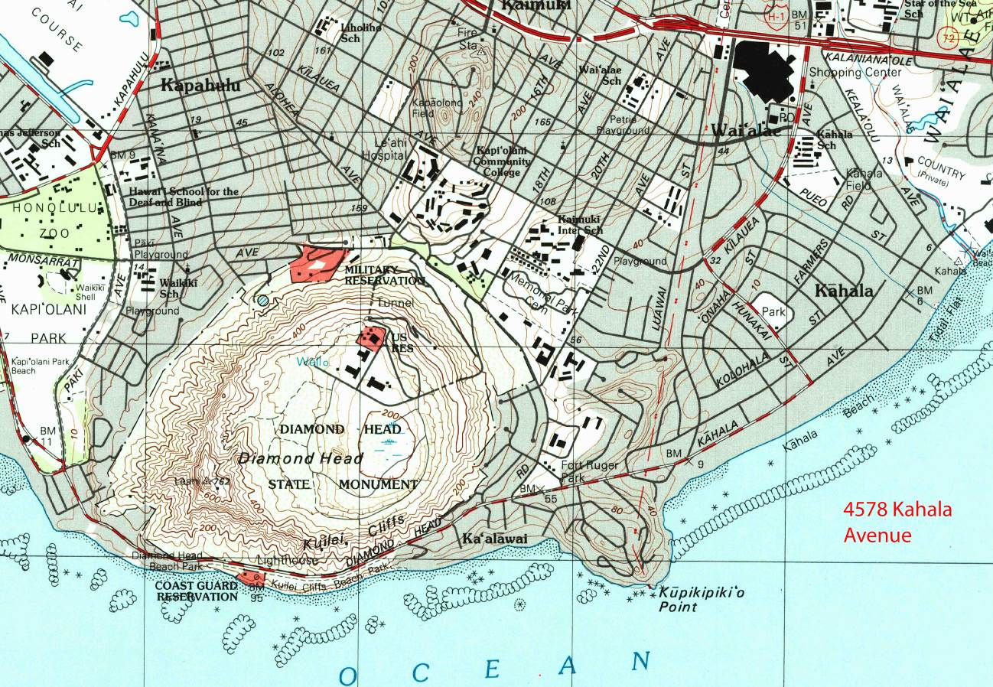
USGS Honolulu Quadrangle, 7.5 Minute Series, 1998. (Location added)

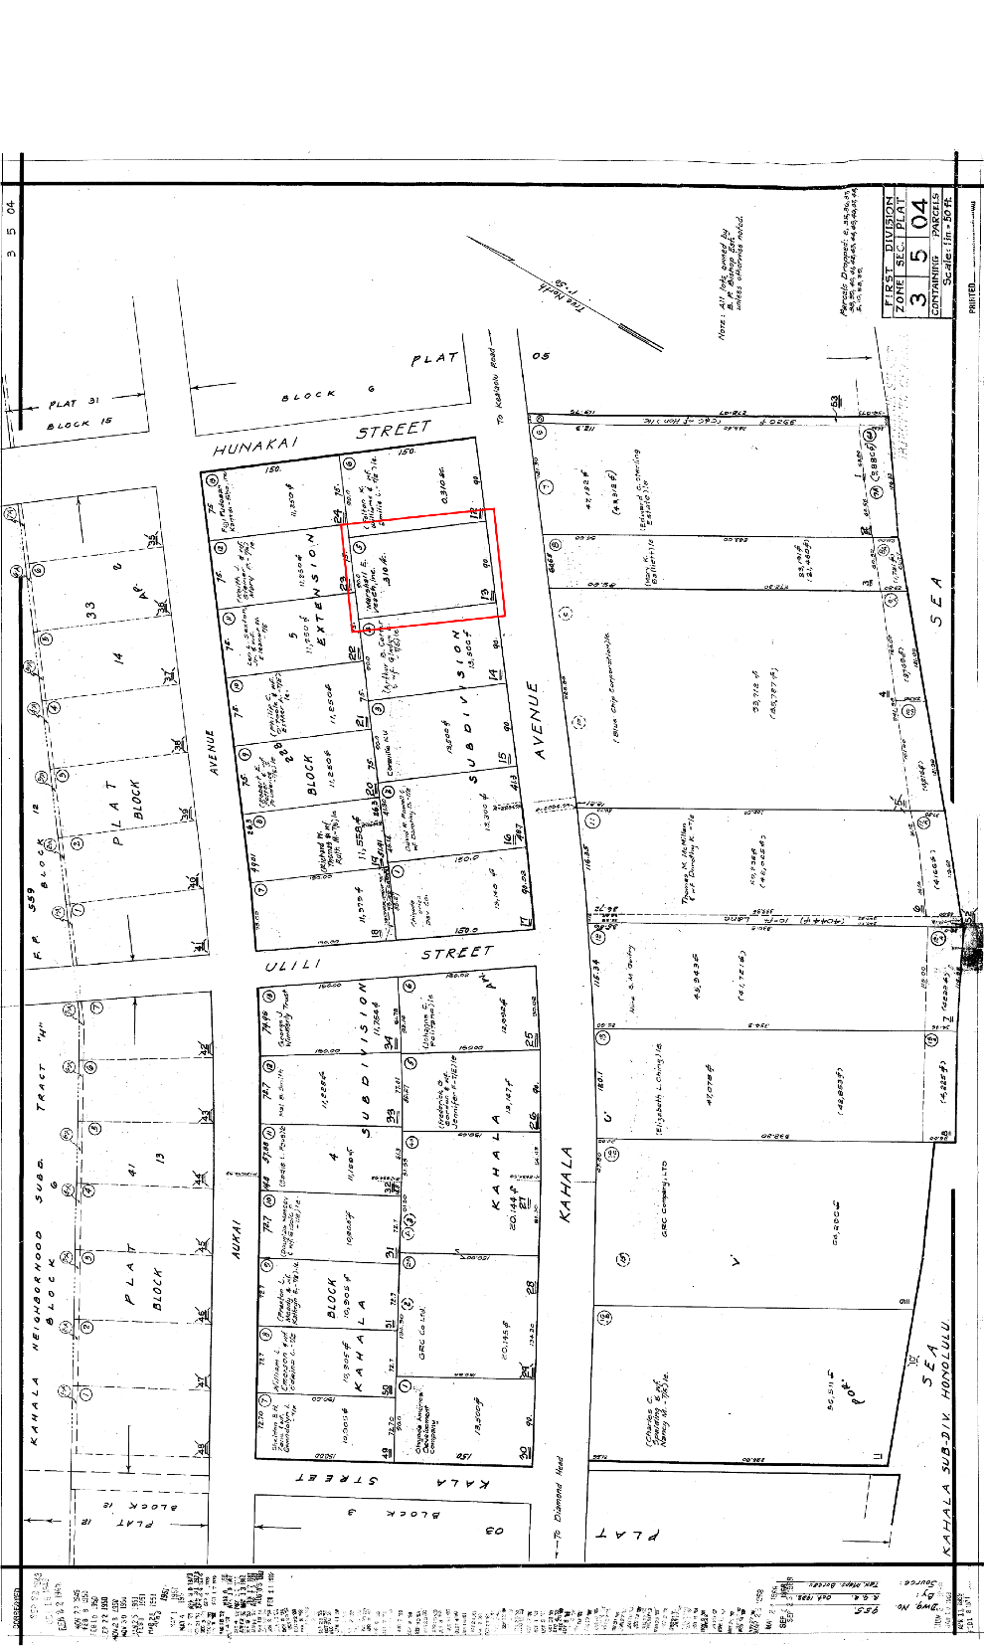
Plat Map for TMK (1) 3-5-004:013. (Location box added)

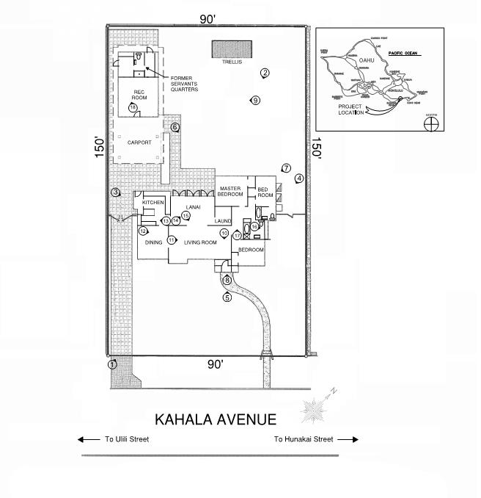
Sketch Map and Photo Key

Photographs

Photo Log

Name of Property: House at 4578 Kahala Avenue

City or Vicinity: Honolulu Hawai’i

County: Honolulu State: Hawai’i

Photographer: Angie Westfall, Mason Architects

Date Photographed: July and August 2018

HI_Honolulu_4578_Kahala_Avenue_0001. Front (south) facade. Camera facing northeast. Note original driveway pavers.

1 of 18.
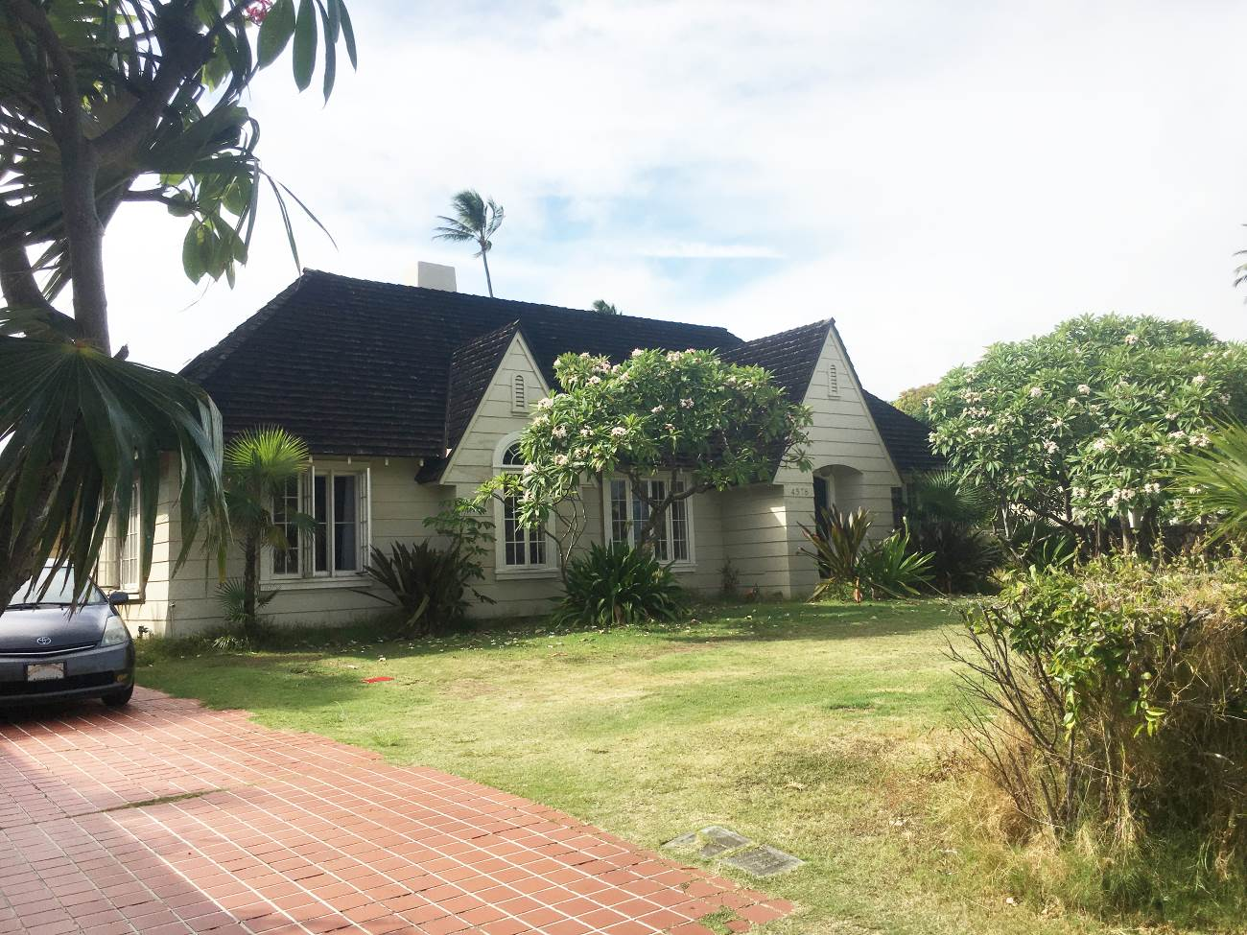

HI_Honolulu_4578_Kahala_Avenue_0002. Rear (north) facade. Camera facing southeast.

2 of 18.
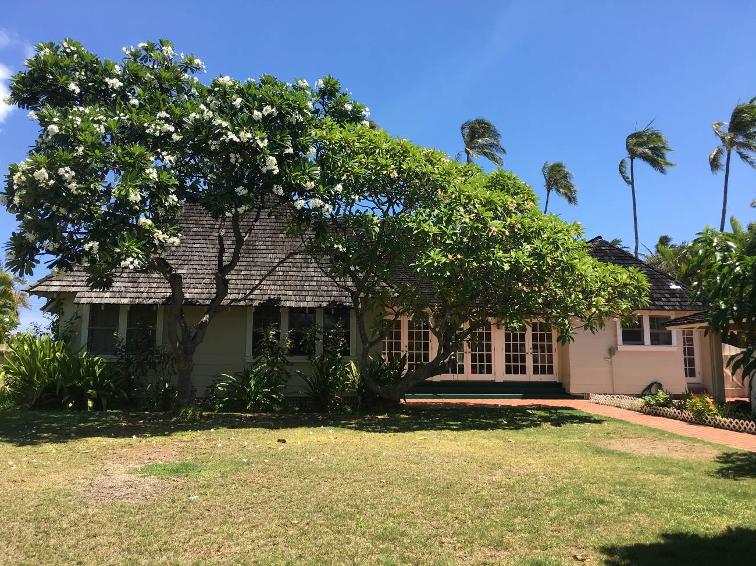

HI_Honolulu_4578_Kahala_Avenue_0003. West facade. Camera facing east. Note flares siding at kitchen projection.

3 of 18.
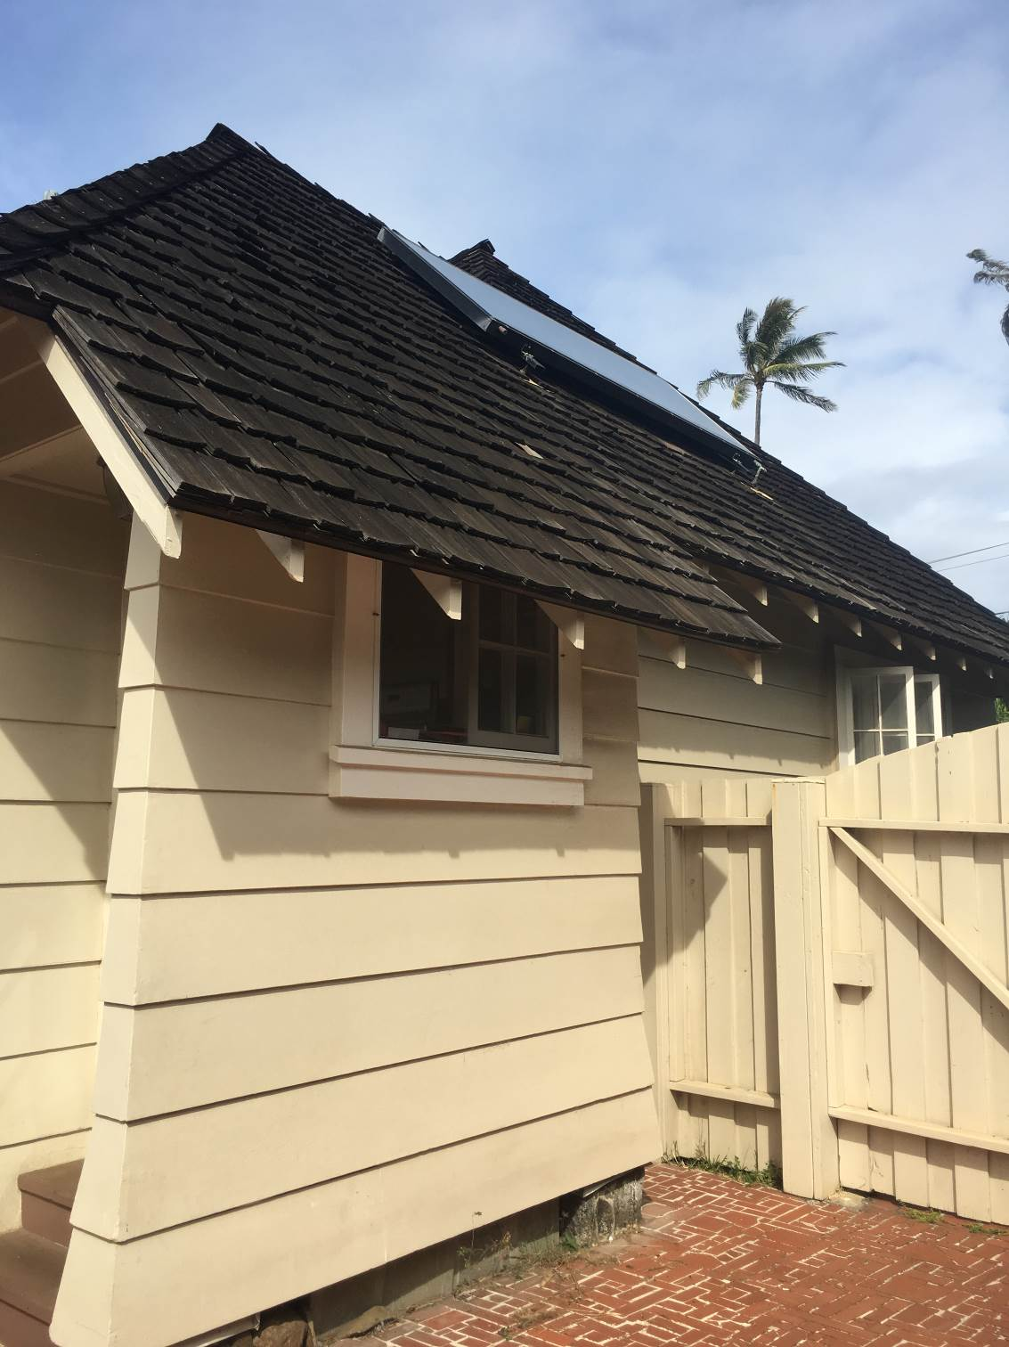

HI_Honolulu_4578_Kahala_Avenue_0004. Partial east facade. Camera facing south.

4 of 18.
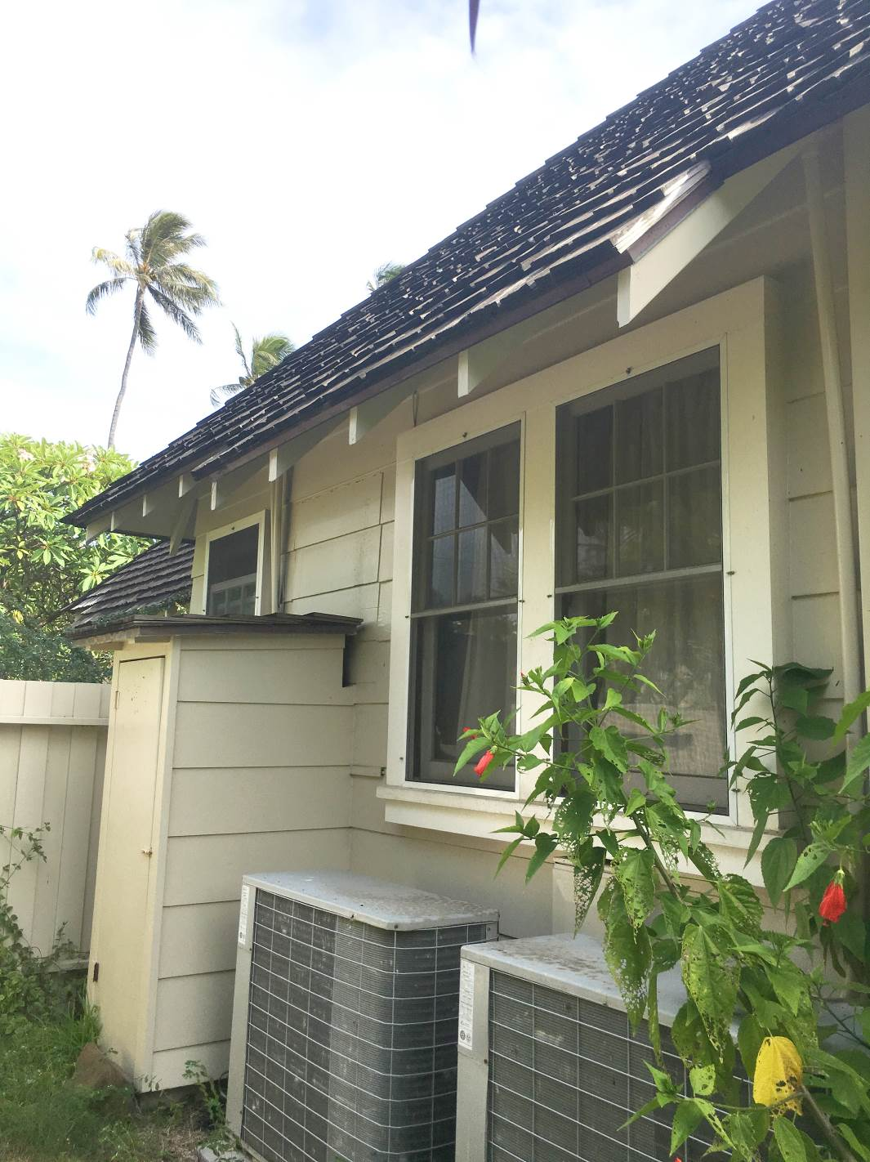

HI_Honolulu_4578_Kahala_Avenue_0005. Cross gable at front door, south facade. Camera facing northwest.

5 of 18.
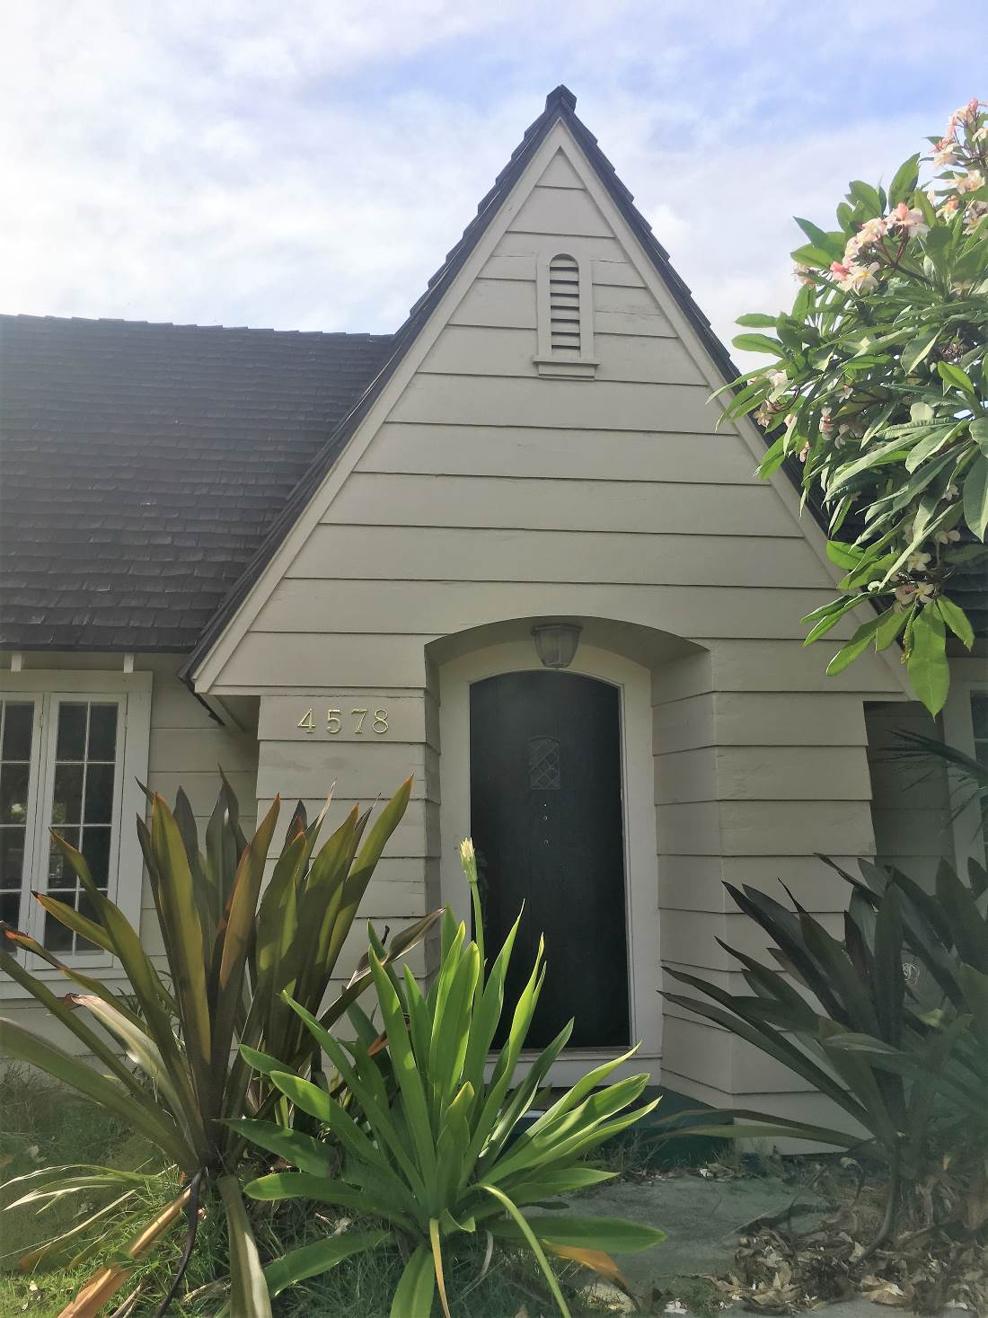

HI_Honolulu_4578_Kahala_Avenue_0006. North façade at enclosed lanai. Note stucco chimney. Camera facing east.

6 of 18.
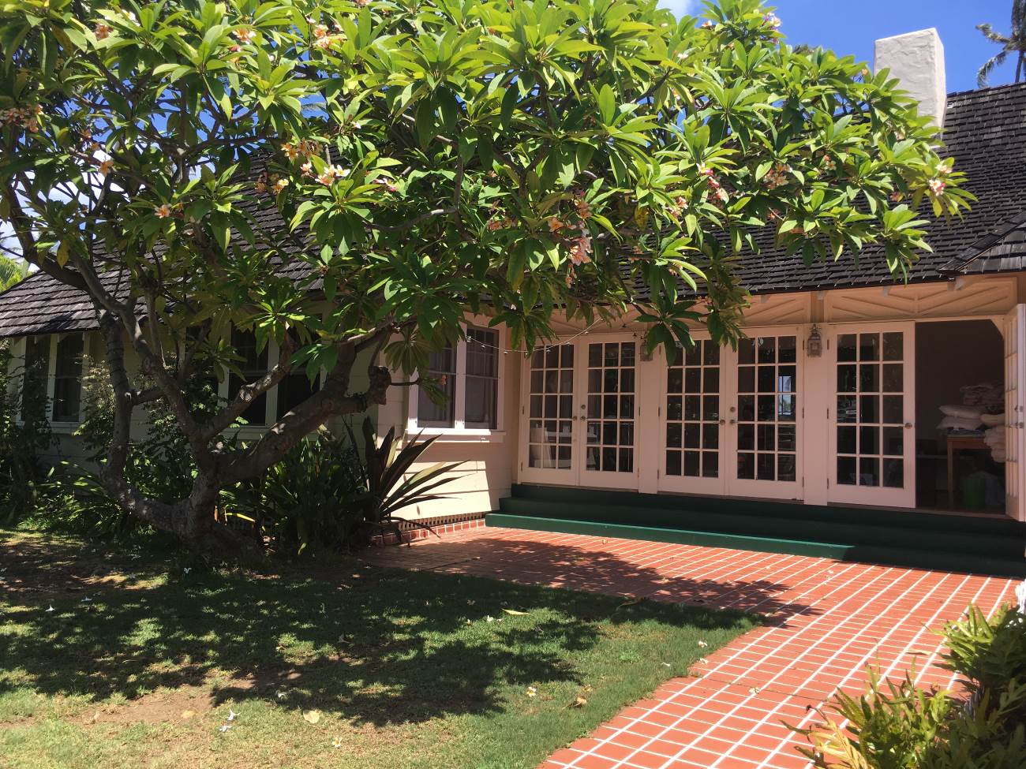

HI_Honolulu_4578_Kahala_Avenue_0007. North façade detail of overhangs and rafter tails. Note outset windows. Camera facing northeast.

7 of 18.
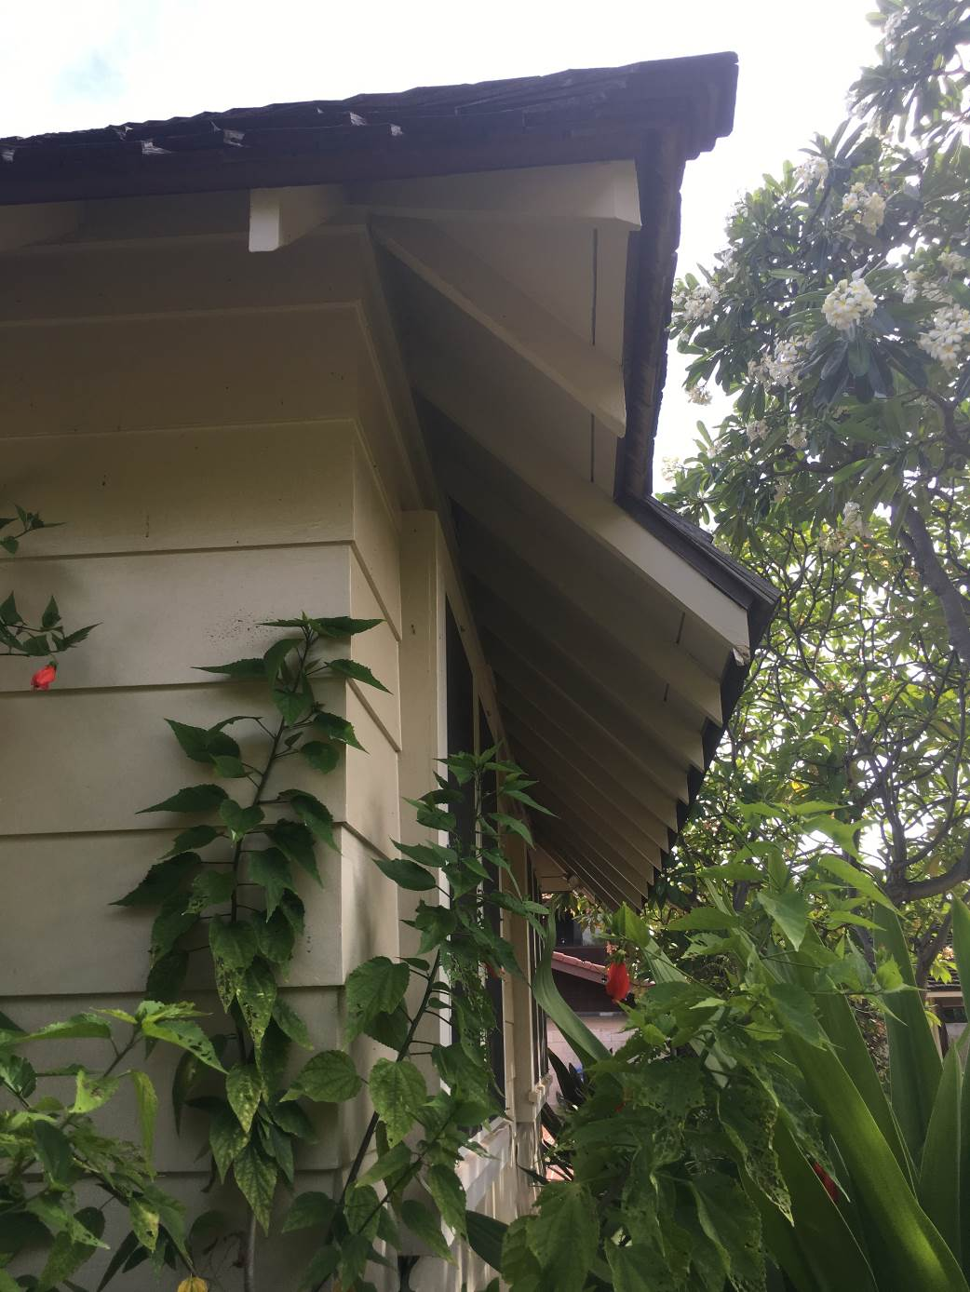

HI_Honolulu_4578_Kahala_Avenue_0008. Front door. Camera facing northwest.

8 of 18.
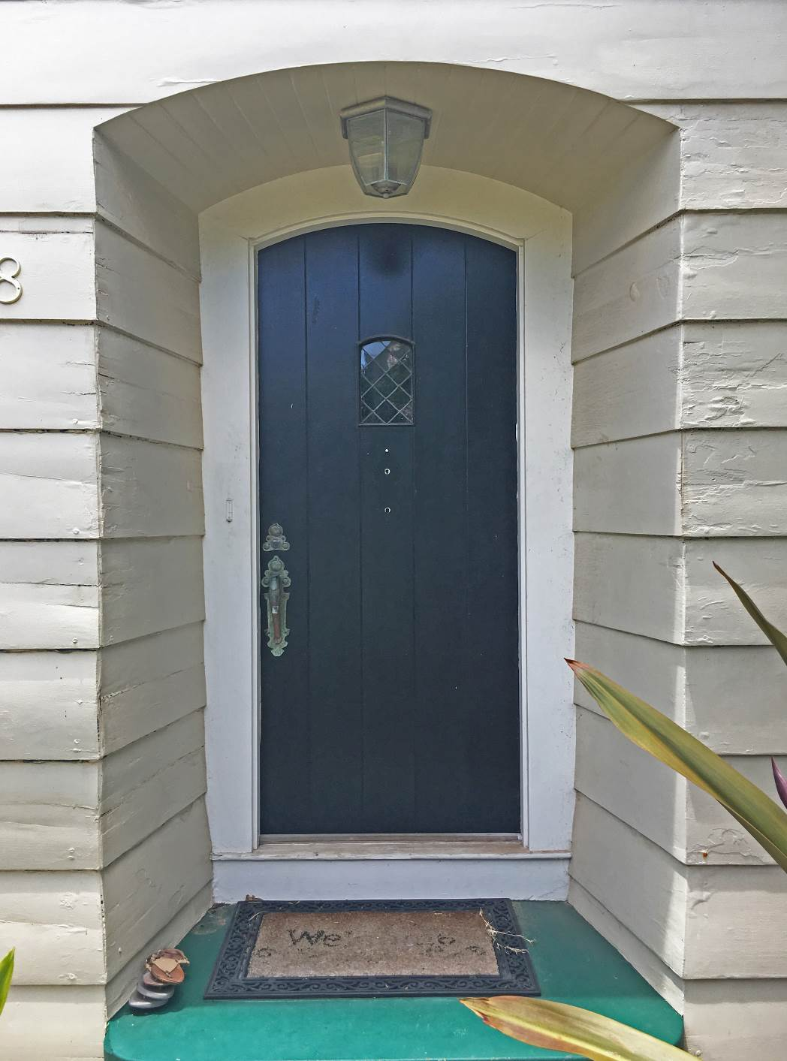

HI_Honolulu_4578_Kahala_Avenue_0009. Carport and former servant’s quarters, east facade. Camera facing southwest.

9 of 18.
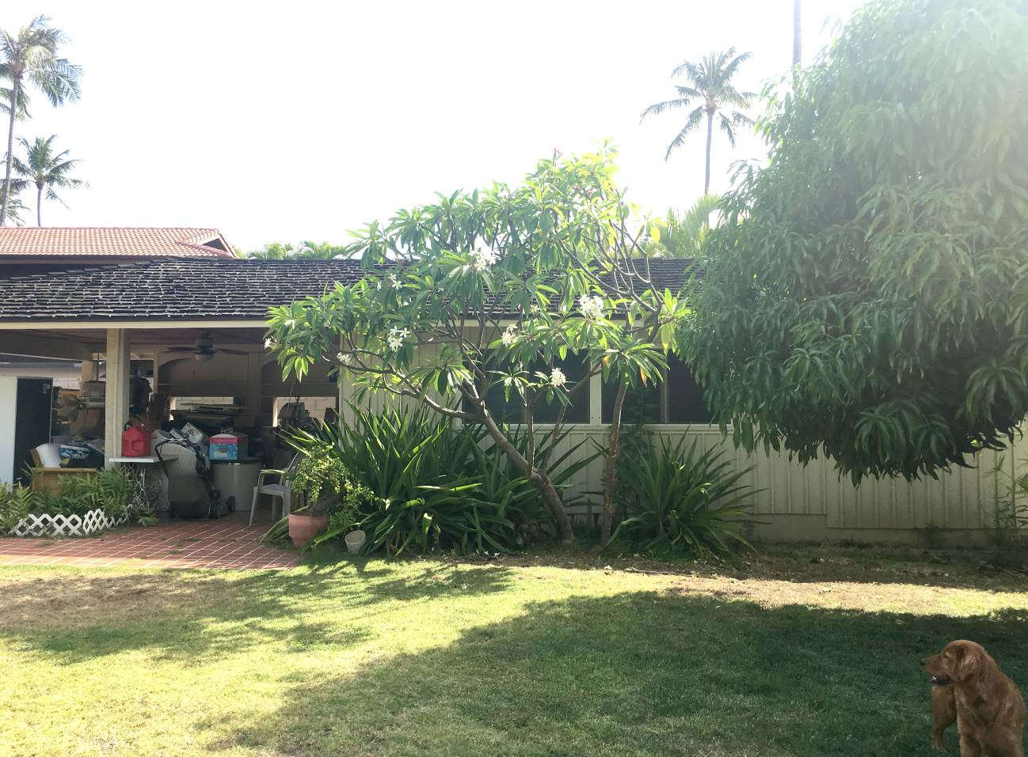

HI_Honolulu_4578_Kahala_Avenue_0010. Front door and closet that sits within larger cross gable. Camera facing southeast.

10 of 18.
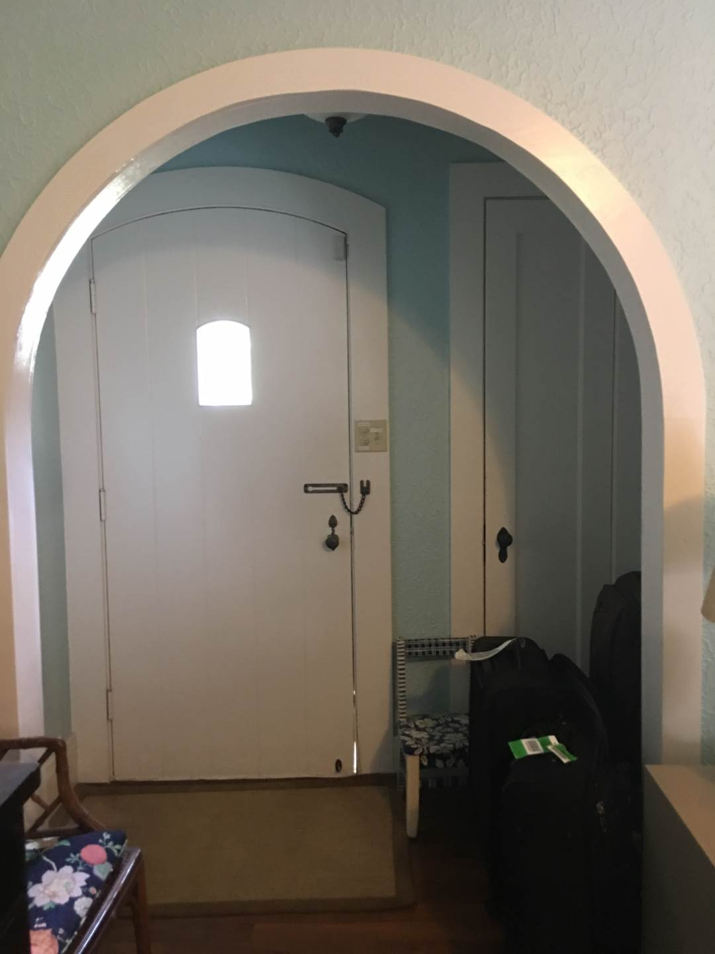

HI_Honolulu_4578_Kahala_Avenue_0011. Living room. Note trusses with decorative connection covers. Camera facing northeast.

11 of 18.
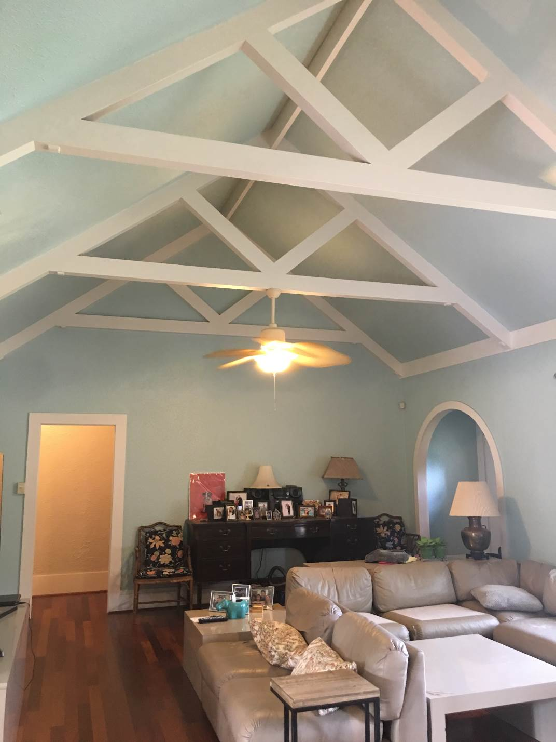

HI_Honolulu_4578_Kahala_Avenue_0012. Dining room. Note ceiling beams with decorative ends and arched doorway. Camera facing northeast.

12 of 18.
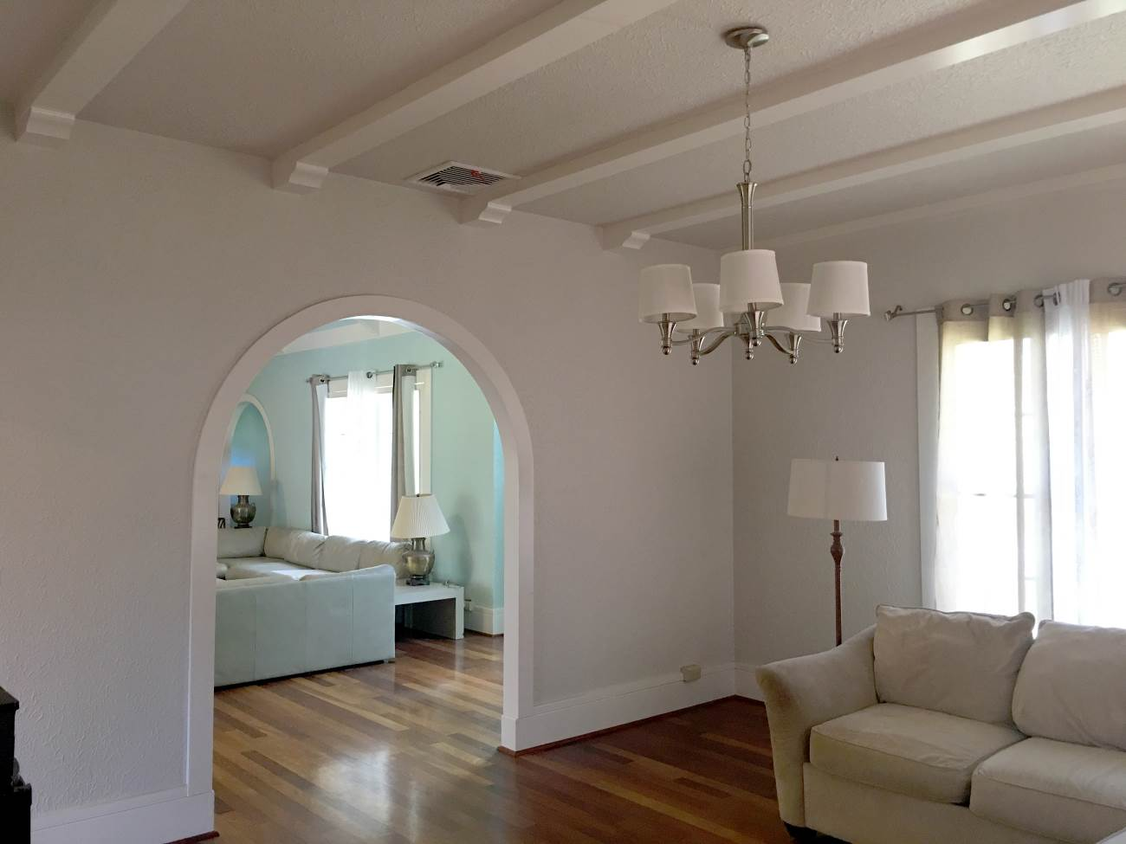

HI_Honolulu_4578_Kahala_Avenue_0013. Kitchen. Note coffered ceiling with recessed lighting (also typical of bedrooms). Camera facing west.

13 of 18.
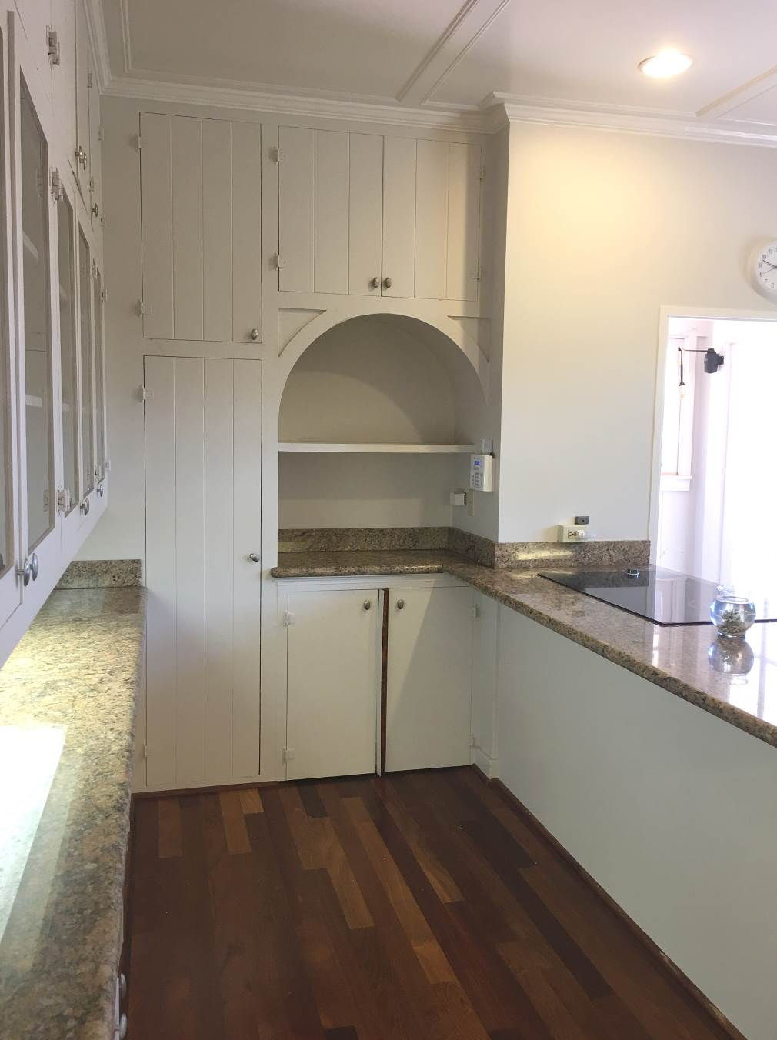

HI_Honolulu_4578_Kahala_Avenue_0014. Enclosed lanai. Note tongue and groove ceiling and arch at doorways. Camera facing north.

14 of 18.
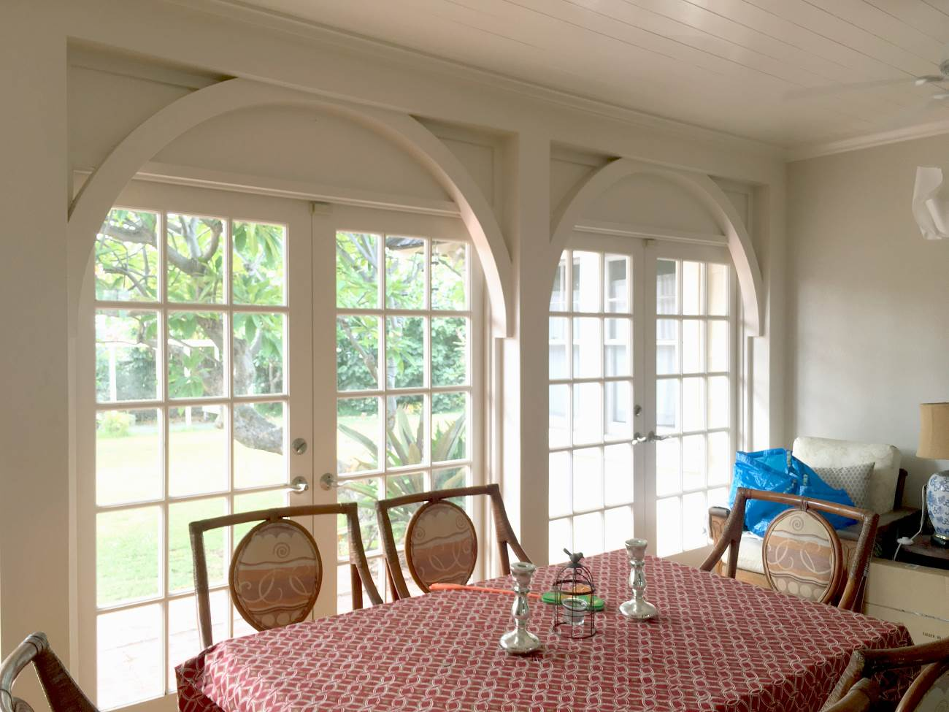

HI_Honolulu_4578_Kahala_Avenue_0015. Door from lanai to living room. Camera facing east.

15 of 18.
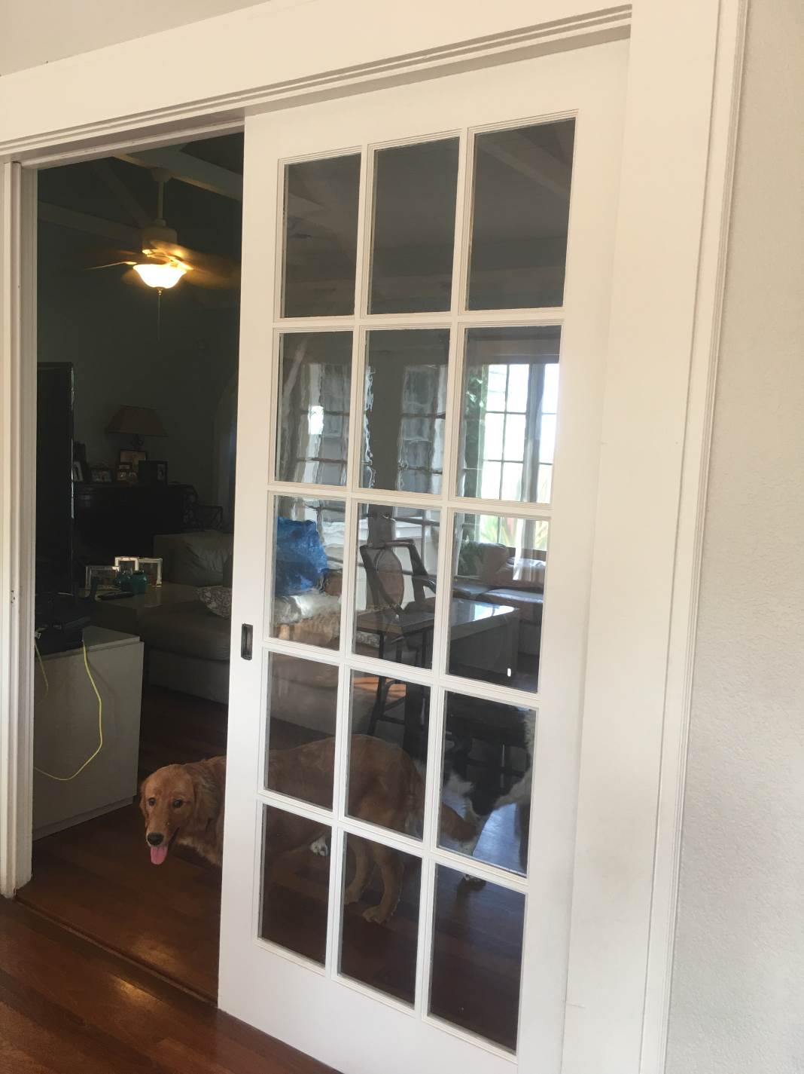

HI_Honolulu_4578_Kahala_Avenue_0016. Hall bath. Original built in storage and vanity. Camera facing east.

16 of 18.
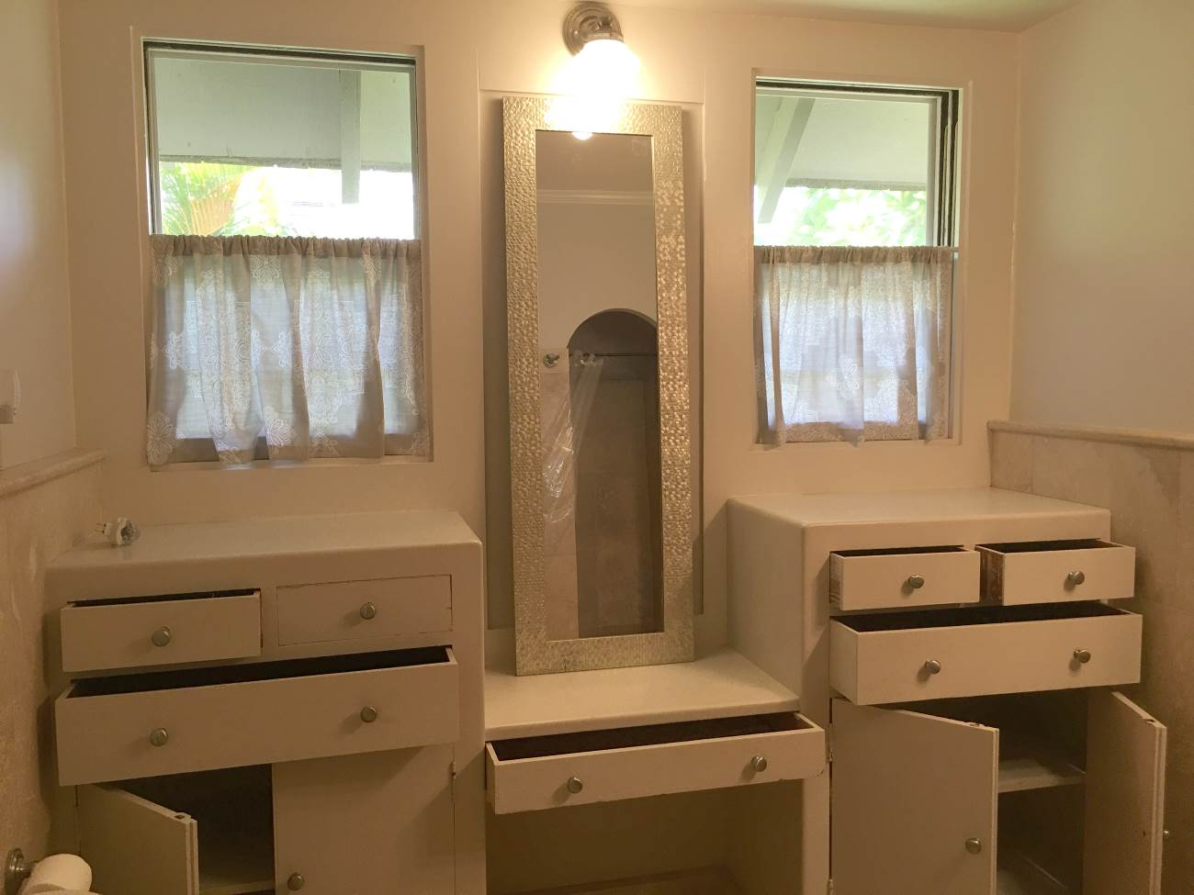

HI_Honolulu_4578_Kahala_Avenue_0017. Hall to bedrooms. Note original phone niche at left of phot. Note texture applied to walls (typical throughout most rooms). Camera facing northwest.

17 of 18.
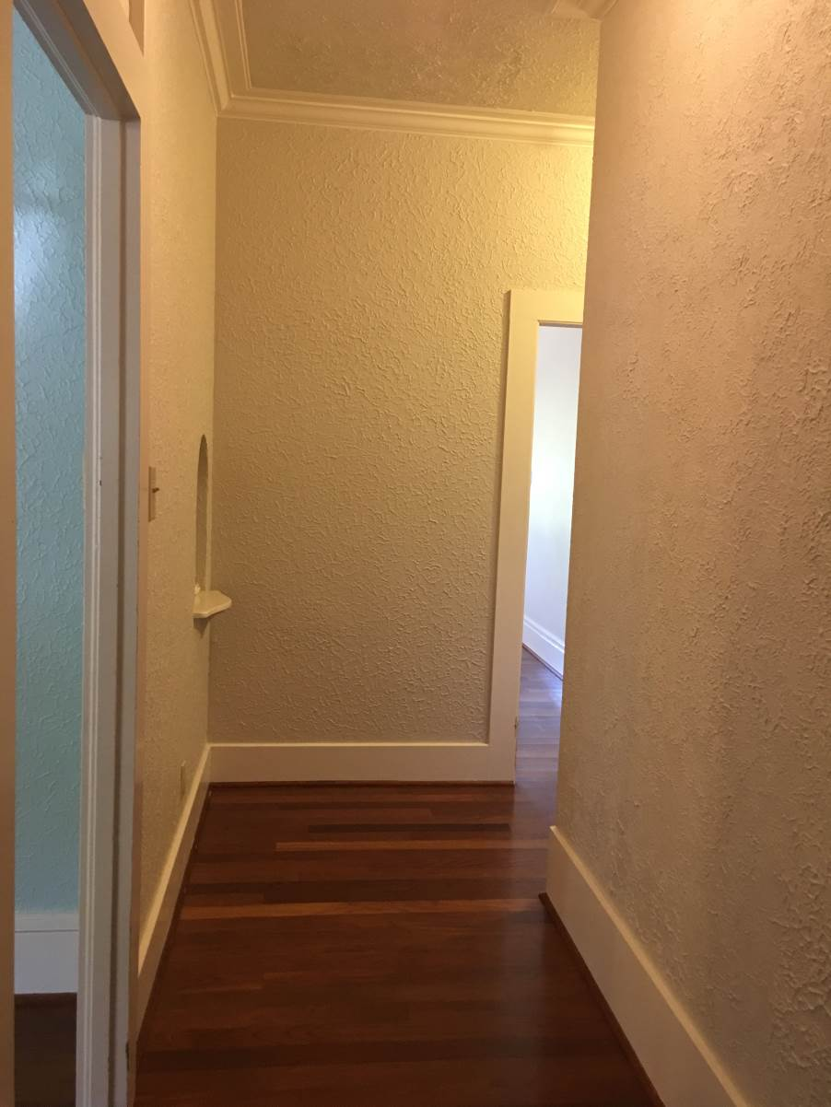

HI_Honolulu_4578_Kahala_Avenue_0018. Former garage and servant’s quarters. Camera facing northwest.

18 of 18.
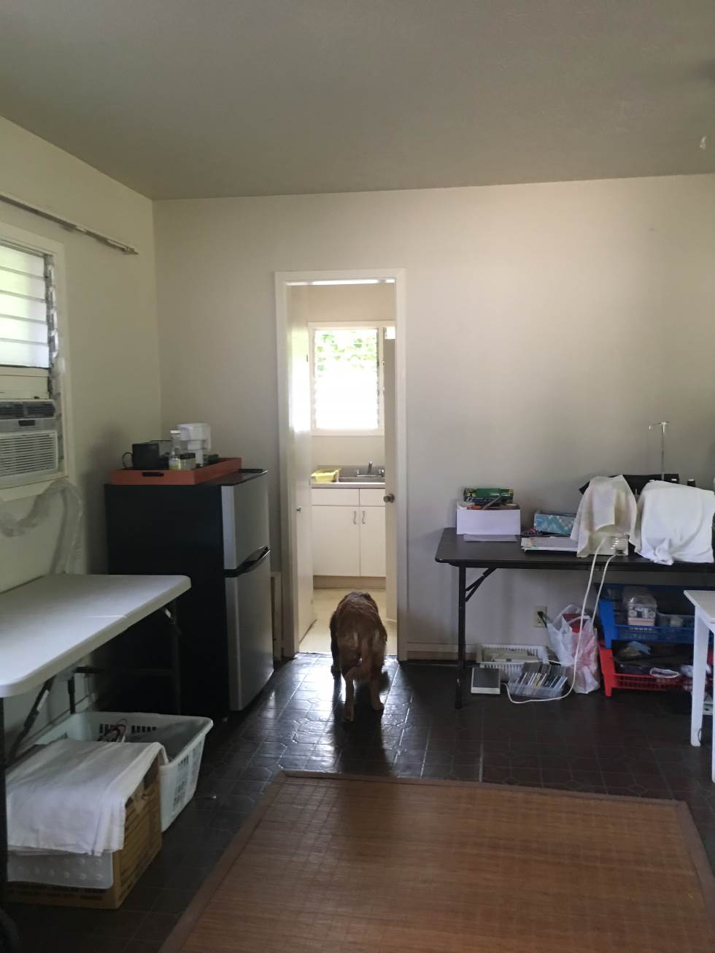

Paperwork Reduction Act Statement: This information is being collected for applications to the National Register of Historic Places to nominate properties for listing or determine eligibility for listing, to list properties, and to amend existing listings. Response to this request is required to obtain a benefit in accordance with the National Historic Preservation Act, as amended (16 U.S.C.460 et seq.).
Estimated Burden Statement: Public reporting burden for this form is estimated to average 100 hours per response including time for reviewing instructions, gathering and maintaining data, and completing and reviewing the form. Direct comments regarding this burden estimate or any aspect of this form to the Office of Planning and Performance Management. U.S. Dept. of the Interior, 1849 C. Street, NW, Washington, DC.

Moku and ahupua‘a are Hawaiian terms that refer to land divisions. An ahupua‘a is a portion of land that is typically somewhat pie-shaped, and runs from the mountains to the ocean, and a moku is a larger district consisting of multiple ahupua‘a. OHA - KIPUKA Database. (n.d.). Retrieved August 3, 2018, from http://kipukadatabase.com/kipuka/TMK.html?ObjectID=75001&b=2#view1
The Hokule’a is a traditional double-hulled voyaging canoe. It was the first voyaging canoe to be built in the Hawaiian Islands in over 600 years. The project was undertaken by the Polynesian Voyaging Society, founded in 1973 to “research and perpetuate traditional Polynesian voyaging methods” and to prove that ancient Polynesians purposely travelled the Polynesian Triangle. Its inaugural voyage, in 1976, was to Tahiti and was accomplished using only traditional, non-instrument, Polynesian navigation methods. Employing only ancient techniques of celestial navigation, the Hokule’a completed eight more voyages; to Micronesia, Polynesia, Japan, Canada, and the mainland United States between 1976 and 2009. In 2014 the Hokule’a and sister vessel Hikianalia embarked on a three-year circumnavigation of the globe, or “Island Earth” as Veach came to call it. This voyage, called Mālama Honua (“to care for our Earth” in Hawaiian), visited 150 ports, 23 countries, and eight UNESCO Marine World Heritage Sites. The canoes returned home to Hawai’i in June 2017 and continues its journey through the Hawaiian Island chain through 2018.

